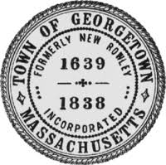 The Commonwealth of Massachusetts Fee: $40
Town of Georgetown Certificate#:
Business Certificate Issued:

In conformity with the provisions of Chapter 337 of the Acts of 1985 & Chapter 110, Section 5 of the Massachusetts General Laws, as amended, the undersigned hereby declare(s) that a business is conducted under the title of:
Name of Business:
Address of Business:

By the following named person(s): (Include corporate name & title, if corporate officer)

Owner Name(s) Owner Residence Address(es) Phone #(s)
1.
2.
3.
4.
Sign below only in the presence of a Notary Public or the Town Clerk
1.____________________________2._____________________________3.___________________________
4.__________________________________

On the above named person(s) personally appeared before and made oath that the foregoing
statement is true.

___________________________
Notary Public
My Commission Expires:________________________ (Notary Stamp)

Business Certificates shall be in effect for four (4) years from the date of issue and shall be renewed each four (4) years thereafter. A statement under oath must be filed with the Town Clerk upon discontinuing, retiring or withdrawing from such business or partnership. The signatories above acknowledge that this certificate is not proof of conformity to Zoning bylaws or Board of Health regulations. It is the responsibility of the applicant to contact the Building Inspector and Health Agent, in order to comply with the town bylaws rules and regulations.

This Certificate Expires:

(Town Seal)

New ☐ Renewal ________________________
Town Clerk

