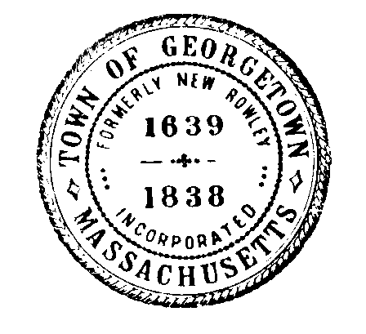
Georgetown Water Department
Town of Georgetown, Massachusetts
One Moulton Street
Georgetown, MA 01833
Tel: (978) 352-5750
Fax: (978) 352-5706

______________________________________________________________________________

Board of Water Commissioners Meeting
Meeting Information

Meeting Date: Monday, September 30, 2019

Meeting Time: 6:45 PM

Meeting Location: Water Department Office
One Moulton Street
Georgetown, MA 01833
______________________________________________________________________________

Meeting Agenda
- Approve Agenda

Water Department
- Utility Director Interview 6:45-7:30
- Utility Director Discussion and Vote.

General Manager
- Next Meeting and Adjourn

Signed: Nick Lawler Date: 9-24-19

Nick Lawler, Chairman

