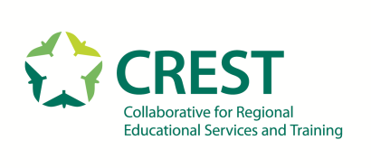

Collaborative for Regional Educational Services and Training Board of Directors Meeting
9 Branch Street, Methuen, MA 01844

AGENDA
Wednesday, January 27, 2021
9:00 am to 10:30 am

CALL TO ORDER (Chairperson, Steven Stone)

This CREST Board of Directors meeting is being held remotely in accordance with the Governors of Massachusetts, March 10, 2020 order suspending certain provisions of the open meeting law of MA. GL 30A, Sections 18 & 20. There will be no public participation. The copy of this meeting will be made available on the CREST website as soon as possible. I ask anyone speaking to identify yourself if you're not speaking, keep yourself on mute and all motions including adjournment will be roll call today.

Board Note Taker: Laura Hillery

- CONSENT AGENDA - Action Needed
a. Acceptance: Meeting minutes from December 16,2020

- FINANCE REPORTS - Action Needed
a. Acceptance: YTD Aging, Enrollment, Fy’ 21 budget reports
b. Information Only: Treasurer Update

- OLD BUSINESS - Action Needed
a. Action Needed: Executive Director Evaluation 2019-2020
b. Information Only: Facility Update
c. Action Needed: Return of Cumulative Surplus

- NEW BUSINESS
- Information Only: Tuition Rates 2021-2022
- First Reading: School Calendar 2021-2022
- Action Needed: Personnel Staffing Report
- Action Needed: Personnel Manual
- Information Only: IA Negotiations

- EXECUTIVE SESSION
- Action Needed: Approval of executive session minutes from December 16, 2020

