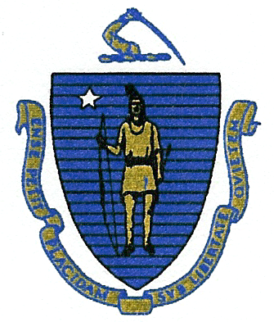
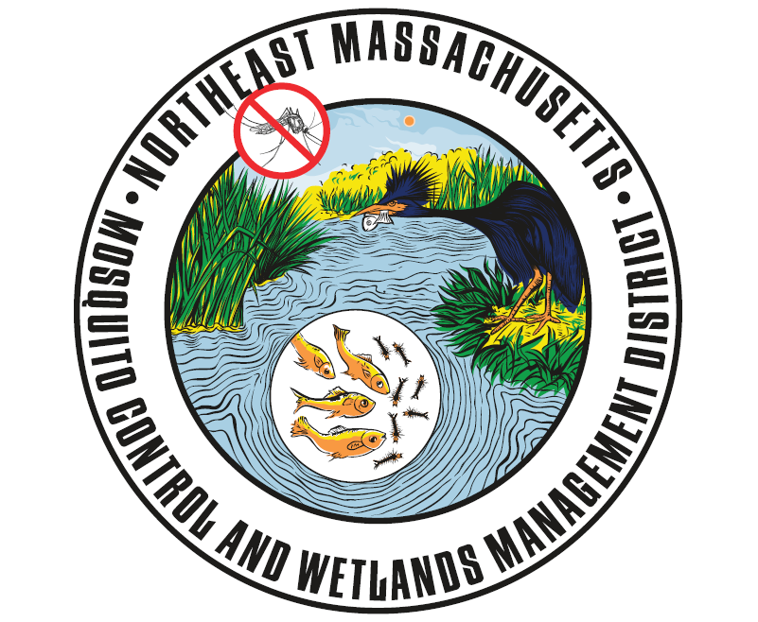
Commonwealth of Massachusetts
State Reclamation and Mosquito Control Board

Northeast Massachusetts Mosquito Control
and Wetlands Management District
118 Tenney Street
Georgetown, MA 01833
Phone: (978) 352-2800
www.nemassmosquito.org

Commissioners
Roy E. Melnick: Executive Director John W. Morris, CHO: Chair
William Mehaffey, Jr.: Operations Manager Vincent J. Russo, MD, MPH: Vice Chair
Kimberly A. Foss: Entomologist Paul Sevigny, RS, CHO
Robyn A. Januszewski: Biologist Joseph T. Giarrusso, Conservation Officer
Rosemary Decie, RS

DATE POSTED: JANUARY 03, 2020

PUBLIC MEETING NOTICE AND AGENDA

NEMMC District Board of Commissioner’s Meeting
January 09, 2020
09:00 AM
118 Tenney Street, Georgetown, MA

As posted with the Commonwealth of Massachusetts Office of the Secretary of State, the Executive Office of Administration and Finance, the State Reclamation and Mosquito Control Board and all subscribing communities, there will be a meeting of the Northeast Massachusetts Mosquito Control and Wetlands Management District (NEMMC) Board of Commissioners to be held on January 09, 2020 at 09:00 AM.

Agenda as follows:

- Call to order and Attendance.

- Review minutes for 12/19/19 NEMMC Commissioner’s Board Meeting (vote for action).

- Update of the Assistant Field Technician job posting/hiring presented by Roy Melnick.

- Job posting of the Contract Seasonal position (2 vacancies) presented by Roy Melnick.

- Public Comment/Input.

- Other business.

- Adjournment.

