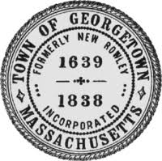
Town of Georgetown
Town Clerk
One Library Street
Georgetown, MA 01833
Tel: 978-352-5711 Email:kmcmanus@georgetownma.gov

NOTICE OF MEETING
BOARD OF REGISTRARS
TOWN CLERK’S OFFICE – ONE LIBRARY STREET
Monday, November 21 2022
9:00AM

AGENDA:

- To review and count any UOCAVA/ FWAB State election ballots received by Friday, November 18th.
- Discuss Registrar’s stamp
- Adjourn

