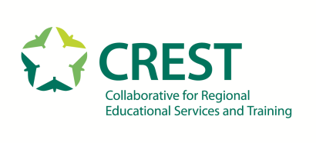

Collaborative for Regional Educational Services and Training Board of Directors Meeting
9 Branch Street, Methuen, MA 01844

AGENDA
Wednesday, January 22, 2020
9:00 am to 10:30 am

CALL TO ORDER (Chairperson, Steven Stone)

- PLEDGE OF ALLEGIANCE

- CONSENT AGENDA - Action Needed
a. Acceptance: Meeting minutes November 20, 2019
b. Action Needed: Personnel Staffing Report

PUBLIC COMMENT

- FINANCE REPORTS - Action Needed
a. Acceptance: YTD Aging, Enrollment, FY 20 budget reports
b. Information Only: Treasurer Update

- NEW BUSINESS
a. Information Only: 2020-2021 School Calendar (First Reading)

- OLD BUSINESS
a. Action Needed: Return of Cumulative Surplus
b. Action Needed: Facilities/Mortgage/Financing

8. EXECUTIVE SESSION
- Action Needed: Approval of executive session minutes from November 20, 2019

