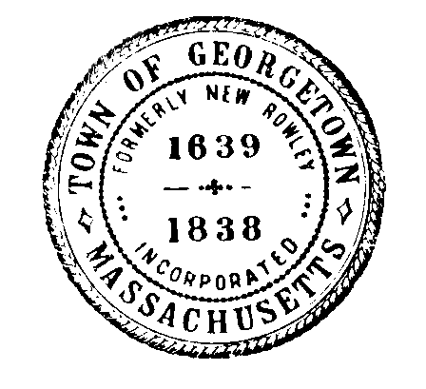
Georgetown Water Department
Town of Georgetown, Massachusetts
One Moulton Street
Georgetown, MA 01833
Tel: (978) 352-5750
Fax: (978) 352-5706

______________________________________________________________________________

Board of Water Commissioners Meeting
Meeting Information

Meeting Date: Tuesday, November 12, 2019

Meeting Time: 7:00 PM

Meeting Location: Water Department Office
One Moulton Street
Georgetown, MA 01833
______________________________________________________________________________

Meeting Agenda
- Approve Agenda
- Approve Minutes from September 30, 2019

Water Department
- FY 20 Financials
- Capital Projects Update
- Rowley Interconnection Update
- Water Treatment Plant – Tighe and Bond
- GWD Headquarters
- GWD Designation of Primary Operators

General Manager
- GM Update
- Action Items for GM
- Next Meeting and Adjourn

Signed: Nick Lawler Date: 11-6-19

Nick Lawler, Chairman

