FORM B − BUILDING

Massachusetts Historical Commission
Massachusetts Archives Building
220 Morrissey Boulevard
Boston, Massachusetts 02125

Photograph
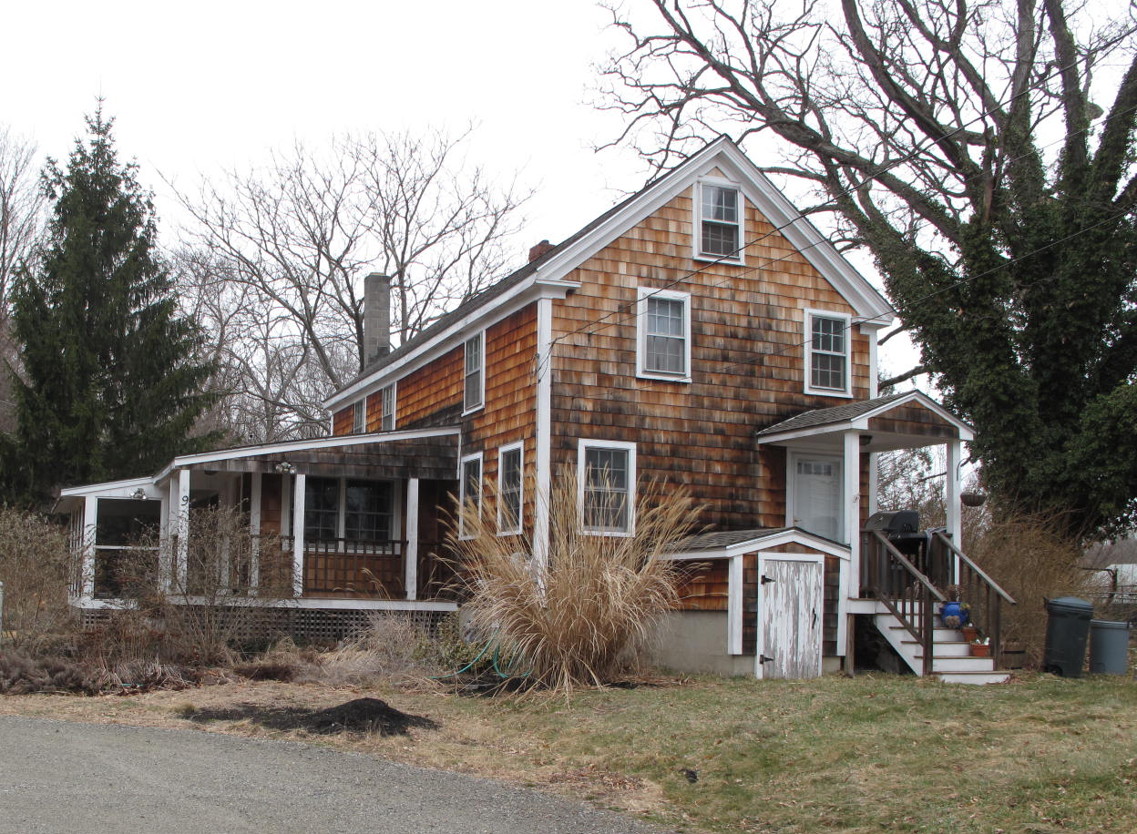
View from SW

Locus Map (north at top)
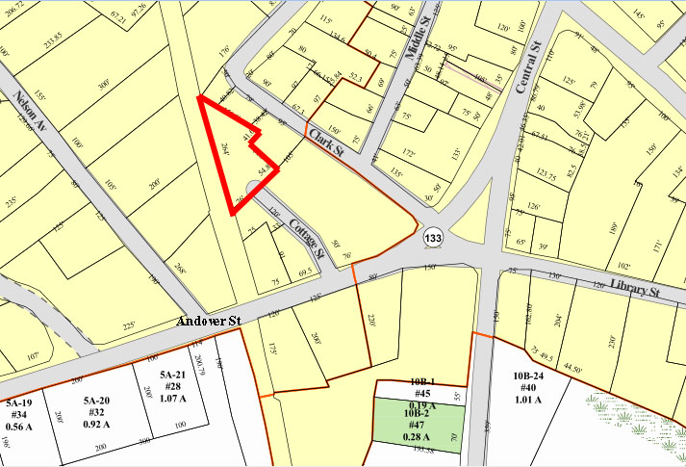

Recorded by: Kathryn Grover & Neil Larson
Organization: Town of Georgetown
Date: October 2012

Assessor’s Number USGS Quad Area(s) Form Number

6C-133 |  | Georgetown |  | C |  | GEO.135

Town/City: Georgetown
Place: (neighborhood or village):
Town Center

Address: 9 Cottage Street
Historic Name: Cronin - Foley House
Uses: Present: single residence
Original: single residence
Date of Construction: ca. 1855
Source: town
Style/Form:
Architect/Builder: unknown
Exterior Material:
Foundation: brick
Wall/Trim: vinyl clapboards
Roof: asphalt shingles
Outbuildings/Secondary Structures:

Major Alterations (with dates):

Condition: good
Moved: no yes Date:
Acreage: 0.39 acre
Setting: This house is sited on a lot with mature trees and shrubs at the end of Cottage Street and borders the former Boston and Maine Railroad corridor on the west. The area is primarily residential.

Recommended for listing in the National Register of Historic Places.
If checked, you must attach a completed National Register Criteria Statement form.

ARCHITECTURAL DESCRIPTION
The Cronin - Foley House is a two-story wood frame single dwelling with a front gable roof located at the north end of Cottage Street. The original front gable street façade likely contained an offset entrance and two windows on the first story, two windows evenly-spaced on the second story and a line window centered in the gable., but more recent alterations, disguised by the addition of wood shingle siding, have removed a window from the first story and relocated another on the upper story. Nevertheless, original six-over-six window sash appear to survive. The current porch at the front entrance is a replacement, and a one-story wing was added to the west side wall in a number of stages.

The house is centered on a triangular lot and surrounded by lawn. The railroad right-of-way forms the western boundary of the lot. An unpaved parking area on the west side of the house coincides with the end of Cottage Street. A paved parking lot behind the First Congregational Church abuts the property and Cottage Street linking it with Clark Street across the church property.

The Cronin - Foley House, built c. 1855, is a representative example of a small single-family dwelling built for working class families in Georgetown during the 19th century. Although altered, the building is a contributing component of the village district.

HISTORICAL NARRATIVE
In 1854, the property at 9 Cottage was part of the estate of the late Nathaniel Nelson (1767-1853), a banker who made his fortune in nearby Newburyport and had extensive real estate holdings; he lived at 8 Elm Street but owned (and may earlier have lived in) a house further west on Andover Street where his son-in-law, the attorney Jeremiah P. Jones, lived since the 1840s, as well as a house on the south side of Andover Street that he used as a boardinghouse. According to Georgetown’s Orlando B. Tenney, Nathaniel Nelson was “a large landholder . . . ever ready to give encouragement or render financial assistance to promote the growth and prosperity of the town” and was “mainly instrumental in the erection of more than twenty five dwelling houses now standing in town.” His executors made numerous deeds in the area, often to Irish immigrants. Local historian Henry M. Nelson noted that Nathaniel Nelson “had several farm laborers of Irish birth transiently employed” between 1840 and 1850” and allowed the first Roman Catholic Mass in Georgetown to be held in 1849 at the Andover Street house later occupied by Jones.

On 3 March 1854, Jones and Joseph Kimball, the executors of Nathaniel Nelson’s estate, sold what later became 9 Cottage Street at auction for $317 to William Cronin, “it being designed by said Cronin to hold the above described premises as a homestead.” The deed for the property does not mention buildings, nor was it of a value that would indicate such, but the 1856 map of the village shows a house on this approximate site indicating the house probably was built 1854 and 1856. Born in Ireland about 1830, Cronin was a shoemaker; he and his wife Catherine had three children, Ellen (or Helen), John, and William, by 1860. Little else is known about Cronin, who appears to have left the village about 1870; in April of that year he sold the land and buildings at 9 Cottage Street to fellow Irish immigrant Patrick Foley.

By 1870, Cottage Street and a small section of Andover Street just to the south and bordering the rail corridor on the west was called the Acre in the Essex County directory, no doubt for the well-known section of Lowell that had emerged as an Irish immigrant neighborhood in the 1820s. The 1870 county directory lists fourteen householders, all Irish immigrants, as residents of Georgetown’s Acre—Cronin; John Doonan; Patrick Hughes; his son Patrick and brother Arthur (1838-96); James Carroll, Henry Early, Owen McGinley, and James, James P., James T., Thomas, and Patrick Molloy 2d. Of these fourteen men, ten are listed as shoemakers, one as a shoe manufacturer, one as a farmer, and two as laborers. The 1872 map of Georgetown center depicts this concentration of Irish American settlement between the Boston and Maine rail corridor to west and Clark Street on the east: the homes of Foley, John Doonan (“Donan” on the map), Patrick Hughes (“Huse”), Patrick Molloy (Maloy), N. (though probably Henry) Early, Owen McGauley (McGoley), three buildings marked “shoe shop,” and two houses belonging to Patrick Moan or Moen, also from Ireland but not listed in the 1870 county directory, are shown in the area alongside that of the Daniel Clark family for whom Clark Street was named.

Born in Munster, Ireland, in March 1844, Patrick Foley came to the United States in 1866. In 1871 in Georgetown he married Ellen Marden, also an Irish immigrant then living in Georgetown. By 1880 he worked as a track repairer for the railroad, and his household included his wife, four children—William P., Margaret E., Mary E., and Nellie, born between 1871 and 1879—and four boarders, all born in Ireland and three of them also working at track repair for the railroad. By 1900 Foley, then fifty-six, worked as a railroad crossing tender, and he and his wife lived at 9 Cottage Street with their daughters Nellie, a bookkeeper, and Julia, a shoe factory packer probably born about 1881; the Foleys then had one boarder, Irish-born railroad laborers Edward Sweeney.

Patrick Foley died at 9 Cottage Street in September 1915, and the 1920 census shows his widow Ellen in the house by herself. She remained through at least 1932 and probably until her death in 1939 or early 1940. In March of the latter year her surviving children deeded 9 Cottage Street to Harold H. and Etta M. Cole McCormick, who are shown there with their children Rose, James, and Patricia in the 1940 census. Harold McCormick was a fisherman and a Georgetown native, born to John F. McCormick and his wife Roseanna Malvina Boulanger in 1906. The property changed hands three more times before 1950, when Alfred E. and Ruth Hurd acquired it. Born in Georgetown in 1920, Alfred Eugene Hurd was the son of shoeworker Thomas Hurd and his wife Cassie Tibbetts Hurd and grew up at 15-17 Clark Street. By 1940 he worked as a shoe laster, and probably in that year he married Ruth Eleanor Eustace of Ipswich. The couple had at least two children—Alfred E. Jr., born in 1941, and Mary Jane, born about 1945 in Lawrence. Hurd is not shown in Georgetown in the 1957 area directory, and he may have rented 9 Cottage Street for some years.

In July 2000 Ruth Hurd died, and Alfred Hurd deeded the property to Douglas C. Hurd (born in 1951, and possibly his son) and his wife Brenda with the proviso that Alfred retain life estate. This proviso remained in the deed the younger Hurds executed with Renee M. Basso of Haverhill in 2003. Alfred Hurd died in April 2004, and the next year Basso sold the property; nine months later current owners Brian S. and Sarah E. Neeley acquired 9 Cottage Street.

BIBLIOGRAPHY and/or REFERENCES
Arrington, Benjamin F., ed. Municipal History of Essex County in Massachusetts. NY: Lewis Historical Publishing Co., 1922.
Field, Jane. A Brief History of Georgetown Massachusetts 1838-1963. Rev. ed. 1988. Georgetown: Georgetown Historical Commission, 1988.
Gage, Thomas. The History of Rowley, Anciently Including Bradford, Boxford, and Georgetown, from the Year 1639 to the Present Time. Boston: F. Andrews, 1840.
Georgetown, Boxford, Byfield, Newbury, and West Newbury, Massachusetts, Directory. Boston: W. E. Shaw, 1901-2, 1905, 1909, 1912, 1914, 1916-17, 1918, 1925.
Hill, Edwin P. “History of Georgetown, Massachusetts.” In Standard History of Essex County, Massachusetts. Edited by Cyrus M. Tracey, William E. Graves, and Henry M. Batchelder. Boston: C. F. Jewett, 1878.
Hull, Forrest P. Georgetown: Story of One Hundred Years, 1838-1938. 1938. Reprint. Georgetown, MA: Georgetown Historical Commission, 2006.
Merrill, Samuel. A Merrill Memorial: An Account of the Descendants of Nathaniel Merrill, an Early Settler of Newbury, Massachusetts. Cambridge, MA, 1917-28.
Nelson, Henry M. “Town of Georgetown History.” In Hurd, D. Hamilton. History of Essex County, Massachusetts, with Biographical Sketches of Many of Its Pioneers and Prominent Men. Vol. 1. Philadelphia: J. W. Lewis and Co., 1888.

MAPS
“Map of the Centre of Georgetown in 1800.” In Perley, Sidney H., “Centre of Georgetown in the Year 1800.” The Essex Antiquarian: A Quarterly Magazine Devoted to the Biography, Genealogy, History, and Antiquities of Essex County, Massachusetts 2, 7 (July 1898): 201.
Map of Georgetown in 1810 and 1840. In Gage, Thomas. The History of Rowley, Anciently Including Bradford, Boxford, and Georgetown, from the Year 1639 to the Present Time. Boston: F. Andrews, 1840. 320.
“Map of New Rowley Surveyed and Drawn by Philander Anderson 1830.” Georgetown Historical Society.
Map of Georgetown. 1856. In Walling. H. F. A Topographical Map Essex County Massachusetts. Boston: Smith and Morley, 1856.
Atlas of Essex County, Massachusetts. Philadelphia: D. G. Beers and Co., 1872). Plates 59 and 61.
“Town of Georgetown Mass.” and “Village of Georgetown Mass.” In Atlas of Essex County, Massachusetts (Boston: George H. Walker, 1884).
“Georgetown, Mass. 1887.” Drawn and Published by George E. Norris, Brockton, Massachusetts. Troy, NY: Burleigh Lithographic Establishment, 1887.”

PHOTOGRAPHS (all photos by Neil Larson, 2012)

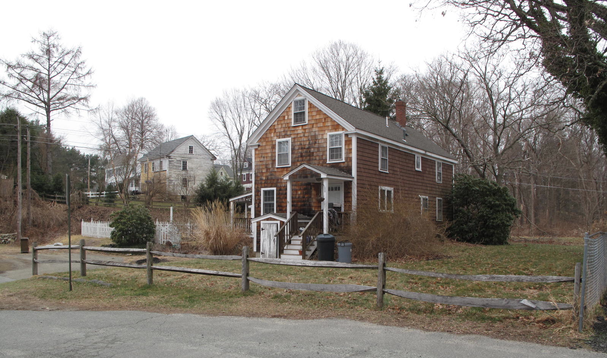
9 Cottage Street: view from SE (top) and NE (bottom)

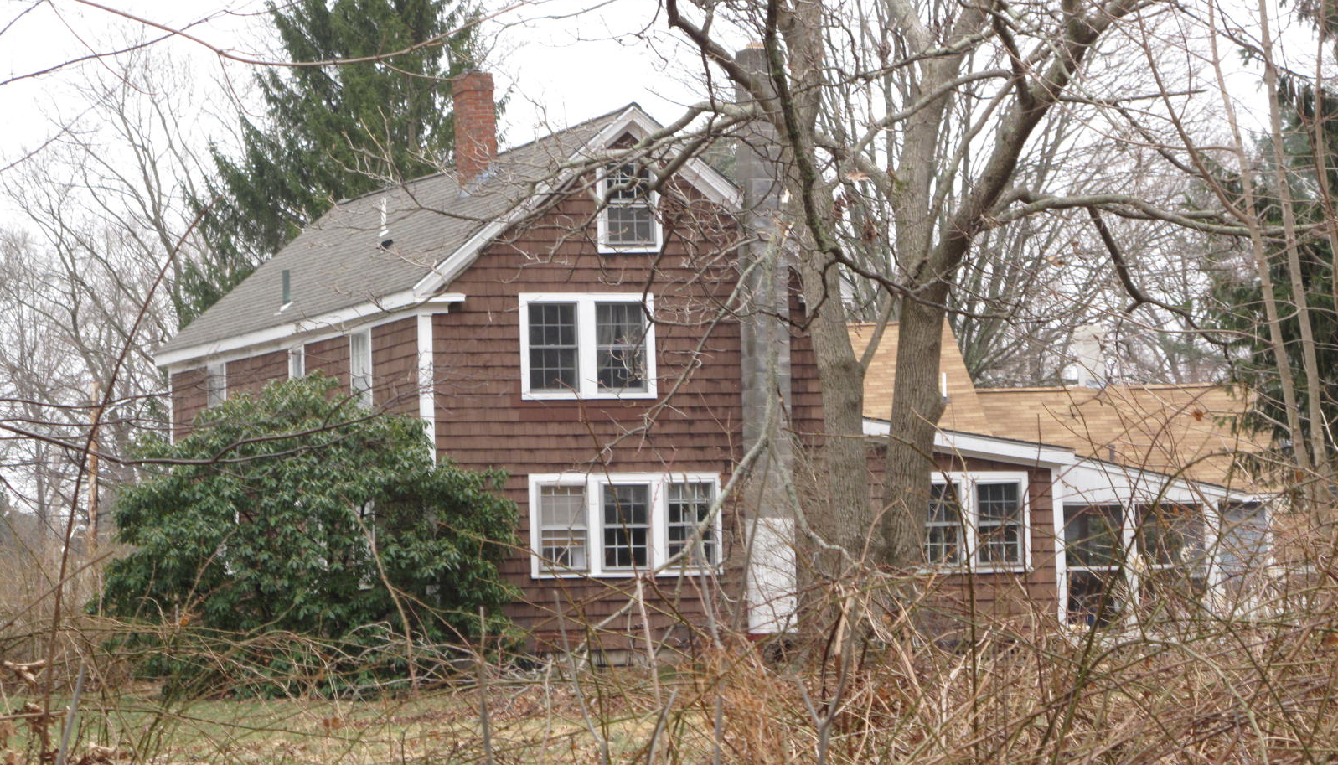

National Register of Historic Places Criteria Statement Form

Check all that apply:

Individually eligible Eligible only in a historic district

Contributing to a potential historic district Potential historic district

Criteria: A B C D

Criteria Considerations: A B C D E F G

Statement of Significance by________Neil Larson_________________________________
The criteria that are checked in the above sections must be justified here.

The Cronin - Foley House, built c. 1855, is a representative example of a small single-family dwelling built for working class families in Georgetown during the 19th century. Although altered, the building is a contributing component of the village district.

“Hon. O. B. Tenney. A Sketch of One of Georgetown’s Oldest and Most Respected Citizens. Together with Other Interesting Historical Matter,” clipping from unidentified newspaper courtesy Joseph Knapp.
“Hon. O. B. Tenney.” The article states that Tenney’s description is “thought to include every dwelling house then standing within the radius named,” which included Andover Street.
Henry M. Nelson, “Town of Georgetown History,” in History of Essex County, Massachusetts, with Biographical Sketches of Many of Its Pioneers and Prominent Men (Philadelphia: J. W. Lewis and Co., 1888), 1:840.
Joseph Kimball and Jeremiah P. Jones, administrators estate Nathanial Nelson, to William Cronin, 3 March 1854, SED 492:101.
William Cronin to Patrick Foley, 9 April 1870, SED 796:89.
See Henry M. Nelson, “Town of Georgetown History.” In History of Essex County, Massachusetts, with Biographical Sketches of Many of Its Pioneers and Prominent Men, ed. D. Hamilton Hurd (Philadelphia: J. W. Lewis and Co., 1888) 1:834, 837.
Margaret E. McBain, Nellie E. Hale, Julia J. Riley (widow), Willie E. Foley to Harold H. and Etta M. McCormick, 30 March 1940, SED 3211:598; Harold H. and Etta M. McCormick to Baker Adams, 25 October 1946, SED 3484:599; Baker Adams to Chesleigh C. and Etta M. Balance, 28 March 1948, SED 3592:508; Chesleigh C. and Etta M. Balance, New York NY, to Alfred E. and Ruth Hurd, 3 March 1950, SED 3725:424.
Alfred E. Hurd to Douglas C. and Brenda J. Hurd, 12 August 2002, SED 19126:404; Douglas C. and Brenda J. Hurd, 14 Moulton St, to Renee M. Basso, Haverhill, 2 May 2003, SED 21936:517; Renee Theofilopoulos, fka Renee M. Basso, Haverhill, to Timothy D. Howard, 169 Jewett St, 22 April 2005, SED 24204:338; Timothy D. Howard, 169 Jewett st, to Brian S. and Sarah E. Neeley, Ipswich, 20 December 2005, SED 25207:317. See also “Plan of Land in Georgetown,” 19 April 2005, SEP 386:95.

