FORM B − BUILDING

Massachusetts Historical Commission
Massachusetts Archives Building
220 Morrissey Boulevard
Boston, Massachusetts 02125

Photograph
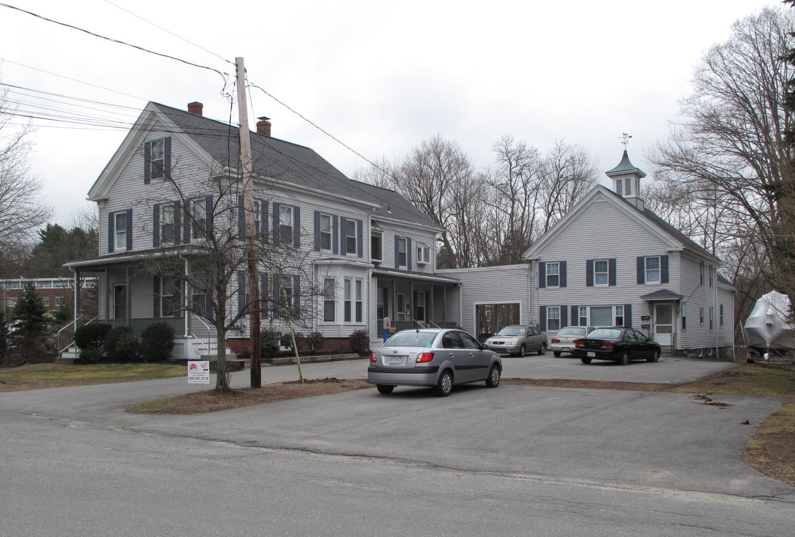
View from southwest

Locus Map (north at top)
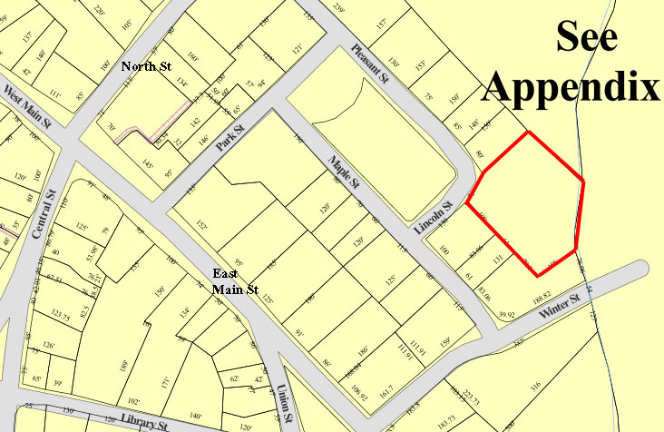

Recorded by: Kathryn Grover & Neil Larson
Organization: Town of Georgetown
Date: October 2012

Assessor’s Number USGS Quad Area(s) Form Number

11A-93 |  | Georgetown |  | C |  | GEO.148

Town/City: Georgetown
Place: (neighborhood or village):
Town Center

Address: 7 Lincoln Street
Historic Name: Joseph E. & Sarah A. Bailey House
Uses: Present: multiple residence
Original: single residence
Date of Construction: ca. 1875
Source: deeds, historic maps
Style/Form: Classical Revival
Architect/Builder: unknown
Exterior Material:
Foundation: brick
Wall/Trim: vinyl clapboards
Roof: asphalt shingles
Outbuildings/Secondary Structures:
Barn (attached)
Major Alterations (with dates):
Barn added ca. 1885
Vinyl siding added
Window sash replaced

Condition: good
Moved: no yes Date:
Acreage: 1.12 acres
Setting: This house and barn are sited on a large lot at the northeast corner of Lincoln Park and borders Penn Brook on the east and the Perley School property on the north. The area is residential.

Recommended for listing in the National Register of Historic Places.
If checked, you must attach a completed National Register Criteria Statement form.

ARCHITECTURAL DESCRIPTION
The Joseph E. & Sarah A. Bailey House is a two-story wood frame dwelling located on the south side of Lincoln Street at its intersection with Pleasant Street. The house has a front gable façade and is two rooms deep with an entry in the northeast corner. The front façade contains an entrance offset by two windows on the first story and three windows on the second story; the entrance bay is shifted to the east side of the façade resulting in irregular spacing on the second story. A single window occupies the gable. The raking edge of the roof is distinguished by a Classical entablature with tall friezes; the entablature returns a short distance across the front from eaves. A porch spans the full width of the first story; it is a recent reconstruction of an earlier structure. The spacing of fenestration on the side walls and the central chimney in the roof ridge reflects the two-room interior plan. A one-story bay window with beveled corners is positioned at the rear of the west wall. A long, two-story rear ell is set back from the west wall and the space filled with a full porch, also a reconstruction. The west wall of the ell contains a center entrance flanked by windows. Two windows on the second story have been replaced with modern oriel; a large oriel also has been installed on the second story of the east side of the ell.

The footprint of the building delineated on the 1884 village map includes a small barn attached to the southwest corner of the rear ell. This depiction evidently represents the one-story hyphen with a vehicle door that now connects the house with the existing large barn, which is illustrated in the 1887 birds-eye view of the village. The two-story wood frame barn with a front gable façade has been altered for use as a dwelling, which has removed vehicle doors (replaced with a picture window) and other barn features for domestic doors and windows. The ventilator centered in the roof is presumably original to the building. A story-and-a-half wood frame addition was built on the rear of the barn recently.

The building is sited in the southwest corner of a large lot that extends back into a creek and wet land that forms the southeasterly boundary. A small yard frames the front and easterly sides of the house, and a paved parking area is located west of the house and in front of the barn. The rest of the property behind the house is wooded.

The Joseph E. & Sarah A. Bailey House is distinctive example of a single-family dwelling with connected outbuildings. Built ca. 1875, the house and connected barn have been altered, the latter converted into dwelling space. Despite these changes, the forms and arrangement of the buildings are clearly discernible, and the property is a contributing component of the village district.

HISTORICAL NARRATIVE
According to historian Jane Field, the streets around what is now Lincoln Park were “opened to home construction” in 1868. The 1830 and 1856 maps of the village show the area completely undeveloped, but by 1872 the “Park” appears on the town map enclosed by Pleasant, Lincoln, Maple, and Park Streets; only Pleasant among these four streets is shown with its name. At that time no houses had been built on either Maple of Lincoln, and the only dwellings bordering Lincoln Park were those of shoe manufacturer Milton G. Tenney (at Park and Pleasant), merchant tailor Stephen Osgood (behind the Baptist Church on Pleasant Street), and shoe industry workers William Augustus Harnden, and George A. Kimball, also on Pleasant Street. The area around Lincoln Park appears to have developed as a series of individual transactions; though shoe manufacturer George Jewett Tenney owned several parcels later developed as house lots, no single developer was involved in the area’s residential growth.

Indeed, non-local people were involved in some of the land dealings that created the built environment around Lincoln Park, including the house and barn at 7 Lincoln Street. In October 1877 Nathaniel Gage, a farmer living in North Andover, sold an acre and 20 rods with its buildings to grocer Joseph Edmund Bailey of Georgetown for $3500; the price suggests the existence of this house and barn at that time. It appears that Gage lived on his family’s farm in North Andover for his entire life, so his reasons for building a house in Georgetown seem to be purely speculative. The 1880 census enumerates Bailey immediately after George A. Kimball, which suggests he was certainly living at 7 Lincoln by that time.

Born in West Newbury in 1839, Joseph Edmund Bailey was the son of Joseph Jenness and Almira Danforth Bailey. In 1850 he was living in his father’s household in Newbury, but by 1860 he had moved to Georgetown, was working as a store clerk, and boarded with John Lewis Huntington at 31 East Main Street. In 1866 he married Sarah Addie Eaton of West Newbury. The 1870 directory lists him as a grocer at the “Corner.” His business was in Bailey’s Block, a three-story frame building in the town center that had been built by 1885. A photograph of the building shows his store sign at the center of the block, billboards advertising coffee and tea, spices, cigars, and other goods, and possibly Bailey himself in a suit on the sidewalk.

By 1900 J. Edmund Bailey, as he was often listed, had left the retail world behind for shoe manufacturing, and by 1907 he was an officer at A. B. Noyes and Company in Georgetown. He and his wife had one child, Elmer Smith Bailey, born in 1873, who graduated Phillips Andover Academy in 1892 and attended Brown University; he became an architect in Boston and is listed in that profession and city in the Georgetown directory for 1901, which shows him as boarding at his parents’ 7 Lincoln Street home. For the most part, however, J. Edmund and Sarah Eaton Bailey lived in the house only with a domestic servant, Katherine Dermody, who worked for them and lived there for at least a decade.

J. Edmund Bailey died in 1912, and his widow then began to rent space in the house. In 1920 she was seventy-two, and the census shows her with eleven other people in the house. Among them was the family of ice dealer Wallace E. Adams had lived there since at least 1917 and included Adams’s wife Rosetta and three adult children, all in the labor force, as well as his father- and brother-in-law. In 1930 she shared the house with the family of physician Raymond B. Root and shoe factory sewer Albert Marsden and his wife Katherine; a cook also lived in the household.

In January 1935 Sarh Eaton Bailey died at 7 Lincoln Street at the age of eighty-seven. The next year Elmer Smith Bailey deeded the property in James P. Flynn, who sold it three years later. The property changed hands frequently until November 1955, when Thomas J. Burke acquired it. The 1957 directory shows Burke in the household with his parents, Thomas M. Burke, a plumber and former resident of Nahant, and Sarah Burke. The Burkes owned 7 Lincoln Street until 1966. Current owner Craig F. Mead acquired it in 1983.

BIBLIOGRAPHY and/or REFERENCES
Arrington, Benjamin F., ed. Municipal History of Essex County in Massachusetts. NY: Lewis Historical Publishing Co., 1922.
Field, Jane. A Brief History of Georgetown Massachusetts 1838-1963. Rev. ed. 1988. Georgetown: Georgetown Historical Commission, 1988.
Gage, Thomas. The History of Rowley, Anciently Including Bradford, Boxford, and Georgetown, from the Year 1639 to the Present Time. Boston: F. Andrews, 1840.
Georgetown, Boxford, Byfield, Newbury, and West Newbury, Massachusetts, Directory. Boston: W. E. Shaw, 1901-2, 1905, 1909, 1912, 1914, 1916-17, 1918, 1925.
Hill, Edwin P. “History of Georgetown, Massachusetts.” In Standard History of Essex County, Massachusetts. Edited by Cyrus M. Tracey, William E. Graves, and Henry M. Batchelder. Boston: C. F. Jewett, 1878.
Hull, Forrest P. Georgetown: Story of One Hundred Years, 1838-1938. 1938. Reprint. Georgetown, MA: Georgetown Historical Commission, 2006.
Merrill, Samuel. A Merrill Memorial: An Account of the Descendants of Nathaniel Merrill, an Early Settler of Newbury, Massachusetts. Cambridge, MA, 1917-28.
Nelson, Henry M. “Town of Georgetown History.” In Hurd, D. Hamilton. History of Essex County, Massachusetts, with Biographical Sketches of Many of Its Pioneers and Prominent Men. Vol. 1. Philadelphia: J. W. Lewis and Co., 1888.
Sammarco, Anthony Mitchell, for Georgetown Historical Society. Images of America: Georgetown. Portsmouth, NH: Arcadia Publishing, 2002.

MAPS
“Map of the Centre of Georgetown in 1800.” In Perley, Sidney H., “Centre of Georgetown in the Year 1800.” The Essex Antiquarian: A Quarterly Magazine Devoted to the Biography, Genealogy, History, and Antiquities of Essex County, Massachusetts 2, 7 (July 1898): 201.
Map of Georgetown in 1810 and 1840. In Gage, Thomas. The History of Rowley, Anciently Including Bradford, Boxford, and Georgetown, from the Year 1639 to the Present Time. Boston: F. Andrews, 1840. 320.
“Map of New Rowley Surveyed and Drawn by Philander Anderson 1830.” Georgetown Historical Society.
Map of Georgetown. 1856. In Walling. H. F. A Topographical Map Essex County Massachusetts. Boston: Smith and Morley, 1856.
Atlas of Essex County, Massachusetts. Philadelphia: D. G. Beers and Co., 1872). Plates 59 and 61.
“Town of Georgetown Mass.” and “Village of Georgetown Mass.” In Atlas of Essex County, Massachusetts (Boston: George H. Walker, 1884).
“Georgetown, Mass. 1887.” Drawn and Published by George E. Norris, Brockton, Massachusetts. Troy, NY: Burleigh Lithographic Establishment, 1887.”

PHOTOGRAPHS (all photos by Neil Larson, 2012)

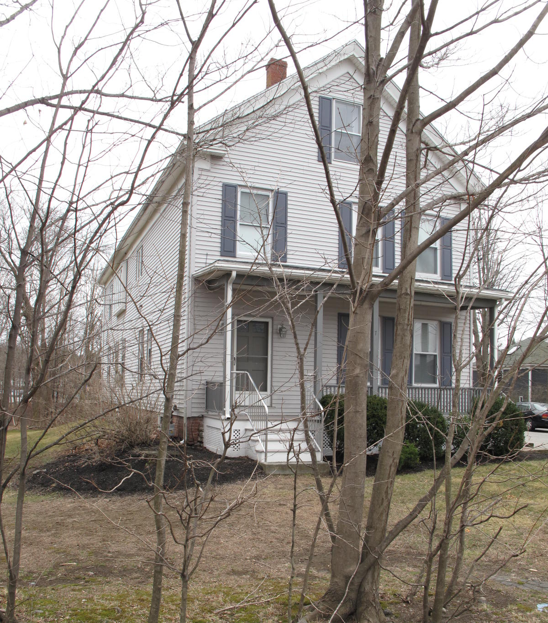
7 Lincoln Street: view from NE

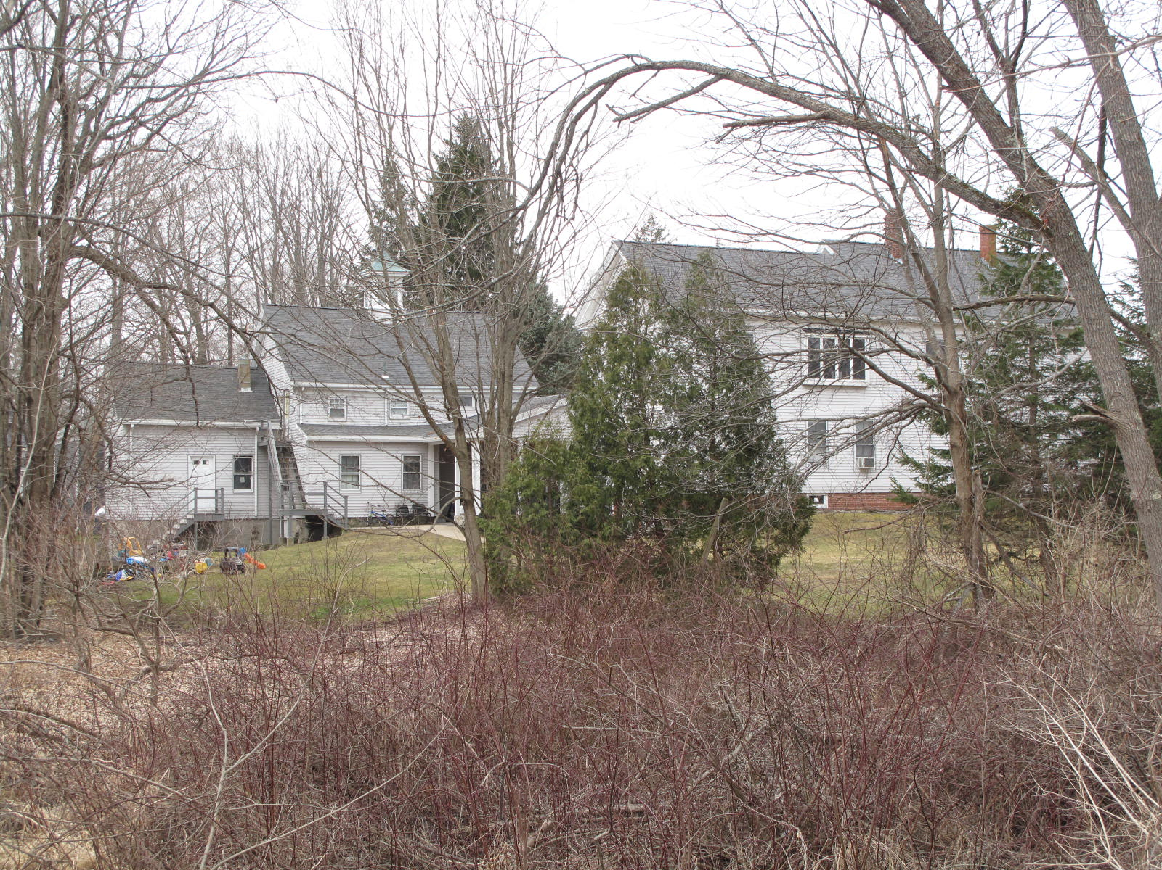
Views from NE (top) and SE (bottom)

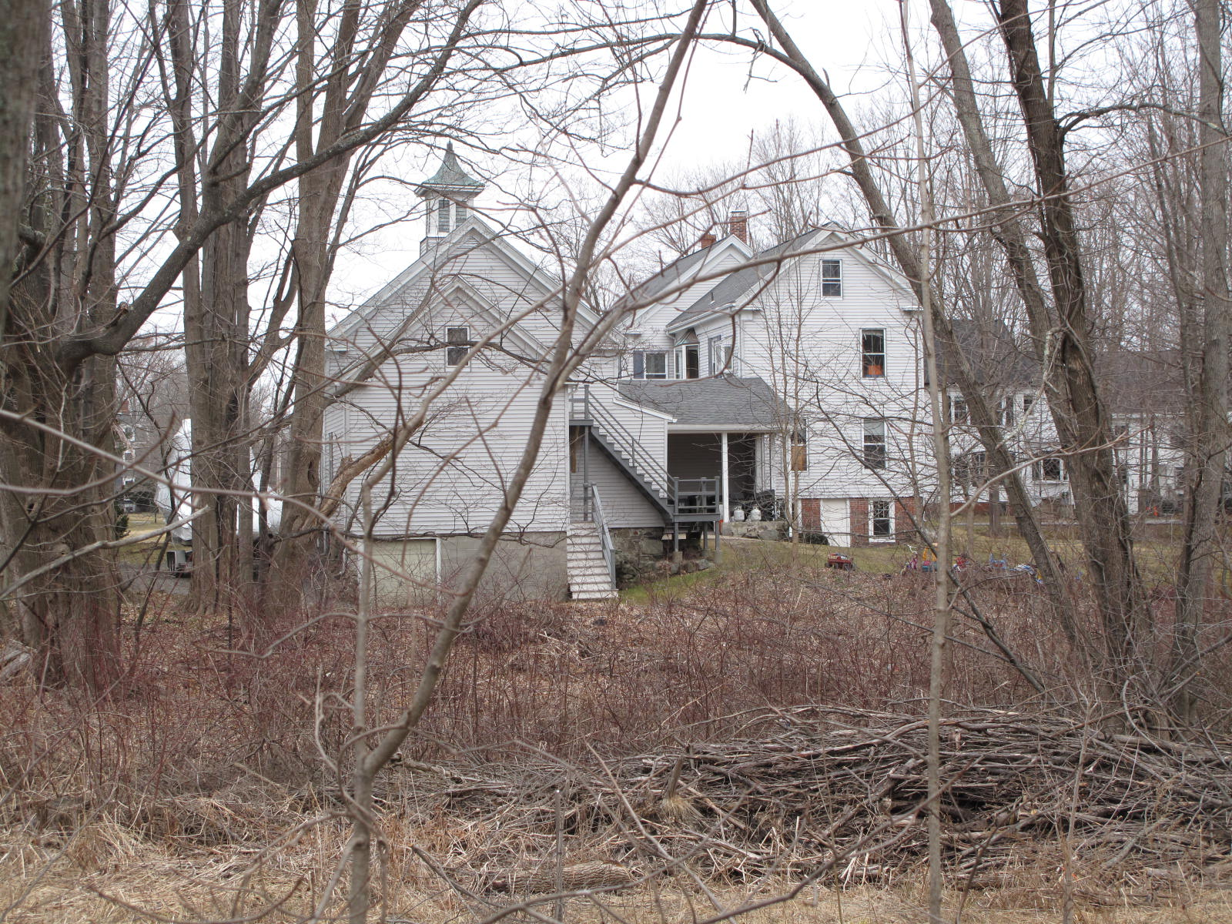

National Register of Historic Places Criteria Statement Form

Check all that apply:

Individually eligible Eligible only in a historic district

Contributing to a potential historic district Potential historic district

Criteria: A B C D

Criteria Considerations: A B C D E F G

Statement of Significance by________Neil Larson________________________
The criteria that are checked in the above sections must be justified here.

The Joseph E. & Sarah A. Bailey House is distinctive example of a single-family dwelling with connected outbuildings. Built ca. 1875, the house and connected barn have been altered, the latter converted into dwelling space. Despite these changes, the forms and arrangement of the buildings are clearly discernible, and the property is a contributing component of the village district.

Nathaniel Gage, North Andover, to Joseph E. Bailey, October 1877, SED 987:244.
Anthony Mitchell Sammarco, Images of America: Georgetown (Portsmouth, NH: Arcadia Publishing Co., 2002), 22. The caption beneath this photograph states that John W. Bailey built the block and ran a stove store there that was “later operated by his son Joseph E. Bailey,” but Joseph E. Bailey’s father was Joseph J. Bailey; John W. Bailey was the son of William Bailey of Rowley.
Elmer Smith Bailey, administrator estate Sarah A. Bailey, to Flynn, 8 May 1936, SED 3073:203; Elmer S Bailey to James P. Flynn, 8 May 1936, SED 3073:204; Lewis T. and Josephine M. Partington to Thomas J. Burke, 23 November 1955, SED 4227:269.
William P. Ingraham and David L. Ives, West Newbury, to Craig F. and Adelina C. Mead, 7 Lincoln Street, 14 June 1983, SED 7136:183.

