FORM B − BUILDING

Massachusetts Historical Commission
Massachusetts Archives Building
220 Morrissey Boulevard
Boston, Massachusetts 02125

Photograph
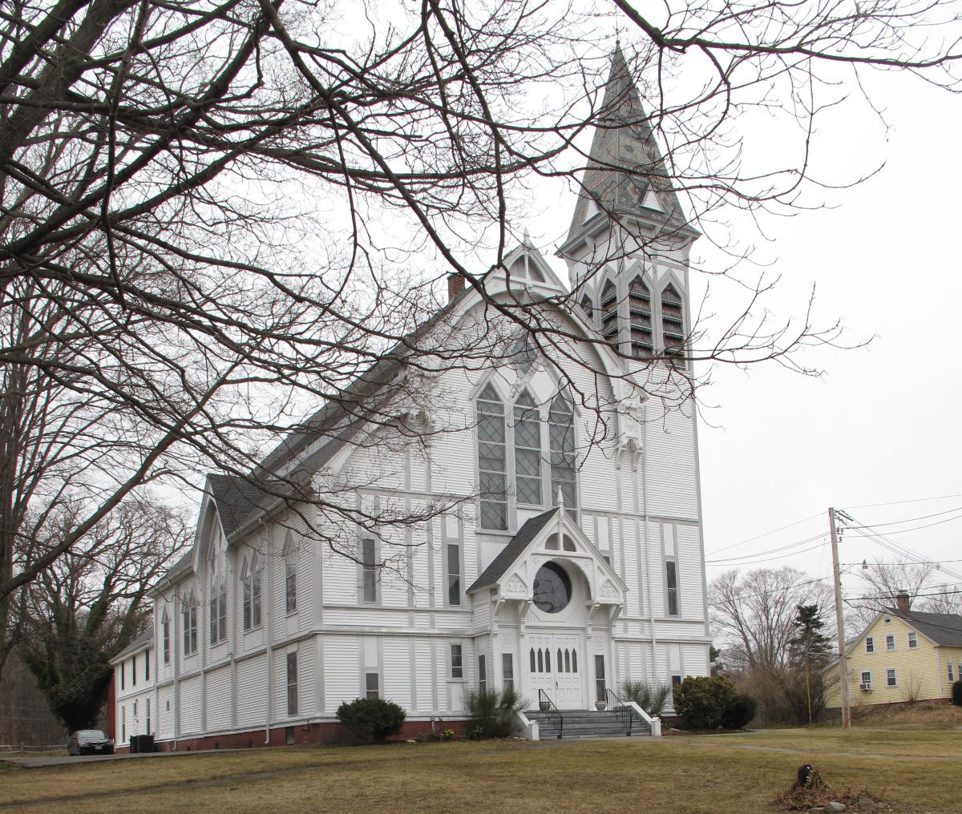
View from south

Locus Map (north at top)
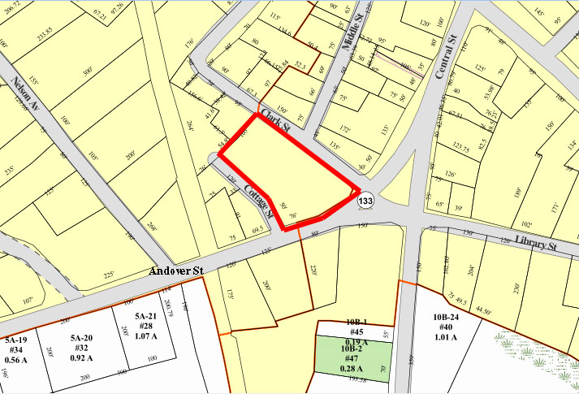

Recorded by: Kathryn Grover & Neil Larson
Organization: Town of Georgetown
Date: October 2012

Assessor’s Number USGS Quad Area(s) Form Number

6C-132 |  | Georgetown |  | C |  | GEO.120

Town/City: Georgetown
Place: (neighborhood or village):
Town Center

Address: 7 Andover Street
Historic Name: First Congregational Church
Uses: Present: religious
Original: religious
Date of Construction: 1874
Source: deeds, local histories
Style/Form: Gothic Revival (Stick Style)
Architect/Builder: Peabody and Stearns
Exterior Material:
Foundation: brick
Wall/Trim: vinyl clapboards
Roof: slate shingles (tower)
asphalt shingles (building)
Outbuildings/Secondary Structures:
none
Major Alterations (with dates):
Vinyl clapboards added

Condition: good
Moved: no yes Date:
Acreage: 1.14 acres
Setting: The First Congregational Church far back on a deep lot facing Andover Street at the northwest corner of its intersection with Clark Street. The area, the town center, is a mix of residential, commercial, and institutional uses.

Recommended for listing in the National Register of Historic Places.
If checked, you must attach a completed National Register Criteria Statement form.

ARCHITECTURAL DESCRIPTION:
The First Congregational Church is situated at the rear of an expansive lawn of a large sloping lot bounded on the south by Andover Street, on the east by Clark Street and the west by Cottage Street. It enjoys a prominent site overlooking one of the important crossroads in the town center. The huge wood frame edifice towers over the residential section in which it is located.

The front gable building presents an elaborate principal façade full of pointed elements and false framing members to Andover Street in a high detailed expression of the Victorian Gothic Revival taste, also known as the Stick Style. A wide central pavilion with a gable decorated with arched verge boards and truss work springs from massive incised plinths floating in the upper regions of the wall. The gable frames a tripartite window with lancets set within a pointed architrave with the top filled with lozenge panels and windows. This feature surmounts a center entry and rose window transom set within a Gothic porch suspended on brackets and decorated with truss work and incised paneling. The two-stage gable roof creates a short clerestory creating side wings, one of which is incorporated on the southerly side on front and the incorporated into a tall, narrow, square tower engaged on the northerly side. The tower contains pairs of pointed openings filled with louvers at the top and is surmounted by a Stick-Style entablature and steep pyramidal roof that retains its original patterned slate roof.

The church’s side walls contain central cross-gable pavilions with pairs of large pointed windows; these are flanked by pairs of smaller pointed windows and those, in turn, by single pointed windows. A short band of clerestory windows distinguish the space between the two stages of the roof. A two-story wing containing administrative, Sunday school and community spaces is centered on the rear. It contains strings of domestic-scale sash windows on both levels and has an unembellished entrance on the northerly side. The roof, originally covered with slate, has been resurfaced with asphalt shingles, and the original wood clapboards have been covered with vinyl clapboards leaving the expressed wood framing and other decorative elements intact.

The First Congregational Church, built in 1874, is architecturally and historically significant in the Georgetown context and appears to be individually eligible for the National Register as well as being a contributing component of a village district. Its associations with the religious history of the town and Rev. Charles Ward Beecher, who served as its pastor for many years are noteworthy. In spite of the addition of new exterior wall and roof materials, the building retains significant features of the Victorian Gothic Revival taste, and particularly elements of the Stick style. The church was an early commission for the Boston architectural firm of Peabody & Stearns, which increases its architectural significance.

HISTORICAL NARRATIVE
Built in 1874, the First Congregational Church at the corner of Andover and Clark Streets was the third building of the first local Congregational Society, organized as Rowley Second Parish in October 1732. In 1769 the society had built its second meetinghouse, the so-called Old South Church, at the junction of East Main and Elm Streets, and this building served for 105 years. In 1878, three years after the building was razed, historian Edwin Hill contended that the Old South sanctuary had “become too dilapidated for agreeable occupancy,” but he also hinted at the more likely possibility that the schism in the congregation that resulted in the construction of Peabody Memorial Church in 1868 may have been the more salient factor in the construction of the 1874 church.

The schism among local Congregationalists was rooted in the ministry of the Rev. Charles Beecher (1815-1900), the son of well known cleric Lyman Beecher and the brother of Presbyterian minister Henry Ward Beecher, famed author Harriet Beecher Stowe, and domestic advisor Catharine Beecher. Born in Litchfield, Connecticut, Charles Beecher graduated from Bowdoin College in 1834 and attended Lane Theological Seminary in Cincinnati, of which his father then served as president. Increasingly deviating from his father’s Presbyterianism, Beecher at first chose a career as a church organist, but in 1846, at the age of thirty-one, he ultimately became an ordained minister and became pastor of a church in Fort Wayne, Indiana. He had married Sarah Leland Coffin in New Orleans, and their daughter Mary was born in Fort Wayne. In 1851 Beecher accepted the pastorate of the First Free Presbyterian Church in Newark, New Jersey. The abolitionist views of that congregation—and of Beecher—triggered the Presbyterian Synod to expel the Newark church in 1853, and it then reorganized as a Congregationalist body.

In 1857 Charles Beecher came to Georgetown as the assistant to the Rev. Isaac Braman (1770-1857), who had served as the First Congregational Society’s pastor since 1770. When Braman died in late December 1857, Beecher became minister. Within several years what Hill described as “the long condition of harmony in the Orthodox Church” unraveled because of Beecher’s “theological eccentricities—the leading one being the doctrine of pre-existence.” In January 1864 eighty-five members of the First Congregationalist Society withdrew and organized themselves as the First Orthodox Society of Georgetown. The next year Georgetown resident Judith Peabody Daniels and her brother, wealthy London banker and philanthropist George Peabody, donated land and funds for constructing a sanctuary for the fledgling congregation, and in 1868 Peabody Memorial Church was built and opened on Main Street.

The existence of the elaborate and fashionable Memorial Church probably spurred the move to build a new church for the older First Congregational Society. In April and December 1874 the widow Clarissa T. Spofford, who owned and occupied 1 Andover Street, and Daniel E. Moulton, Alfred B. Noyes, and Henry Prescott Chaplin deeded three lots to the First Congregational Society along Andover Street at its intersection with Clark Street—together comprising about 176 rods, or about 1.1 acres. Deeds mention the presence of buildings on two of these tracts, but none were significant enough to be shown on the 1872 map of Georgetown center. After the church was built at the corner of Andover and Clark Street, the Old South Church was razed. According to Hill, “From its fragments were manufactured canes, rulers, and other mementoes, which have been widely distributed among the sons of this interesting and somewhat ‘peculiar’ town.” The bell from the Old South Church, made by the Paul Revere foundry in 1816 and paid for by seventy-five members of the congregation, was moved to the bell tower of the new church.

Hill stated that those members of the First Congregational Society who supported Beecher were supplemented “by additionals from the less conservative portion of the community, who saw in his position, made prominent by the action of the seceders, a new religious departure.” Hill was apparently not among these supporters, for he wrote that Beecher “retained and still retains the leading evangelical views of the Congregationalists, blended with his own philosophy, forming a theory, probably, more harmonious to his own mind than it is to the judgment of many others.” He added, ambiguously, that Beecher’s ideas, “if followed to their legitimate results, would open into very broad fields.” Still, Beecher’s congregation at the time Hill wrote was “large, flourishing, and intelligent.”

Beecher remained at the First Congregational Church until 1881, but through the years after the Civil War he must have been only a part-time minister. After the war he had begun to work with his sister Harriet Beecher Stowe and her husband Calvin to minister to formerly enslaved people in Florida, and he served as Florida’s Superintendent of Public Instruction from 1871 to 1873. Beecher held his final pastorate in Pennsylvania from 1885 to 1893, and then returned to Georgetown to live with his daughter Mary, who had married shoe manufacturer George W. Noyes in 1870. Beecher died at the Noyes home on Central Street in April 1900.

In 1908 the two Congregationalist parishes were reunited and used this church building as its sanctuary; the Orthodox Memorial Church was then used for town meetings until it burned in October 1920. Since 1961 the congregation has been a member of the United Church of Christ organization.

PEABODY & STEARNS
Peabody & Stearns was one of the oldest and best known architectural offices in Boston. Robert Swain Peabody (1845-1917) was born in New Bedford, Massachusetts, where his father, the Rev. Ephraim Peabody, was minister of the Unitarian church. In 1846 his father answered the call to minister at King’s Chapel in Boston, where he remained for the next decade and founded the Boston Provident Society. His mother was Mary Derby of Salem. After graduating Harvard University in 1866, Peabody began the study of architecture with Gridley J.P. Bryant, then at the height of his career, and enrolled in classes at M.I.T. under William R. Ware. Later Peabody studied architecture in England and France; he was one of the first Americans trained at the Ecole des Beaux Arts in Paris. Upon his return to Boston in 1870, Peabody joined John G. Stearns in a partnership that would continue until both men died within months of each other in 1917. John Goddard Stearns (1843-1917) spent his early life in Brookline, Massachusetts. He was son of John G. Stearns, a manufacturer, and his wife, Eliza, of whose background nothing yet is known. After graduating from the Lawrence Scientific School in Cambridge in 1863, his further study in architecture was interrupted by military service in the Civil War, after which time he was employed in the Boston office of Ware & Van Brunt. Like Peabody, Stearns spent a number of years under William R. Ware’s instruction, which likely was how the future partners met.

During their 47-year association, Peabody and Stearns designed many of Boston’s notable commercial and academic buildings, as well as others elsewhere in the state and country. Significant among their Boston commissions are the Exchange Building at 53 State Street, where the firm was later headquartered, Boston Insurance Building at 87 Kilby Street, Hotel Bellevue at 19-25 Beacon Street, Unitarian Association Building, and the tower of the Custom House. Robert S. Peabody clearly was the more outgoing partner, and his name is associated with numerous civic commissions and professional organizations. Peabody was a member of the commission in charge of the designs for the Columbian Exposition in Chicago (1893) and the Pan-American Exposition in Buffalo (1901). He was a member of the board of overseers of Harvard College, member of the corporation of the Massachusetts Institute of Technology, member of the American Institute of Architects, serving as its president in 1900-1901, and member and president of the Boston Society of Architects.

BIBLIOGRAPHY and/or REFERENCES
Arrington, Benjamin F., ed. Municipal History of Essex County in Massachusetts. NY: Lewis Historical Publishing Co., 1922.
Field, Jane. A Brief History of Georgetown Massachusetts 1838-1963. Rev. ed. 1988. Georgetown: Georgetown Historical Commission, 1988.
Gage, Thomas. The History of Rowley, Anciently Including Bradford, Boxford, and Georgetown, from the Year 1639 to the Present Time. Boston: F. Andrews, 1840.
Georgetown, Boxford, Byfield, Newbury, and West Newbury, Massachusetts, Directory. Boston: W. E. Shaw, 1901-2, 1905, 1909, 1912, 1914, 1916-17, 1918, 1925.
Hill, Edwin P. “History of Georgetown, Massachusetts.” In Standard History of Essex County, Massachusetts. Edited by Cyrus M. Tracey, William E. Graves, and Henry M. Batchelder. Boston: C. F. Jewett, 1878.
Hull, Forrest P. Georgetown: Story of One Hundred Years, 1838-1938. 1938. Reprint. Georgetown, MA: Georgetown Historical Commission, 2006.
Merrill, Samuel. A Merrill Memorial: An Account of the Descendants of Nathaniel Merrill, an Early Settler of Newbury, Massachusetts. Cambridge, MA, 1917-28.
Nelson, Henry M. “Town of Georgetown History.” In Hurd, D. Hamilton. History of Essex County, Massachusetts, with Biographical Sketches of Many of Its Pioneers and Prominent Men. Vol. 1. Philadelphia: J. W. Lewis and Co., 1888.
Sammarco, Anthony Mitchell, for Georgetown Historical Society. Images of America: Georgetown. Portsmouth, NH: Arcadia Publishing, 2002.

MAPS
“Map of the Centre of Georgetown in 1800.” In Perley, Sidney H., “Centre of Georgetown in the Year 1800.” The Essex Antiquarian: A Quarterly Magazine Devoted to the Biography, Genealogy, History, and Antiquities of Essex County, Massachusetts 2, 7 (July 1898): 201.
Map of Georgetown in 1810 and 1840. In Gage, Thomas. The History of Rowley, Anciently Including Bradford, Boxford, and Georgetown, from the Year 1639 to the Present Time. Boston: F. Andrews, 1840. 320.
“Map of New Rowley Surveyed and Drawn by Philander Anderson 1830.” Georgetown Historical Society.
Map of Georgetown. 1856. In Walling. H. F. A Topographical Map Essex County Massachusetts. Boston: Smith and Morley, 1856.
Atlas of Essex County, Massachusetts. Philadelphia: D. G. Beers and Co., 1872). Plates 59 and 61.
“Town of Georgetown Mass.” and “Village of Georgetown Mass.” In Atlas of Essex County, Massachusetts (Boston: George H. Walker, 1884).
“Georgetown, Mass. 1887.” Drawn and Published by George E. Norris, Brockton, Massachusetts. Troy, NY: Burleigh Lithographic Establishment, 1887.”

PHOTOGRAPHS (all photos by Neil Larson, 2012)

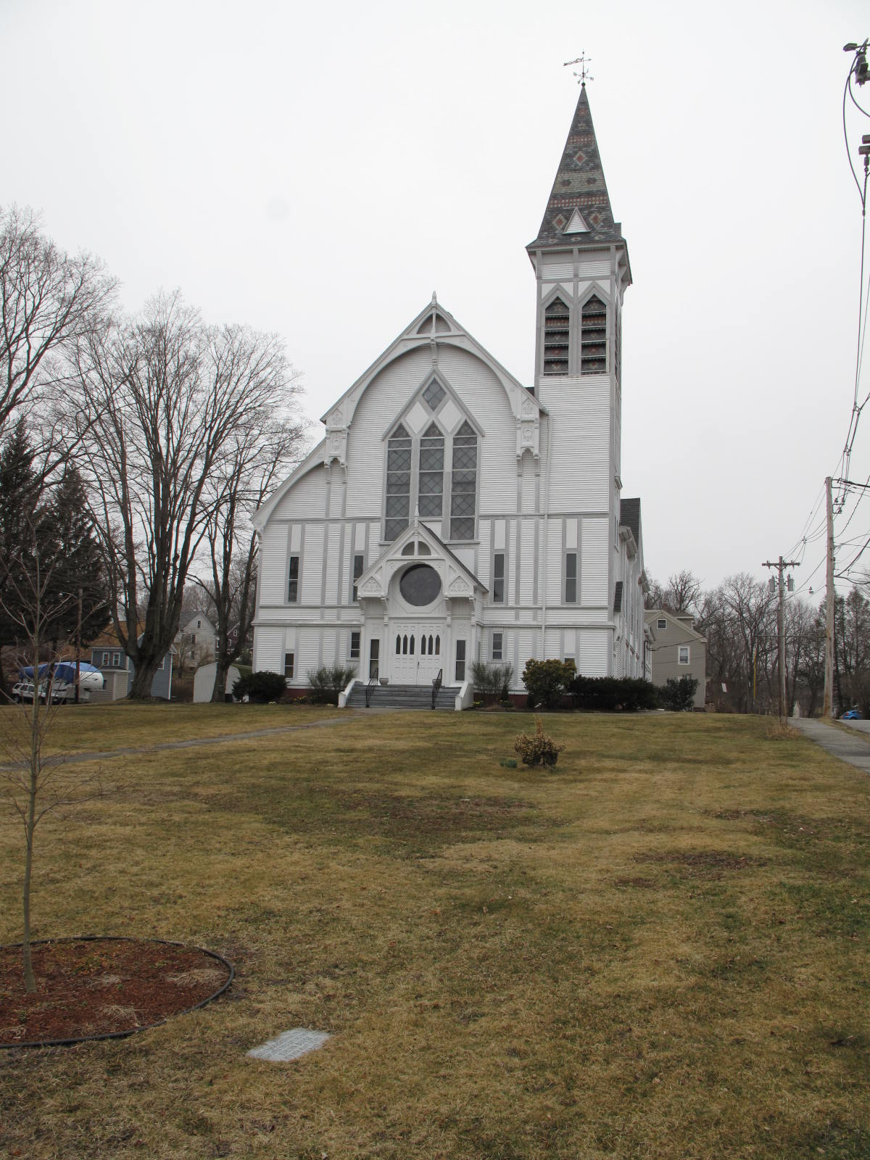
View from southeast (Andover Street)

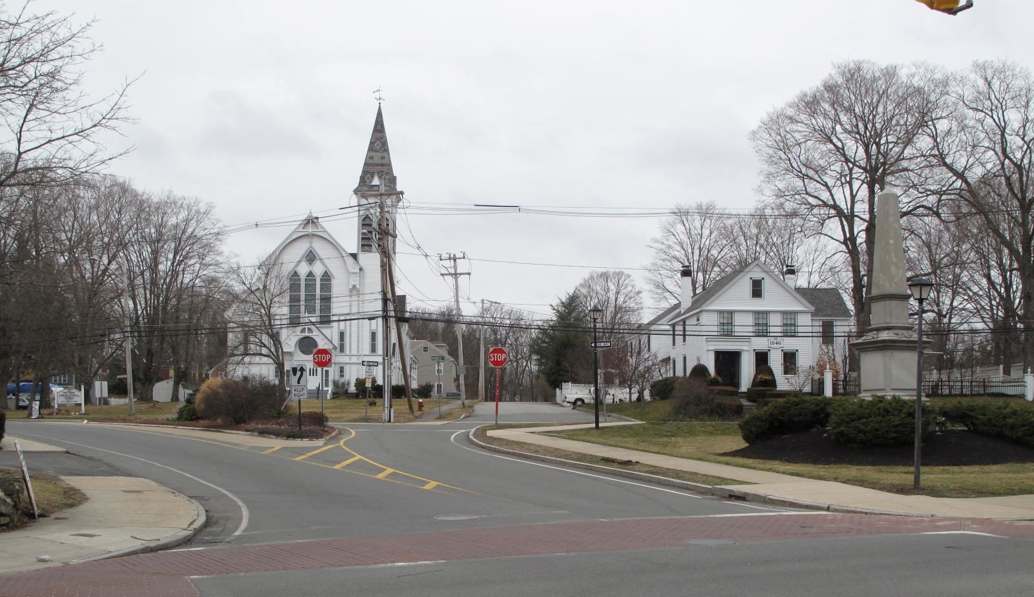
First Congregational Church from Central Street at its intersection with Andover and Clark Streets; at far right
is the Civil War Memorial, next to it is 1 Andover Street, and Clark Street is at center.

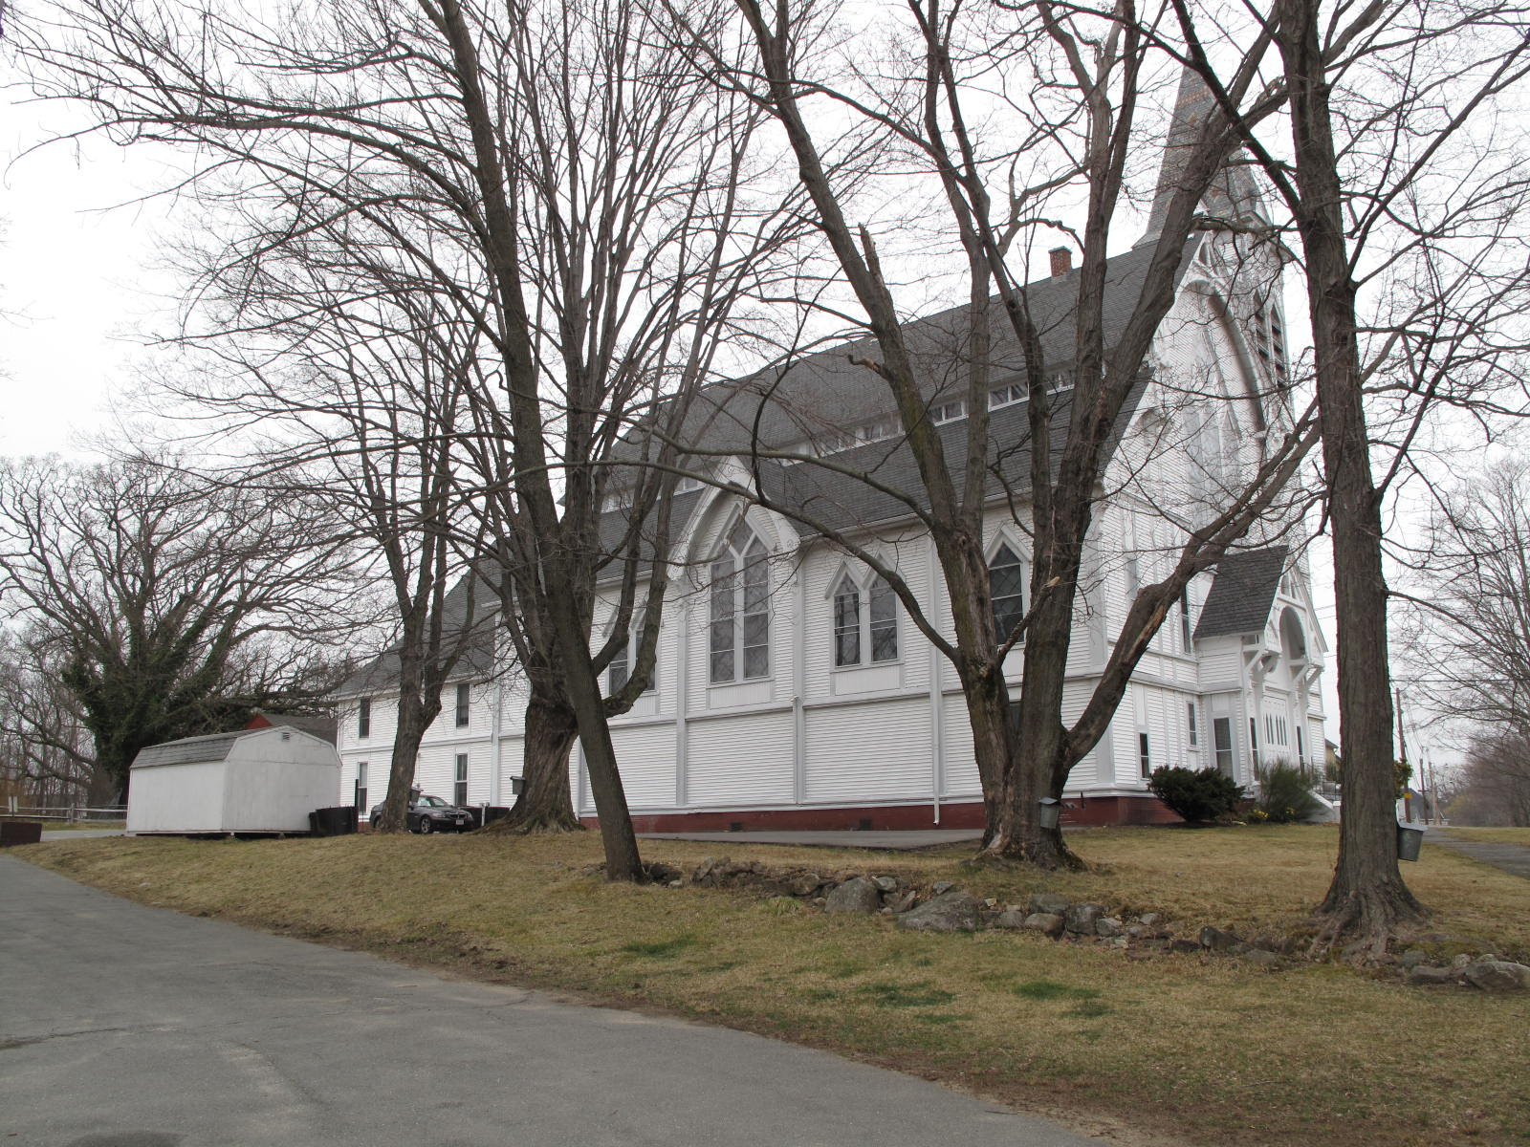
View from southwest

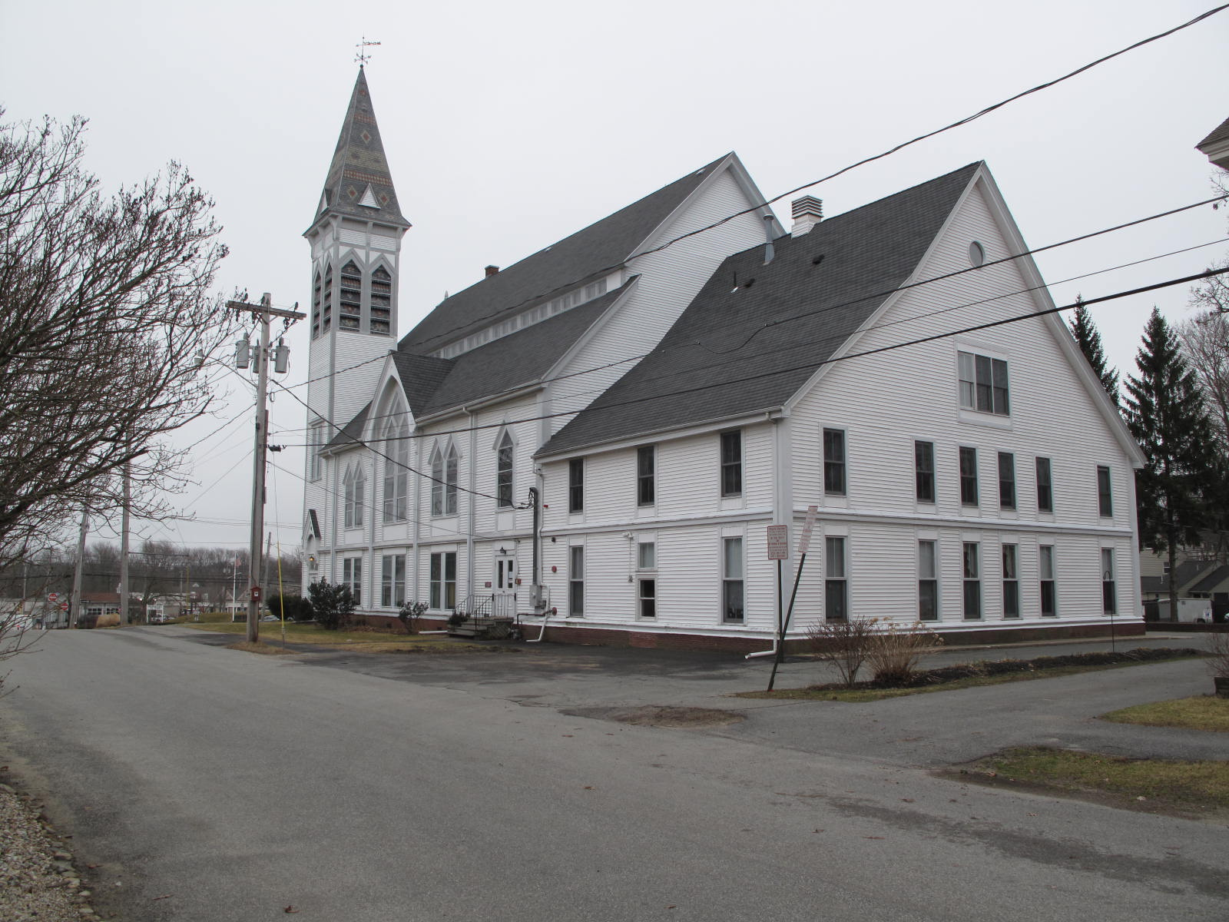
View from northeast (Clark Street in foreground)

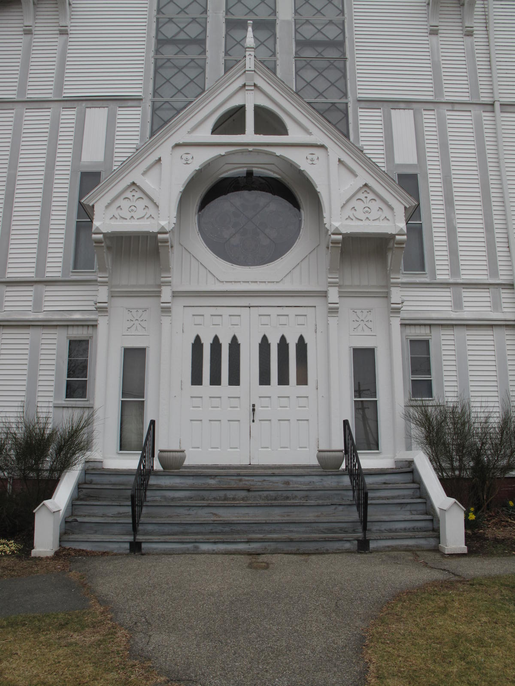 Detail of entry

National Register of Historic Places Criteria Statement Form

Check all that apply:

Individually eligible Eligible only in a historic district

Contributing to a potential historic district Potential historic district

Criteria: A B C D

Criteria Considerations: A B C D E F G

Statement of Significance by______Neil Larson_________________________________
The criteria that are checked in the above sections must be justified here.

The First Congregational Church, built in 1874, is architecturally and historically significant in the Georgetown context and appears to be individually eligible for the National Register as well as being a contributing component of a village district. Its associations with the religious history of the town and Rev. Charles Ward Beecher, who served as its pastor for many years are noteworthy. In spite of the addition of new exterior wall and roof materials, the building retains significant features of the Victorian Gothic Revival taste, and particularly elements of the Stick style. The church was an early commission for the Boston architectural firm of Peabody & Stearns, which increases its architectural significance.

Edwin P. Hill, “History of Georgetown, Massachusetts,” in Standard History of Essex County, Massachusetts, eds. Cyrus M. Tracey, William E. Graves, and Henry M. Batchelder (Boston: C. F. Jewett, 1878), 123-24.
Clarissa T. Spofford to Frist Congregational Society, 18 April 1874, SED 920:59; Daniel E. Moulton, Alfred B. Noyes, and Henry P. Chaplin to First Congregational Society, 9 December 1874, SED 920:60.
Nelson, Henry M. “Town of Georgetown History.” In D. Hamilton Hurd, History of Essex County, Massachusetts, with Biographical Sketches of Many of Its Pioneers and Prominent Men (Philadelphia: J. W. Lewis and Co., 1888), 1:827; Anthony Mitchell Sammarco, Images of America: Georgetown (Portsmouth, NH: Arcadia Publishing, 2002), 33.
National Cyclopedia of American Biography, vol. 12 (1904).
Technology Review, vol. 19, Massachusetts Institute of Technology Alumni Association, 1917.
Henry F. Withey & Elsie Rathburn Withey, Biographical Dictionary of American Architects (Deceased) (1956; rpt. Los Angeles: Hennessey & Ingalls, 1970),463.
Ibid., 568.

