FORM B − BUILDING

Massachusetts Historical Commission
Massachusetts Archives Building
220 Morrissey Boulevard
Boston, Massachusetts 02125

Photograph
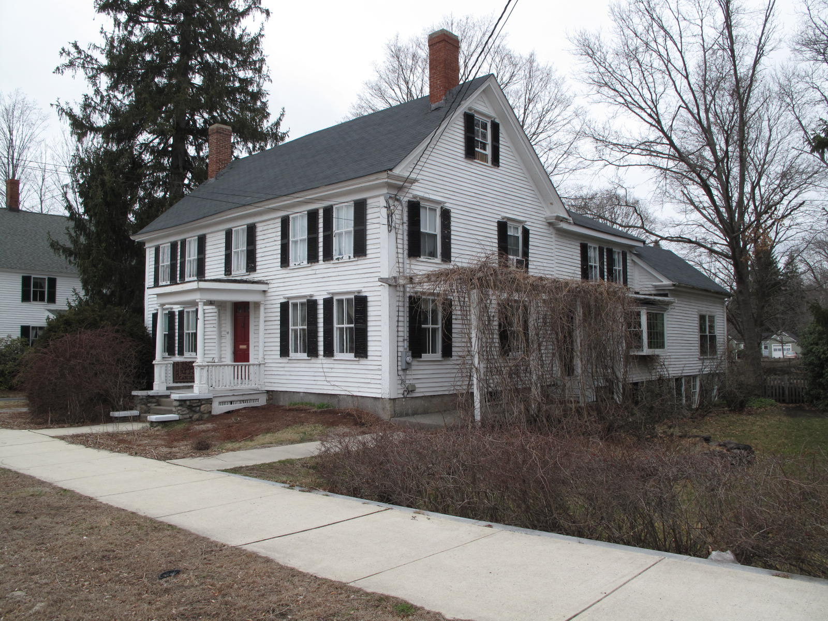
View from south

Locus Map (north at top)
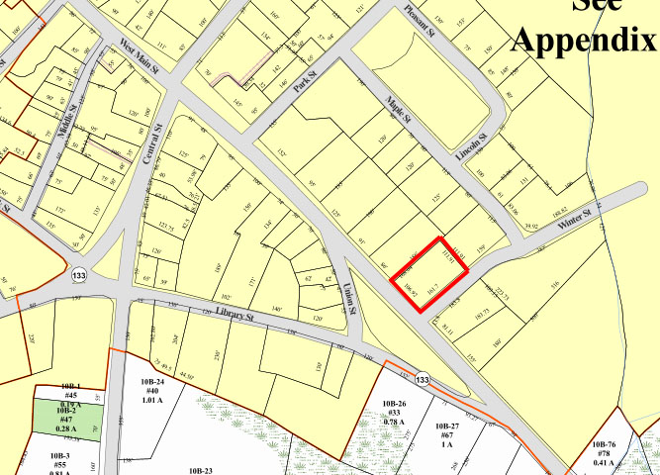

Recorded by: Kathryn Grover & Neil Larson
Organization: Town of Georgetown
Date: October 2012

Assessor’s Number USGS Quad Area(s) Form Number

11A-114 |  | Georgetown |  | C |  | GEO.142

Town/City: Georgetown
Place: (neighborhood or village):
Town Center

Address: 52 East Main Street
Historic Name: Mary Hatch House
Uses: Present: single residence
Original: single residence
Date of Construction: ca. 1840
Source: deeds, historic maps, visual assessment
Style/Form: Greek Revival
Architect/Builder: unknown
Exterior Material:
Foundation: stone
Wall/Trim: wood clapboards
Roof: asphalt shingles
Outbuildings/Secondary Structures:
Barn (attached)
Major Alterations (with dates):
Entrance porch rebuilt, early 20th C
One-story addition on rear, late 20th C

Condition: good
Moved: no yes Date:
Acreage: 0.41 acre
Setting: This house is sited at the northwest corner of East Main and Winter Streets on a lot with mature trees. The area is largely residential.

Recommended for listing in the National Register of Historic Places.
If checked, you must attach a completed National Register Criteria Statement form.

ARCHITECTURAL DESCRIPTION
The Mary Hatch House is a two-story wood frame single dwelling located on the northerly side of East Main Street and the westerly side of Winter Street. Built ca. 1840, the house presents a five-bay façade to the street with a center entrance with a flat-roof Doric porch, which is a later feature that probably resembles the original. Flanking windows are paired closely in an 18th-century manner. Original wood clapboard siding is intact. Two-over-two wood sash and wood-framed storm windows are late 19th century alterations. Wide corner pilasters terminate at a tall frieze beneath a substantial roof-line cornice, Greek Revival-style features updating the otherwise antiquated proportions of the façade.

The gable end walls contain two windows on the two principal stories and a single window centered in the attic. The lower windows are widely spaced to accommodate the end chimneys; the plan appears to be a room-and-a-half deep. A two-story, cross-gable ell spans the full length of the rear wall. It is connected to a two-story barn that is offset so that it can be entered from a driveway on the west side of the house. With its wood shingled end wall and stable windows, the barn is a rare intact feature. A historic one-story ell is appended to the rear of the barn, and non-historic one-story wing has been added to the rear of the kitchen ell. The large corner lot is landscaped in lawn distinguished by numerous and various mature specimen trees.

The Mary Hatch House, built c. 1840, is architecturally significant as a distinctive Greek Revival-style residence of unusual physical integrity in Georgetown center. Its association with the town’s earliest shoe manufacturers, as well as with Lewis H. Bateman, a noteworthy businessman and civic leader, contributes to the property’s historical significance. The quality and integrity of the house and connected barn along with its historical associations combine to make it eligible for the National Register. The building also is a contributing component of the village district.

HISTORICAL NARRATIVE
Town records maintain that the house at 52 East Main Street was built in 1840, and it seems likely to have been on the site by that date judging from census records and maps. The 1856 map of the village attaches the name “Mrs. Hatch” to the dwelling at this corner, and the 1840 census lists Mary H. Hatch as a woman between fifty and sixty years old living alone in a household in this neighborhood. The 1850 census shows her as sixty-one years old with no occupation, as does the 1855 state census. When Hatch died in Georgetown in 1860, she was shown as having been born in Marshfield, Massachusetts, as unmarried, and as the daughter of Phebe Hatch. Much-deteriorated Marshfield town records document the birth of several children to Joseph and Phebe Hatch in Marshfield in the 1780s as well as the death of Phebe Hatch, the daughter of Joshua and Phebe Tilden, in 1795.

Sarah Anna Emery’s 1879 memoir Reminiscences of a Nonagenarian provides more definitive information on Mary Hatch. According to this account, she was the sister of Lewis Hatch, who had “been left an orphan as a mere child,” had later “purchased his freedom,” presumably from indenture, and then came to Georgetown at the age of eighteen. He initially boarded with Susannah Little Adams, the widow of Robert Adams and sister of Georgetown shoe manufacturers Joseph and Benjamin Little of West Newbury; then, before 1810, Lewis Hatch was hired by Major Paul Nelson to tenant the “shoe-maker’s shop” on his property, where Nelson also ran a tannery. Hatch boarded at Nelson’s, near “a crossing of roads called ‘New Rowley Corner’” (the junction of Elm an East Main Streets) and soon was joined there by Joseph Little. As the business grew Benjamin Little came to work at Georgetown and board at Nelson’s, who hired a housekeeper to attend to the three unmarried men. At some point Mary Hatch became the “mistress of the bachelor establishment.” The Little brothers, credited with having been the first to manufacture boots and shoes “on a large scale” in Georgetown, also kept a store, and as their business grew larger the moved the store and presumably the shoe factory to what later became known as “Little’s Corner” in Georgetown center. Emery continued,

A house was also built for the convenience of the bachelor family. In a short time uncle Ben. Little put up a large dwelling house in the vicinity, and some indications of a match between himself and Miss Hatch were thought to be tangible. At this juncture Mr. Lewis Hatch was suddenly prostrated with typhoid fever. After a short illness he died ere he had reached his thirtieth birth-day. . . . Miss Hatch, a delicate person, was overwhelmed by the death of her brother, and being a victim to disease, and though living to an advanced age, she ever after remained an invalid.

The house Emery described is the Benjamin Little House at 38 East Main Street, which dates to about 1814. Although a the deed conveying 52 East Main Street to Mary Hatch has not yet been located, it appears to have become the property of Georgetown druggist Lewis Hatch Bateman shortly after her death in 1860; his middle name, shared by one of his sisters, certainly suggests some relation to Lewis and Mary Hatch. Born in Georgetown in 1815, Lewis H. Bateman was the son of the currier John Batton Bateman, born in Salem, and Betsy Merrill, who married in Rowley in 1814 and were living in Georgetown probably by 1820. The 1922 history of the town describes his early commercial enterprise:

In 1837 Lewis H. Bateman (one of the town’s most enterprising and all-around successful business men) formed a partnership with Charles S. Tenney, and they opened one of the largest (at that time) department stores in the country. This was possible, because Georgetown then, as now, was the “hub” of a large purchasing population. The firm “carried” a varied stock: dry-goods, groceries, boots and shoes; it did dressmaking, and upstairs ran millinery parlors. At the same time the firm was associates with a brother of Mr. Tenney in the conduct of a meat market.

In 1842 Lewis Bateman married Sarah S. Lambert Nelson, the daughter of Stephen Mighill Nelson and Apphia Lambert Nelson of Georgetown, and by 1850 his household included three children—Jeremiah, born about 1946, Sarah, born 1874, and Elizabeth Nelson, born in 1850. The 1850 census shows Bateman with $1200 in real estate, while the 1860 census lists his real estate holdings as worth $2300.

By 1860 Bateman was sufficiently well off to afford a servant for his family of six, and he boarded a tailoress in his home as well; she probably worked in his “department store.” By 1870 the census shows Bateman as a retail apothecary with $8000 in real and personal property. The household then included his wife, adult daughters Sarah and Elizabeth, the couple’s eighteen-year-old son Lewis Jr., who clerked for his father, and a domestic servant, and the family rented space in the house to retail grocer Charles H. Tenney and his wife and infant son. According to the industrial schedules of the census that year, Bateman manufactured both patent medicines and cigars in 1870. With two employees he used alcohol, essential oils, aloes, and molasses to produce 350 gross of half-pint bitters worth $4000 and 150 gross of four-ounce “essences” wroth $2700; his cigar shop had two male and three female employees and used 3000 pounds of leaf tobacco to make 150,000 cigars valued at $3000. Bateman’s cigar factory was the on the second floor of an East Main Street house, and at some point after the Little Block was built his drugstore, later owned and operated by his son Lewis, was located there. Bateman was also town clerk from 1852 to 1855 and town treasurer in 1863.

Lewis H. Bateman died in 1871 at the age of fifty-five, and his widow, daughters Sarah and Elizabeth, and son Lewis remained at 52 East Main Street. By 1880 the younger Sarah Bateman was working as a telegraph office assistant, her sister was an assistant teacher at the town high school (she held that post from 1873 to 1886), and Lewis was a telegraph operator and druggist; the town’s telegraph office was in the Bateman drug store. None of the three married, and they continued to live together in the family house until their deaths. Sarah Nelson Bateman died in 1911, Lewis H. Bateman Jr. died in 1928, Sarah Bateman died in 1932, and Elizabeth died in 1937 at the age of eighty-six.

In 1930 Sarah and Elizabeth Bateman occupied 52 East Main Street with the seventy-year-old widow Mary Bickford Noyes, who worked as a domestic servant for the even more elderly sisters. Noyes was their cousin, the daughter of their aunt Susan Bateman Bickford and Isaac T. Bickford. She was the widow of Francis Verne Noyes, and her son Samuel was then a farmer of Baldpate Road. Mary B. Noyes died in her bed in this house on 21 May 1937, only a little more than two months after the last of the Bateman children died. The house was left to Noyes’s son Samuel, who is shown there in the 1940 census. Born in 1894 in Georgetown, Samuel Vernon Noyes was then working as a dairy inspector for the state, and he lived in the house with his wife Bertha Dawkins Noyes, their five sons, and a domestic servant. Noyes had graduated from the Massachusetts Agricultural College in the 1910s and worked during the First World War as a herdsman for affluent farmer Russell Grinnell in Exeter, Rhode Island.

The Noyes family occupied 52 East Main for only a short time. In July 1940 Samuel Noyes sold the property to Elizabeth E. Pingree, the wife of Georgetown accountant H. Nelson Pingree. Born in Norwich, Connecticut, Elizabeth Emily Johnson Pingree was twenty-five years old and living in Georgetown when she married H. Nelson Pingree in 1934. Pingree was the son of printer Calvin Noyes Pingree and his wife Olive Harriman. In 1932 he was a student at Boston University and living at his parents’ Pleasant Street house; his father was then office foreman at the Haverhill Record, and by 1939 he was superintendent of the Record Publishing Group. By the 1950s H. Nelson Pingree had founded an insurance agency, and the 1957 directory shows him as resident at this address and as head of Pingree Insurance Agency at 20 East Main Street. The Pingrees had five children: Calvin, who later joined his father’s firm; Alice, Olive, Robert, and Dorothy.

In 1974 H. Nelson Pingree deeded 52 East Main Street to his daughter Olive, who had married William P. Ingraham of Topsfield in 1960; the couple lived then in Newbury. It is unclear whether they ever occupied the house. In 1982 they sold the property to Michael W. and Becky J. Hegerfeld, who sold it in 2005 to current owner Paul J. MacDonald.

BIBLIOGRAPHY and/or REFERENCES
Arrington, Benjamin F., ed. Municipal History of Essex County in Massachusetts. NY: Lewis Historical Publishing Co., 1922.
Field, Jane. A Brief History of Georgetown Massachusetts 1838-1963. Rev. ed. 1988. Georgetown: Georgetown Historical Commission, 1988.
Gage, Thomas. The History of Rowley, Anciently Including Bradford, Boxford, and Georgetown, from the Year 1639 to the Present Time. Boston: F. Andrews, 1840.
Georgetown, Boxford, Byfield, Newbury, and West Newbury, Massachusetts, Directory. Boston: W. E. Shaw, 1901-2, 1905, 1909, 1912, 1914, 1916-17, 1918, 1925.
Hill, Edwin P. “History of Georgetown, Massachusetts.” In Standard History of Essex County, Massachusetts. Edited by Cyrus M. Tracey, William E. Graves, and Henry M. Batchelder. Boston: C. F. Jewett, 1878.
Hull, Forrest P. Georgetown: Story of One Hundred Years, 1838-1938. 1938. Reprint. Georgetown, MA: Georgetown Historical Commission, 2006.
Merrill, Samuel. A Merrill Memorial: An Account of the Descendants of Nathaniel Merrill, an Early Settler of Newbury, Massachusetts. Cambridge, MA, 1917-28.
Nelson, Henry M. “Town of Georgetown History.” In Hurd, D. Hamilton. History of Essex County, Massachusetts, with Biographical Sketches of Many of Its Pioneers and Prominent Men. Vol. 1. Philadelphia: J. W. Lewis and Co., 1888.
Sammarco, Anthony Mitchell, for Georgetown Historical Society. Images of America: Georgetown. Portsmouth, NH: Arcadia Publishing, 2002.

MAPS
“Map of the Centre of Georgetown in 1800.” In Perley, Sidney H., “Centre of Georgetown in the Year 1800.” The Essex Antiquarian: A Quarterly Magazine Devoted to the Biography, Genealogy, History, and Antiquities of Essex County, Massachusetts 2, 7 (July 1898): 201.
Map of Georgetown in 1810 and 1840. In Gage, Thomas. The History of Rowley, Anciently Including Bradford, Boxford, and Georgetown, from the Year 1639 to the Present Time. Boston: F. Andrews, 1840. 320.
“Map of New Rowley Surveyed and Drawn by Philander Anderson 1830.” Georgetown Historical Society.
Map of Georgetown. 1856. In Walling. H. F. A Topographical Map Essex County Massachusetts. Boston: Smith and Morley, 1856.
Atlas of Essex County, Massachusetts. Philadelphia: D. G. Beers and Co., 1872). Plates 59 and 61.
“Town of Georgetown Mass.” and “Village of Georgetown Mass.” In Atlas of Essex County, Massachusetts (Boston: George H. Walker, 1884).
“Georgetown, Mass. 1887.” Drawn and Published by George E. Norris, Brockton, Massachusetts. Troy, NY: Burleigh Lithographic Establishment, 1887.”

PHOTOGRAPHS (all photos by Neil Larson, 2012)

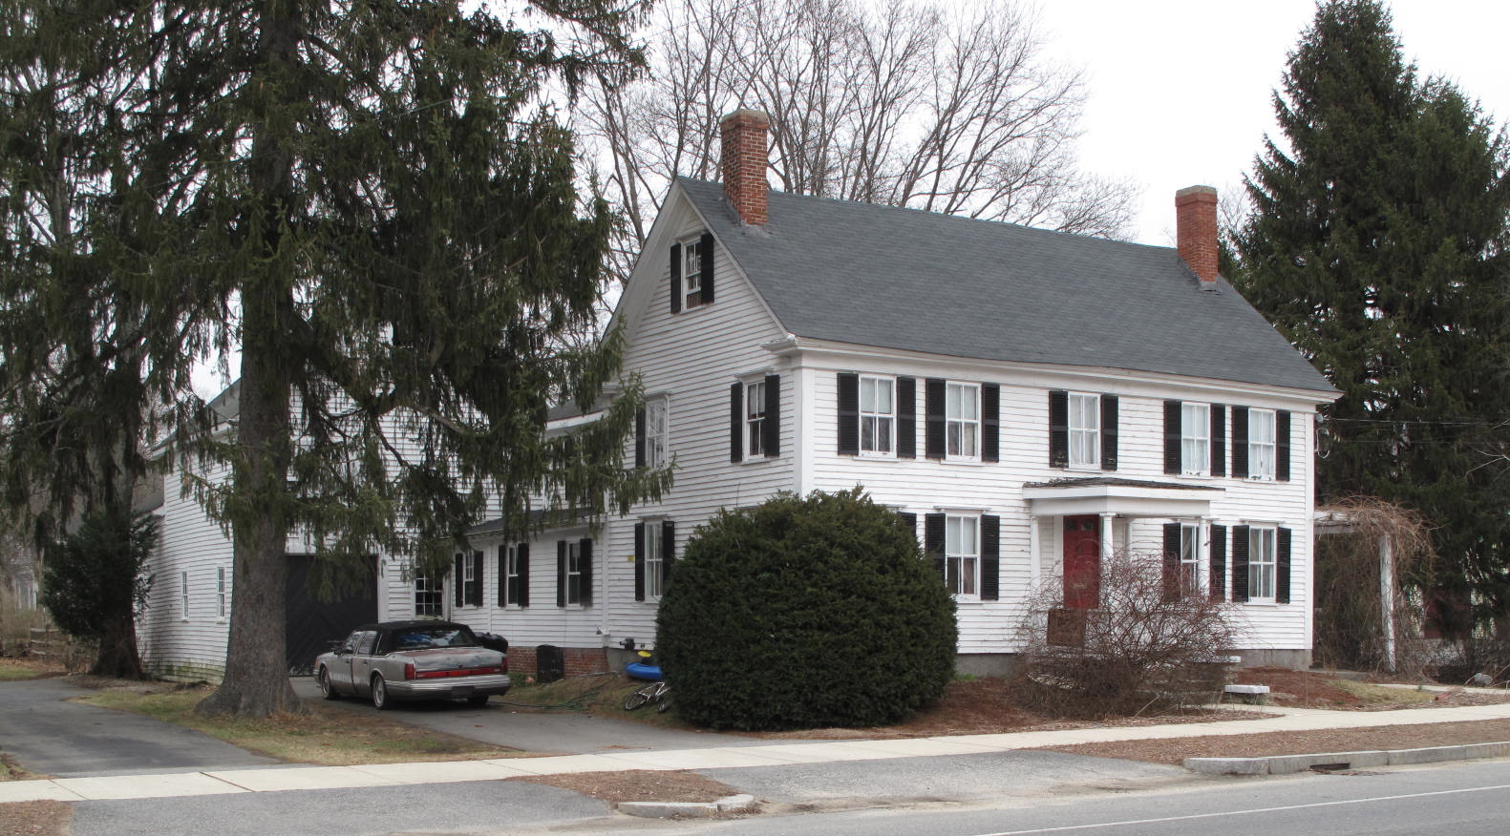
52 East Main Street: views from SW (top) and SE (bottom)

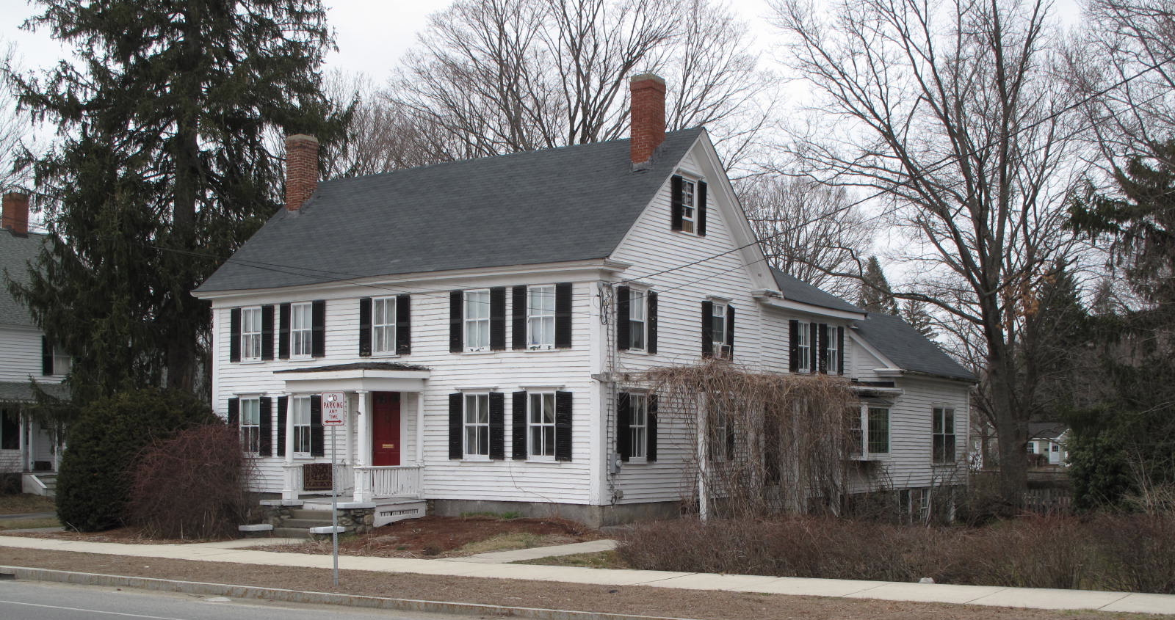

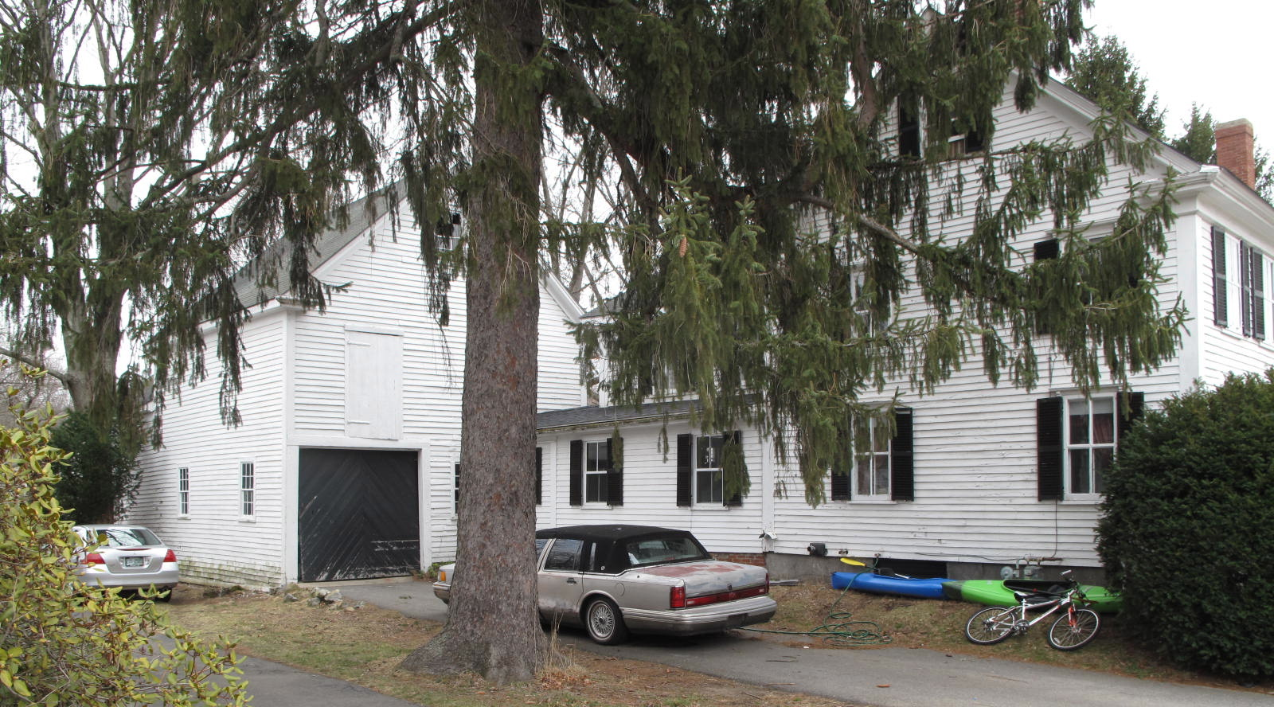
Views from SW (top) and NE (bottom)

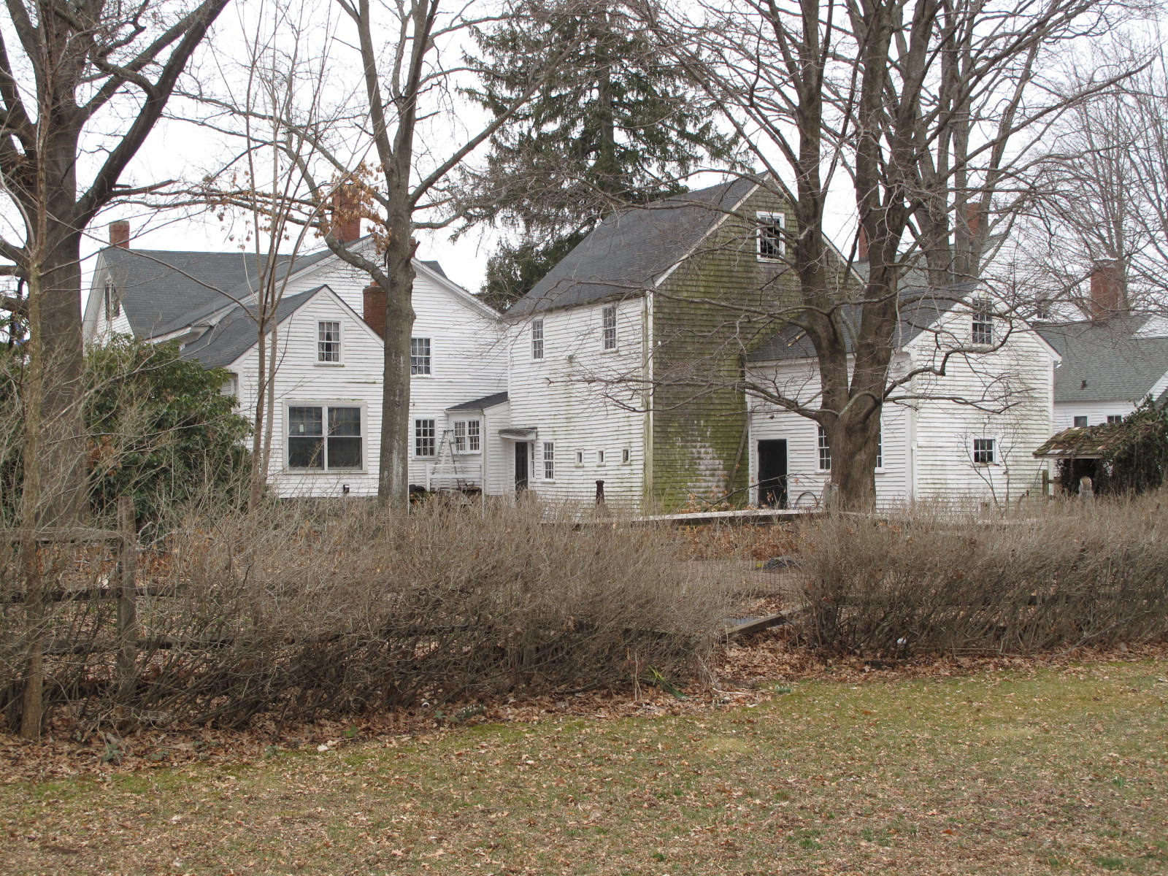

National Register of Historic Places Criteria Statement Form

Check all that apply:

Individually eligible Eligible only in a historic district

Contributing to a potential historic district Potential historic district

Criteria: A B C D

Criteria Considerations: A B C D E F G

Statement of Significance by________Neil Larson_________________________________
The criteria that are checked in the above sections must be justified here.

The Mary Hatch House, built c. 1840, is architecturally significant as a distinctive Greek Revival-style residence of unusual physical integrity in Georgetown center. Its association with the town’s earliest shoe manufacturers, as well as with Lewis H. Bateman, a noteworthy businessman and civic leader, contributes to the property’s historical significance. The quality and integrity of the house and connected barn along with its historical associations combine to make it eligible for the National Register. The building also is a contributing component of the village district.

Sarah Anna Emery, Reminiscences of a Nonagenarian (Newburyport, William H. Huse, 1879), 87-89. Emery, born in 1787, was the niece of Joseph and Benjamin Little. Rowley vital records include the death of Lewis Hatch on 1 January 1814; he was then twenty-seven years old.
Benjamin F. Arrington, ed., Municipal History of Essex County in Massachusetts (New York: Lewis Historical Publishing Co., 1922), 255.
See Henry M. Nelson, “Town of Georgetown History,” in History of Essex County, Massachusetts, with Biographical Sketches of Many of Its Pioneers and Prominent Men (Philadelphia: J. W. Lewis and Co., 1888), 823-24, 846, 852, 856.
Samuel V. Noyes to Elizabeth E. Pingree, 1 July 1940, SED 3223:45
Elizabeth E. Pingree to H. Nelson and Elizabeth E. Pingree, 5 January 1972, SED 5835:598; H. Nelson Pingree to William P. and Olive N. Ingraham, 20 June 1974, SED 6076:782; William P. and Olive N. Ingraham, Newbury, to Michael W. and Becky J. Hegerfeld, 52 E Main, 29 September 1982, SED 6983:117; Michael W. and Becky J. Hegerfeld to Michael J. and Paul J. MacDonald, 15 June 2005, SED 24425:515.

