FORM B − BUILDING

Massachusetts Historical Commission
Massachusetts Archives Building
220 Morrissey Boulevard
Boston, Massachusetts 02125

Photograph
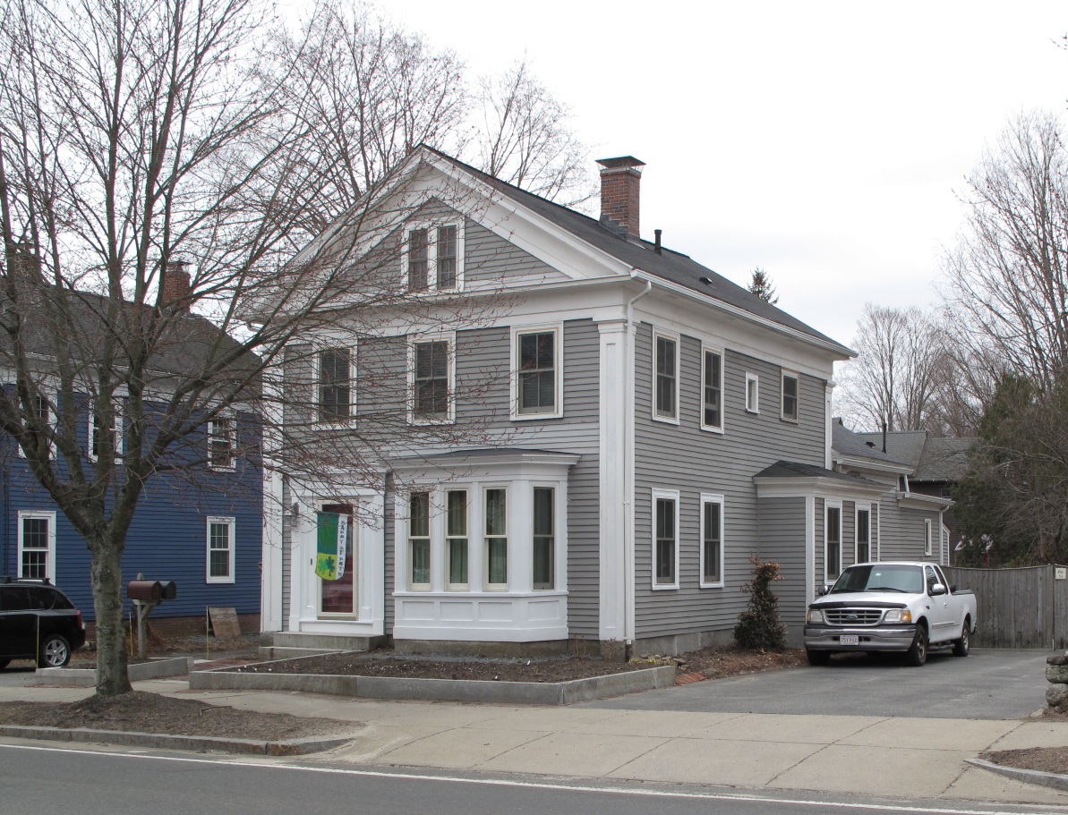
View from north

Locus Map (north at top)
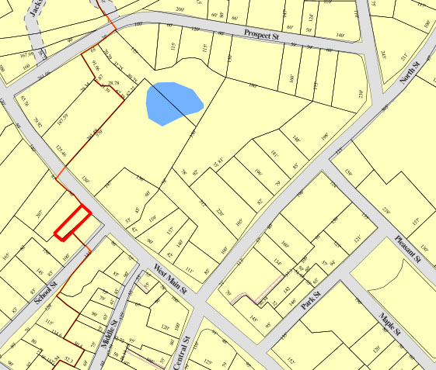

Recorded by: Kathryn Grover & Neil Larson
Organization: Town of Georgetown
Date: October 2012

Assessor’s Number USGS Quad Area(s) Form Number

11A-33 |  | Georgetown |  | C |  | GEO.195

Town/City: Georgetown
Place: (neighborhood or village):
Town Center

Address: 42 West Main Street
Historic Name: Erie P. & Mary J. Thompson House
Uses: Present: single residence
Original: single residence
Date of Construction: ca. 1850
Source: historic maps, local history
Style/Form: Greek Revival
Architect/Builder: unknown
Exterior Material:
Foundation: stone
Wall/Trim: wood clapboards
Roof: asphalt shingles
Outbuildings/Secondary Structures:
none
Major Alterations (with dates):
Rear ell added
Second-story entrance & exterior stairs added

Condition: good
Moved: no yes Date:
Acreage: 0.14 acre
Setting: This house is sited on the south side of West Main Street one house lot north of the intersection with School Street. The lot features mature trees, and the area is a mix of residential, commercial, and institutional uses.

Recommended for listing in the National Register of Historic Places.
If checked, you must attach a completed National Register Criteria Statement form.

ARCHITECTURAL DESCRIPTION
The Erie P. & Mary J. Thompson House is located on the southwesterly side of West Main Street northwest of School Street. Built ca. 1850, the plan of the house has two principal rooms on the westerly side and an entry and a third room on the other side. The front façade is framed by wide corner pilasters and the gable is enclosed in a full pediment edged with a stolid Classical entablature with a tall frieze characteristic of the Greek Revival taste. An entrance with a trabeated architrave is positioned on the easterly side of the first story offset by a wide one-story box bay window, which may be a later addition. Three windows are evenly spaced across the second story. A pair of attic windows is centered within the pediment. Two windows are grouped on both stories in the front of the westerly side wall, with another box bay window positioned in the rear. Two later windows have been added above the bay window. The easterly wall has a windowless space in the front where stairs are located on the interior. Elsewhere, windows are grouped in pairs. One second-story window has been converted to a doorway accessed by exterior wood stairs. A one-story rear ell spans the rear façade and has an entrance and porch on its easterly side. An extension was added to the rear of the ell later.

The house is sited on the easterly side of the lot with a paved parking area to the west. A small yard is located in the rear of the property.

The Erie P. & Mary J. Thompson House, built ca. 1850, is an intact example of Greek Revival-style domestic architecture in Georgetown and is sufficiently intact to be a contributing property in the village district.

HISTORICAL NARRATIVE
The house at 42 West Main Street is shown on the 1856 map of Georgetown with the name “F. P. Thompson” attached. By comparing the 1860 census to the 1856 map, it seems clear that “F. P. Thompson” was actually shoe manufacturer Erie Poor Thompson (1822-91), son of John Thompson of New Hampshire and Cora Poor of Georgetown. The 1860 industrial schedules of the census show Thompson among the smaller of the 14 local shoe, boot, and boot and shoe manufacturers in Georgetown: he had $4000 in capital invested, used $4825 of calf, goat, and sheep skins and other materials, employed eight men and five women, and produced 2,600 pair of boots and 4,000 pair of shoes valued together at $9,700.

By 1869 Thompson had moved his family and business to the larger shoe manufacturing center of Haverhill when shoecutter Eben Jewett Hobson and his family occupied 42 West Main Street. Hobson, born in Rowley in 1825, is shown in the 1870 census with $3500 in real property. His household included his wife Caroline A. Kimball Hobson, whom he married in 1849, his daughter Fanny Louise, then fourteen, and a domestic servant. Caroline Hobson was also part of the local business world: she was a milliner and dry goods dealer from at least 1880 into the 1920s. The 1880 industrial schedules show her with $2000 invested capital, five employees working twelve-hour days for six months out of the year and using $1200 in materials to make $3000 worth of goods. The 1900 census shows her as a millinery proprietor, and her divorced daughter Fannie L. Everett working for her as a saleswoman. Fannie’s son Wilbur George, born in 1887, lived with the family, as did a domestic servant named Eunice Ann Brown, born in 1868 in Ipswich.

Eben Hobson died in 1904, and Caroline Hobson and her daughter remained in this house. By 1914 her millinery and fancy goods shop was at 47 West Main Street. The 1920 census shows her as still running her millinery store at the age of ninety-one; her daughter was still her saleswoman, and Eunice A. Brown remained in the household. In March of the same year Caroline Hobson died, and her daughter became owner of the 42 West Main property and her mother’s business. The 1932 directory shows her with a variety store at 23 West Main, and Eunice A. Brown, here called Annie, was clerking for her and boarding at 42 West Main. Everett also had boarders, the family of shoe worker Fred W. Chick.

In March 1939 Fannie Hobson Everett died and the 42 West Main Street property passed to Eunice Brown. After her death in 1955, her administrator sold 42 West Main to Bertha A. Heathcock, born about 1890 in Massachusetts; she and her husband Joseph had lived in Lowell in the 1930s and had moved to Georgetown by 1940. The 1957 directory shows her as a widow at 42 West Main Street living with Joseph and Katherine McDougall. Heathcock deeded it to herself and her daughter Barbara H. Perley, of Boxford, in 1961, and three years later Perley sold 42 West Main to Joseph B. and Mildred M. Ford of North Andover. The property then changed hands often. Current owners Diana S. Kilroe and Jeffrey K. and Deborah K. Lamoureaux acquired it in 2004.

BIBLIOGRAPHY and/or REFERENCES
Arrington, Benjamin F., ed. Municipal History of Essex County in Massachusetts. NY: Lewis Historical Publishing Co., 1922.
Field, Jane. A Brief History of Georgetown Massachusetts 1838-1963. Rev. ed. 1988. Georgetown: Georgetown Historical Commission, 1988.
Gage, Thomas. The History of Rowley, Anciently Including Bradford, Boxford, and Georgetown, from the Year 1639 to the Present Time. Boston: F. Andrews, 1840.
Georgetown, Boxford, Byfield, Newbury, and West Newbury, Massachusetts, Directory. Boston: W. E. Shaw, 1901-2, 1905, 1909, 1912, 1914, 1916-17, 1918, 1925.
Hill, Edwin P. “History of Georgetown, Massachusetts.” In Standard History of Essex County, Massachusetts. Edited by Cyrus M. Tracey, William E. Graves, and Henry M. Batchelder. Boston: C. F. Jewett, 1878.
Hull, Forrest P. Georgetown: Story of One Hundred Years, 1838-1938. 1938. Reprint. Georgetown, MA: Georgetown Historical Commission, 2006.
Merrill, Samuel. A Merrill Memorial: An Account of the Descendants of Nathaniel Merrill, an Early Settler of Newbury, Massachusetts. Cambridge, MA, 1917-28.
Nelson, Henry M. “Town of Georgetown History.” In Hurd, D. Hamilton. History of Essex County, Massachusetts, with Biographical Sketches of Many of Its Pioneers and Prominent Men. Vol. 1. Philadelphia: J. W. Lewis and Co., 1888.
Sammarco, Anthony Mitchell, for Georgetown Historical Society. Images of America: Georgetown. Portsmouth, NH: Arcadia Publishing, 2002.

MAPS
“Map of the Centre of Georgetown in 1800.” In Perley, Sidney H., “Centre of Georgetown in the Year 1800.” The Essex Antiquarian: A Quarterly Magazine Devoted to the Biography, Genealogy, History, and Antiquities of Essex County, Massachusetts 2, 7 (July 1898): 201.
Map of Georgetown in 1810 and 1840. In Gage, Thomas. The History of Rowley, Anciently Including Bradford, Boxford, and Georgetown, from the Year 1639 to the Present Time. Boston: F. Andrews, 1840. 320.
“Map of New Rowley Surveyed and Drawn by Philander Anderson 1830.” Georgetown Historical Society.
Map of Georgetown. 1856. In Walling. H. F. A Topographical Map Essex County Massachusetts. Boston: Smith and Morley, 1856.
Atlas of Essex County, Massachusetts. Philadelphia: D. G. Beers and Co., 1872). Plates 59 and 61.
“Town of Georgetown Mass.” and “Village of Georgetown Mass.” In Atlas of Essex County, Massachusetts (Boston: George H. Walker, 1884).
“Georgetown, Mass. 1887.” Drawn and Published by George E. Norris, Brockton, Massachusetts. Troy, NY: Burleigh Lithographic Establishment, 1887.”

PHOTOGRAPHS (all photos by Neil Larson, 2012)

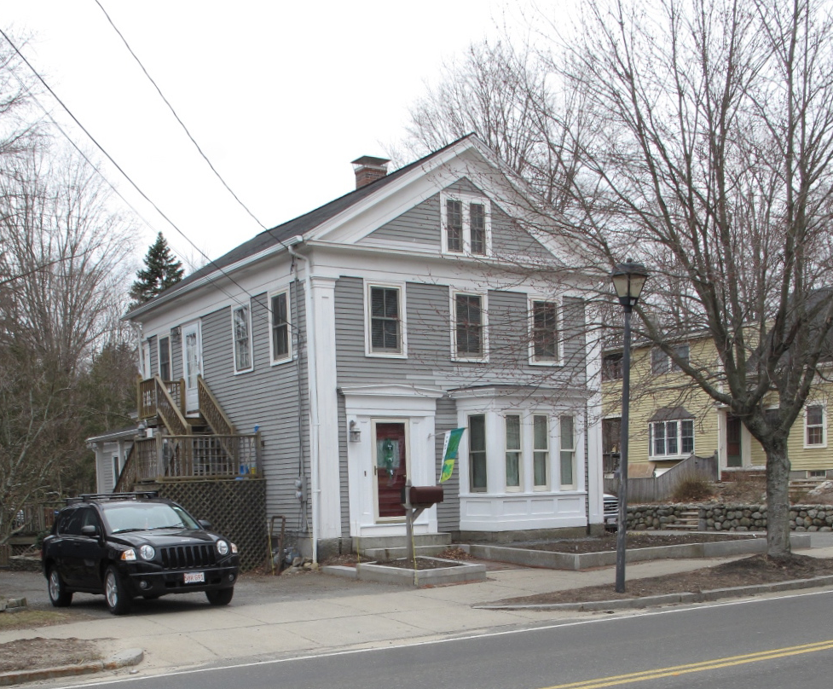
42 West Main Street: view from east

National Register of Historic Places Criteria Statement Form

Check all that apply:

Individually eligible Eligible only in a historic district

Contributing to a potential historic district Potential historic district

Criteria: A B C D

Criteria Considerations: A B C D E F G

Statement of Significance by________Neil Larson_________________________________
The criteria that are checked in the above sections must be justified here.

The Erie P. & Mary J. Thompson House, built ca. 1850, is an intact example of Greek Revival-style domestic architecture in Georgetown and is sufficiently intact to be a contributing property in the village district.

Baker Adams, administrator estate E. Annie Brown aka Eunice Annie Brown, to Bertha A. Heathcock, 28 October 1955, SED 4220:238; Bertha A. Heathcock to Bertha A. Heathcock and Barbara H. Perley, August 1961, SED 4804:178; Barbara H. Perley, Boxford, to Joseph B. and Mildred M. Ford, 21 May 1964, SED 5172:242; David R. and Patricia Q. Brouillette to Diana S. Kilroe and Jeffrey K. and Deborah K. Lamoureaux, 42 West Main, 23 November 2004, SED 23657:488. See also “Plan Showing Property as Surveyed for Joseph B. and Mildred M. Ford, West Main Street, Georgetown, Mass.,” July 1967, SEP 5741:800.

