FORM B − BUILDING

Massachusetts Historical Commission
Massachusetts Archives Building
220 Morrissey Boulevard
Boston, Massachusetts 02125

Photograph
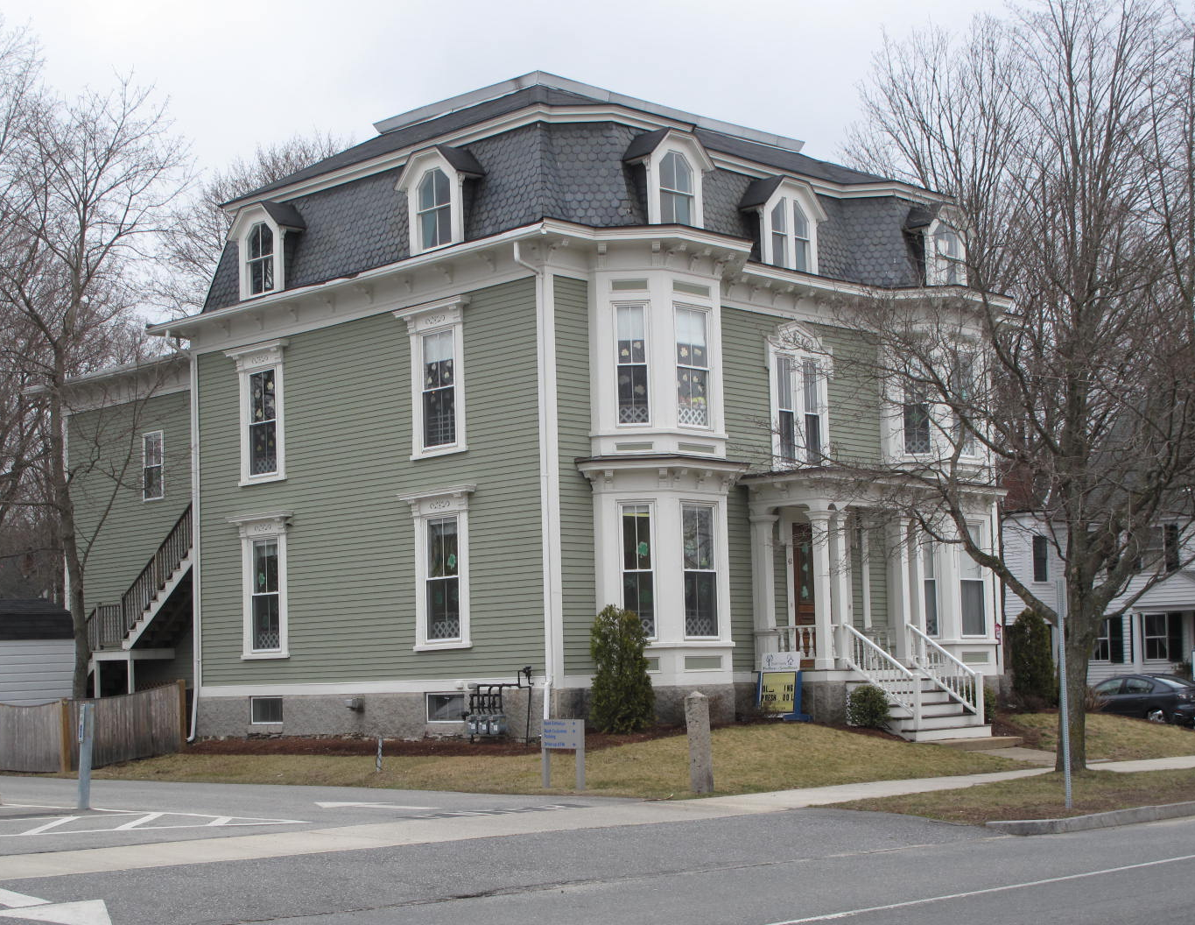
View from southwest

Locus Map (north at top)
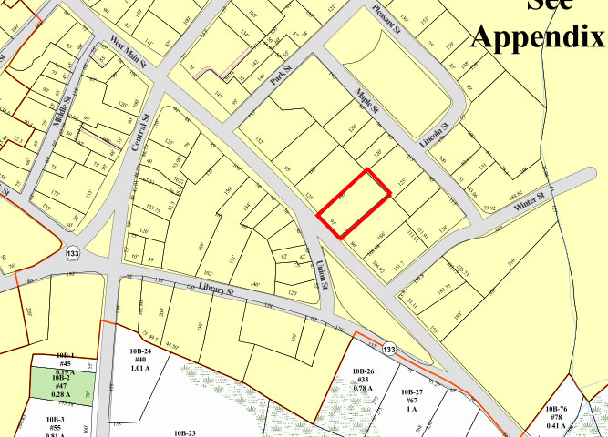

Recorded by: Kathryn Grover & Neil Larson
Organization: Town of Georgetown
Date: October 2012

Assessor’s Number USGS Quad Area(s) Form Number

11A-116 |  | Georgetown |  | C |  | GEO.141

Town/City: Georgetown
Place: (neighborhood or village):
Town Center

Address: 42 East Main Street
Historic Name: Samuel & Harriet Plummer House
Uses: Present: child care facility and apartments
Original: single residence
Date of Construction: ca. 1884

Source: town records, historic maps
Style/Form: Second Empire
Architect/Builder: unknown
Exterior Material:
Foundation: stone
Wall/Trim: wood clapboards
Roof: slate shingles
Outbuildings/Secondary Structures:
none
Major Alterations (with dates):
Two-story rear ell enlarged

Condition: good
Moved: no yes Date:
Acreage: 0.42 acre
Setting: This house is sited on the north side of East Main Street near the intersection with Union Street on a lot iwht mature trees. The area combines residential, commercial, and institutional uses.

Recommended for listing in the National Register of Historic Places.
If checked, you must attach a completed National Register Criteria Statement form.

ARCHITECTURAL DESCRIPTION
The Samuel & Harriet Plummer House is a two-story, wood frame house with a mansard roof located on the north side of East Main Street opposite its intersection with Union Street. The large second empire-style dwelling has a three-bay front façade with a center entrance set within a substantial flat-roof porch with paired pillars in the front and a bracketed cornice and surmounted by a paired windows with an elaborate header in the second story. Two-story bay windows with beveled corners flank the entry and are embellished with bracketed cornices at each level. A bracketed cornice distinguishes the roof edge and three dormers with clipped gables in the mansard are aligned with the stories below. The side walls contain two windows on the first and second stories, each having a large cornice. They are aligned with dormers in the roof. A historic view depicts a two-story, flat roof rear ell on the east side of the house; this feature has been doubled in size and extended across the entire rare façade of the building.

The house is sited close to the street and has narrow yards on the front and sides. A wide paved driveway enters the lot from the street on the east side of the house and terminates at a parking lot in the center of the property. A yard at the very rear of the parcel has been made into a children’s playground.

The Samuel & Harriet Plummer House is a rare and distinctive example of late 19th-centuy domestic architecture in the Second Empire style in the town center. Alterations are few and the property is a contributing component of the village district.

HISTORICAL NARRATIVE
A 1905 deed transferring this property refers to it as “Samuel Plumer’s [sic] new house,” meaning to indicate the house Plummer had constructed between his first East Main Street house, just to the southeast (48 E. Main St.), and that of John P. Coker to the northwest. The new house is depicted on the 1884 map of Georgetown center, as is the old house; both were labeled with the name of Samuel Plummer. Born in Rowley in 1813, Samuel Plummer (often spelled Plumer) was the son of Bradstreet and Anna Todd Plumer, and he was living in Georgetown in 1838 when he married Harriet N. Keniston. Plummer worked as a merchant tailor, but 1860 and 1870 census enumerators apparently did not consider his business large enough to list it on the town’s industrial census. The Plumers’ family consisted of children Horace Bradstreet, born in 1841; Mary Jewett, born in 1846, Harriet Ann, born in 1849, and Sarah, born in 1860.

Between 1870 and 1880 Harriet N. Keniston Plumer died, and in 1880 Samuel Plummer was sixty-eight years old and living at 48 East Main Street with his daughters Mary and Sarah and a domestic servant. In 1884 Sarah married attorney William A. Butler, who had grown up in Georgetown and was the son of clergyman Oliver Butler and his wife Sarah M. Ferguson. Samuel Plummer died in 1890, and it appears that the Butlers occupied the house for some undetermined time afterward. The 1900 census shows them occupying this house or Plummer’s earlier one with their young daughter Amy and a niece and nephew, Rhea and Horace B. Moore, who were born in Illinois.

In 1905 the Essex County probate court appointed a commissioner to apportion the real estate of Rhea and Horace Moore, identified as “Samuel Plumer’s new house,” between Sarah Plummer Butler and her brother Horace. The 42 East Main Street property was sold at auction that year Horace Plummer for $2000. By 1909 the Butlers had moved to North Street, where William A. Butler died by 1912; Sarah Plummer Butler lived later on Middle Street and School Street.

Horace Plummer died by December 1924 in Boston, and at that time, his widow Emelyn and daughter Marie sold 42 East Main Street to Wilhelmine S. Bray, whose parents, William and Eliza Spofford Bray, ran the Baldpate Inn in Georgetown. In 1920 Wilhelmine worked as a clerk in the hotel, and by the time she married William Amos Harriman in 1927 she was managing the Baldpate Inn, her father having died in 1922. She and her sisters Ruth and Pauline sold the property in 1928 to Jennie Wentworth Mitchell, a native of Somerville and the widow of Haverhill shoe factory foreman Benjamin T. Mitchell. In 1920 she was living in Haverhill wit her son Harvey B. Mitchell, a druggist’s clerk; by 1930 he was a city fireman in Haverhill.

Jennie Mitchell owned and occupied 42 East Main Street until her death, and in May 1952 her son sold the property to Elizabeth E. Pingree, the wife of H. Nelson Pingree, and Weldon and Constance M. Ray jointly. The two parties converted the property to the Pingree-Apartments, which had seven occupied units in 1957. They owned the property until February 1974, when they sold it to Lewis Skeirik of Georgetown and Fred J. Nahil of Groveland, who sold it in 1775 to James J. and Jean S. Jovell. The Jovells sold 42 East Main Street to current owners Rodney M. and Douglas M. Smith as trustees of the Smith Family Trust in 1997.

BIBLIOGRAPHY and/or REFERENCES
Arrington, Benjamin F., ed. Municipal History of Essex County in Massachusetts. NY: Lewis Historical Publishing Co., 1922.
Field, Jane. A Brief History of Georgetown Massachusetts 1838-1963. Rev. ed. 1988. Georgetown: Georgetown Historical Commission, 1988.
Gage, Thomas. The History of Rowley, Anciently Including Bradford, Boxford, and Georgetown, from the Year 1639 to the Present Time. Boston: F. Andrews, 1840.
Georgetown, Boxford, Byfield, Newbury, and West Newbury, Massachusetts, Directory. Boston: W. E. Shaw, 1901-2, 1905, 1909, 1912, 1914, 1916-17, 1918, 1925.
Hill, Edwin P. “History of Georgetown, Massachusetts.” In Standard History of Essex County, Massachusetts. Edited by Cyrus M. Tracey, William E. Graves, and Henry M. Batchelder. Boston: C. F. Jewett, 1878.
Hull, Forrest P. Georgetown: Story of One Hundred Years, 1838-1938. 1938. Reprint. Georgetown, MA: Georgetown Historical Commission, 2006.
Merrill, Samuel. A Merrill Memorial: An Account of the Descendants of Nathaniel Merrill, an Early Settler of Newbury, Massachusetts. Cambridge, MA, 1917-28.
Nelson, Henry M. “Town of Georgetown History.” In Hurd, D. Hamilton. History of Essex County, Massachusetts, with Biographical Sketches of Many of Its Pioneers and Prominent Men. Vol. 1. Philadelphia: J. W. Lewis and Co., 1888.
Sammarco, Anthony Mitchell, for Georgetown Historical Society. Images of America: Georgetown. Portsmouth, NH: Arcadia Publishing, 2002.

MAPS
“Map of the Centre of Georgetown in 1800.” In Perley, Sidney H., “Centre of Georgetown in the Year 1800.” The Essex Antiquarian: A Quarterly Magazine Devoted to the Biography, Genealogy, History, and Antiquities of Essex County, Massachusetts 2, 7 (July 1898): 201.
Map of Georgetown in 1810 and 1840. In Gage, Thomas. The History of Rowley, Anciently Including Bradford, Boxford, and Georgetown, from the Year 1639 to the Present Time. Boston: F. Andrews, 1840. 320.
“Map of New Rowley Surveyed and Drawn by Philander Anderson 1830.” Georgetown Historical Society.
Map of Georgetown. 1856. In Walling. H. F. A Topographical Map Essex County Massachusetts. Boston: Smith and Morley, 1856.
Atlas of Essex County, Massachusetts. Philadelphia: D. G. Beers and Co., 1872). Plates 59 and 61.
“Town of Georgetown Mass.” and “Village of Georgetown Mass.” In Atlas of Essex County, Massachusetts (Boston: George H. Walker, 1884).
“Georgetown, Mass. 1887.” Drawn and Published by George E. Norris, Brockton, Massachusetts. Troy, NY: Burleigh Lithographic Establishment, 1887.”

PHOTOGRAPHS (all photos by Neil Larson, 2012)

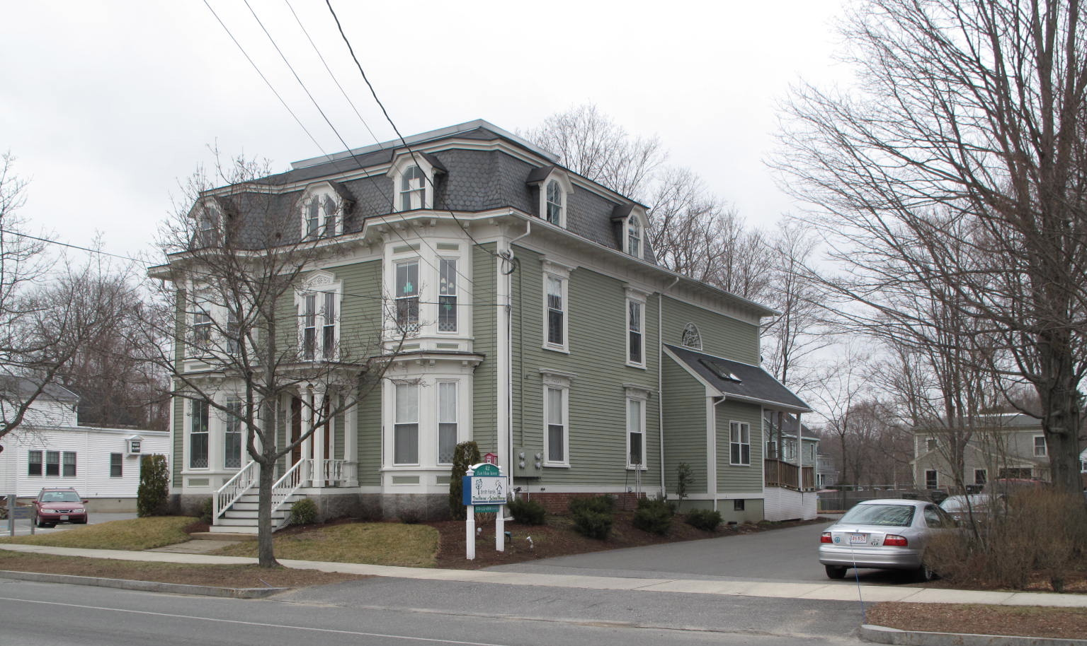
View from SE

National Register of Historic Places Criteria Statement Form

Check all that apply:

Individually eligible Eligible only in a historic district

Contributing to a potential historic district Potential historic district

Criteria: A B C D

Criteria Considerations: A B C D E F G

Statement of Significance by________Neil Larson_________________________________
The criteria that are checked in the above sections must be justified here.

The Samuel & Harriet Plummer House is a rare and distinctive example of late 19th-centuy domestic architecture in the Second Empire style in the town center. Alterations are few and the property is a contributing component of the village district.

George D. Dyke to Horace B. Plumer, 17 October 1905, SED 1796:490.
Emelyn H. S. Plumer, widow of Horace B. Plumer,and Marie E. Plumer, both Boston, to Wilhelmiine S. Bray, 2 December 1924, SED 2630:22 On the Baldpate Inn see Anthony Mitchell Sammarco, Images of America: Georgetown (Portsmouth, NH: Arcadia Publishing, 2002), 115-19.
Wilhelmine B. Harriman fka Wilhelmine S. Bray; Ruth B. Doty, Winchester; Pauline B. Scheele fka Pauline Bray, NY, to Jennie Mitchell, 20 October 1928, SED 2785:592.
Harvey B. Mitchell, Haverhill, to Elizabeth E. Pingree and Weldon M. and Constance A. Ray, 19 May 1952, 3898:361; H. Nelson Pingree executor will of Elizabeth E. Pingree, to Lewis Skeirik, Georgetown, and Fred J. Nahil, Groveland, 22 February 1974, SED 6047:205; Constance A. Tripp, fka Constance A. Ray,to Lewis Skeirik and Fred J. Nahill, 22 February 1974, SED 6047:206; Lewis Skeirik and Fred J. Nahil to James J. Jovell and Richard M. King, 6 January 1975, SED 6122:7; Richard M. King, Orlando FL, to James J. Jovell, 88 E Main, 27 February 1978, SED 6446:396; Jean S. Jovell, trustee Golden Pond Realty Trust, to Rodney M. and Douglas M. Smith, trustees Smith Family Realty Trust, 2 May 1997, SED 14094:269.

