FORM B − BUILDING

Massachusetts Historical Commission
Massachusetts Archives Building
220 Morrissey Boulevard
Boston, Massachusetts 02125

Photograph
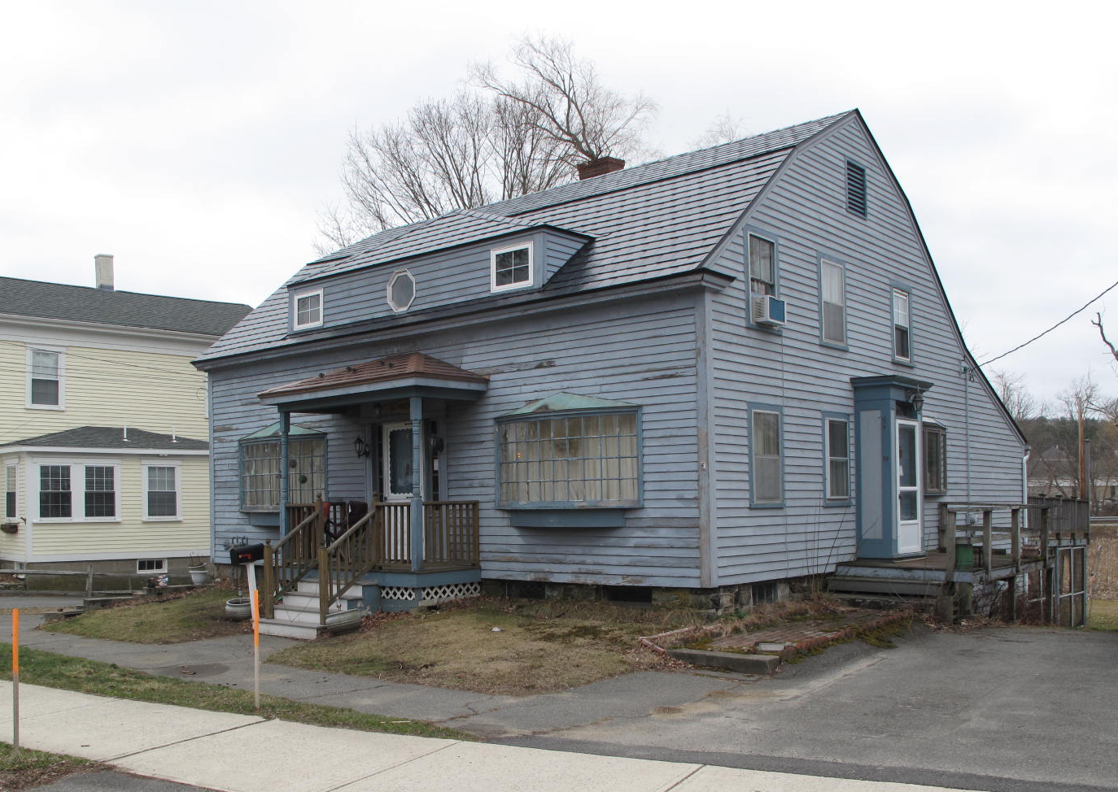
View from NW

Locus Map (north at top)
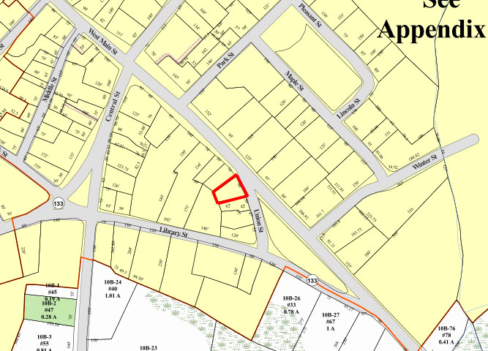

Recorded by: Kathryn Grover & Neil Larson
Organization: Town of Georgetown
Date: October 2012

Assessor’s Number USGS Quad Area(s) Form Number

11A-73 |  | Georgetown |  | C |  | GEO.140

Town/City: Georgetown
Place: (neighborhood or village):
Town Center

Address: 41 East Main Street
Historic Name: Enoch & Elizabeth B. Dresser House
Uses: Present: two-family residence
Original: single residence
Date of Construction: ca. 1800
Source: maps, deeds, visual assessment
Style/Form: Federal
Architect/Builder: unknown
Exterior Material:
Foundation: stone
Wall/Trim: wood clapboards
Roof: simulated slate
Outbuildings/Secondary Structures:
none
Major Alterations (with dates):
Bow windows added to front façade
Dormers added front and rear
Additions on rear
Window sash replaced

Condition: good
Moved: no yes Date:
Acreage: 0.15 acre
Setting: This house is sited on East Main Street at its junction with Union Street on a lot with mature trees. The area is largely residential.

Recommended for listing in the National Register of Historic Places.
If checked, you must attach a completed National Register Criteria Statement form.

ARCHITECTURAL DESCRIPTION
The Enoch & Elizabeth B. Dresser House is a story-and-a-half, wood frame house with a gambrel roof located on the south side of East Main Street at its intersection with Union Street. What apparently was a five-bay front façade with a center entrance has been altered by the replacement of the windows on either side of the entrance with wide bow windows. The center doorway is flanked by sidelights and set within a recent hipped-roof porch. A hipped roof dormer has been added to the center of the roof.

The end walls have two tiers of windows irregularly spaced; the east end of the house contains a door set within a shallow exterior vestibule found on many houses built in the period. It may have been moved from the front entrance, where these features are commonly located, or simply added to the end wall when the house was made into a two-family dwelling in the early 19th century. A one-story shed roof ell is attached to the east side of the rear wall. This early feature has been enlarged with the addition of a porch, now enclosed and a shed dormer in the roof; a deck has been built on the rear end of the ell. The lot slopes from the street to the rear exposing the stone basement on the rear of the house. There is a small yard in the rear of the lot and paved driveways on both sides.

The house is sited close to the street on the southerly side of a sloping site. The basement is exposed at grade on the rear side of the house and opens on a large yard. The front area of the property has been paved for parking.

The Enoch & Elizabeth B. Dresser House is an early and distinctive example of early 19th-centuy domestic architecture in the town center. Alterations are such that it is not individually eligible for the National Register, but it is a contributing component of the village district.

HISTORICAL NARRATIVE
The house at 41 East Main Street is depicted on the 1830 map of the town and is labeled “Mrs E. Dresser,” indicating that it was occupied by the widow Elizabeth Bridges Dresser after her husband, Enoch Dresser died in 1824. Born in 1774 in Boxford, Enoch Dresser was the son of John and Jane Harriman Dresser, and he married Betsey (Elizabeth) Bridges in Rowley in 1800. By outward appearance, the house at 41 East Main Street could have been built for them at this time. The couple had at least seven children between 1803 and 1821—Eliza, Silena, Mahala, Elbridge Gerry, Thomas Newman, William Otis, Leonard, and Mary Jane. The 1820 Rowley census is alphabetical and thus provides no clue about where the family was living, Enoch Dresser’s household included nine persons—five males and four females, just as vital records indicate, for Mary Jane, the youngest, had not yet been born.

In October 1824, when he was forty-eight, Enoch Dresser was killed after falling from his horse. The 1830 Rowley census does not show Elizabeth or Betsey Dresser, though she may be the elderly woman living in the household of Elijah C. Dresser, her son-in-law and the husband of her eldest daughter Eliza. Elijah C. Dresser was a carpenter born in Ipswich, where Enoch Dresser and Betsey Bridges married, and might have been the son of Enoch’s brother John; Elijah’s death record identifies his father by that name. He married Eliza Dresser in 1825. In that same year, Elizabeth Dresser, as administrator of her husband’s estate, conveyed to her son-in-law for 57 dollars part of a house “a half-mile northwest of Isaac Braman’s Meeting House” and part of the “Elizabeth Dresser house” adjoining it.

The 1840 Georgetown census lists her in a household by herself before that of Elijah Dresser, who had moved to a new house at what now is 19 Library Street. By 1850 Elizabeth Dresser was shown with $1,000 in real estate in this neighborhood. She shared the house with the family of shoemaker William Richards, and enumerated just before her in the census is her son William Otis Dresser, a teamster with $500 in real property and a household comprised of his wife, three children, and four boarders, who lived next door at 1 Union Street.

Elizabeth Bridges Dresser lived in this neighborhood until her death in June 1864 at the age of eighty-five. In November of that year her children deeded the property to Mary Jane Sawins of Haverhill. The deed states that the property had been owned by Elizabeth B. Dresser at her death and included a lot with a “cottage house” and “half a dwelling house and woodshed,” the latter perhaps being where William O. Dresser and his family lived. Less than a year later Sawins sold the lot with its “cottage dwelling house” to Augustus P. Holt for $700, and a year after that Holt sold it for the same price to Dennis Donoghue; the deed stated that Donahue “intends to hold the same as a homestead.”

Born in Ireland about 1835, Dennis Donoghue emigrated in 1850 and settled in Georgetown by 1855. In 1859 he married Sarah Molloy, the daughter of Irish immigrant Thomas Molloy, who had come to the United States the year before. Their son Sylvester, named for Dennis Donoghue’s father, was born the same year, and by 1860 the three are shown in a three-family house elsewhere in Georgetown. In 1860 Donoghue worked as a shoemaker and his wife bound shoes; he is shown in the census with only twenty dollars in personal property. The 1870 census shows Donoghue in the house, valued at $1,200, with his wife, sons Sylvester and James Crowley Donoghue (born in 1865), and a boarding shoe worker; at that time Donoghue was working as a shoe cutter. By 1880 he had changed careers and was running a retail grocery store in the village; by 1885 his store was located opposite Middle Street on Main Street. In 1880 Donoghue’s son Sylvester was an upper leather cutter at a shoe shop, and by 1885 son James was working as a clerk for his father. James later attended Harvard Medical School, from which he graduated in 1897, and became an allopathic physican at Boston Dispensary and St. Mary’s Infant Asylum. The couple’s youngest son, Francis Dennis Donoghue, born in 1871, was also a Boston physician.

Dennis and Sarah Molloy Donoghue lived at 41 East Main Street for the rest of their lives, usually with their eldest son Sylvester. The 1910 census shows the couple living on their own income and Sylvester as a shoe factory bookkeeper. Dennis Donoghue died in December 1917, and his wife died in 1920. Donoghue had deeded the property to Arda Hoyt Carey of Campton, New Hampshire, in 1910, and she appears to have rented the house; in 1932 the directory shows the property as vacant. The property changed hands several times between 1910 and 1952, when Paul Carroll Wilmarth acquired it.

Born in Georgetown in 1929, Paul C. Wilmarth was a reporter for the Lawrence Eagle-Tribune in the 1950s. He was the son of musician Thomas W. Wilmarth and his wife Gertrude Wetmore Wilmarth, and in 1947 he married Gretchen Marie Stone of Newburyport. In 1957 the Wilmarths shared the house with Othie Reed, a Maine-born laborer, his wife Lydia Collins Reed, and their daughter Rita. The Wilmarth family continues to own 41 East Main Street.

BIBLIOGRAPHY and/or REFERENCES
Arrington, Benjamin F., ed. Municipal History of Essex County in Massachusetts. NY: Lewis Historical Publishing Co., 1922.
Field, Jane. A Brief History of Georgetown Massachusetts 1838-1963. Rev. ed. 1988. Georgetown: Georgetown Historical Commission, 1988.
Gage, Thomas. The History of Rowley, Anciently Including Bradford, Boxford, and Georgetown, from the Year 1639 to the Present Time. Boston: F. Andrews, 1840.
Georgetown, Boxford, Byfield, Newbury, and West Newbury, Massachusetts, Directory. Boston: W. E. Shaw, 1901-2, 1905, 1909, 1912, 1914, 1916-17, 1918, 1925.
Hill, Edwin P. “History of Georgetown, Massachusetts.” In Standard History of Essex County, Massachusetts. Edited by Cyrus M. Tracey, William E. Graves, and Henry M. Batchelder. Boston: C. F. Jewett, 1878.
Hull, Forrest P. Georgetown: Story of One Hundred Years, 1838-1938. 1938. Reprint. Georgetown, MA: Georgetown Historical Commission, 2006.
Merrill, Samuel. A Merrill Memorial: An Account of the Descendants of Nathaniel Merrill, an Early Settler of Newbury, Massachusetts. Cambridge, MA, 1917-28.
Nelson, Henry M. “Town of Georgetown History.” In Hurd, D. Hamilton. History of Essex County, Massachusetts, with Biographical Sketches of Many of Its Pioneers and Prominent Men. Vol. 1. Philadelphia: J. W. Lewis and Co., 1888.
Sammarco, Anthony Mitchell, for Georgetown Historical Society. Images of America: Georgetown. Portsmouth, NH: Arcadia Publishing, 2002.
MAPS
“Map of the Centre of Georgetown in 1800.” In Perley, Sidney H., “Centre of Georgetown in the Year 1800.” The Essex Antiquarian: A Quarterly Magazine Devoted to the Biography, Genealogy, History, and Antiquities of Essex County, Massachusetts 2, 7 (July 1898): 201.
Map of Georgetown in 1810 and 1840. In Gage, Thomas. The History of Rowley, Anciently Including Bradford, Boxford, and Georgetown, from the Year 1639 to the Present Time. Boston: F. Andrews, 1840. 320.
“Map of New Rowley Surveyed and Drawn by Philander Anderson 1830.” Georgetown Historical Society.
Map of Georgetown. 1856. In Walling. H. F. A Topographical Map Essex County Massachusetts. Boston: Smith and Morley, 1856.
Atlas of Essex County, Massachusetts. Philadelphia: D. G. Beers and Co., 1872). Plates 59 and 61.
“Town of Georgetown Mass.” and “Village of Georgetown Mass.” In Atlas of Essex County, Massachusetts (Boston: George H. Walker, 1884).
“Georgetown, Mass. 1887.” Drawn and Published by George E. Norris, Brockton, Massachusetts. Troy, NY: Burleigh Lithographic Establishment, 1887.”

PHOTOGRAPHS (all photos by Neil Larson, 2012)

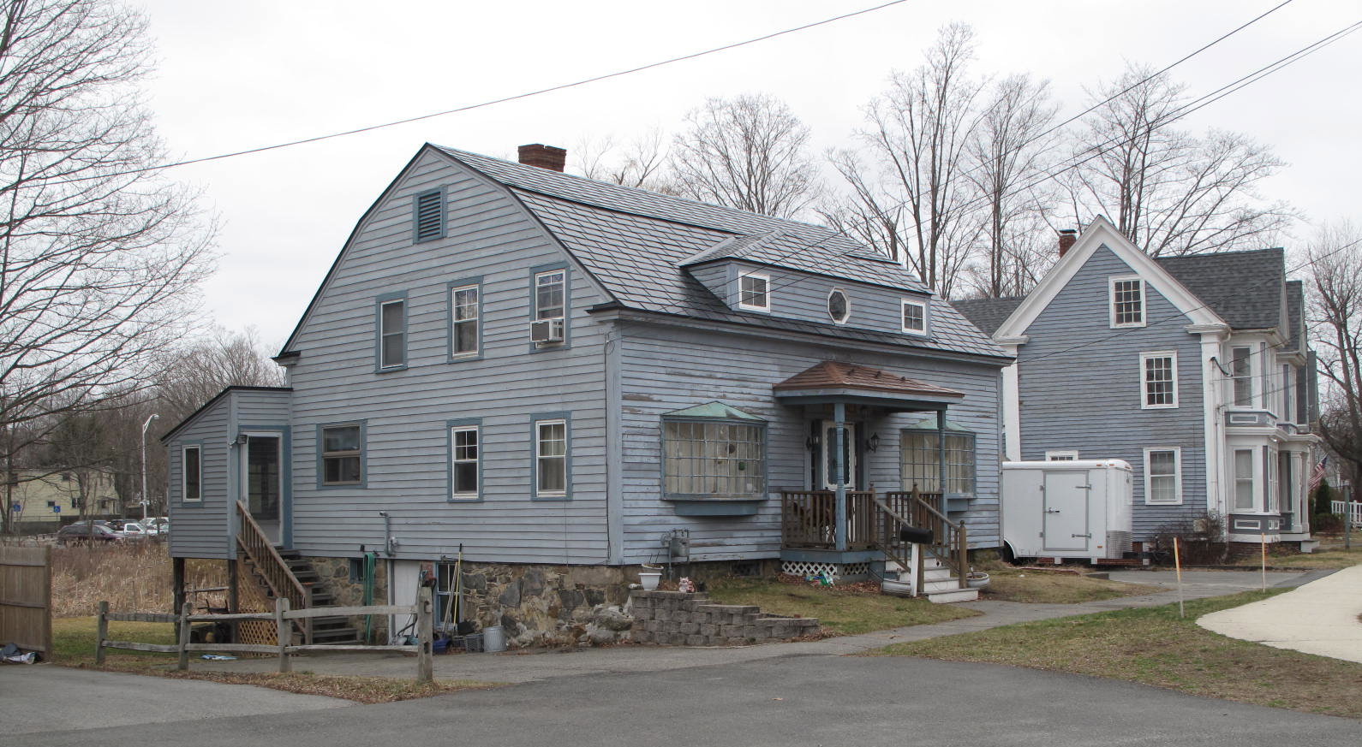
41 East Main Street: views from NE (top) and SE (bottom)

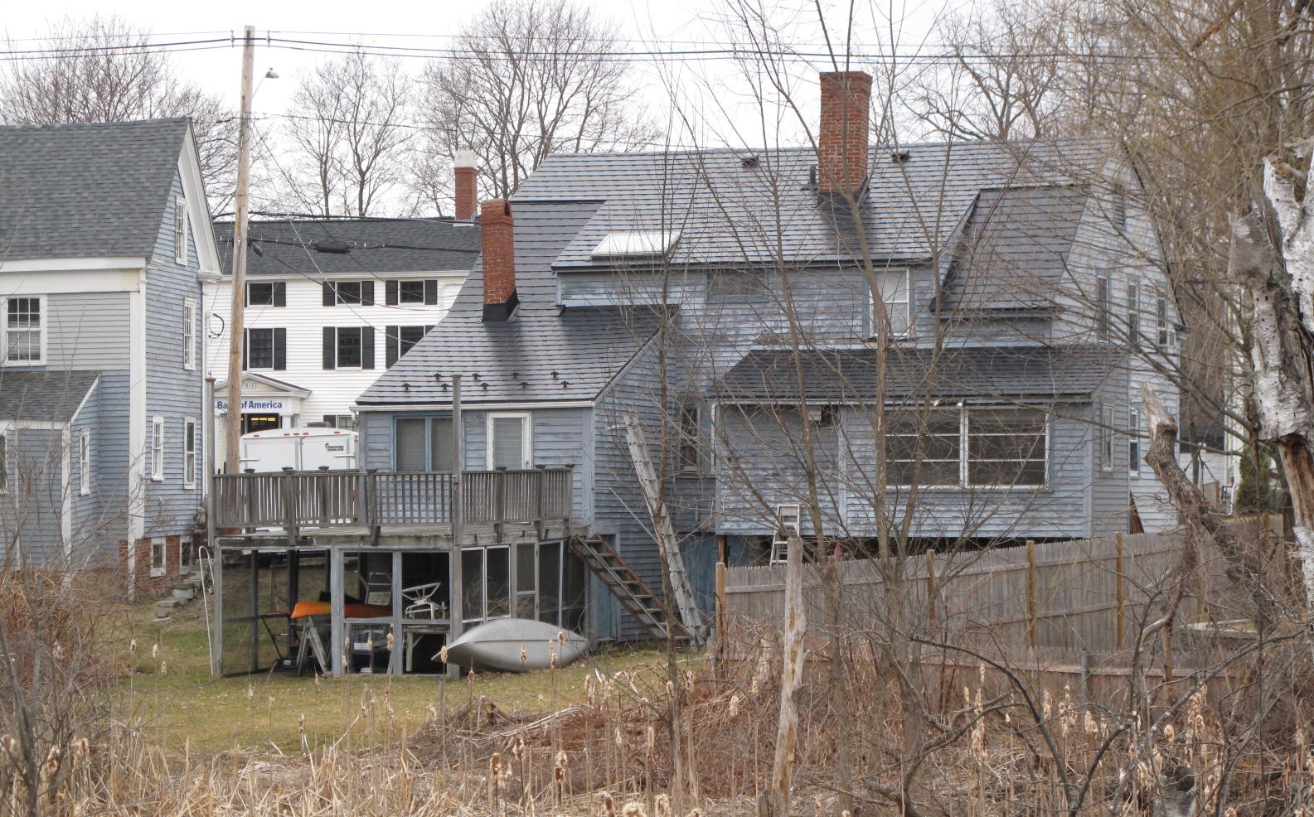

National Register of Historic Places Criteria Statement Form

Check all that apply:

Individually eligible Eligible only in a historic district

Contributing to a potential historic district Potential historic district

Criteria: A B C D

Criteria Considerations: A B C D E F G

Statement of Significance by________Neil Larson_________________________________
The criteria that are checked in the above sections must be justified here.

The Enoch & Elizabeth B. Dresser House is an early and distinctive example of early 19th-centuy domestic architecture in the town center. Alterations are such that it is not individually eligible for the National Register, but it is a contributing component of the village district.

Elizabeth Dresser, Rowley, administrator estate Enoch Dresser, to Elijah Dresser, joiner, 20 July 1825, SED 299:157.
David M. and Silena Winter; John B. and Mahala Pickett; Elijah C. and Eliza Dresser; Elbridge G. and Mary Dresser; Thomas N. and Elizabeth R. Dresser; Leonard P. and Ann Dresser, William O. and Deborah Dresser, to Mary Jane Sawins, Haverhill, 16 November 1864, SED 691:101-2; Mary Jane Sawins, Haverhill, to Augustus P. Holt, 12 September 1865, SED 691:102; Augustus P. Holt to Dennis Donohue, 8 September 1866, SED 710:71.
The 1917 passport application for Donoghue’s son Francis states that his father came to the United States from the port of Queenstown about 1855 and lived in Georgetown from that year to his death. See Ancestry.com.
James Crowley Donoghue shot himself to death “while temporarily insane” in February 1911 when he was living in Boston. See the Directory of Deceased American Physicians, 1804-1929.
In 1864 Donoghue acquired a triangular piece of land four rods square adjacent to his house from Charles Boynton (SED 721:78), and subsequent deeds transfer both parcels. See Denis D. Donoghue to Arda Hoyt Carey, Campton NH, 20 September 1910, SED 2164:273, Merton E. Roberts and Robert F. Metcalf, trustees will Edward M. Hoyt, to Florence C. Tuttle, 26 December 1945, SED 3436:388; Florence C. Tuttle to Frank L. and Lidie K. Johnson, Barrington NH, 1 October 1948, SED 3626:188; Frank L. and Lidie K. Johnson to Paul C. and Gretchen M. Wilmarth, 5 August 1952, SED 3914:94; Paul C. and Gretchen M. Wilmarth to Paul C. Wilmarth, 35 E Main, 15 September 1969, SED 5643:602; Paul C. Wilmarth, as trustee and individually, to Thomas P. and Karin S. Wilmarth, 41 East Main, 29 June 1994, SED 12641:247.

