FORM B − BUILDING

Massachusetts Historical Commission
Massachusetts Archives Building
220 Morrissey Boulevard
Boston, Massachusetts 02125

Photograph
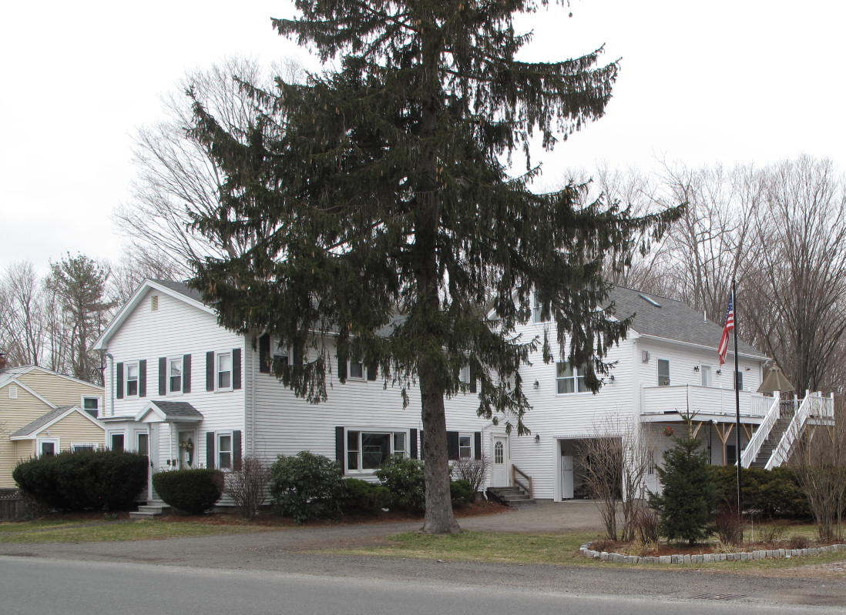
View from southeast

Locus Map (north at top)
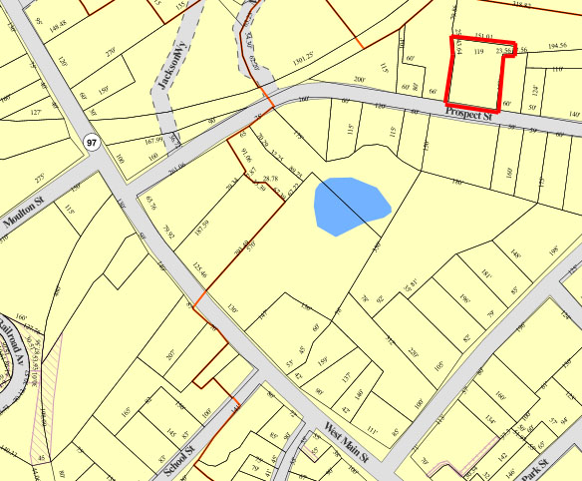

Recorded by: Kathryn Grover & Neil Larson
Organization: Town of Georgetown
Date: October 2012

Assessor’s Number USGS Quad Area(s) Form Number

11A-6 |  | Georgetown |  | C |  | GEO.180

Town/City: Georgetown
Place: (neighborhood or village):
Town Center

Address: 36 Prospect Street
Historic Name: Jerome B. & Laura A. Spofford House
Uses: Present: single residence
Original: single residence
Date of Construction: ca. 1880
Source: deeds
Style/Form: Classical Revival
Architect/Builder: unknown
Exterior Material:
Foundation: stone
Wall/Trim: vinyl clapboards
Roof: asphalt shingles
Outbuildings/Secondary Structures:
none
Major Alterations (with dates):
Additional bay added on E side, mid-20th C
2 sty annex added to rear, early 21st C
Vinyl siding added
Window sash replaced

Condition: good
Moved: no yes Date:
Acreage: 0.49 acre
Setting: This house is sited on the north side of Prospect Street on a lot with mature trees. The area is largely residential.

Recommended for listing in the National Register of Historic Places.
If checked, you must attach a completed National Register Criteria Statement form.

ARCHITECTURAL DESCRIPTION
The Jerome B. & Laura A. Spofford House is a two-story wood frame dwelling with a front gable roof located on the north side of Prospect Street west of Pond Street. Built ca. 1880, the house originated with a two-bay front façade and an interior plan with two principal rooms aligned front-to-back on the westerly side of the house and an entry and secondary room on the easterly side; a one-story rear ell contained the kitchen. The entrance and one-story bay window on the front façade are in their original locations, but there was a one-story porch on the east side that, in more recent years, was removed and replaced by a two-story addition that raised and extended the roof on that side. The kitchen wing was raised to two stories, probably at the same time, and fenestration on the side walls was altered with new windows added.

Until quite recently, a historic barn was sited directly behind the house, very close to the rear wall but not connected. That building has been removed and a new and much larger two-story annex erected and attached to the northeast corner of the house. Designed to resemble a traditional connected barn, the annex has a front gable façade with a single garage bay in the first story and dwelling space above, which is accessed by an exterior stair and deck on the east side of the building.

The house is positioned along the westerly boundary of the one-acre lot with large yards on the east side and rear. A paved parking area fills the space in the hollow of the L formed by the house and annex; an in-ground swimming pool is located just east of the annex. ,

The Jerome B. & Laura A. Spofford House, built ca. 1880, is an altered example of late-19th-century domestic architecture in Georgetown. Originating with a small plan characteristic of factory workers’ homes, it has been enlarged more recently to accommodate more contemporary living standards. In spite of these alterations, the historic appearance of the building still is discernible. As such, the property is a contributing component of the village district.

HISTORICAL NARRATIVE
In May 1872, Georgetown shoe manufacturer George Jewett Tenney sold to Edwin Brown lots “numbered sixteen and seventeen on a plan drawn by Nelson Spofford” on a “proposed street” that became Prospect Street. Tenney owned numerous lots in this area, and he sold several of them to house builders who constructed dwellings on the lots before Tenney deeded them the land. Brown was a Vermont-born custom bootmaker who already owned land in Georgetown, and it is he who had the house at 36 Prospect Street built; he paid $300 for the lot in 1872 and sold it and its house in April 1880 for $2000.

Brown sold the 36 Prospect Street property to Jerome Bonaparte Spofford, the son of Mighill and Mehitable Spofford of Rowley. Born in 1825, Spofford was working as a farmer in 1850 and boarding in Georgetown with the carpenter Edward Dole. On the last day of 1851 he married Laura L. Littlefield of Wells, Maine, and the couple had two daughters—Mary Frances, born in 1853, and Grace Mabel, born in 1868. In 1860 Spofford was working as a miller and his wife bound shoes; by 1870 the census and directory for the same year shows him as a farmer on Spofford’s Hill in Georgetown.

Jerome B. Spofford died in August 1880, only four months after having acquired 36 Prospect Street; his mother had died in January of the same year. The 1885 directory lists Laura Spofford and her daughter Grace, then a music teacher, at this house. By 1900 Grace Spofford had married and had probably already divorced William Lennon, about whom nothing is yet known; the couple had three children—Ruth Moody, born in 1892, and the twins Louis M. and Ralph P, born in 1894—who in 1900 lived with their grandmother Laura Spofford and her unmarried daughter Mary at 36 Prospect.

In 1903 Grace Spofford Lennon remarried, to Haverhill shoe worker William R. Twombley, and three years later her sister married New Hampshire-born widowed shoemaker George B. Miller. In 1911 Laura Littlefield Spofford died, and in 1920 the 36 Prospect Street household included Grace Twombley, her three children, all in their twenties and in the workforce (Ruth was a dry goods store bookkeeper, and Ralph and Louis were both heel cutters), and her married sister Mary F. Miller, then sixty-six. They also had the income of one boarder. In 1940 the household included only Grace Spofford Twombley, by then widowed, and her unmarried son Ralph, still working as a shoe shop heeler; his twin brother Louis had married Sylvia Boulanger in 1917 and lived at 31 Prospect Street.

Grace M. Spofford Twombley died in 1952, and by 1954 36 Prospect Street had been acquired by Shirley J. and Arlene Dalton Meisner. Born in 1926, Meisner was a machinist and later a “planningman” at General Electric Company in Lynn; in the early 1950s he and his wife had lived in Salem. His wife was a native of Springfield, Massachusetts, and worked as a bookkeeper. Arlene Meisner died in 1969 at the age of thirty-eight, and her husband and his second wife, Barbara, sold the property to Robert J. and Lisa J. Lessard and Raymond A. and Mary J. Lessard in 1990; Lisa J. Lessard, now Lisa J. Simmons, and her second husband Thomas E. Simmons are the current owners.

BIBLIOGRAPHY and/or REFERENCES
Arrington, Benjamin F., ed. Municipal History of Essex County in Massachusetts. NY: Lewis Historical Publishing Co., 1922.
Field, Jane. A Brief History of Georgetown Massachusetts 1838-1963. Rev. ed. 1988. Georgetown: Georgetown Historical Commission, 1988.
Gage, Thomas. The History of Rowley, Anciently Including Bradford, Boxford, and Georgetown, from the Year 1639 to the Present Time. Boston: F. Andrews, 1840.
Georgetown, Boxford, Byfield, Newbury, and West Newbury, Massachusetts, Directory. Boston: W. E. Shaw, 1901-2, 1905, 1909, 1912, 1914, 1916-17, 1918, 1925.
Hill, Edwin P. “History of Georgetown, Massachusetts.” In Standard History of Essex County, Massachusetts. Edited by Cyrus M. Tracey, William E. Graves, and Henry M. Batchelder. Boston: C. F. Jewett, 1878.
Hull, Forrest P. Georgetown: Story of One Hundred Years, 1838-1938. 1938. Reprint. Georgetown, MA: Georgetown Historical Commission, 2006.
Merrill, Samuel. A Merrill Memorial: An Account of the Descendants of Nathaniel Merrill, an Early Settler of Newbury, Massachusetts. Cambridge, MA, 1917-28.
Nelson, Henry M. “Town of Georgetown History.” In Hurd, D. Hamilton. History of Essex County, Massachusetts, with Biographical Sketches of Many of Its Pioneers and Prominent Men. Vol. 1. Philadelphia: J. W. Lewis and Co., 1888.
Sammarco, Anthony Mitchell, for Georgetown Historical Society. Images of America: Georgetown. Portsmouth, NH: Arcadia Publishing, 2002.

MAPS
“Map of the Centre of Georgetown in 1800.” In Perley, Sidney H., “Centre of Georgetown in the Year 1800.” The Essex Antiquarian: A Quarterly Magazine Devoted to the Biography, Genealogy, History, and Antiquities of Essex County, Massachusetts 2, 7 (July 1898): 201.
Map of Georgetown in 1810 and 1840. In Gage, Thomas. The History of Rowley, Anciently Including Bradford, Boxford, and Georgetown, from the Year 1639 to the Present Time. Boston: F. Andrews, 1840. 320.
“Map of New Rowley Surveyed and Drawn by Philander Anderson 1830.” Georgetown Historical Society.
Map of Georgetown. 1856. In Walling. H. F. A Topographical Map Essex County Massachusetts. Boston: Smith and Morley, 1856.
Atlas of Essex County, Massachusetts. Philadelphia: D. G. Beers and Co., 1872). Plates 59 and 61.
“Town of Georgetown Mass.” and “Village of Georgetown Mass.” In Atlas of Essex County, Massachusetts (Boston: George H. Walker, 1884).
“Georgetown, Mass. 1887.” Drawn and Published by George E. Norris, Brockton, Massachusetts. Troy, NY: Burleigh Lithographic Establishment, 1887.”

PHOTOGRAPHS (all photos by Neil Larson, 2012)

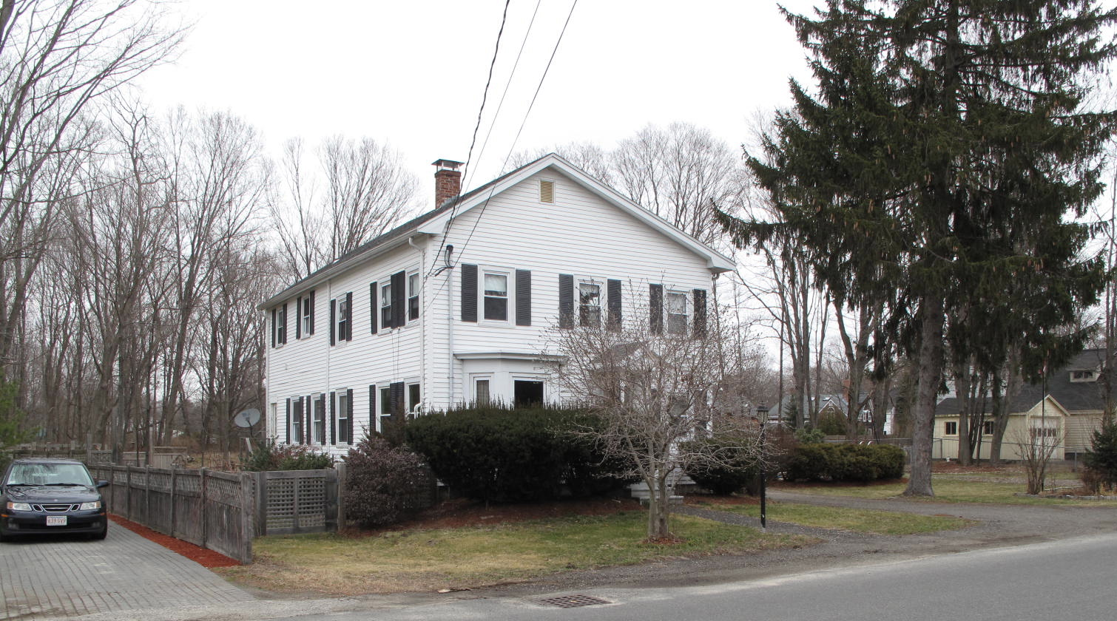
36 Prospect Street: views from SW (top) and SE (bottom)

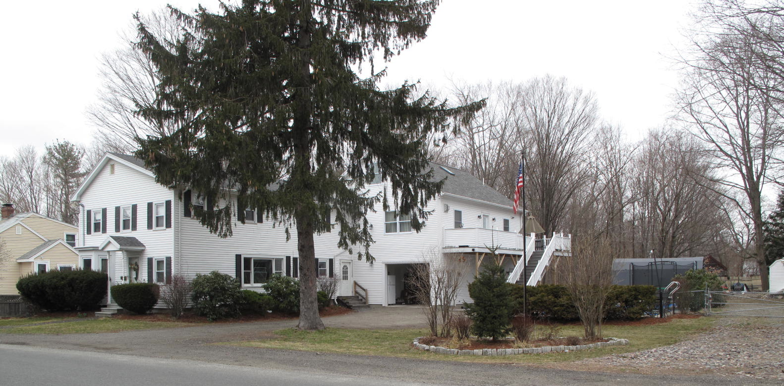

National Register of Historic Places Criteria Statement Form

Check all that apply:

Individually eligible Eligible only in a historic district

Contributing to a potential historic district Potential historic district

Criteria: A B C D

Criteria Considerations: A B C D E F G

Statement of Significance by________Neil Larson_________________________________
The criteria that are checked in the above sections must be justified here.

The Jerome B. & Laura A. Spofford House, built ca. 1880, is an altered example of late-19th-century domestic architecture in Georgetown. Originating with a small plan characteristic of factory workers’ homes, it has been enlarged more recently to accommodate more contemporary living standards. In spite of these alterations, the historic appearance of the building still is discernible. As such, the property is a contributing component of the village district.

George J. Tenney to Edwin Brown, 17 May 1872, SED 884:81; Edwin Brown to Jerome B. Spofford, 15 April 1880, SED 1036:56.
Baker Adams, executor will of Grace M. Twombley, to Doris A. Marston, 10 August 1953, SED 4000:56; Doris A. Marston to Leonard L. Foster, 14 November 1953, SED 4026:586; Leonard L. Foster, Groveland, to Shirley J. and Arlene D. Meisner, 28 October 1954, SED 4114:138; Shirley J. and Barbara P. Meisner to Robert J. and Lisa J. Lessard, 36 Prospect Street, and Raymond A. and Mary J. Lessard, 31 July 1990, SED 10518:216.

