FORM B − BUILDING

Massachusetts Historical Commission
Massachusetts Archives Building
220 Morrissey Boulevard
Boston, Massachusetts 02125

Photograph
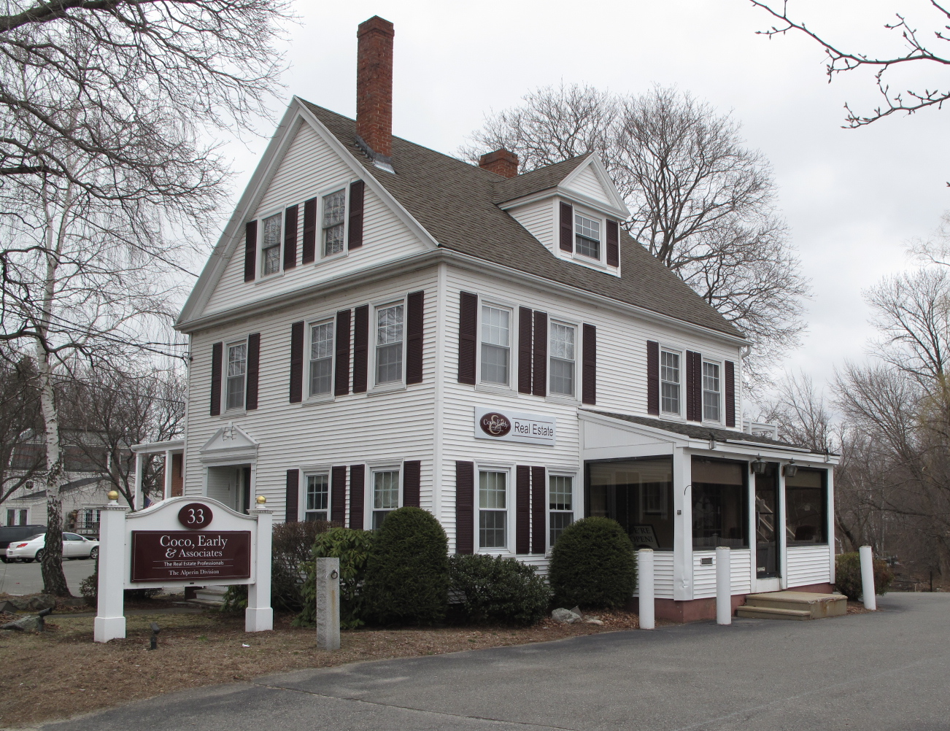
View from south

Locus Map (north at top)
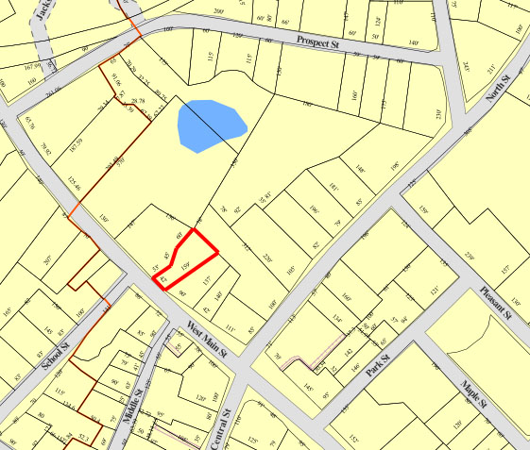

Recorded by: Kathryn Grover & Neil Larson
Organization: Town of Georgetown
Date: October 2012

Assessor’s Number USGS Quad Area(s) Form Number

11A-30 |  | Georgetown |  | C |  | GEO.194

Town/City: Georgetown
Place: (neighborhood or village):
Town Center

Address: 33 West Main Street
Historic Name: Tenney - Bailey House
Uses: Present: commercial
Original: single residence
Date of Construction: ca. 1820
Source: censuses, historic maps
Style/Form: Federal
Architect/Builder: unknown
Exterior Material:
Foundation: brick
Wall/Trim: vinyl clapboards
Roof: asphalt shingles
Outbuildings/Secondary Structures:
none
Major Alterations (with dates):

Front entrance replaced
Porch & dormer added southerly side
Exterior stairs added on rear
Vinyl siding added
Window sash replaced
Condition: good
Moved: no yes Date:
Acreage: 0.17 acre
Setting: This house is sited on the north side of „est Main Street on a lot with mature trees. The area is a mix of residential, commercial, and institutional uses.

Recommended for listing in the National Register of Historic Places.
If checked, you must attach a completed National Register Criteria Statement form.

ARCHITECTURAL DESCRIPTION
The Tenney – Bailey House is located on the northerly side of West Main Street nearly opposite its intersection with School Street. Built ca. 1820, the plan of the house has two principal rooms on the easterly side and an entry and a third room on the other side. The front façade has an entrance on the westerly side of the first story offset by two windows; three windows are unevenly spaced across the second story as they are aligned with the entrance and windows below. The entrance is recessed, but without the heavy trabeated architrave typical of Greek Revival style. A porch probably distinguished the entrance, but there is none now, and a Colonial Revival-style broken pediment has been added over the doorway. The gable is enclosed in a full pediment with a bed across the base. Although features are now concealed by added vinyl siding, the entablatures are less massive and more attenuated than those that were designed in the Greek Revival style later. Two attic windows are contained within the pediment. Windows are grouped in pairs on both stories on the easterly wall for front and back rooms; two windows are paired in the center of each story on the westerly wall. The location of the chimney off the ridge on the front wall, as well as the tight placement of large windows, suggest that hearths were placed on the wall between the front room and the entry. A second chimney is located off the ridge towards the rear of the house. A narrow, two-story rear ell is aligned with the westerly side of the house. It had an entrance and probably a porch in the hollow on the easterly side. This façade has been altered with the addition of more doorways on the second story and an exterior stair.

The house is sited in the northwest corner of an irregularly-shaped lot, the rest of which has been paved for parking.

The Tenney – Bailey House, built ca. 1820, is a distinctive example of Federal-style domestic architecture in Georgetown and is sufficiently intact to be a contributing property in the village district.

HISTORICAL NARRATIVE
The house at 33 West Main Street was built for David B. Tenney (1758-1830) soon after his marriage to Hannah T. Little in 1816 in Salem. When Tenney died in 1830 he left his widow and young family in the West Main Street residence. Their daughter, Eveline Matilda Tenney, married shoe cutter, Charles James Bailey, in 1839, and the newlyweds joined the 33 West Main Street household. The 1850 census enumerates two households at the address, one of them headed by Charles Bailey and the other by his wife’s brother, David B. Tenney. Hannah Little Tenney had passed away by this time. Charles and Eveline Bailey had two children—Frank P., born about 1842, and Rosa T., born about 1847. By the time the 1856 map of Georgetown was published, David B. Tenney had relocated to Haverhill and “C. Bailey” is associated with the property. The 1860 census shows Bailey in this household with his family and that of shoemaker Edward P. Wildes.

Charles Bailey remained in this house almost until he died, in August 1907. By 1906 he appears to have sold the property to Henrietta P. Chaplin of Georgetown, who sold it in October of that year to Fred Perkins Andrews. Andrews, born in Topsfield about 1871, was a store clerk and by 1907 a news dealer; he had been living in Georgetown since about 1905. In 1910 he married Mary Cleora Whitney of Gorham, Maine, and by 1912 Andrews was also running an insurance agency, either from this house or from 25 West Main Street. Andrews is shown at 33 West Main Street in the 1930 census with his wife Mary, son Bruce, then seventeen, daughter Bernice, then fourteen, and an elderly Danish-born widow boarder.

Fred P. Andrews died in 1933, and by 1940 his widow owned the insurance agency and his son Bruce was managing it; it was then at 33 West Main. In 1958 Mary Andrews deeded the property to her son Bruce, and in 1966 he sold it to Nancy Anne Gardner. The property changed hands fairly often in the 1970s and was acquired in part by Stephen D. Horne in July 1976. Horne’s son Stephen D. Horne is the current owner, and the building houses Coco, Early & Associates Real Estate.

BIBLIOGRAPHY and/or REFERENCES
Arrington, Benjamin F., ed. Municipal History of Essex County in Massachusetts. NY: Lewis Historical Publishing Co., 1922.
Field, Jane. A Brief History of Georgetown Massachusetts 1838-1963. Rev. ed. 1988. Georgetown: Georgetown Historical Commission, 1988.
Gage, Thomas. The History of Rowley, Anciently Including Bradford, Boxford, and Georgetown, from the Year 1639 to the Present Time. Boston: F. Andrews, 1840.
Georgetown, Boxford, Byfield, Newbury, and West Newbury, Massachusetts, Directory. Boston: W. E. Shaw, 1901-2, 1905, 1909, 1912, 1914, 1916-17, 1918, 1925.
Hill, Edwin P. “History of Georgetown, Massachusetts.” In Standard History of Essex County, Massachusetts. Edited by Cyrus M. Tracey, William E. Graves, and Henry M. Batchelder. Boston: C. F. Jewett, 1878.
Hull, Forrest P. Georgetown: Story of One Hundred Years, 1838-1938. 1938. Reprint. Georgetown, MA: Georgetown Historical Commission, 2006.
Merrill, Samuel. A Merrill Memorial: An Account of the Descendants of Nathaniel Merrill, an Early Settler of Newbury, Massachusetts. Cambridge, MA, 1917-28.
Nelson, Henry M. “Town of Georgetown History.” In Hurd, D. Hamilton. History of Essex County, Massachusetts, with Biographical Sketches of Many of Its Pioneers and Prominent Men. Vol. 1. Philadelphia: J. W. Lewis and Co., 1888.
Sammarco, Anthony Mitchell, for Georgetown Historical Society. Images of America: Georgetown. Portsmouth, NH: Arcadia Publishing, 2002.

MAPS
“Map of the Centre of Georgetown in 1800.” In Perley, Sidney H., “Centre of Georgetown in the Year 1800.” The Essex Antiquarian: A Quarterly Magazine Devoted to the Biography, Genealogy, History, and Antiquities of Essex County, Massachusetts 2, 7 (July 1898): 201.
Map of Georgetown in 1810 and 1840. In Gage, Thomas. The History of Rowley, Anciently Including Bradford, Boxford, and Georgetown, from the Year 1639 to the Present Time. Boston: F. Andrews, 1840. 320.
“Map of New Rowley Surveyed and Drawn by Philander Anderson 1830.” Georgetown Historical Society.
Map of Georgetown. 1856. In Walling. H. F. A Topographical Map Essex County Massachusetts. Boston: Smith and Morley, 1856.
Atlas of Essex County, Massachusetts. Philadelphia: D. G. Beers and Co., 1872). Plates 59 and 61.
“Town of Georgetown Mass.” and “Village of Georgetown Mass.” In Atlas of Essex County, Massachusetts (Boston: George H. Walker, 1884).
“Georgetown, Mass. 1887.” Drawn and Published by George E. Norris, Brockton, Massachusetts. Troy, NY: Burleigh Lithographic Establishment, 1887.”

PHOTOGRAPHS (all photos by Neil Larson, 2012)

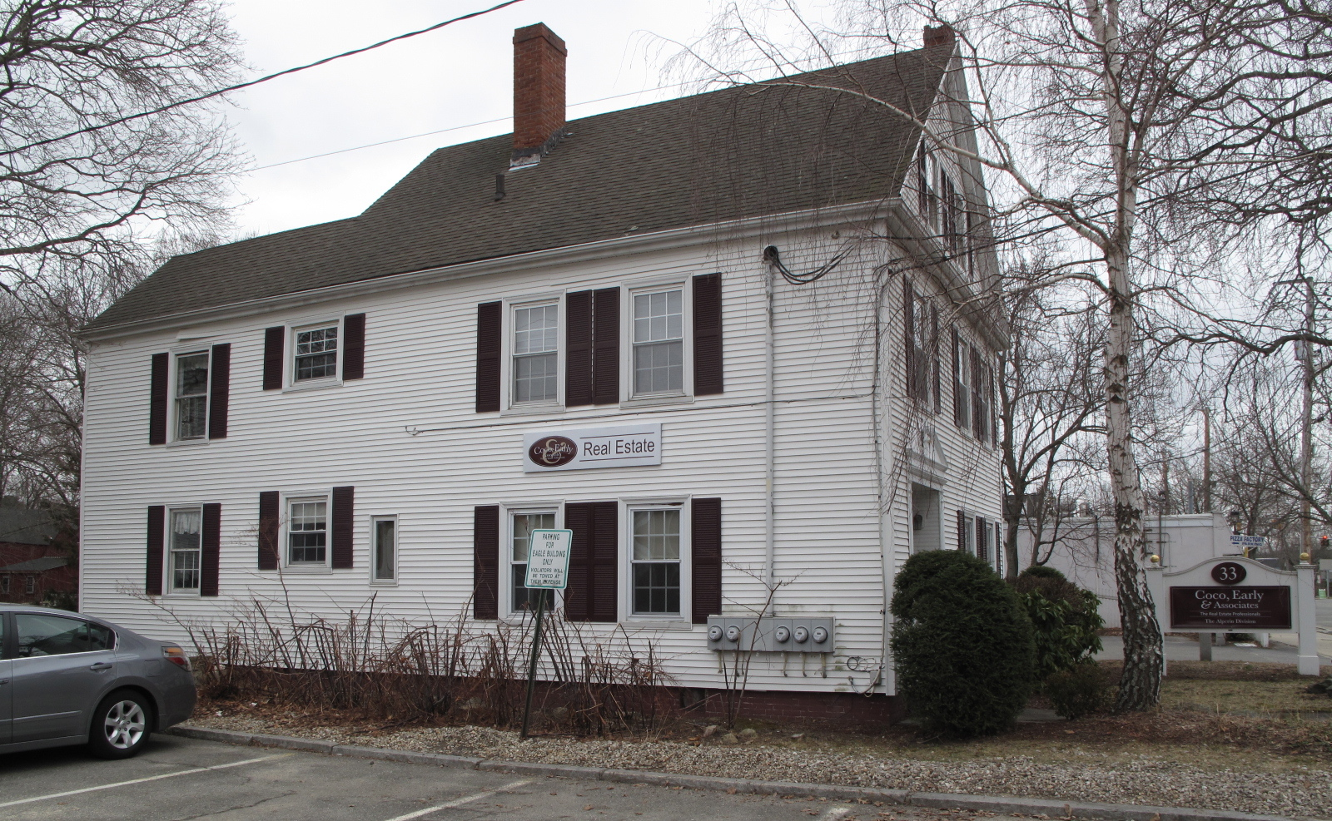
33 West Main Street: views from NW (top) and NE (bottom)

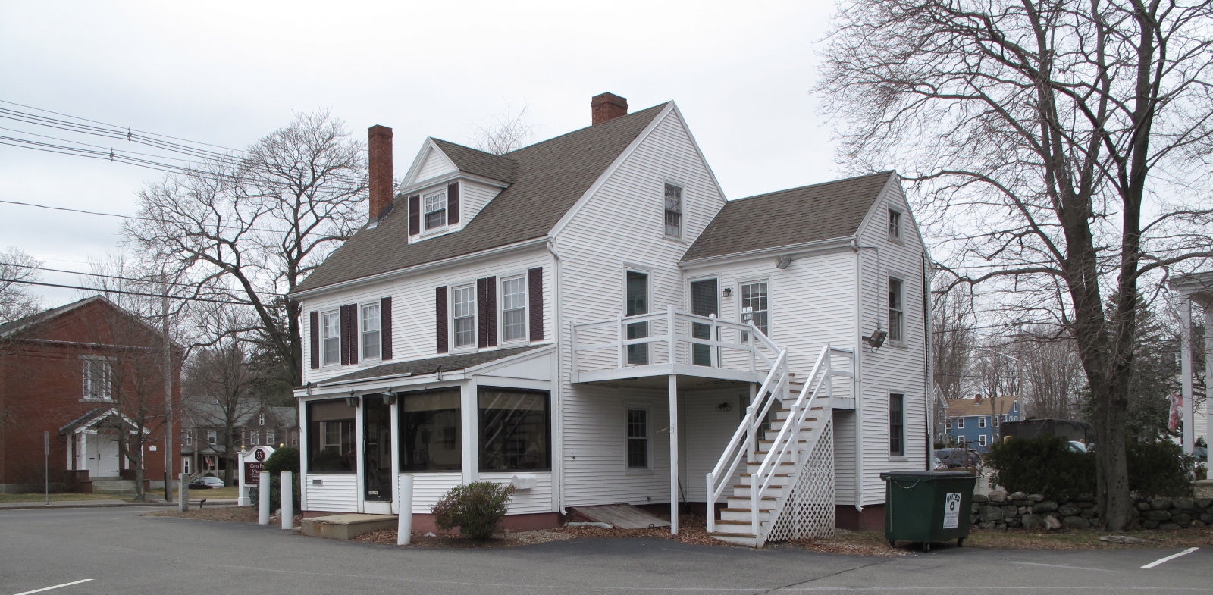

National Register of Historic Places Criteria Statement Form

Check all that apply:

Individually eligible Eligible only in a historic district

Contributing to a potential historic district Potential historic district

Criteria: A B C D

Criteria Considerations: A B C D E F G

Statement of Significance by________Neil Larson_________________________________
The criteria that are checked in the above sections must be justified here.

The Tenney – Bailey House, built ca. 1820, is a distinctive example of Federal-style domestic architecture in Georgetown and is sufficiently intact to be a contributing property in the village district.

Henrietta P. Chaplin to Fred P. Andrews, 26 October 1906, SED 1846:201. Charles Bailey survived three wives-Eveline Matilda Tenney, who died in 1863; Mary J. Hardy of Groveland, who died in 1872; and Rebecca S. Smith, an English émigré, who died in 1886.
Mary C. Andrews to Bruce G. Andrews, 1 October 1958, SED 4505:168; Bruce G. Andrews to Nancy Anne Gardner, 14 January 1966, SED 5333:535; Hellenic Credit Union, Peabody, to Paul L. Killam and Stephen D. Horne, 23 July 1976, SED 6262:527; Stephen D. Horne Jr., trustee Central Street Realty Trust, 85 Central Street, to Stephen D. Horne Jr. and Judith A. Horne, 85 Central, 23 July 1997, SED 14231:75.

