FORM B − BUILDING

Massachusetts Historical Commission
Massachusetts Archives Building
220 Morrissey Boulevard
Boston, Massachusetts 02125

Photograph
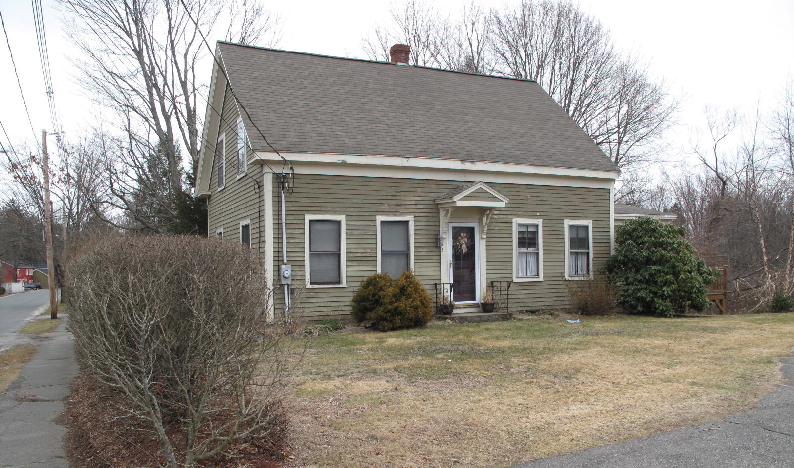
View from northwest

Locus Map (north at top)
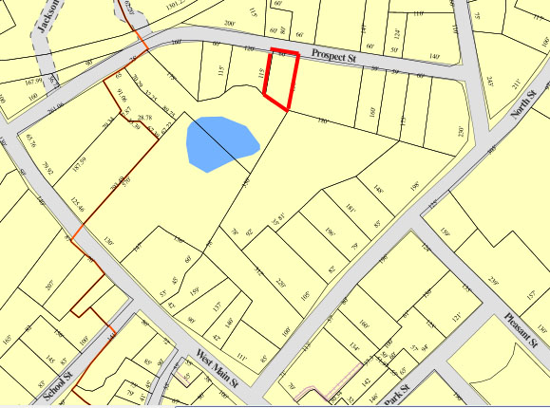

Recorded by: Kathryn Grover & Neil Larson
Organization: Town of Georgetown
Date: October 2012

Assessor’s Number USGS Quad Area(s) Form Number

11A-16 |  | Georgetown |  | C |  | GEO.179

Town/City: Georgetown
Place: (neighborhood or village):
Town Center

Address: 31 Prospect Street
Historic Name: Dennis C. & Sarah J. Hayes House
Uses: Present: single residence
Original: single residence
Date of Construction: ca. 1890
Source: deeds, censuses
Style/Form: Classical Revival
Architect/Builder: unknown
Exterior Material:
Foundation: stone
Wall/Trim: wood clapboards
Roof: asphalt shingles
Outbuildings/Secondary Structures:
none
Major Alterations (with dates):

Rear ell extended east, late 20th C
Window sash replaced
Condition: good
Moved: no yes Date:
Acreage: 0.13 acre
Setting: This house is sited on the south side of Prospect Street on a lot with mature trees. The area is largely residential.

Recommended for listing in the National Register of Historic Places.
If checked, you must attach a completed National Register Criteria Statement form.

ARCHITECTURAL DESCRIPTION
The Dennis C. & Sarah J. Hayes House is a story-and-a-half wood frame dwelling with a gable roof located on the southerly side of Prospect Street west of Pond Street. Built ca. 1890, the house has interior plan with a room-and-a-half deep with a center entry. The principal façade contains a center entrance with a pedimented hood supported by turned braces and flanked by two windows on each side. It is oriented to the west with a gable end containing windows facing the street. The design is similar to other front-gable houses with their entries on the side, such as the associated Poor House at 26 Prospect Street, but without the characteristic porch and cross-wing. The steep gable roof and fully-exposed, symmetrical five-bay façade create an old-fashioned appearance. The front façade is framed by narrow corner pilasters and a simplified Classical entablature along the roof edge, with short returns at the base of the raking gable roof edge. End walls have regular fenestration. Two gabled wall dormers on the east side of the house may be additions. A rear ell with a low-pitched gable roof is set back from the “front” façade in a typical manner, but the entrance is now on the opposite (east) side within an added enclosed porch. The ell may be a later addition or the subject of a later alteration that moved the entrance to the opposite (east) side where a driveway is located. (The front façade is so close to the west lot line that there is no room for a driveway on that side of the house.)

The property has small yards on the east and south sides of the house, the latter sloping down to a depression containing a wetland. The west side of the house faces the large lawn of the neighboring lot. A hedge screens the house from the street.

The Dennis C. & Sarah J. Hayes House, built ca. 1890, is an unusual example of factory worker housing built during the late-19th century in Georgetown. The house has a traditional story-and-a-half gable-roof form with a five-bay front façade with center entrance giving it an old-fashioned appearance; yet, its plan is similar to the many front-gable houses with entrances on side walls typical of the period. The building is a contributing component of the village district.

HISTORICAL NARRATIVE
The house at 31 Prospect Street appears to have been built on speculation by Georgetown grocer Prescott Poor, who also owned 26 Prospect Street, where his older brother Henry Bacon Poor lived. By the time Prescott Poor sold the property to Dennis C. Hayes in July 1893 for $950, a house stood on the lot. The 1900 census shows Hayes as owning the property and living there with his wife Sarah J. Murphy Hayes and their two sons, William F., born in 1882, and Edward Dennis, born in 1885.

Born in Georgetown in 1859, Dennis C. Hayes was the son of Irish immigrant shoemaker John Hayes and his wife Margaret McCormick Hayes. The couple was living in Georgetown by 1854, when their son Thomas was born, and by 1860 they were living in a three-family house in town with their children Ellen, John, Thomas, James, and Dennis C., as well as the Irish-born shoemaker James Nary, who boarded with them. John Hayes owned $900 in real property, and the family is shown on “Back Street” in the 1870 county directory, which probably is what became known as Chestnut Street, where the family lived in the 1880s.

In 1880 Dennis C. Hayes was working in the shoe industry and living in Georgetown when he married Sarah J. Murphy, a native of Lowell, Vermont then living in Georgetown. By 1900 Hayes was a shoe shop machinist. By 1910 the Prospect Street household included Hayes, his wife, and his son Edward, a shoe factory edge setter. Dennis Hayes died by July 1918, and at that time his sons William, who lived in Beverly, and Edward D., of Haverhill, conveyed the 31 Prospect Street property to their mother Sarah Murphy Hayes. She remained there until her own death in November 1934, and in September the next year her sons sold the property to Sylvia H. Lennon. Born Sylvia Boulanger in 1899 in Boxford, she had married Georgetown native Louis M. Lennon in 1917. Lennon, a leather sorter, was the son of William Lennon and probably Grace M. Spofford, who had lived at 36 Prospect Street at one time. In 1900 he was living at 36 Prospect with his grandmother Louisa S. Spofford, her single daughter Mary, and his siblings Ruth, born in 1892, and Ralph, his twin, born in February 1894. In the 1932 and 1957 directories, Louis and Shirley Lennon are shown as living at 16 Chestnut Street (in the latter year they rented 31 Prospect Street to Laurence W. Craig), but the 1940 census and 1940 directory locate them at 31 Prospect Street.

In 1974 Sylvia Lennon deeded 31 Prospect Street to herself and her daughter Sylvia Gloria Brow, who were both then living in the house. Lennon reserved to herself life tenancy. Sylvia Lennon died in March 1987, and in 1997 her daughter, then living in Summerfield, Florida, sold the house to current owner Patricia A. Sorenson of Salem.

BIBLIOGRAPHY and/or REFERENCES
Arrington, Benjamin F., ed. Municipal History of Essex County in Massachusetts. NY: Lewis Historical Publishing Co., 1922.
Field, Jane. A Brief History of Georgetown Massachusetts 1838-1963. Rev. ed. 1988. Georgetown: Georgetown Historical Commission, 1988.
Gage, Thomas. The History of Rowley, Anciently Including Bradford, Boxford, and Georgetown, from the Year 1639 to the Present Time. Boston: F. Andrews, 1840.
Georgetown, Boxford, Byfield, Newbury, and West Newbury, Massachusetts, Directory. Boston: W. E. Shaw, 1901-2, 1905, 1909, 1912, 1914, 1916-17, 1918, 1925.
Hill, Edwin P. “History of Georgetown, Massachusetts.” In Standard History of Essex County, Massachusetts. Edited by Cyrus M. Tracey, William E. Graves, and Henry M. Batchelder. Boston: C. F. Jewett, 1878.
Hull, Forrest P. Georgetown: Story of One Hundred Years, 1838-1938. 1938. Reprint. Georgetown, MA: Georgetown Historical Commission, 2006.
Merrill, Samuel. A Merrill Memorial: An Account of the Descendants of Nathaniel Merrill, an Early Settler of Newbury, Massachusetts. Cambridge, MA, 1917-28.
Nelson, Henry M. “Town of Georgetown History.” In Hurd, D. Hamilton. History of Essex County, Massachusetts, with Biographical Sketches of Many of Its Pioneers and Prominent Men. Vol. 1. Philadelphia: J. W. Lewis and Co., 1888.
Sammarco, Anthony Mitchell, for Georgetown Historical Society. Images of America: Georgetown. Portsmouth, NH: Arcadia Publishing, 2002.

MAPS
“Map of the Centre of Georgetown in 1800.” In Perley, Sidney H., “Centre of Georgetown in the Year 1800.” The Essex Antiquarian: A Quarterly Magazine Devoted to the Biography, Genealogy, History, and Antiquities of Essex County, Massachusetts 2, 7 (July 1898): 201.
Map of Georgetown in 1810 and 1840. In Gage, Thomas. The History of Rowley, Anciently Including Bradford, Boxford, and Georgetown, from the Year 1639 to the Present Time. Boston: F. Andrews, 1840. 320.
“Map of New Rowley Surveyed and Drawn by Philander Anderson 1830.” Georgetown Historical Society.
Map of Georgetown. 1856. In Walling. H. F. A Topographical Map Essex County Massachusetts. Boston: Smith and Morley, 1856.
Atlas of Essex County, Massachusetts. Philadelphia: D. G. Beers and Co., 1872). Plates 59 and 61.
“Town of Georgetown Mass.” and “Village of Georgetown Mass.” In Atlas of Essex County, Massachusetts (Boston: George H. Walker, 1884).
“Georgetown, Mass. 1887.” Drawn and Published by George E. Norris, Brockton, Massachusetts. Troy, NY: Burleigh Lithographic Establishment, 1887.”

PHOTOGRAPHS (all photos by Neil Larson, 2012)

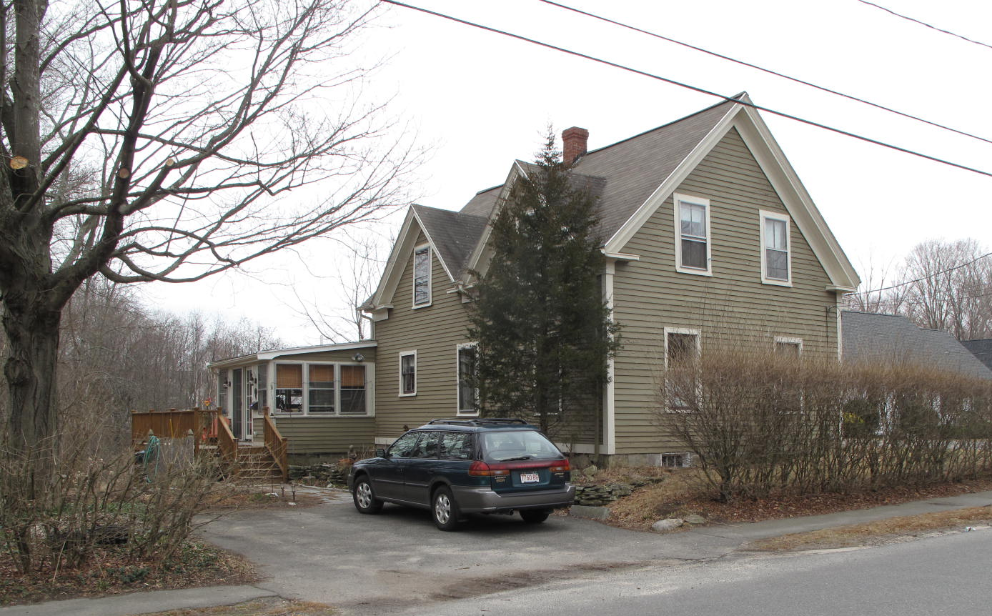
31 Prospect Street: view from NE (top) and SW (bottom)

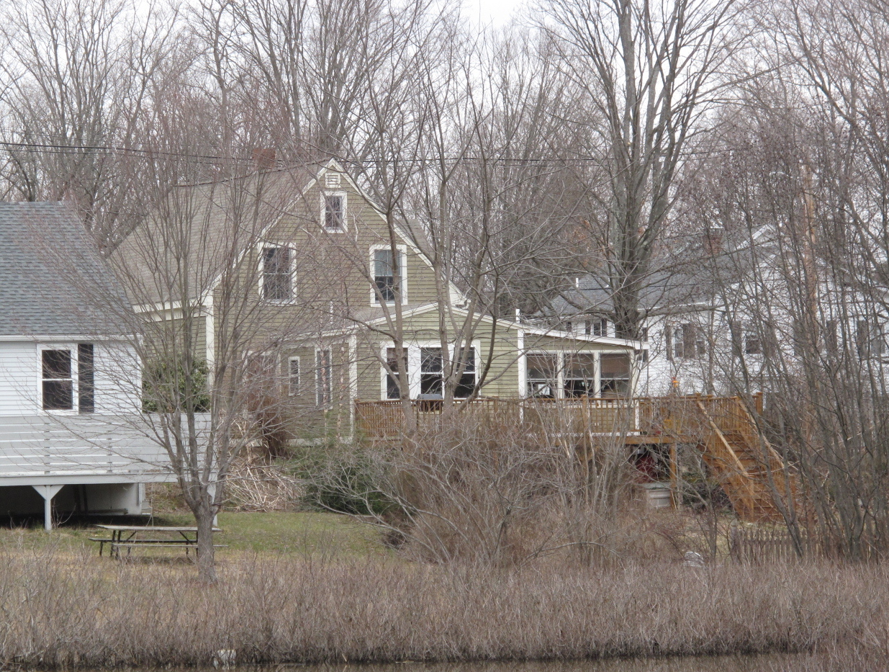

National Register of Historic Places Criteria Statement Form

Check all that apply:

Individually eligible Eligible only in a historic district

Contributing to a potential historic district Potential historic district

Criteria: A B C D

Criteria Considerations: A B C D E F G

Statement of Significance by________Neil Larson_________________________________
The criteria that are checked in the above sections must be justified here.

The Dennis C. & Sarah J. Hayes House, built ca. 1890, is an unusual example of factory worker housing built during the late-19th century in Georgetown. The house has a traditional story-and-a-half gable-roof form with a five-bay front façade with center entrance giving it an old-fashioned appearance; yet, its plan is similar to the many front-gable houses with entrances on side walls typical of the period. The building is a contributing component of the village district.

Prescott Poor to Dennis C. Hayes, 29 July 1893, SED 1384:522.
William F. Hayes, Beverly, and Edward D. Hayes, Haveerhill, to Sarah J. Hayes, Georgetown, 13 July 1918, SED 2396:425.
William F. Hayes, Beverly, and Edward D. Hayes, Haverhill, to Sylvia H. Lennon, 30 September 1935, SED 3211:521.
Sylvia H. Lennon to Sylvia H. Lennon and Sylvia Glory Brow, 5 November 1974, SED 6109:513; Sylvia Glory Brow, Summerfield FL, to Patricia A. Sorenson, Salem, 21 March 1997, SED 14070:492.

