FORM B − BUILDING

Massachusetts Historical Commission
Massachusetts Archives Building
220 Morrissey Boulevard
Boston, Massachusetts 02125

Photograph
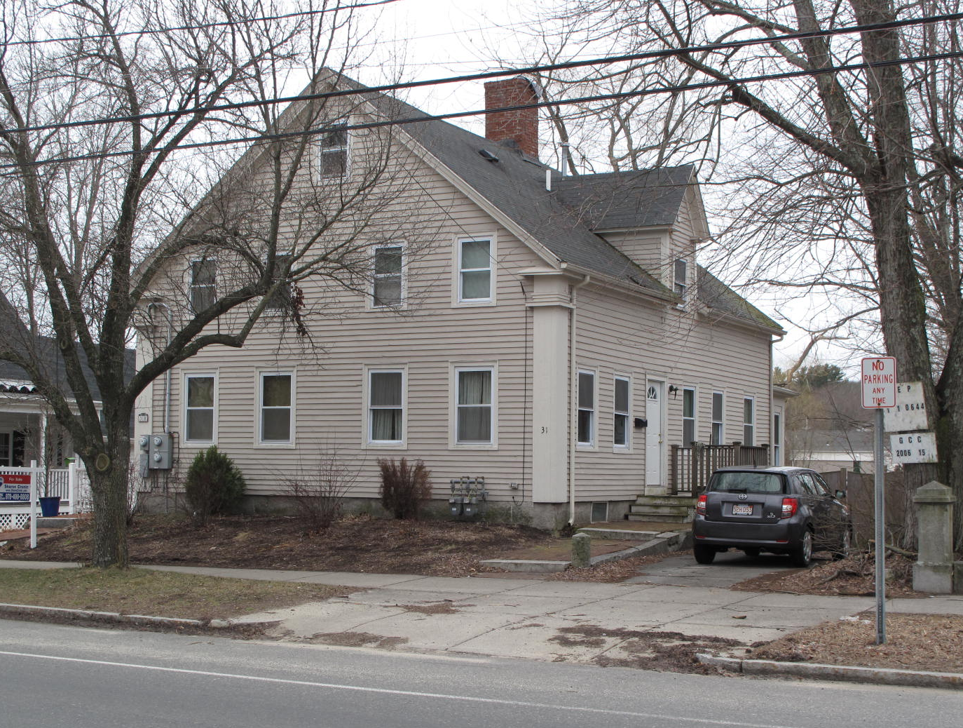
View from NW

Locus Map (north at top)
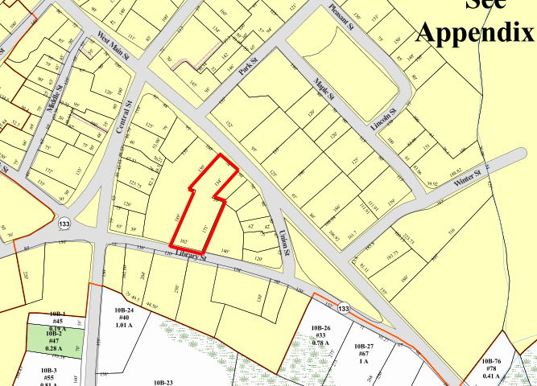

Recorded by: Kathryn Grover & Neil Larson
Organization: Town of Georgetown
Date: October 2012

Assessor’s Number USGS Quad Area(s) Form Number

11A-70 |  | Georgetown |  | C |  | GEO.137

Town/City: Georgetown
Place: (neighborhood or village):
Town Center

Address: 31 East Main Street
Historic Name: Perkins - Huntington House
Uses: Present: multiple residence (condominiums)
Original: double residence
Date of Construction: ca. 1845
Source: deeds, genealogy, visual analysis
Style/Form: Greek Revival
Architect/Builder: unknown
Exterior Material:
Foundation: brick
Wall/Trim: vinyl clapboards
Roof: asphalt shingles
Outbuildings/Secondary Structures:
None
Major Alterations (with dates):
Dormers added
Vinyl siding added
Doors and window sash replaced

Condition: good
Moved: no yes Date:
Acreage: approx. 0.85
Setting: This house is sited on the south side of East Main Street on a lot with mature trees just east of the town parking lot. The area combines residential, commercial, and institutional uses.

Recommended for listing in the National Register of Historic Places.
If checked, you must attach a completed National Register Criteria Statement form.

ARCHITECTURAL DESCRIPTION
The Perkins - Huntington House is a story-and-a-half wood frame double dwelling on the southerly side of East Main Street west of Union Street. With an end gable facing the street, separate entrances are on the side walls. The street-side gable end contains four windows on each of the two stories separated in the center into two groups of windows, two to a story, that indicates the internal central division of the two interior living units. A large chimney, roughly centered on the ridge of the roof was designed to service both living units. Entrances are located on the side walls flanked by two windows at the front and three at the rear. Wide pilasters on the front corners are all that are visible left to associate the building with the Greek revival style. Wall dormers interrupting the eaves are located above the entrances; they were added in the 20th century, probably for bathrooms. A one-story rear ell with a low-pitched appears to have been a later addition, but it also is divided internally for be shared by the two households. The house site slopes to the rear exposing most of the brick basement at grade, which probably is where the original kitchens were located.

The house is positioned at the northern, East Main Street end of a long lot that stretches back to library Street. The house is surrounded by lawn that, like the house, is divided in two sections by a stockade fence. There is a short driveway on the west side of the building. The southern part of the lot is wet and is covered with brushy natural plants.

The Perkins - Huntington House, built c. 1845, is a distinctive example of a double house with entrances on the sides, which was a common form for worker housing in the period. Often built as income-producing properties by wealthier local individuals, they also were a means for more middling homeowners to subsidize the costs of home construction and upkeep with rental income. Modestly altered, the building is a contributing component of the village district.

HISTORICAL NARRATIVE
The 1856 map of Georgetown ascribes the name “I. Perkins” to the house at 31 East Main Street. Born in Deerfield, New Hampshire, about 1810, Isaiah Perkins was a shoe cutter and was living in Georgetown by 1841, when he married Priscilla M. Hardy of Bradford. By July 1860 Isaiah Perkins had sold 31 East Main Street to the shoemaker Samuel Cutler Weston and moved to a house on North Street next to Henry Pettengill.

Born about 1828 in Rowley, Samuel C. Weston was the son of Salem mariner Cutler Weston and Eliza Masury Weston, who married in Rowley in 1824. Cutler Weston’s brothers Flint (born 1807) and Oren (born 1799 in Reading) were living and farming in Georgetown in 1850, and it may have been their presence that drew their nephew to the town, where he was recorded to be living by 1856, when he attended Boston Mercantile Academy. Samuel C. Weston married Julia Ann Stocker in Georgetown in August of 1857. The 1860 census shows Samuel Weston with $2,000 in real property and living in this neighborhood with his wife and their son Orin Stocker Weston, born in March of that year. He sold the lot and its building in July of the same year for only seven hundred dollars and moved to Salem, where he worked as a shoe stitcher and sewing machine dealer; by the early 1890s he and his son had moved to southern California.

Weston sold 31 East Main Street to shoemaker John Lewis Huntington (1825-1909), a native of Addison County, Vermont, who was living in Newbury by 1849 (his mother Mary Poor Huntington’s native town) when he married Elizabeth A. Bailey, the daughter of Joseph L. and Myra (or Almira) Danforth Bailey of Newbury. Huntington is shown with his wife in the 1850 Georgetown census owning $600 in property; the 1860 census shows them with $1500 in property, probably the same house in a different part of town. By then the couple had had a daughter, Myra Ellen, in 1853, and Elizabeth Bailey’s brother Joseph Edmond Bailey lived with the family and clerked in a store. In 1866 Joseph Bailey sold his son-in-law a 20-rod lot with its buildings adjacent to the parcel Huntington had sold him in 1860, and in 1888 George J. Tenney, who lived at 30 East Main, sold Elizabeth Bailey Huntington a larger tract bordering Library Street. The lot by then ranged, as it does now, from East Main to Library Streets. The 1872 village map marks the 31 East Main Street “Hunterdon; the 1884 map attributes the property to him with the correct surname spelling. The 1880 census shows Huntington as a shoe treer and the couple’s daughter Myra, then twenty-seven, as a jewelry store clerk.

Elizabeth Bailey Huntington died in 1896, and her widower and daughter lived in the house together. In 1908, the year before he died at the age of eighty-three, John Huntington deeded the three parcels to Elmer S. Bailey, his brother-in-law Joseph Edmond Bailey’s son. Elmer Bailey rented the property for more than two decades. In 1910 the census suggests that Myra Huntington still lived in the house; another part of it was rented to shoe finisher Fred Robinson, his wife, and their two young children. Myra Huntington is not listed in Georgetown directories, and she died a patient of the Cambridge Holy Ghost Hospital for Incurables in 1920.

In 1932 Elmer Bailey rented 31 East Main Street to the widow Mary J. Smith, whose husband George died between 1920 and 1930. Two years later Bailey defaulted on a mortgage he had taken out with Institution for Savings in Newburyport in 1926, and on 1 November 1934 the bank sold the property to Mary R. B. Palardy, who was born about 1913 and had lived in Georgetown with her father, Quebecois immigrant shoe worker and farmer Thomas Palardy, and his wife since at least the mid-1920s. Palardy owned the property until May 1950, when she sold it to Joseph Armand and Phyllis A. Soucy, who owned and occupied it until their deaths, in 1994 and 1998 respectively. Born in 1922, Joseph Soucy was the son of factory foreman and farmer Antoine Joseph Soucy and his wife Zelie Desrosier Soucy, who lived on Parsonage Road in Georgetown since at least 1930. Antoine Soucy worked for Charles S. Marston Company, which manufactured shoe skates on Park Street, during the Second World War. Joseph A. Soucy was a shoeworker at the time of his first marriage in 1941 to Norma Powers Sanborn of Byfield; he was a cutting room foreman at a shoe shop in Haverhill in 1957 when his second marriage, to Phyllis Swap Soucy, took place. In 2006, eight years after Phyllis Soucy’s death, the administrator of her estate sold 31 East Main Street to Home Prep LLC, which converted the house into two condominiums. The property is now owned by Julie A. Stanton and Sarah L. Leavitt.

BIBLIOGRAPHY and/or REFERENCES
Arrington, Benjamin F., ed. Municipal History of Essex County in Massachusetts. NY: Lewis Historical Publishing Co., 1922.
Field, Jane. A Brief History of Georgetown Massachusetts 1838-1963. Rev. ed. 1988. Georgetown: Georgetown Historical Commission, 1988.
Gage, Thomas. The History of Rowley, Anciently Including Bradford, Boxford, and Georgetown, from the Year 1639 to the Present Time. Boston: F. Andrews, 1840.
Georgetown, Boxford, Byfield, Newbury, and West Newbury, Massachusetts, Directory. Boston: W. E. Shaw, 1901-2, 1905, 1909, 1912, 1914, 1916-17, 1918, 1925.
Hill, Edwin P. “History of Georgetown, Massachusetts.” In Standard History of Essex County, Massachusetts. Edited by Cyrus M. Tracey, William E. Graves, and Henry M. Batchelder. Boston: C. F. Jewett, 1878.
Hull, Forrest P. Georgetown: Story of One Hundred Years, 1838-1938. 1938. Reprint. Georgetown, MA: Georgetown Historical Commission, 2006.
Merrill, Samuel. A Merrill Memorial: An Account of the Descendants of Nathaniel Merrill, an Early Settler of Newbury, Massachusetts. Cambridge, MA, 1917-28.
Nelson, Henry M. “Town of Georgetown History.” In Hurd, D. Hamilton. History of Essex County, Massachusetts, with Biographical Sketches of Many of Its Pioneers and Prominent Men. Vol. 1. Philadelphia: J. W. Lewis and Co., 1888.
Sammarco, Anthony Mitchell, for Georgetown Historical Society. Images of America: Georgetown. Portsmouth, NH: Arcadia Publishing, 2002.

MAPS
“Map of the Centre of Georgetown in 1800.” In Perley, Sidney H., “Centre of Georgetown in the Year 1800.” The Essex Antiquarian: A Quarterly Magazine Devoted to the Biography, Genealogy, History, and Antiquities of Essex County, Massachusetts 2, 7 (July 1898): 201.
Map of Georgetown in 1810 and 1840. In Gage, Thomas. The History of Rowley, Anciently Including Bradford, Boxford, and Georgetown, from the Year 1639 to the Present Time. Boston: F. Andrews, 1840. 320.
“Map of New Rowley Surveyed and Drawn by Philander Anderson 1830.” Georgetown Historical Society.
Map of Georgetown. 1856. In Walling. H. F. A Topographical Map Essex County Massachusetts. Boston: Smith and Morley, 1856.
Atlas of Essex County, Massachusetts. Philadelphia: D. G. Beers and Co., 1872). Plates 59 and 61.
“Town of Georgetown Mass.” and “Village of Georgetown Mass.” In Atlas of Essex County, Massachusetts (Boston: George H. Walker, 1884).
“Georgetown, Mass. 1887.” Drawn and Published by George E. Norris, Brockton, Massachusetts. Troy, NY: Burleigh Lithographic Establishment, 1887.”

PHOTOGRAPHS (all photos by Neil Larson, 2012)

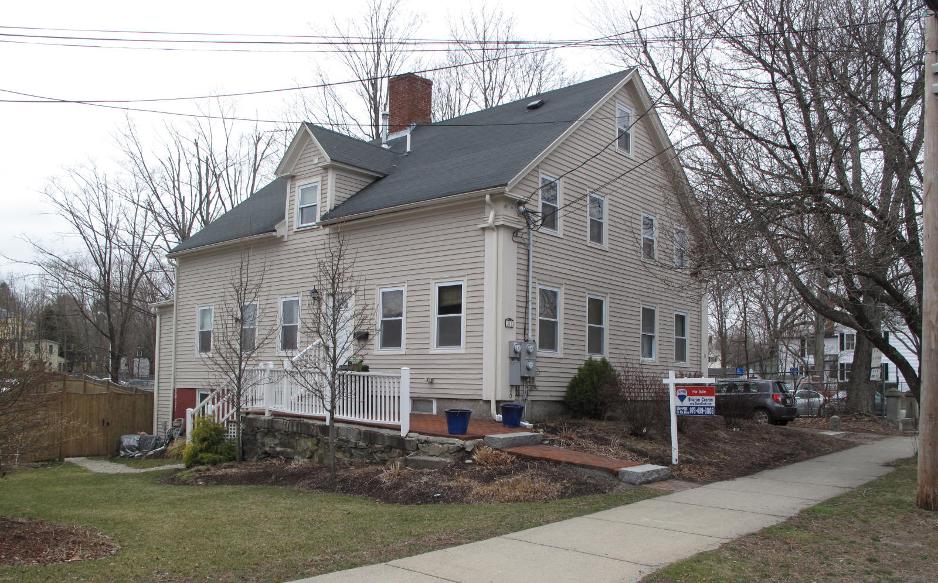
31 East Main Street: view from NE (top) and S (bottom)

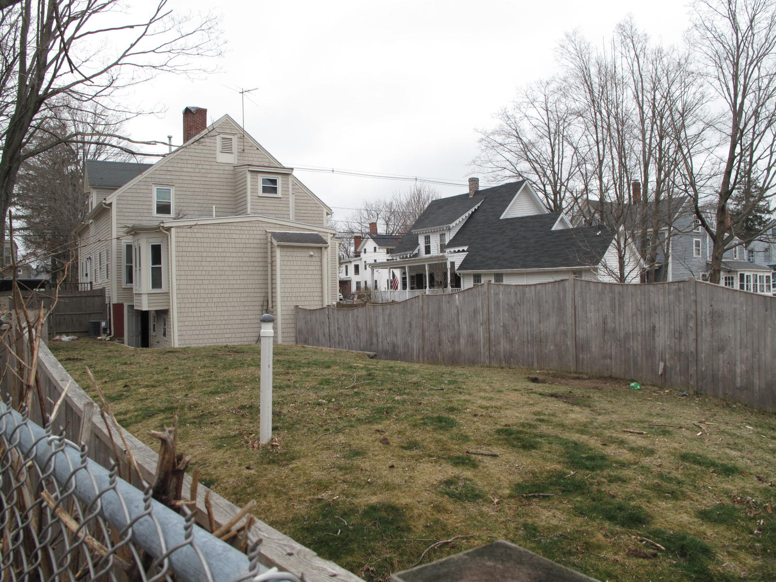

National Register of Historic Places Criteria Statement Form

Check all that apply:

Individually eligible Eligible only in a historic district

Contributing to a potential historic district Potential historic district

Criteria: A B C D

Criteria Considerations: A B C D E F G

Statement of Significance by________Neil Larson_________________________________
The criteria that are checked in the above sections must be justified here.

The Perkins - Huntington House, built c. 1845, is a distinctive example of a double house with entrances on the sides, which was a common form for worker housing in the period. Often built as income-producing properties by wealthier local individuals, they also were a means for more middling homeowners to subsidize the costs of home construction and upkeep with rental income. Modestly altered, the building is a contributing component of the village district.

Priscilla Perkins was identified as the daughter of Jonathan and Susan Carleton Kimball of Bradford in her 1899 death record and as Priscilla M. Hardy in her 1841 marriage record.
Samuel C. Weston, gentleman, to John L. Huntington, 6 July 1860, SED 609:207.
Joseph E. Bailey to John L. Huntington, 19 January 1866, SED 696:114; George J. Tenney to Elisabeth A. Huntington, 8 May 1888, SED 1227:373.
John L. Huntington to Elmer S. Bailey, 11 September 1908, SED 1933:139. See “Huntington Estate Georgetown, Mass. Survyed for E. S. Bailey, Esq.,” 1908, SEP 1933:1.

