FORM B − BUILDING

Massachusetts Historical Commission
Massachusetts Archives Building
220 Morrissey Boulevard
Boston, Massachusetts 02125

Photograph
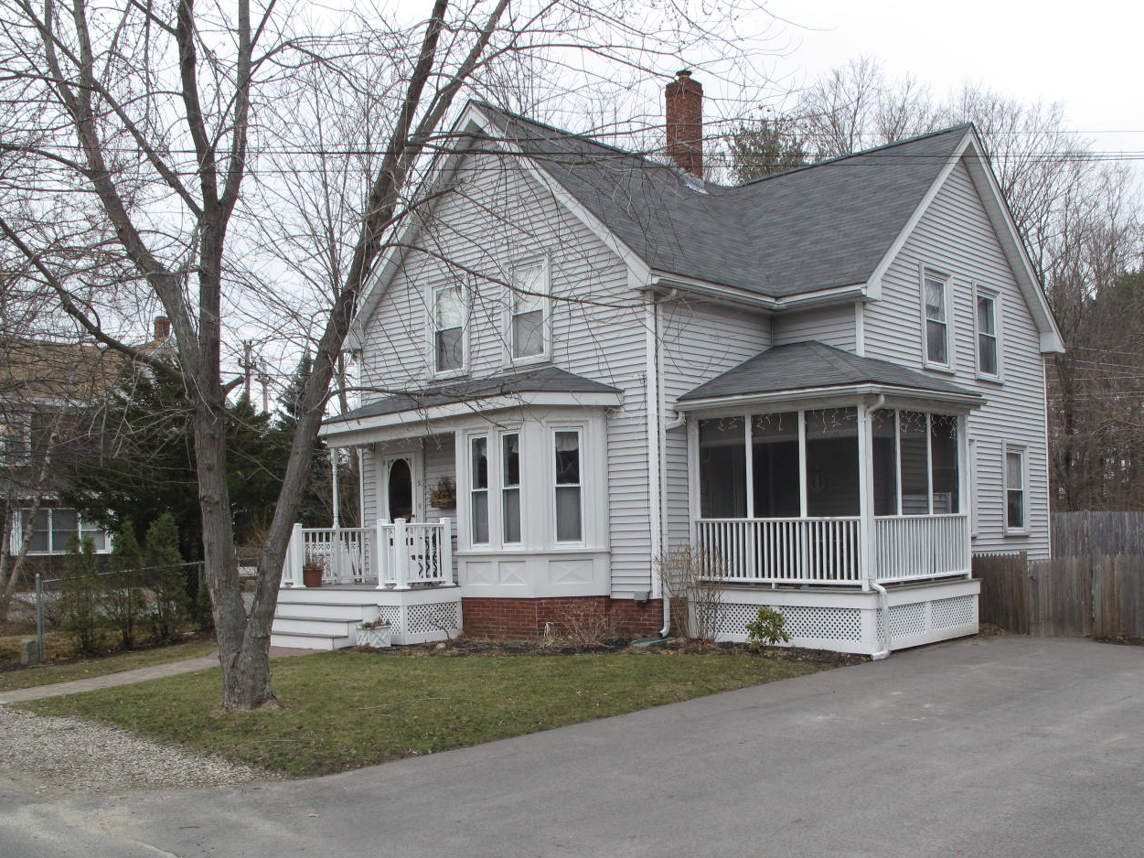
View from southeast

Locus Map (north at top)
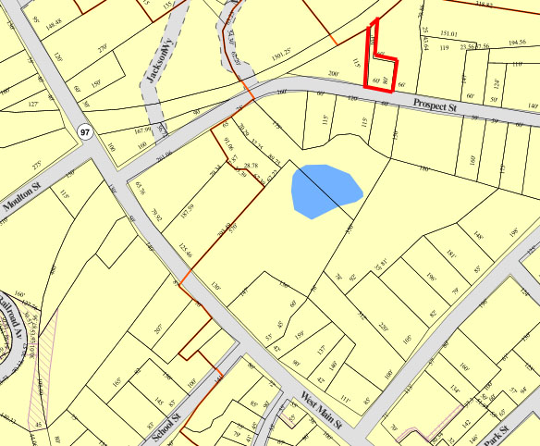

Recorded by: Kathryn Grover & Neil Larson
Organization: Town of Georgetown
Date: October 2012

Assessor’s Number USGS Quad Area(s) Form Number

11A-8 |  | Georgetown |  | C |  | GEO.178

Town/City: Georgetown
Place: (neighborhood or village):
Town Center

Address: 30 Prospect Street
Historic Name: George B. & Ann Poor House
Uses: Present: single residence
Original: single residence
Date of Construction: ca. 1880
Source: censuses
Style/Form: Gothic Revival
Architect/Builder: George B. Poor, probable builder
Exterior Material:
Foundation: brick
Wall/Trim: vinyl clapboards
Roof: asphalt shingles
Outbuildings/Secondary Structures:
none
Major Alterations (with dates):
porches reconstructed
vinyl clapboards added
window sash replaced

Condition: good
Moved: no yes Date:
Acreage: 0.14 acre
Setting: This house is sited on the north side of Prospect Street in a largely residential neighborhood.

Recommended for listing in the National Register of Historic Places.
If checked, you must attach a completed National Register Criteria Statement form.

ARCHITECTURAL DESCRIPTION
The George B. & Ann Poor House is a story-and-a-half wood frame dwelling located on the north side of Prospect Street west of Pond Street. The front-gable facade contains an entrance with a porch and a one-story bay window with beveled sides covered by a single hipped roof. The porch has been enlarged by a front extension with a balustrade. Two windows are evenly spaced across the upper story. The roof creates deep eaves over the walls with entablatures without returns; any surviving decoration has been concealed under vinyl siding. The plan of the house includes a short cross-wing on the east side; a second porch fills the corner space formed by the wing, which is an original feature pictured in the 1887 birdseye view of the village. A gable wall dormer is located in the roof on the west side of the house, and a one-story ell is attached to the rear.

The house is sited along the west line of the small rectangular lot set back behind a small front yard. Most of the yard on the east side has been paved for parking; the rear yard has a narrow tail that extends along the west property line back to the railroad right-of-way.

The George B. & Ann Poor House is a distinctive example of late-19th-century middle-class domestic architecture in the village. It is designed in a picturesque manner that is still evident in spite of altered porches and added vinyl siding and windows. Built ca. 1880, the house is a contributing component of the village district.

HISTORICAL NARRATIVE
Judging by the enumeration order of the 1880 census, the house long occupied by the family of carpenter and builder George Bacon Poor was probably standing by 1880. The deed in which Georgetown shoe manufacturer George Jewett Tenney transferred the lot on which the house stands was not executed until 1891, and it may be that Tenney had agreed to sell the lot if Poor built a house on it. Such may have been the case with 23 Prospect as well, which Tenney sold to carpenter and builder Chauncey Noyes after the house was built for $50, the same price Poor paid for his lot.

The deed for the 30 Prospect Street lot was between Tenney and Prescott Poor, the younger brother of Henry B. Poor and both sons of Edward and Maria Poor. Born in 1831, Henry B. Poor was living on his father’s Georgetown farm and working as a shoemaker in 1850, when he was eighteen. By 1863 he had married an English immigrant whose first name was Ann; no marriage record has been found for the two in Massachusetts. In that year Poor was working as a laborer and living in Lawrence. By 1870 he is shown as an engineer at the House of Corrections in Lawrence; while both he and his wife had substantial personal property, neither owned real estate. Their son George was born in 1869, but no birth record has been located for him.

The 1884 map of Georgetown attaches the name “G. Poor” to the 30 Prospect Street house, and the 1885 directory shows Poor as a carpenter and builder. The 1900 census shows him and his wife in the household with a son Charles, born in 1872. By 1910 Charles was no longer in the household, and by 1920 Poor’s sister-in-law Frances E. Southward was living with the couple in this house.

George Bacon Poor died in 1922, and in December 1923 Henry Prescott Poor, the son of Prescott Poor, sold 30 Prospect Street to Alice J. Smith, who in turn sold six months later to Clara E. Belyea Olmstead. Olmstead had emigrated from Canada in 1903 and was the wife of Ernest M. Olmstead, a traveling salesman for a salt company who emigrated from New Brunswick. The Olmsteads owned and occupied 30 Prospect Street until 1948, when Ernest Olmstead died in March, and in July his widow sold the house to Edward J. and Bessie M. Bertaux of Lynn. In 1958 Raymond Leslie and Ruth F. Bateman acquired the property. Born in 1912, Bateman was the son of Georgetown nurseryman Boyd Bateman and his wife Alice. The Bateman family sold the house to current owners Robert S. and Juanita Bornholdt in 1998.

BIBLIOGRAPHY and/or REFERENCES
Arrington, Benjamin F., ed. Municipal History of Essex County in Massachusetts. NY: Lewis Historical Publishing Co., 1922.
Field, Jane. A Brief History of Georgetown Massachusetts 1838-1963. Rev. ed. 1988. Georgetown: Georgetown Historical Commission, 1988.
Gage, Thomas. The History of Rowley, Anciently Including Bradford, Boxford, and Georgetown, from the Year 1639 to the Present Time. Boston: F. Andrews, 1840.
Georgetown, Boxford, Byfield, Newbury, and West Newbury, Massachusetts, Directory. Boston: W. E. Shaw, 1901-2, 1905, 1909, 1912, 1914, 1916-17, 1918, 1925.
Hill, Edwin P. “History of Georgetown, Massachusetts.” In Standard History of Essex County, Massachusetts. Edited by Cyrus M. Tracey, William E. Graves, and Henry M. Batchelder. Boston: C. F. Jewett, 1878.
Hull, Forrest P. Georgetown: Story of One Hundred Years, 1838-1938. 1938. Reprint. Georgetown, MA: Georgetown Historical Commission, 2006.
Merrill, Samuel. A Merrill Memorial: An Account of the Descendants of Nathaniel Merrill, an Early Settler of Newbury, Massachusetts. Cambridge, MA, 1917-28.
Nelson, Henry M. “Town of Georgetown History.” In Hurd, D. Hamilton. History of Essex County, Massachusetts, with Biographical Sketches of Many of Its Pioneers and Prominent Men. Vol. 1. Philadelphia: J. W. Lewis and Co., 1888.
Sammarco, Anthony Mitchell, for Georgetown Historical Society. Images of America: Georgetown. Portsmouth, NH: Arcadia Publishing, 2002.

MAPS
“Map of the Centre of Georgetown in 1800.” In Perley, Sidney H., “Centre of Georgetown in the Year 1800.” The Essex Antiquarian: A Quarterly Magazine Devoted to the Biography, Genealogy, History, and Antiquities of Essex County, Massachusetts 2, 7 (July 1898): 201.
Map of Georgetown in 1810 and 1840. In Gage, Thomas. The History of Rowley, Anciently Including Bradford, Boxford, and Georgetown, from the Year 1639 to the Present Time. Boston: F. Andrews, 1840. 320.
“Map of New Rowley Surveyed and Drawn by Philander Anderson 1830.” Georgetown Historical Society.
Map of Georgetown. 1856. In Walling. H. F. A Topographical Map Essex County Massachusetts. Boston: Smith and Morley, 1856.
Atlas of Essex County, Massachusetts. Philadelphia: D. G. Beers and Co., 1872). Plates 59 and 61.
“Town of Georgetown Mass.” and “Village of Georgetown Mass.” In Atlas of Essex County, Massachusetts (Boston: George H. Walker, 1884).
“Georgetown, Mass. 1887.” Drawn and Published by George E. Norris, Brockton, Massachusetts. Troy, NY: Burleigh Lithographic Establishment, 1887.”

PHOTOGRAPHS (all photos by Neil Larson, 2012)

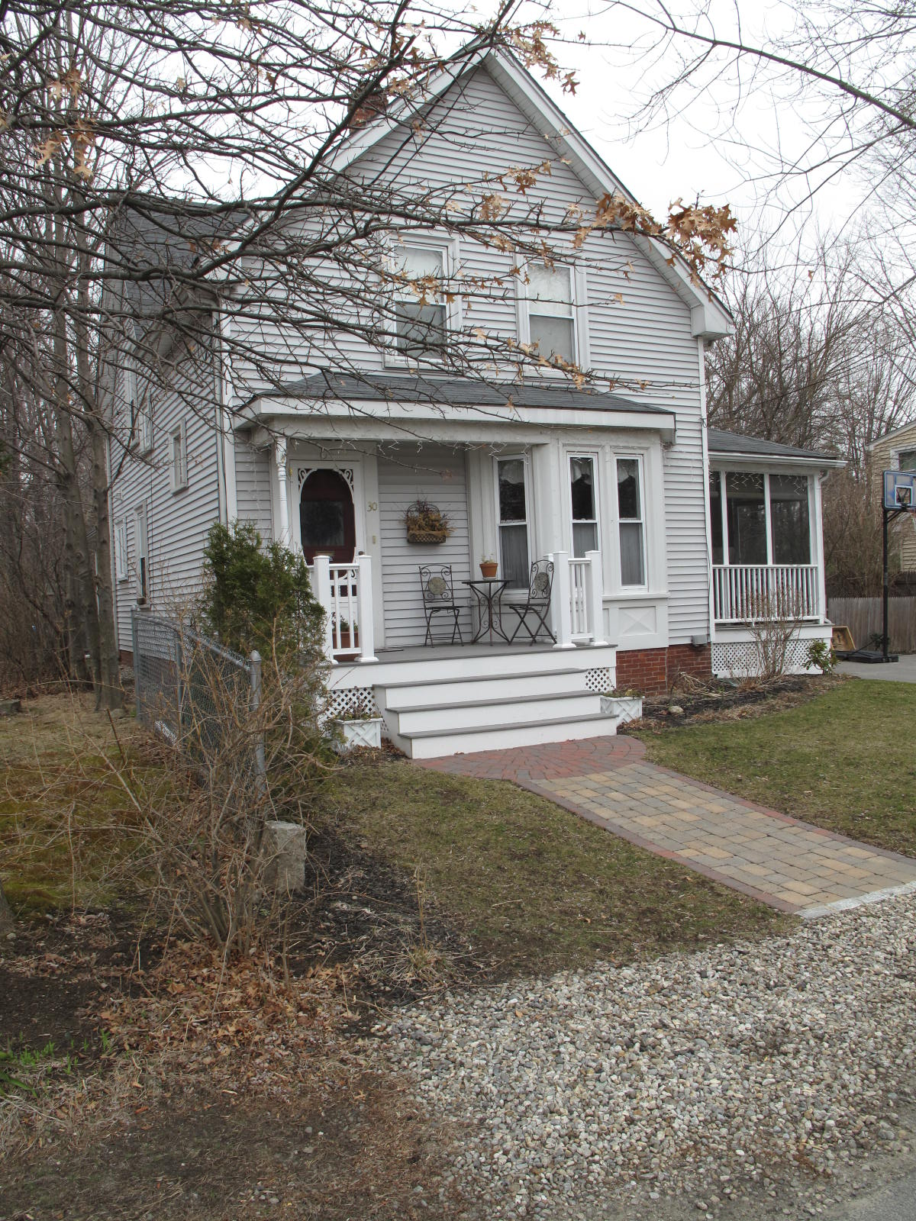
30 Prospect Street: view from SE (top) and W (bottom)

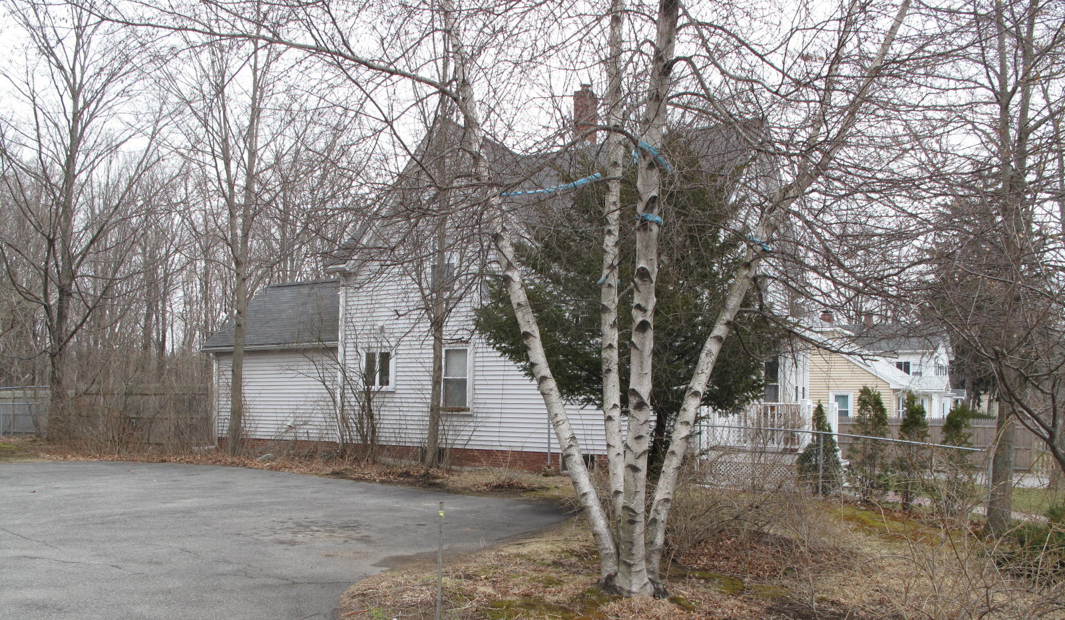

National Register of Historic Places Criteria Statement Form

Check all that apply:

Individually eligible Eligible only in a historic district

Contributing to a potential historic district Potential historic district

Criteria: A B C D

Criteria Considerations: A B C D E F G

Statement of Significance by________Neil Larson_________________________________
The criteria that are checked in the above sections must be justified here.

The George B. & Ann Poor House is a distinctive example of late-19th-century middle-class domestic architecture in the village. It is designed in a picturesque manner that is still evident in spite of altered porches and added vinyl siding and windows. Built ca. 1880, the house is a contributing component of the village district.

George J. Tenney to Prescott Poor, 10 November 1891, SED 1333:131.
Prescott Poor to Henry P. Poor, 24 April 1903, SED 1706:466; Henry P. Poor to Alice J. Smith, 8 December 1923, SED 2580:495; Alice J. Smith to Clara E. Olmstead, 26 April 1924, SED 2592:350.
Clara E. Olmstead to Edward J. and Bessie M. Bertaux, Lynn, 30 July 1948, SED 3542:398; Malcolm F. and Helene M. Morse to Raymond L. and Ruth F. Bateman, 26 July 1958, SED 4480:341; Roberta F. Bateman, 8 High St, to Robert S. and Juanita Bornholdt, 30 Prospect, 28 July 1998, SED 14984:125. The property is shown as Lot 8 on “Plan of Land Located in Georgetown, Massachusetts,” 17 July 1998, SED 327:46.

