FORM B − BUILDING

Massachusetts Historical Commission
Massachusetts Archives Building
220 Morrissey Boulevard
Boston, Massachusetts 02125

Photograph
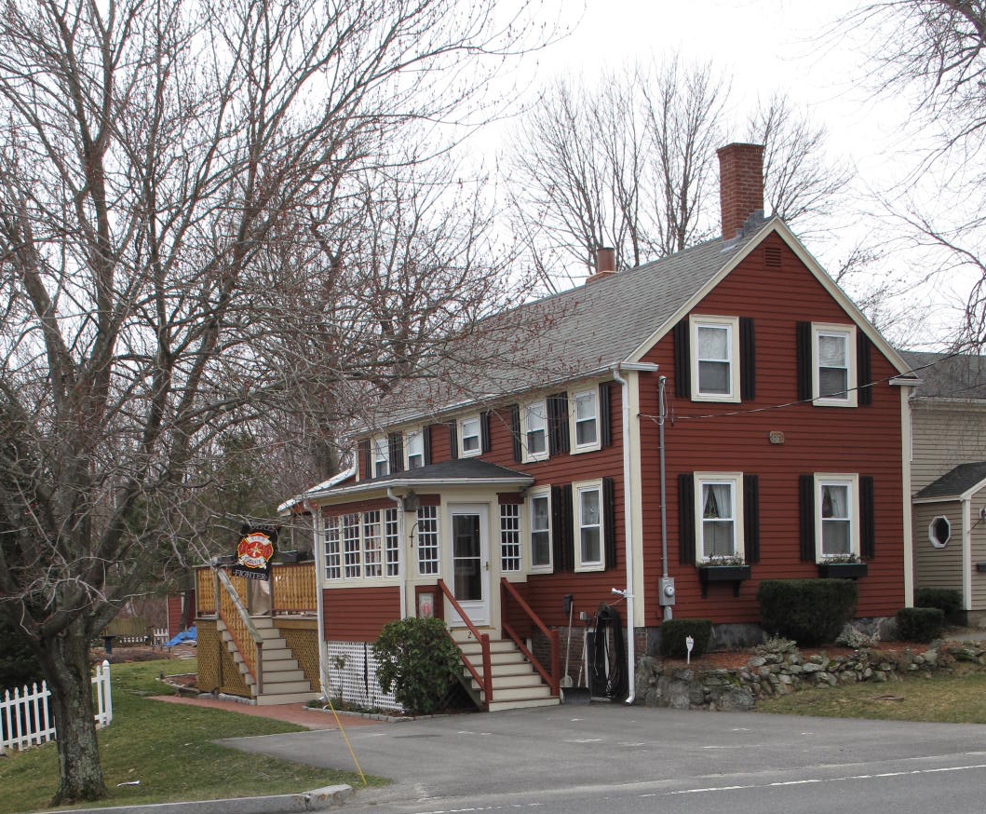
View from northeast

Locus Map (north at top)
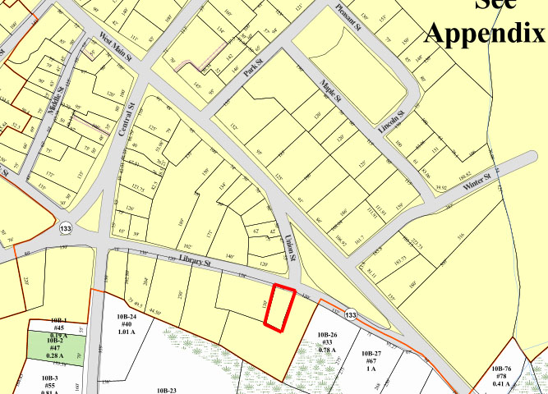

Recorded by: Kathryn Grover & Neil Larson
Organization: Town of Georgetown
Date: October 2012

Assessor’s Number USGS Quad Area(s) Form Number

11A-83 |  | Georgetown |  | C |  | GEO.146

Town/City: Georgetown
Place: (neighborhood or village):
Town Center

Address: 25 Library Street
Historic Name: James & Mary Barry House
Uses: Present: single residence
Original: single residence
Date of Construction: ca. 1845
Source: historic maps, deeds
Style/Form: Greek Revival
Architect/Builder: Benjamin Baldwin, prob. builder
Exterior Material:
Foundation: stone, brick
Wall/Trim: wood clapboards
Roof: asphalt shingles
Outbuildings/Secondary Structures:
none
Major Alterations (with dates):
Porch added at entrance
Rear addition
Window sash replaced

Condition: good
Moved: no yes Date:
Acreage: 0.15 acre
Setting: This house is sited on the south side of Library Street across from the street’s intersection with Union Street. The area is largely residential.

Recommended for listing in the National Register of Historic Places.
If checked, you must attach a completed National Register Criteria Statement form.

ARCHITECTURAL DESCRIPTION
The James & Mary Barry House is a story-and-a-half wood frame dwelling located on the south side of Library Street opposite Union Street. With its gable end oriented to the street and principal façade facing east, its plan conforms to middling urban housing of the period, much of it multiple-family in use. The house backs up to the western lot line, exposing the front façade to the side yard. The five-bay front (east) façade has windows closely-spaced and a central entrance now concealed within a later enclosed porch; a window of reduced size occupies the center of the second story above the existing porch roof. The roof has a shallow eave on the front and a thin frieze that the tops of the second-story window trim abut.

The north end of the house facing Library Street contains two windows evenly spaced in each story. The cornice along the raking roof edge makes a short return across the end wall from the eave. Two second-story windows are visible on the south end wall; the lower story has been covered by a one-story, shed roof addition built across the full width of the original building. The back wall of the house has two windows on the first story and a shed-roof wall dormer has been raised in the center of the façade, for a bathroom addition.

The house is sited in the northwest corner of the lot with the northeast corner paved for parking. The yard is located in the rear of the house with a large garden in the back. A wood fence encircles the rear yard.

The James & Mary Barry House is an intact example of a tenant dwelling associated with Georgetown’s early development. Built ca. 1845, with its narrow gable end oriented to the street, the house was sited in the mode of urban examples of this type. The building is a contributing component of the village district.

HISTORICAL NARRATIVE
In December 1845, Elijah C. Dresser, who then lived at 29 Library next south, sold land next to his house to Benjamin Baldwin for $175. The 1850 census enumerated Benjamin Baldwin and his household just before Dresser in the Georgetown population schedule. In that year, Baldwin was 39 years of age, born in Massachusetts, a carpenter, and the owner of $500 of real property. He lived with his wife, Sarah, 38 years old and born in New Hampshire, and their three young children, all under the age of ten. Baldwin had come from Salem and he returned there after selling the house and lot to Georgetown shoe manufacturer Samuel Little in April 1855. In 1864 Little deeded the property to Irish immigrant shoe worker James Barry, probably was his employee, who had been renting the house since at least 1860.

Born in Ireland about 1820, James Barry and his wife Mary Collins appear to have come to the United States with their eldest daughters Ellen and Catherine; according to nearly all records related to him, the couple’s son Joseph Edward (usually shown as J. Edward in censuses) was born “at sea” in August 1853, probably during the family’s passage to this country. They were living in Spencer in 1858 when their fourth child, Hannah, was born, and by 1860 Barry was living in this neighborhood with his family—judging from the order of enumeration, quite likely in this house—which then included five-month-old Mary. His real property in 1860, before he acquired 25 Library Street, was valued at $450; it had not appreciated greatly by 1870, when the census estimated its value at $500. Why he is shown with real property in 1860 is unclear, as the deed is dated 1864. In 1863 the Barrys had a sixth child, John L. Barry. By 1880 James Barry was employed as a shoe factory bottom finisher, and three of the four adult children living in his household were also contributing their income to it. Edward was a boot treer, Hannah a domestic servant, and John a sixteen-year-old shoe factory nailer. In 1875 Barry purchased the tenanted house next door at 23 Library Street from Samuel L. Tuttle.

In 1877 the Barrys lost their twenty-six-year-old daughter Catherine to consumption, and in March 1882 their youngest child, John, was taken by the same disease at the age of eighteen. A month later, James Barry died at the age of sixty-five. The family remained at 25 Library Street; the widow Mary Barry is shown in the 1885-86 directory as living in a house on Library Street “opposite Union.” Mary Collins Barry died in 1886, and in 1900 the house was occupied by J. Edward Barry, still working as a shoe treer, his unmarried sister Mary, who is shown as the property owner, and a niece, Mary E. Purcell, a shoe stitcher who lived with the Barry siblings for decades.

Toward the end of his working life J. Edward Barry was employed in a Haverhill shoe shop but continued to live at 25 Library Street with his sister and niece. In 1919 he died at the age of sixty-five, and his sister and Mary Purcell stayed in the house. Both worked—Barry at bench work and Mary Purcell as a stitcher in a shoe shop—and Barry rented space to two small families.

Mary Barry remained at 25 Library Street until she sold it in 1929 to Annie T. W. DeQuoy, who acquired 23 Library Street from Barry at the same time and lived in that house until 1946. In 1931 she sold 25 Library Street to James Phillip and Harriette Stetson Poole. Born in 1894, Poole was the son of shoeworker William H. Poole and his wife Susan Reed Poole, and he grew up at 140 Elm Street in Georgetown. By the time he was sixteen years old he was “drawing out” in a shoe factory, and he appears to have remained in his parents’ household until 1920, when he married Harriette Endicott Stetson, a native of Boxford then teaching school in Georgetown. The 1930 census shows the Poole family at 25 Library Street. James P. Poole was then working as a salesman for Cushman Bakery.

In 1957 James P. and Harriette Poole still owned and occupied 25 Library Street. The directory shows him without occupation, but Harriette Poole was teaching at Perley Elementary School. James Poole died in December of the same year, and his widow deeded a half-interest in the property to her daughter Barbara Root Poole, born in 1921 and married to Roland E. Spofford of Georgetown since 1942, and remained in this house. In October 1989 she reserved a life tenancy for herself there in another deed to her daughter.

Harriette Stetson Poole died in June 1991, and the next year her daughter sold 25 Library Street to Gregory A. and Susan E. Denoncour, who in turn sold it five years later to current owner Harold C. Roeder.

BIBLIOGRAPHY and/or REFERENCES
Arrington, Benjamin F., ed. Municipal History of Essex County in Massachusetts. NY: Lewis Historical Publishing Co., 1922.
Field, Jane. A Brief History of Georgetown Massachusetts 1838-1963. Rev. ed. 1988. Georgetown: Georgetown Historical Commission, 1988.
Gage, Thomas. The History of Rowley, Anciently Including Bradford, Boxford, and Georgetown, from the Year 1639 to the Present Time. Boston: F. Andrews, 1840.
Georgetown, Boxford, Byfield, Newbury, and West Newbury, Massachusetts, Directory. Boston: W. E. Shaw, 1901-2, 1905, 1909, 1912, 1914, 1916-17, 1918, 1925.
Hill, Edwin P. “History of Georgetown, Massachusetts.” In Standard History of Essex County, Massachusetts. Edited by Cyrus M. Tracey, William E. Graves, and Henry M. Batchelder. Boston: C. F. Jewett, 1878.
Hull, Forrest P. Georgetown: Story of One Hundred Years, 1838-1938. 1938. Reprint. Georgetown, MA: Georgetown Historical Commission, 2006.
Merrill, Samuel. A Merrill Memorial: An Account of the Descendants of Nathaniel Merrill, an Early Settler of Newbury, Massachusetts. Cambridge, MA, 1917-28.
Nelson, Henry M. “Town of Georgetown History.” In Hurd, D. Hamilton. History of Essex County, Massachusetts, with Biographical Sketches of Many of Its Pioneers and Prominent Men. Vol. 1. Philadelphia: J. W. Lewis and Co., 1888.
Sammarco, Anthony Mitchell, for Georgetown Historical Society. Images of America: Georgetown. Portsmouth, NH: Arcadia Publishing, 2002.

MAPS
“Map of the Centre of Georgetown in 1800.” In Perley, Sidney H., “Centre of Georgetown in the Year 1800.” The Essex Antiquarian: A Quarterly Magazine Devoted to the Biography, Genealogy, History, and Antiquities of Essex County, Massachusetts 2, 7 (July 1898): 201.
Map of Georgetown in 1810 and 1840. In Gage, Thomas. The History of Rowley, Anciently Including Bradford, Boxford, and Georgetown, from the Year 1639 to the Present Time. Boston: F. Andrews, 1840. 320.
“Map of New Rowley Surveyed and Drawn by Philander Anderson 1830.” Georgetown Historical Society.
Map of Georgetown. 1856. In Walling. H. F. A Topographical Map Essex County Massachusetts. Boston: Smith and Morley, 1856.
Atlas of Essex County, Massachusetts. Philadelphia: D. G. Beers and Co., 1872). Plates 59 and 61.
“Town of Georgetown Mass.” and “Village of Georgetown Mass.” In Atlas of Essex County, Massachusetts (Boston: George H. Walker, 1884).
“Georgetown, Mass. 1887.” Drawn and Published by George E. Norris, Brockton, Massachusetts. Troy, NY: Burleigh Lithographic Establishment, 1887.”

PHOTOGRAPHS (all photos by Neil Larson, 2012)

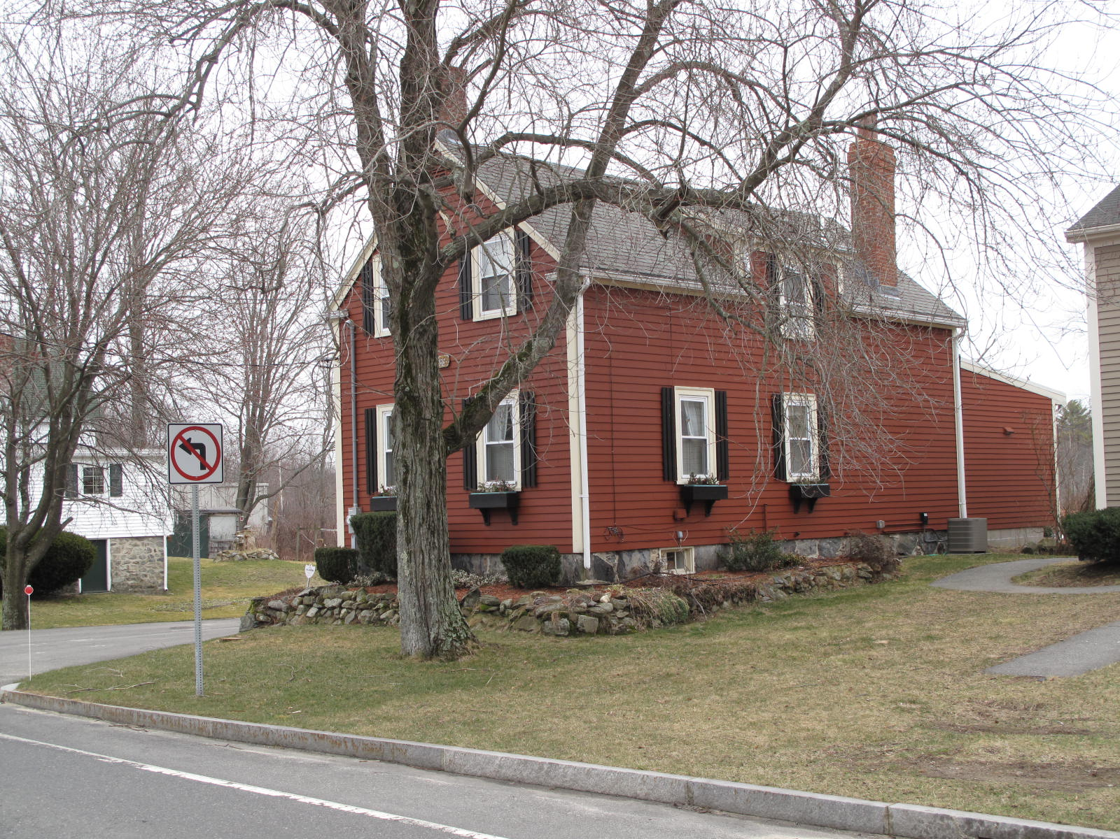
25 Library Street: view from NW

National Register of Historic Places Criteria Statement Form

Check all that apply:

Individually eligible Eligible only in a historic district

Contributing to a potential historic district Potential historic district

Criteria: A B C D

Criteria Considerations: A B C D E F G

Statement of Significance by________Neil Larson_________________________________
The criteria that are checked in the above sections must be justified here.

The James & Mary Barry House is an intact example of a tenant dwelling associated with Georgetown’s early development. Built ca. 1845, with its narrow gable end oriented to the street, the house was sited in the mode of urban examples of this type. The building is a contributing component of the village district.

Elijah C. Dresser to Benjamin Baldwin, 6 December 1845, SED 365:34; Benjamin Baldwin, Salem, to Samuel Little, 14 April 1855, SED 512:246.
Samuel Little to James Barry, 3 March 1864, SED 677:220.
Samuel L. Tuttle, Boston, to James Barry, 8 June 1875, SED 932:218.
Mary A. Barry to Annie T. DeQuoy, 20 May 1929, SED 2831: 316; Annie T. DeQuoy to James P. and Harriette S. Poole, 16 April 1931, SED 2879:408.
Harriette S. Poole to Harriette S. Poole and Barbara S. Spofford, 30 September 1958, SED 4499:354; Barbara S. Spofford to Harriette S. Poole, 26 March 1960, SED 4653:503; Harriette S. Poole to Barbara R. Spofford, 17 October 1989, SED 10197:252.
Barbara R. Spofford to Gregory A. and Susan E. Denoncour, 30 September 1992, SED 11510:587; Gregory A. and Susan E. Denoncour to Harold C. Roeder, 25 Library Street, 24 june 1997, SED 14175:330.

