FORM B − BUILDING

Massachusetts Historical Commission
Massachusetts Archives Building
220 Morrissey Boulevard
Boston, Massachusetts 02125

Photograph
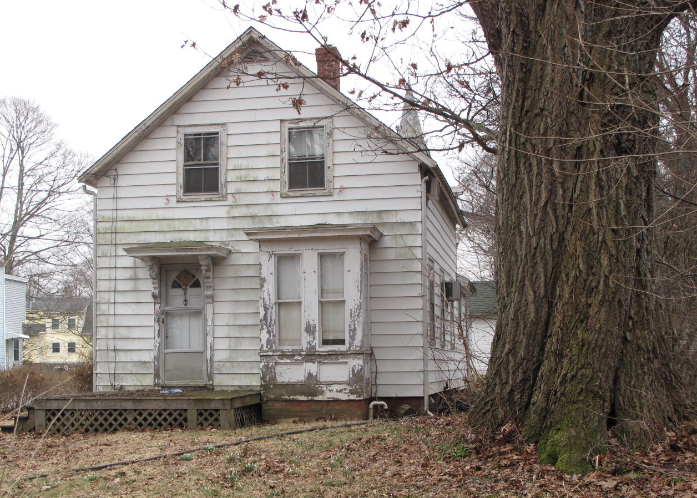
View from northwest

Locus Map (north at top)
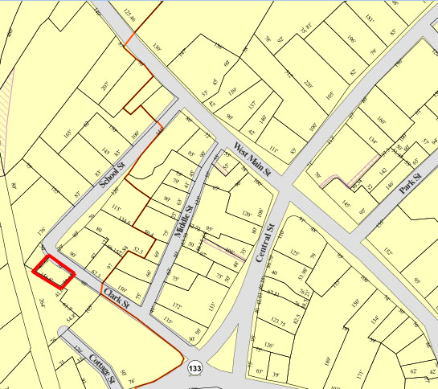

Recorded by: Kathryn Grover & Neil Larson
Organization: Town of Georgetown
Date: October 2012

Assessor’s Number USGS Quad Area(s) Form Number

6C-130 |  | Georgetown |  | C |  | GEO.189

Town/City: Georgetown
Place: (neighborhood or village):
Town Center

Address: 24 School Street
Historic Name: Stephen Osgood Rental House
Uses: Present: single residence
Original: single residence
Date of Construction: ca. 1870
Source: historic maps
Style/Form: Classical Revival
Architect/Builder: unknown
Exterior Material:
Foundation: brick
Wall/Trim: vinyl clapboards
Roof: asphalt shingles
Outbuildings/Secondary Structures:
garage
Major Alterations (with dates):

vinyl siding added
Condition: good
Moved: no yes Date:
Acreage: 0.07 acre
Setting: This house is sited on the east side of School Street at its end, just south of its intersection with Clark Street. The area is largely residential.

Recommended for listing in the National Register of Historic Places.
If checked, you must attach a completed National Register Criteria Statement form.

ARCHITECTURAL DESCRIPTION
The Stephen Osgood Rental House is a story-and-a-half wood frame dwelling located on the southerly side of corner intersection of School and Clark streets. The front-gable facade contains an entrance, under a hood mounted on scrolled brackets, on the first story, offset by a one-story box bay window with a plain Classical cornice. Two windows are centered in the upper story within the raking gable eaves edged with plain cornices. There are two windows on the northerly side wall spaced behind a section of blank wall where interior stairs are located; three windows are evenly spaced across the southerly side wall. A one-story ell is attached to the rear with its own entrance on the easterly end.

A one-story wood frame garage with a front gable roof is located behind the house; it contains one vehicle bay with an overhead door. A driveway enters the back of the lot and terminates at a parking area in front of the garage. A small yard is located in front of the house and contains a large tree.

The Stephen Osgood Rental House is a representative example of the story-and-a-half front gable dwelling that was ubiquitous in factory towns in eastern Massachusetts during the last half of the 19th-century. Built ca. 1870, the house is relatively intact and a contributing component of the village district.

HISTORICAL NARRATIVE
By 1870, the area on both sides of and northwest of Cottage Street, between Clark Street on the north, Andover Street on the south, and the rail corridor on the west, was called the Acre in the Essex County directory, no doubt for the same reasons as the well-known section of Lowell that had emerged as an Irish immigrant neighborhood in the 1820s. The 1870 county directory lists fourteen householders, all Irish immigrants, as residents of Georgetown’s Acre—William Cronin, John Doonan, Patrick Hughes, his son Patrick and brother Arthur, James Carroll, Henry Early, Owen McGinley, and James, James P., James T., Thomas, and Patrick Molloy 2d. Of these fourteen men, ten are listed as shoemakers, one as a shoe manufacturer, one as a farmer, and two as laborers. The 1872 map of Georgetown center depicts this concentration of Irish American settlement: the homes of Patrick Foley, John Doonan (“Donan” on the map), Patrick Hughes (“Huse”), Patrick Molloy (Maloy), N. (though probably Henry) Early, Owen McGauley (McGoley), three buildings marked “shoe shop,” and two houses belonging to Patrick Moan or Moen, also from Ireland but not listed in the 1870 county directory, are shown in the area alongside that of the Daniel Clark family for whom Clark Street was named.

The house at 24 School Street is tucked between Clark Street and the rail (now power transmission) corridor, and at one time, though not today, School Street extended past it to the rail corridor. The house appears to have been the home of Patrick Hughes (or “Huse,” as it is sometimes spelled) at the latest by 1872 when his name is associated with the property on the village map. Born about 1830, Hughes was a shoeworker and lived with his wife Mary and six children, all born in Massachusetts between 1855 and 1866. Hughes likely was a tenant of Georgetown merchant tailor Stephen Osgood, who owned a factory just northeast of the house on School Street. The 1884 map of Georgetown shows Osgood owning not just the factory, but three houses nearby, including 24 School Street. Osgood, who lived at 10 Pleasant Street from about 1870, owned a substantial amount of real estate in Georgetown.

In May 1889 Osgood sold 24 School Street to Emma L. Martin of Newburyport, who continued to rent the property for the next twenty years. In 1919 she sold 24 School Street to Carrie A. Murray Decrow of Westville, New Hampshire, for $600, what she had paid for the property in 1889. Born in Connecticut about 1866, Carrie Murray was a dressmaker in Lynn by 1900; Adelbert (usually shown as Delbert) Decrow, a native of Malden then married to his first wife Harriet, lived with her and their son Howard in Whitman and worked as a baggagemaster. In 1912, after Harriet Decrow’s death, Delbert Decrow married Carrie Murray in Lynn; he was sixty-one years old, and she was fifty.

The 1920 census shows Delbert and Carrie Decrow, both without occupations, at 24 School Street, but by 1925 the directory shows her as a widow and states that she had moved to New Hampshire. In January 1920 she sold the property to John P. Ryan, and the property changed hands five more times before 1934, when Harold G. and Celena Field acquired it. Born in Norway, Maine, in 1908, Harold George Field was a shoeworker in Georgetown in 1929 when he married Lena (or Celena) Moffitt, a native of Groveland then also working as a shoe factory operative in Georgetown. The 1940 census, oddly, shows the family as renting and shows the head of household as Eva Moffitt, Celena Field’s mother, who lived with them and their daughter Doris, born about 1930.

Harold G. Field died in 1950, and the 1957 directory shows his widow still living at 24 School Street. She had remarried by 1957, when she deeded the house to herself and her second husband, Floyd W. Chapman. The property is now owned by Robert A. Field, whose title stems from the estate of Celena Field Chapman.

BIBLIOGRAPHY and/or REFERENCES
Arrington, Benjamin F., ed. Municipal History of Essex County in Massachusetts. NY: Lewis Historical Publishing Co., 1922.
Field, Jane. A Brief History of Georgetown Massachusetts 1838-1963. Rev. ed. 1988. Georgetown: Georgetown Historical Commission, 1988.
Gage, Thomas. The History of Rowley, Anciently Including Bradford, Boxford, and Georgetown, from the Year 1639 to the Present Time. Boston: F. Andrews, 1840.
Georgetown, Boxford, Byfield, Newbury, and West Newbury, Massachusetts, Directory. Boston: W. E. Shaw, 1901-2, 1905, 1909, 1912, 1914, 1916-17, 1918, 1925.
Hill, Edwin P. “History of Georgetown, Massachusetts.” In Standard History of Essex County, Massachusetts. Edited by Cyrus M. Tracey, William E. Graves, and Henry M. Batchelder. Boston: C. F. Jewett, 1878.
Hull, Forrest P. Georgetown: Story of One Hundred Years, 1838-1938. 1938. Reprint. Georgetown, MA: Georgetown Historical Commission, 2006.
Merrill, Samuel. A Merrill Memorial: An Account of the Descendants of Nathaniel Merrill, an Early Settler of Newbury, Massachusetts. Cambridge, MA, 1917-28.
Nelson, Henry M. “Town of Georgetown History.” In Hurd, D. Hamilton. History of Essex County, Massachusetts, with Biographical Sketches of Many of Its Pioneers and Prominent Men. Vol. 1. Philadelphia: J. W. Lewis and Co., 1888.
Sammarco, Anthony Mitchell, for Georgetown Historical Society. Images of America: Georgetown. Portsmouth, NH: Arcadia Publishing, 2002.

MAPS
“Map of the Centre of Georgetown in 1800.” In Perley, Sidney H., “Centre of Georgetown in the Year 1800.” The Essex Antiquarian: A Quarterly Magazine Devoted to the Biography, Genealogy, History, and Antiquities of Essex County, Massachusetts 2, 7 (July 1898): 201.
Map of Georgetown in 1810 and 1840. In Gage, Thomas. The History of Rowley, Anciently Including Bradford, Boxford, and Georgetown, from the Year 1639 to the Present Time. Boston: F. Andrews, 1840. 320.
“Map of New Rowley Surveyed and Drawn by Philander Anderson 1830.” Georgetown Historical Society.
Map of Georgetown. 1856. In Walling. H. F. A Topographical Map Essex County Massachusetts. Boston: Smith and Morley, 1856.
Atlas of Essex County, Massachusetts. Philadelphia: D. G. Beers and Co., 1872). Plates 59 and 61.
“Town of Georgetown Mass.” and “Village of Georgetown Mass.” In Atlas of Essex County, Massachusetts (Boston: George H. Walker, 1884).
“Georgetown, Mass. 1887.” Drawn and Published by George E. Norris, Brockton, Massachusetts. Troy, NY: Burleigh Lithographic Establishment, 1887.”

PHOTOGRAPHS (all photos by Neil Larson, 2012)

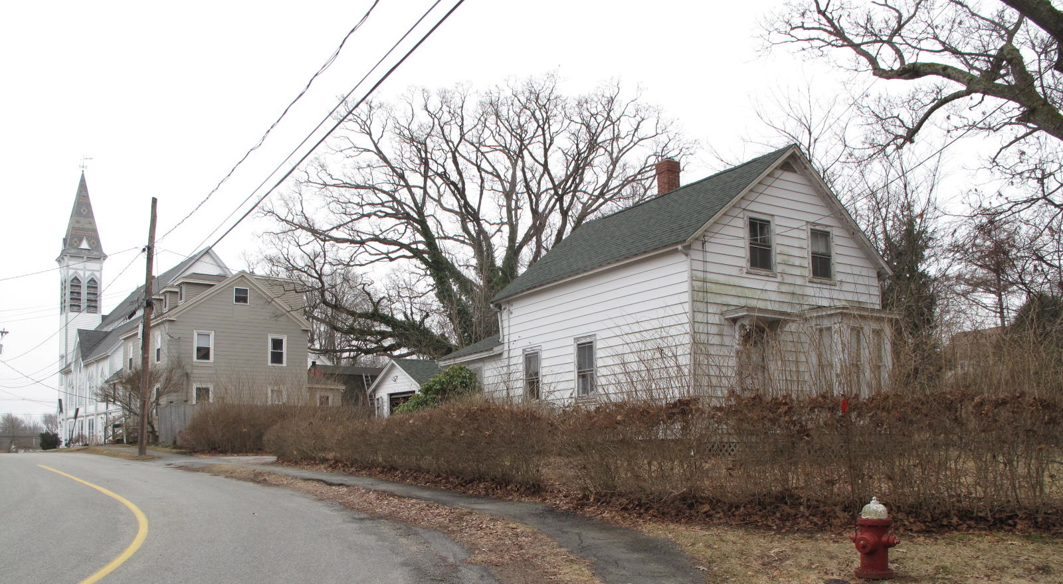
24 School Street: views from NW (top) and NE (bottom)

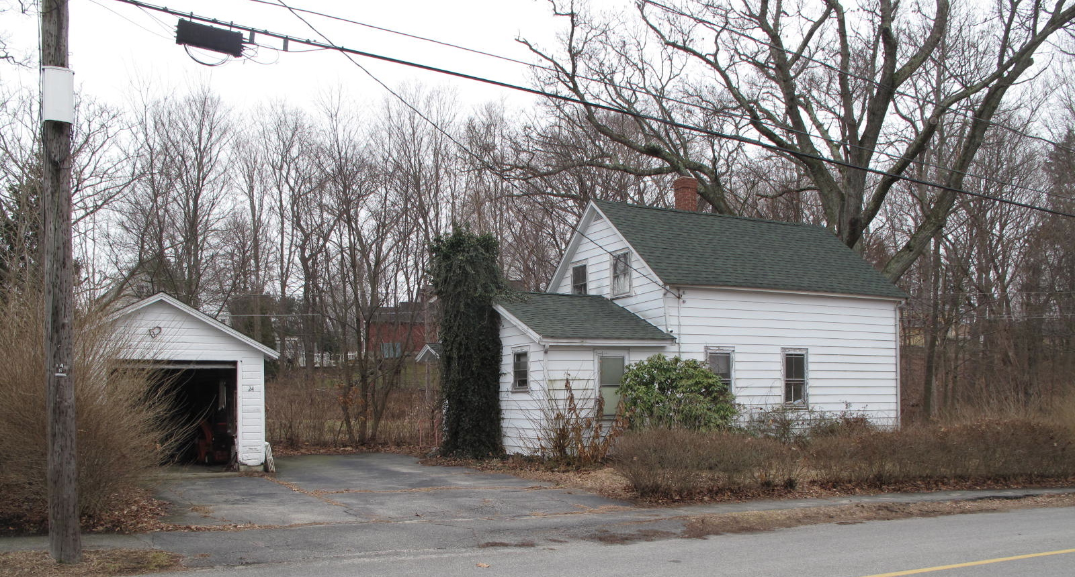

National Register of Historic Places Criteria Statement Form

Check all that apply:

Individually eligible Eligible only in a historic district

Contributing to a potential historic district Potential historic district

Criteria: A B C D

Criteria Considerations: A B C D E F G

Statement of Significance by________Neil Larson_________________________________
The criteria that are checked in the above sections must be justified here.

The Stephen Osgood Rental House is a representative example of the story-and-a-half front gable dwelling that was ubiquitous in factory towns in eastern Massachusetts during the last half of the 19th-century. Built ca. 1870, the house is relatively intact and a contributing component of the village district.

See Henry M. Nelson, “Town of Georgetown History.” In History of Essex County, Massachusetts, with Biographical Sketches of Many of Its Pioneers and Prominent Men, ed. D. Hamilton Hurd (Philadelphia: J. W. Lewis and Co., 1888) 1:834, 837.
Stephen Osgood to Emma L. Martin, 10 May 1889, SED 1251:26; Emma L. Martin, Newburyport, to Carrie A. Decrow, Westville NH, 4 June 1919, SED 2415:123.
New Hampshire vital records state, however, that Delbert S. Decrow died in Lancastter in May 1928.
Carrie A. Decrow to John P. Ryan, 10 January 1920, SED 2439:308; Sarah J. Ross, Malden, to Harold G. and Celena Field, 31 December 1934, SED 3024:244; Celene Chapman, fka Celena Field, to Floyd W. and Celena Chapman, 23 November 1957, SED 4423:118; Georgetown Savings Bank to Robert A. Field, mortgage deed, 9 January 1990, SED 10295:384, which cites the date of his deed as 12 May 1989 but provides no book and page citation; the deed cannot be located in Essex County probate indices.

