FORM B − BUILDING

Massachusetts Historical Commission
Massachusetts Archives Building
220 Morrissey Boulevard
Boston, Massachusetts 02125

Photograph
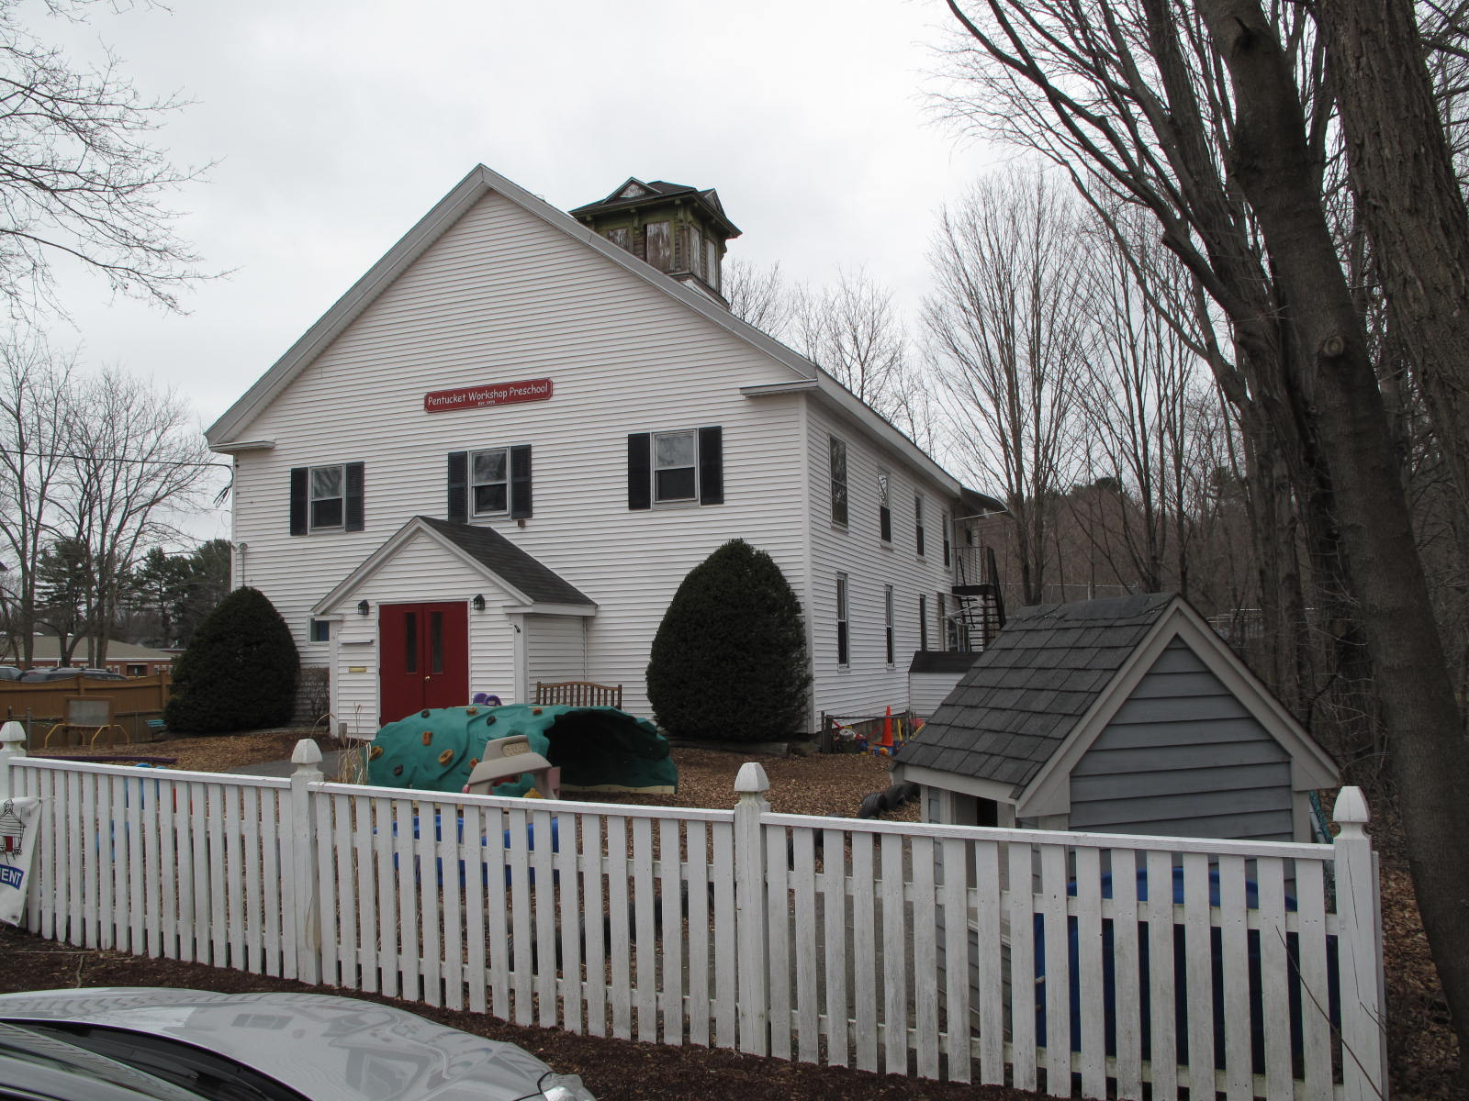

Locus Map (north at top)
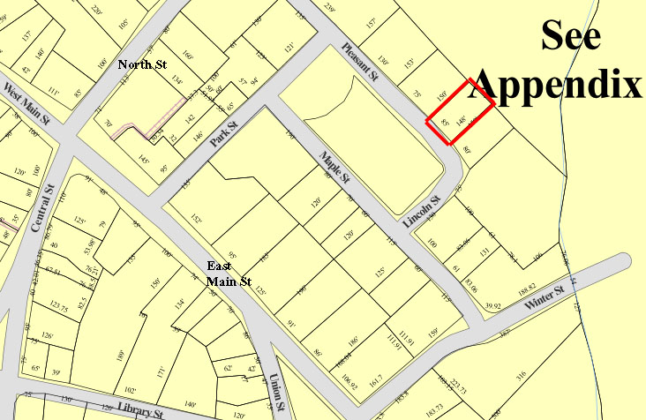

Recorded by: Kathryn Grover & Neil Larson
Organization: Town of Georgetown
Date: October 2012

Assessor’s Number USGS Quad Area(s) Form Number

11A-95 |  | Georgetown |  | C |  | GEO.171

Town/City: Georgetown
Place: (neighborhood or village):
Town Center

Address: 22 Pleasant Street
Historic Name: Calvin R. Titcomb Warehouse
Georgetown Grange (1924-1973)
Uses: Present: day care facility
Original: warehouse
Date of Construction: ca. 1891
Source: deeds, directories
Style/Form: Classical Revival
Architect/Builder: unknown
Exterior Material:
Foundation: stone
Wall/Trim: vinyl clapboards
Roof: asphalt shingles
Outbuildings/Secondary Structures:
none
Major Alterations (with dates):
Converted to grange hall, front façade altered, 1924
Vinyl siding added
Window sash replaced

Condition: good
Moved: no yes Date:
Acreage: 0.29 acre
Setting: This building is sited on the north side of Pleasant Street on a lot with mature trees bounded on the northeast by the grounds of the Perley School and on the southwest by Lincoln Park. The area is a mix of residential and institutional uses.

Recommended for listing in the National Register of Historic Places.
If checked, you must attach a completed National Register Criteria Statement form.

ARCHITECTURAL DESCRIPTION
The Calvin R. Titcomb Warehouse / Georgetown Grange is a large two-story wood frame barn-type building located on the northerly side of Pleasant Street northwest of Lincoln Street. Built ca. 1891, the building was constructed by a dealer of meat and provisions and evidently functioned as a warehouse, workspace and, perhaps livery. A building this size suggests that Calvin R. Titcomb was preparing and delivering meat products on a large-scale basis. The front façade has been altered with the addition of an entrance vestibule replacing what originally would have been one or more vehicle and service doors. Fenestration is regularly spaced on the front and sides suggesting that the present replacement windows are in pre-existing locations. The absence of windows at the rear of the side walls indicate that that section of the interior enclosed for a particular storage or stabling use; the vinyl siding may be concealing am exterior doorway, as well. The one surviving feature that aids in the determination of the age and original function of the building is a large ventilator in the center of the roof. This four-sided structure contains two rectangular openings on each wall that would have contained louvers, removed and the openings sealed when the ventilation function was no longer desired (ca. 1924). The hipped roof has deep overhangs decorated with brackets and blind dormers on each side. It would be expected that the roof edge of the building itself had been similarly distinguished.

The building is sited at the rear of the lot leaving the front open for vehicles and the loading and unloading of goods. Side yards are minimal, and part of the area in front has been fenced in for a playground. The rest of the front, closest to the street, has been paved for parking.

The Calvin R. Titcomb Warehouse / Georgetown Grange, built ca. 1891, is a distinctive surviving example of a late-19th-century warehouse in the village. While its historic exterior form and fenestration pattern are intact, changes in use, first as a grange hall and recently as a day-care center, have led to significant alterations to the façade and interior. With only a roof-top ventilator spared from the overlay of vinyl clapboard siding, alterations have compromised the visual integrity of the building. However, it is a contributing component of the village district.

HISTORICAL NARRATIVE
According to historian Jane Field, the streets around what is now Lincoln Park were “opened to home construction” in 1868. The 1830 and 1856 maps of the village show the area completely undeveloped, but by 1872 the “Park” appears on the town map enclosed by Pleasant, Lincoln, Maple, and Park Streets; only Pleasant among these four streets is shown with its name. At that time no houses had been built on either Maple or Lincoln, and the only dwellings bordering Lincoln Park were those of shoe manufacturer Milton G. Tenney (at Park and Pleasant), the 10 Pleasant Street home of merchant tailor Stephen Osgood, behind the Baptist Church on Pleasant Street, and the homes of shoe industry workers William Augustus Harnden (now 14 Pleasant Street) and George A. Kimball, in this house at 18 Pleasant Street. The area around Lincoln Park appears to have developed as a series of individual transactions; though shoe manufacturer George Jewett Tenney owned several parcels later developed as house lots, no single developer platted the area’s residential growth.

In April 1874 Tenney sold the merchant tailor Hamilton Luzerne Perkins the lot on which 22 Pleasant Street was later built for $200. Born in Georgetown in 1845, Perkins was the son of Isaiah and Priscilla Kimball Perkins. He served for about eighteen months of the Civil War as a musician, first in Company K of the Massachusetts 50th Regiment and then with the Massachusetts Seventeenth Unattached Infantry. In 1869 Perkins married Ellen Moulton, the daughter of local boot and shoe manufacturer Daniel E. Moulton, and the 1880 census shows the couple in Moulton’s home with their two young daughters, Florence and Luella.

One 1922 local history calls Hamilton Perkins “the third of the remarkable trio of Georgetown’s great manufacturing tailors” and notes that he learned his trade from Samuel Plumer, who had begun making clothing in Georgetown in 1838 and remained in business until 1890. In 1870 Perkins became partners with Plumer and remained so for thirteen years, when he began his own business. By 1887 he had relocated to Haverhill (as had the son of merchant tailor Stephen Osgood of 10 Pleasant Street) and worked there in the clothing business for another thirty years.

In 1882, Perkins sold the Pleasant Street lot for the price he had paid eight years earlier to Martha J. Dorman Wildes, the wife of Edward Payson Wildes. She had bought the adjoining lot on the southeast in 1874, about six months after Perkins had bought this lot from Tenney, where she and her husband lived. Also a native of Georgetown, Edward P. Wildes had been a sergeant in Company K of the Massachusetts 50th, Perkins’s regiment, and they later also served together in the Seventeenth Unattached Infantry. Wildes is not shown as a musician, as Perkins, but he was a music teacher for most of his career. The son of Green and Mary D. Jewett Wildes, Edward P. Wildes was a Civil War soldier for about three years and left the service as a first lieutenant.

In 1857 Edward Wildes, then working in Georgetown as a music teacher, married Martha S. Dorman, the daughter of Cyrus and Sarah Dorman. Judging by the order of enumeration in the 1880 census, the Wildes had built a house on what is now 24 Pleasant Street by 1880. The 1880 census shows him as a shoe cutter, a church organist, and a music teacher living with his wife Martha and son Charles E., also a shoe cutter and an organist. No building is depicted next door at 22 Pleasant Street on the 1887 birdseye view of the village. In April 1891 the Wildeses sold two lots, comprising the present parcel of 22 Pleasant Street, to grocer Calvin R. Titcomb, a native of Rowley. The deeds do not mention the presence of any buildings, and the price Titcomb paid for both--$290—suggests that there were none. He constructed the extant building shortly after, probably as a workspace, warehouse and, perhaps livery for his grocery and butchering business. The 1901 directory shows Calvin R. Titcomb as a meat and provisions dealer living on Lincoln Park, but the 1900 census shows him boarding with the family of Martin L. Hoyt on Maple Street. Titcomb lived most of his life in Rowley, and after his death in 1924 the trustee of his will sold the lot, with its buildings, to the Georgetown Grange for $3000.

The Georgetown Grange owned 22 Pleasant Street until 1973. Current owners Sandra F. Devellis and Helen M. Murgida acquired it in 1976, and the building now houses the Pentucket Workshop Preschool.

BIBLIOGRAPHY and/or REFERENCES
Arrington, Benjamin F., ed. Municipal History of Essex County in Massachusetts. NY: Lewis Historical Publishing Co., 1922.
Field, Jane. A Brief History of Georgetown Massachusetts 1838-1963. Rev. ed. 1988. Georgetown: Georgetown Historical Commission, 1988.
Gage, Thomas. The History of Rowley, Anciently Including Bradford, Boxford, and Georgetown, from the Year 1639 to the Present Time. Boston: F. Andrews, 1840.
Georgetown, Boxford, Byfield, Newbury, and West Newbury, Massachusetts, Directory. Boston: W. E. Shaw, 1901-2, 1905, 1909, 1912, 1914, 1916-17, 1918, 1925.
Hill, Edwin P. “History of Georgetown, Massachusetts.” In Standard History of Essex County, Massachusetts. Edited by Cyrus M. Tracey, William E. Graves, and Henry M. Batchelder. Boston: C. F. Jewett, 1878.
Hull, Forrest P. Georgetown: Story of One Hundred Years, 1838-1938. 1938. Reprint. Georgetown, MA: Georgetown Historical Commission, 2006.
Merrill, Samuel. A Merrill Memorial: An Account of the Descendants of Nathaniel Merrill, an Early Settler of Newbury, Massachusetts. Cambridge, MA, 1917-28.
Nelson, Henry M. “Town of Georgetown History.” In Hurd, D. Hamilton. History of Essex County, Massachusetts, with Biographical Sketches of Many of Its Pioneers and Prominent Men. Vol. 1. Philadelphia: J. W. Lewis and Co., 1888.
Sammarco, Anthony Mitchell, for Georgetown Historical Society. Images of America: Georgetown. Portsmouth, NH: Arcadia Publishing, 2002.

MAPS
“Map of the Centre of Georgetown in 1800.” In Perley, Sidney H., “Centre of Georgetown in the Year 1800.” The Essex Antiquarian: A Quarterly Magazine Devoted to the Biography, Genealogy, History, and Antiquities of Essex County, Massachusetts 2, 7 (July 1898): 201.
Map of Georgetown in 1810 and 1840. In Gage, Thomas. The History of Rowley, Anciently Including Bradford, Boxford, and Georgetown, from the Year 1639 to the Present Time. Boston: F. Andrews, 1840. 320.
“Map of New Rowley Surveyed and Drawn by Philander Anderson 1830.” Georgetown Historical Society.
Map of Georgetown. 1856. In Walling. H. F. A Topographical Map Essex County Massachusetts. Boston: Smith and Morley, 1856.
Atlas of Essex County, Massachusetts. Philadelphia: D. G. Beers and Co., 1872). Plates 59 and 61.
“Town of Georgetown Mass.” and “Village of Georgetown Mass.” In Atlas of Essex County, Massachusetts (Boston: George H. Walker, 1884).
“Georgetown, Mass. 1887.” Drawn and Published by George E. Norris, Brockton, Massachusetts. Troy, NY: Burleigh Lithographic Establishment, 1887.”

PHOTOGRAPHS (all photos by Neil Larson, 2012)

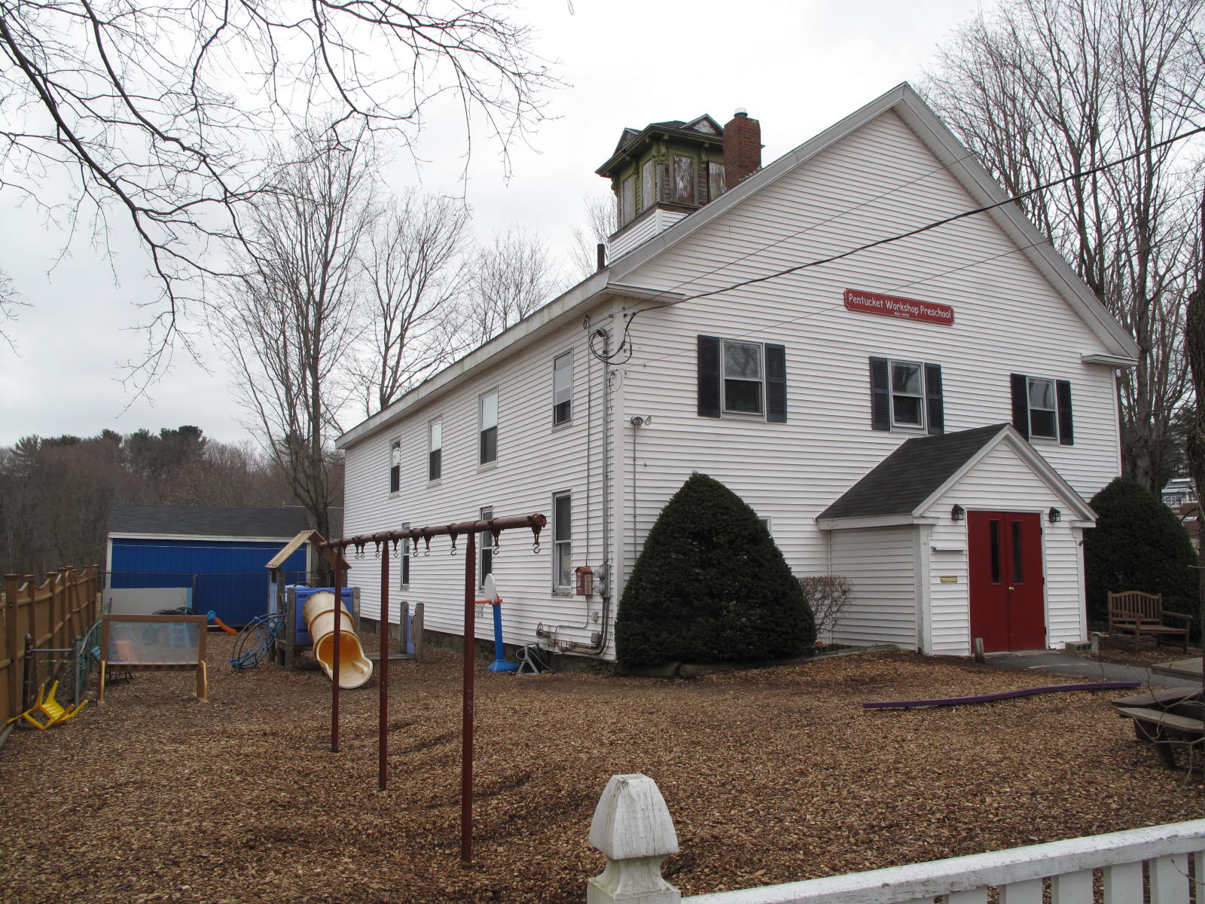
22 Pleasant Street: views from NW (top and bottom)

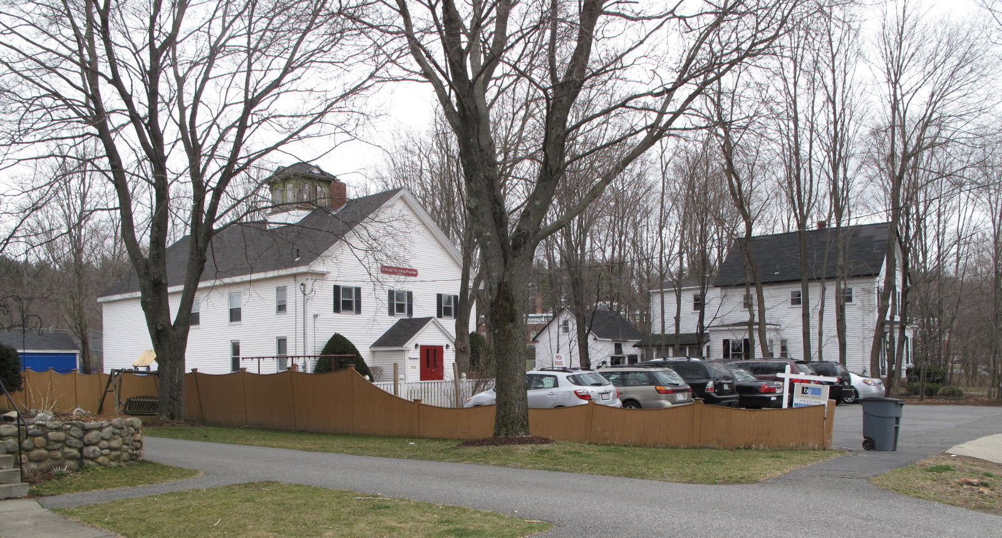

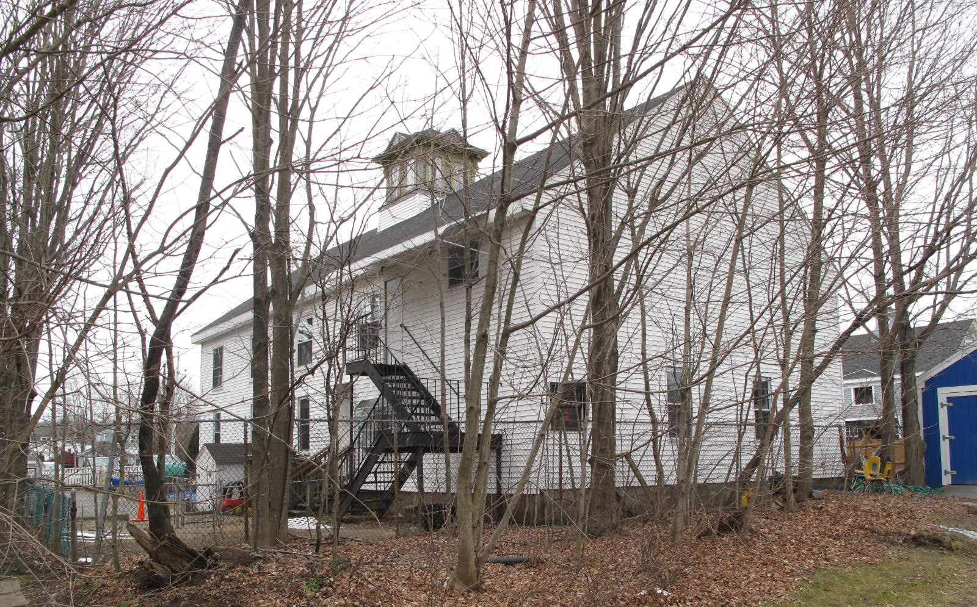
Views from NE (top) and NW (bottom)

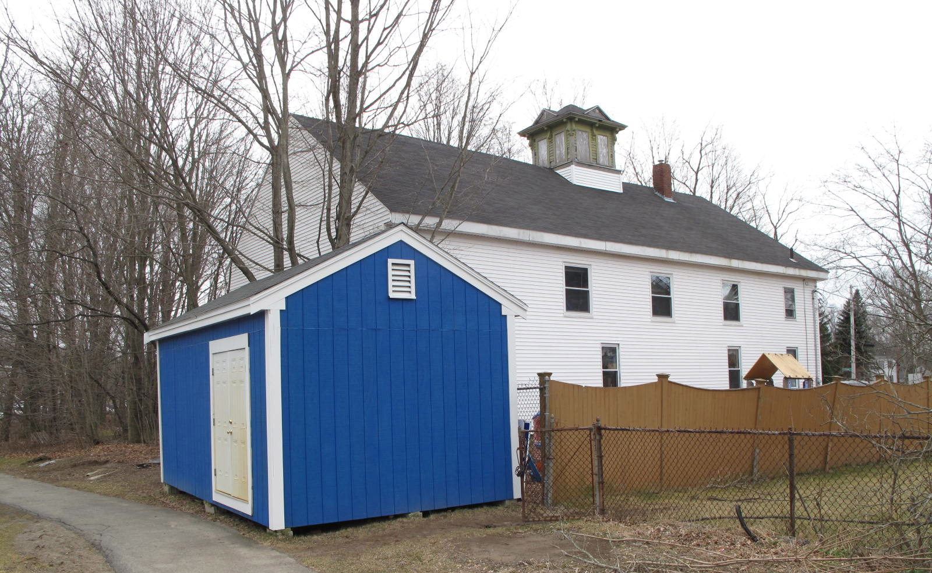

National Register of Historic Places Criteria Statement Form

Check all that apply:

Individually eligible Eligible only in a historic district

Contributing to a potential historic district Potential historic district

Criteria: A B C D

Criteria Considerations: A B C D E F G

Statement of Significance by________Neil Larson_________________________________
The criteria that are checked in the above sections must be justified here.

The Calvin R. Titcomb Warehouse / Georgetown Grange, built ca. 1891, is a distinctive surviving example of a late-19th-century warehouse in the village. While its historic exterior form and fenestration pattern are intact, changes in use, first as a grange hall and recently as a day-care center, have led to significant alterations to the façade and interior. With only a roof-top ventilator spared from the overlay of vinyl clapboard siding, alterations have compromised the visual integrity of the building. However, it is a contributing component of the village district.

George J. Tenney to Hamilton L. Perkins, 15 April 1874, SED 902:35.
Henry M. Nelson, “Town of Georgetown History,” in History of Essex County, Massachusetts, with Biographical Sketches of Many of Its Pioneers and Prominent Men, ed. D Hamilton Hurd (Philadelphia: J. W. Lewis and Co., 1888), 846; Benjamin F. Arrington Jr., ed., Municipal History of Essex County in Massachusetts (New York: Lewis Historical Publishing Co., 1922), 258.
Hamilton L. Perkins to Martha J. Wildes, 9 June 1882, SED 1086:49.
Edward P. and Martha J. Wildes to Calvin R. Titcomb, Rowley, 28 September 1891, SED, 1330:297; Edward P. and Martha J. Wildes to Calvin R. Titcomb, Rowley, 30 April 1891, SED 1312:115.
Roland E. Titcomb, trustee under will of Calvin R. Titcomb, to Georgetown Grange, 10 December 1924, SED 2623:353.

