FORM B − BUILDING

Massachusetts Historical Commission
Massachusetts Archives Building
220 Morrissey Boulevard
Boston, Massachusetts 02125

Photograph
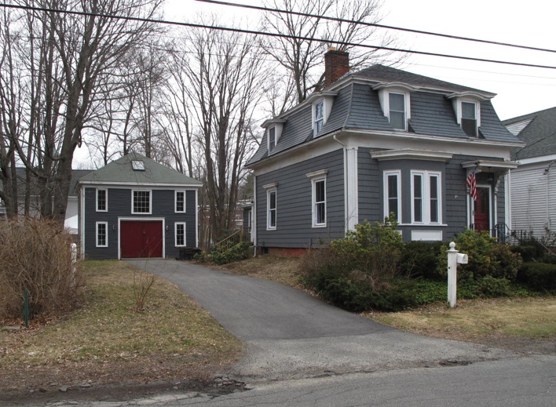
View from northwest

Locus Map (north at top)
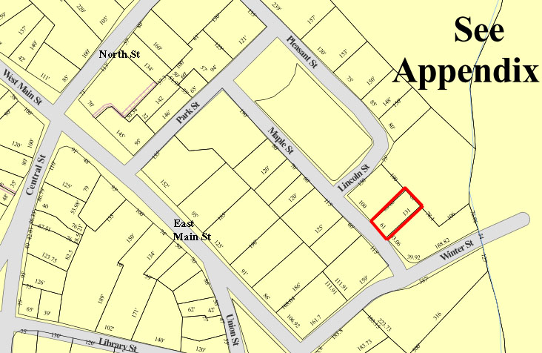

Recorded by: Kathryn Grover & Neil Larson
Organization: Town of Georgetown
Date: October 2012

Assessor’s Number USGS Quad Area(s) Form Number

11A-91 |  | Georgetown |  | C |  | GEO.153

Town/City: Georgetown
Place: (neighborhood or village):
Town Center

Address: 22 Maple Street
Historic Name: John M. & Margaret Perley House
Uses: Present: single residence
Original: single residence
Date of Construction: ca. 1873
Source: historic maps, deeds
Style/Form: Second Empire
Architect/Builder: unknown
Exterior Material:
Foundation: brick
Wall/Trim: wood shingles
Roof: wood shingles
Outbuildings/Secondary Structures:
barn
Major Alterations (with dates):
Wood shingle siding added
Hipped roof added
Rear ell added
Window sash replaced

Condition: good
Moved: no yes Date:
Acreage: 0.18 acre
Setting: This house is sited on the easterly side of Maple Street just southeast of Lincoln Park on a lot with mature trees. The area is residential.

Recommended for listing in the National Register of Historic Places.
If checked, you must attach a completed National Register Criteria Statement form.

ARCHITECTURAL DESCRIPTION
The John M. & Margaret Perley House is a one-story wood frame dwelling located on the easterly side of Maple Street north of Winter Street. The small, square-plan house was built with a “French” or mansard roof; this roof appears to have been repaired with the addition of a low hipped roof above its originally flat top section. The mansard flares out at its base to project as eaves over the house walls terminating with a plain cornice (no brackets). There are two dormers with pedimented headers on each of the walls on the front, rear and northerly sides. The remaining southerly side contains but one dormer centrally placed. The dormers are recessed into the roof. A substantial cornice distinguishes the top of the mansard. The front façade contains an entrance, under a hood mounted on scrolled brackets; the original door appears to be intact. The entrance is paired with a one-story bay window with beveled corners and a pronounced cornice. A one-story ell with a low-pitched gable roof is attached to the southerly side of the rear wall of the building. It more lately has been enlarged with an addition off its rear wall. The existing wood shingle siding was added over the original wood clapboard siding sometime in the early 20th century.

The house is elevated on a high brick basement and the surrounding yard has been graded up to it. It is sited close to the southerly lot line with a small front yard and a larger yard located in the rear. A paved driveway leads from the street along the northerly lot line to a two-story, detached barn in the rear. The wood frame, hipped roof outbuilding has a three-bay front façade with a central vehicle entrance with hanging track doors.

The John M. & Margaret Perley House is a distinctive example of a single-family dwelling designed in the Mansard or Second Empire style. Built ca. 1873, the house and its surviving detached barn are contributing components of the village district.

HISTORICAL NARRATIVE
According to historian Jane Field, the streets around what is now Lincoln Park were “opened to home construction” in 1868. The 1830 and 1856 maps of the village show the area completely undeveloped, but by 1872 the “Park” appears on the town map enclosed by Pleasant, Lincoln, Maple, and Park Streets; only Pleasant among these four streets is shown with its name. At that time no houses had been built on either Maple or Lincoln, and the only dwellings bordering Lincoln Park were those of shoe manufacturer Milton G. Tenney (at Park and Pleasant), merchant tailor Stephen Osgood (behind the Baptist Church on Pleasant Street), and shoe industry workers William Augustus Harnden, and George A. Kimball, also on Pleasant Street. The area around Lincoln Park appears to have developed as a series of individual transactions; though shoe manufacturer George Jewett Tenney owned several parcels later developed as house lots, including this one, no single developer platted the area’s residential growth.

In May 1874, George J. Tenney conveyed the land and building that is now numbered 22 Maple Street to Georgetown farmer and fuel dealer John Monroe Perley. Whether Tenney built the house is unclear, but the house was certainly on the lot when Perley acquired the property. When Tenney sold shoe shop cutter Edward A. Chaplin the lot at 11 Maple Street in 1871, the deed stipulated that it “be used as a house lot and . . . have a two story or one story & French roof on it.” This house, designed according to that specification, might have been Tenney’s model for his vision of the neighborhood—or at least those parts of it that he owned, including 9 Maple Street, where a house in similar style was constructed. By 1884, this house was one of six that had been built since 1872 on the Maple Street, two of them south of Lincoln Park on the northeast side of the street.

Born in 1844 in Rowley, John Monroe Perley was the son of David Erie and Abigail C. Perley. His father was a farmer, as John Perley was until the mid-1800s. In 1876 Perley married Margaret Howe of Boxford, and in 1880 the couple lived in Rowley with their three-year-old daughter Ethel in a household enumerated just before his father’s.

The 1884 map of Georgetown attaches the name “J. Perley” to 22 Maple, and the 1885-86 directory shows him as a wood and lumber dealer living on Maple Street. In April 1886, however, Perley sold “the messuage now occupied by me situated . . . on the street known as Maple Street” to Mary Henderson of the Boston suburb of Hyde Park for $2150. By 1900 he and his family were living in Wakefield. The Henderson family rented 22 Maple Street until October 1902, when they sold the property to Asa F. Howe, a Rowley native who worked as a traveling agent for the state reform school in Haverhill. Born in 1845, Howe served in the Massachusetts Fourth Heavy Artillery Regiment in the last year of the Civil War and in 1876 in Lewiston, Maine, married Emma M. Perley, who was born in Harrison, Maine. In 1880 he was working as a stock dealer and living with his wife and one-year-old daughter, Josephine, in the Yankee Hill section of Lincoln, Nebraska. Howe had returned to Maine by 1887, when the couple’s second daughter, Alice, was born, and by 1900 he was working for the Massachusetts Parole Department and living in Georgetown. The 1910 census shows the Howes at 22 Maple Street, by which time Asa Howe had retired. His unmarried daughter, Alice, was working as a department store stenographer; his mother-in-law, Maria C. Perley Libby, also lived with the family.

Asa Howe died in January 1929, and later that month his daughter, Alice, sold 22 Maple Street to Mary A. Hopkins. Born in Italy about 1903, Mary Balogna Mancini Hopkins emigrated in 1910 and married first Donald Mancini; the couple’s daughter, Rena, was born in Boston in October 1916. Whether Mary Mancini was widowed or divorced when she married Howard Sewell Hopkins, a Georgetown native born in August 1902, is not known. Hopkins’s father, George, was a grocer’s clerk from Hartland, Maine; his mother, Elizabeth Dummer, was a native of Rowley. The family lived on North Street in Georgetown. By 1930 Howard S. Hopkins was working in the shoe industry, and the couple lived at 22 Maple with Mary Hopkins’s daughter, Rena Mancini. By 1940 Hopkins was a post office driver and his wife worked in a shoe packing room.

In March 1951, after the death of Mary A. Hopkins, her husband and daughter, Rena, the latter the administrator of her estate, deeded the property to Rena, then married and living in Newton Center. Her husband, Howard Cole Loring, was born October 1918 and grew up in Wellesley. At the time they married in 1942, Rena Mancini was working as an actress. It was Loring’s second marriage, and six days later he enlisted in the armed services. Rena Loring had a son, Charles Raymond Loring, in May 1943 in Chicago.

In 1953 Howard Loring was a clerk at Eliot Savings Bank in Roxbury and lived in Boston, but by 1957 the Lorings had moved to 22 Maple Street. In 1985 Rena Loring deeded the Maple Street property to her son and herself, and in 2001 she deeded it to him and reserved a life estate for herself. Rena Loring died in 2003, but when her husband died is not yet known. When he died in September 2008 in Bethlehem, New Hampshire, Charles Raymond Loring was living at 22 Maple Street. In August 2009 his executor sold 22 Maple Street to current owners John Ryan Thomas and Megan C. Conlin.

BIBLIOGRAPHY and/or REFERENCES
Arrington, Benjamin F., ed. Municipal History of Essex County in Massachusetts. NY: Lewis Historical Publishing Co., 1922.
Field, Jane. A Brief History of Georgetown Massachusetts 1838-1963. Rev. ed. 1988. Georgetown: Georgetown Historical Commission, 1988.
Gage, Thomas. The History of Rowley, Anciently Including Bradford, Boxford, and Georgetown, from the Year 1639 to the Present Time. Boston: F. Andrews, 1840.
Georgetown, Boxford, Byfield, Newbury, and West Newbury, Massachusetts, Directory. Boston: W. E. Shaw, 1901-2, 1905, 1909, 1912, 1914, 1916-17, 1918, 1925.
Hill, Edwin P. “History of Georgetown, Massachusetts.” In Standard History of Essex County, Massachusetts. Edited by Cyrus M. Tracey, William E. Graves, and Henry M. Batchelder. Boston: C. F. Jewett, 1878.
Hull, Forrest P. Georgetown: Story of One Hundred Years, 1838-1938. 1938. Reprint. Georgetown, MA: Georgetown Historical Commission, 2006.
Merrill, Samuel. A Merrill Memorial: An Account of the Descendants of Nathaniel Merrill, an Early Settler of Newbury, Massachusetts. Cambridge, MA, 1917-28.
Nelson, Henry M. “Town of Georgetown History.” In Hurd, D. Hamilton. History of Essex County, Massachusetts, with Biographical Sketches of Many of Its Pioneers and Prominent Men. Vol. 1. Philadelphia: J. W. Lewis and Co., 1888.
Sammarco, Anthony Mitchell, for Georgetown Historical Society. Images of America: Georgetown. Portsmouth, NH: Arcadia Publishing, 2002.

MAPS
“Map of the Centre of Georgetown in 1800.” In Perley, Sidney H., “Centre of Georgetown in the Year 1800.” The Essex Antiquarian: A Quarterly Magazine Devoted to the Biography, Genealogy, History, and Antiquities of Essex County, Massachusetts 2, 7 (July 1898): 201.
Map of Georgetown in 1810 and 1840. In Gage, Thomas. The History of Rowley, Anciently Including Bradford, Boxford, and Georgetown, from the Year 1639 to the Present Time. Boston: F. Andrews, 1840. 320.
“Map of New Rowley Surveyed and Drawn by Philander Anderson 1830.” Georgetown Historical Society.
Map of Georgetown. 1856. In Walling. H. F. A Topographical Map Essex County Massachusetts. Boston: Smith and Morley, 1856.
Atlas of Essex County, Massachusetts. Philadelphia: D. G. Beers and Co., 1872). Plates 59 and 61.
“Town of Georgetown Mass.” and “Village of Georgetown Mass.” In Atlas of Essex County, Massachusetts (Boston: George H. Walker, 1884).
“Georgetown, Mass. 1887.” Drawn and Published by George E. Norris, Brockton, Massachusetts. Troy, NY: Burleigh Lithographic Establishment, 1887.”

PHOTOGRAPHS (all photos by Neil Larson, 2012)

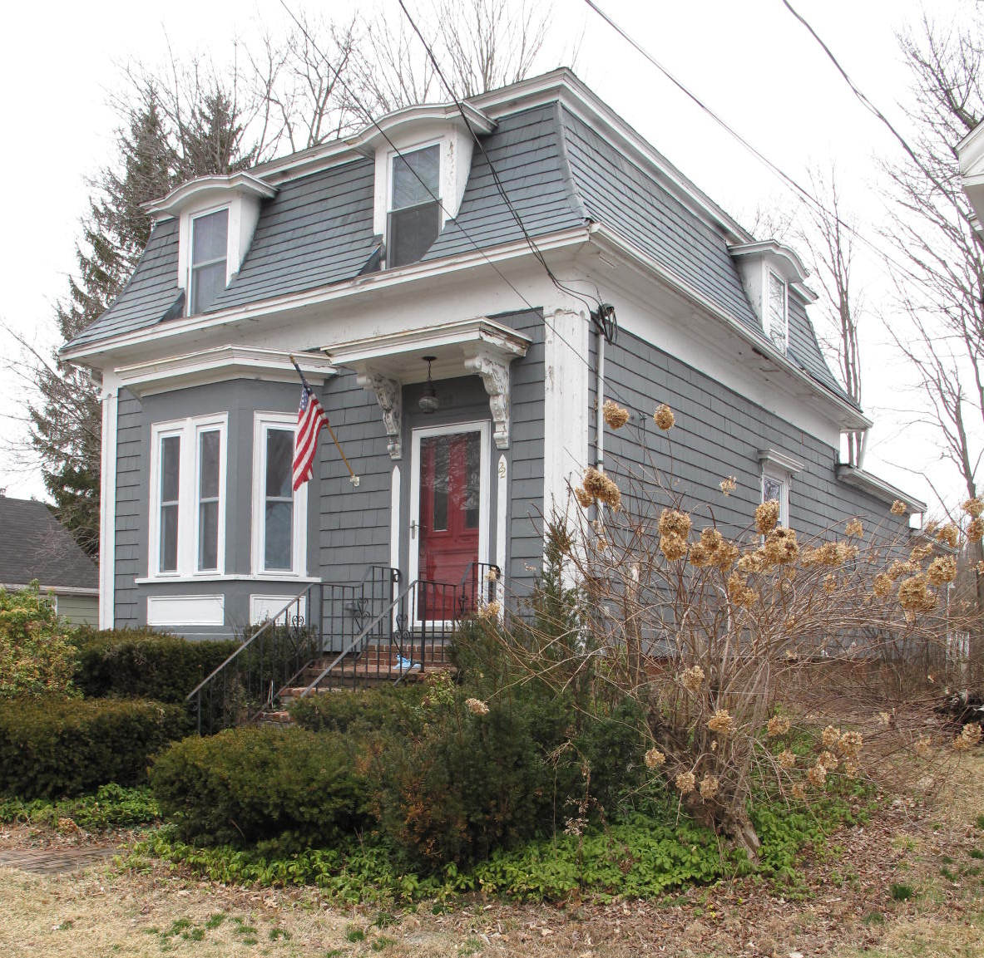
22 Maple Street: view from SW

National Register of Historic Places Criteria Statement Form

Check all that apply:

Individually eligible Eligible only in a historic district

Contributing to a potential historic district Potential historic district

Criteria: A B C D

Criteria Considerations: A B C D E F G

Statement of Significance by________Neil Larson_________________________________
The criteria that are checked in the above sections must be justified here.

The John M. & Margaret Perley House is a distinctive example of a single-family dwelling designed in the Mansard or Second Empire style. Built ca. 1873, the house and its surviving detached barn are contributing components of the village district.

George J. Tenney to John M. Perley, 7 May 1874, SED 953:2.
See George J. Tenney to Edward A. Chaplin, 2 June 1871, SED 826:165.
John M. Perley to Mary Henderson, 6 April 1886, SED 1171:111.
Eliza J. Henderson, Southborough, to Asa F. Howe, 23 October 1902, SED 1688:464.
Alice M. Howe to Mary A. Hopkins, 23 January 1929, SED 2796:215. See also Asa F. Howe to LeRoy H. Clough, 11 March 1907, SED 1869:121; LeRoy H. Clough, Bradford, to Emma M. Howe, 11 March 1907, SED 1869:122; and Emma M. Howe to Alice M. Howe, 10 January 1927, SED 2711:48. LeRoy Herbert Clough married the Howe’s daughter Josephine in 1906.
Howard S. Hopkins to Rena A. Loring, wife of Howard C. Loring, 26 March 1951, SED 3809:352; Rena A. Loring, administrator of estate of Mary A. Hopkins, to Rena A. Loring, Newton Center, 26 March 1951, SED 3809:351-52.
Rena Loring to Rena A. and Charles Raymond Loring, 6 January 1985, SED 7645:29; Rena A. Loring and Charles Raymond Loring, 22 Maple, to Charles Raymond Loring, 15 January 2001, SED 16826:240; Stephen Price, Essex, affidavit, 14 August 2009, SED 28863:361; Stephen Price, executor of will Charles Raymond Loring II, late of 22 Maple St, to John Ryan Thomas and Megan C. Conlin, 10 August 2009, SED 28851:317.

