FORM B − BUILDING

Massachusetts Historical Commission
Massachusetts Archives Building
220 Morrissey Boulevard
Boston, Massachusetts 02125

Photograph
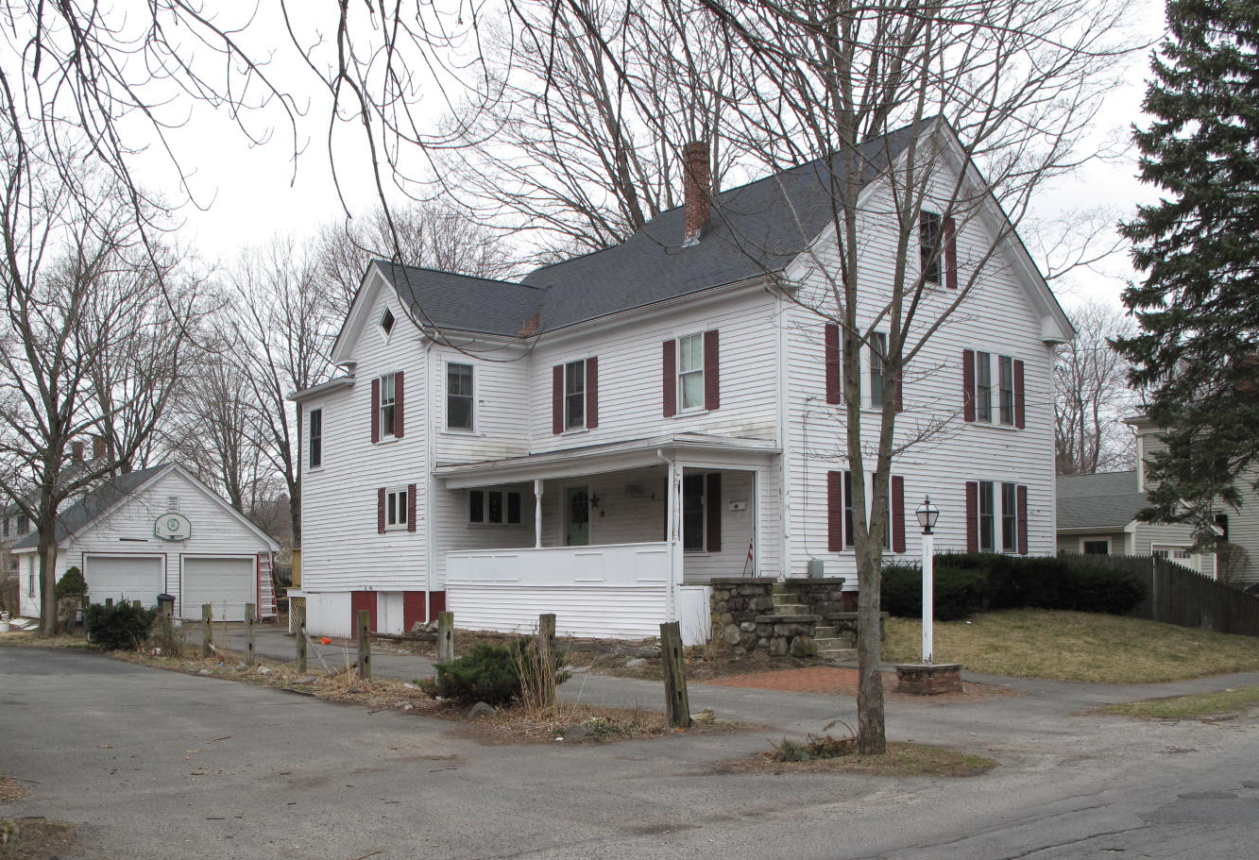
View from northeast

Locus Map (north at top)
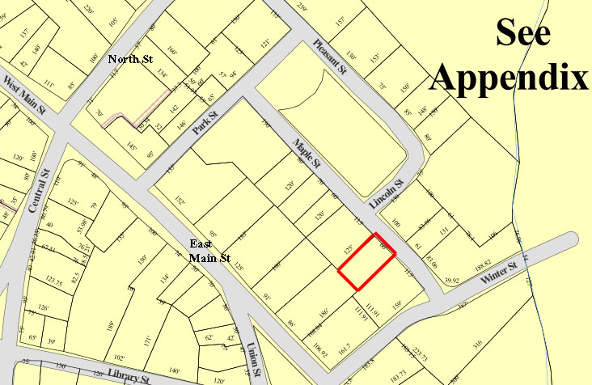

Recorded by: Kathryn Grover & Neil Larson
Organization: Town of Georgetown
Date: October 2012

Assessor’s Number USGS Quad Area(s) Form Number

11A-112 |  | Georgetown |  | C |  | GEO.152

Town/City: Georgetown
Place: (neighborhood or village):
Town Center

Address: 19 Maple Street
Historic Name: Hoyt Brothers’ House
(Martin L. & Mary F. Hoyt and Charles N. & Addie Hoyt House)
Uses: Present: single residence
Original: double residence
Date of Construction: ca. 1878
Source: deeds, historic maps, vital records
Style/Form: Classical Revival
Architect/Builder: unknown
Exterior Material:
Foundation: brick
Wall/Trim: wood clapboards
Roof: asphalt shingles
Outbuildings/Secondary Structures:
garage
Major Alterations (with dates):
Base of side porch reconstructed
Rear addition

Condition: good
Moved: no yes Date:
Acreage: 0.17 acre
Setting: This house is sited on the westerly side of Maple Street just southeast of Lincoln Park on a lot with mature trees. The area is residential.

Recommended for listing in the National Register of Historic Places.
If checked, you must attach a completed National Register Criteria Statement form.

ARCHITECTURAL DESCRIPTION
The Hoyt Brothers’ House is a two-story wood frame dwelling located on the westerly side of Maple Street south of Lincoln Street. The front-gable house was constructed as a two-family dwelling with separate living units on each story. The front façade contains two pairs of windows on each level and a single window in the attic. The façade is framed by narrow corner pilasters and a Classical entablature along the raking roof edge that terminates at short returns at the eaves. The entrance is located in the center of the southerly side of the house under an open porch that extends from the front corner to a two-story cross-gable pavilion at the rear of the façade. The pavilion is one bay wide and one bay deep, with a lozenge window centered in the gable; original windows on the first story have been replaced with casements, evidently part of a recent kitchen remodeling within. Turned posts support the hipped porch roof, but what likely was a balustrade has been replaced with a paneled kneewall at floor level. The underside of the porch has been walled in with vinyl clapboards, and stone steps have been added at the front. The single entrance appears to have served both interior dwellings.

The northerly side of the house contains two window bays on both stories. A two-story rear ell is offset to the southerly side. The pavilion visible on the southerly side is an extension of the ell. A two-story, flat roof wing attached to the rear of the pavilion looks to be an exterior staircase later enclosed. The house is elevated on a high brick basement, with the yard terraced around it on the front and northerly side; the yard is characterized as lawn with a few mature trees and foundation plantings. A paved driveway is aligned with the southerly lot line and runs from the street to a one-story, wood frame garage at the rear of the property. The front-gable façade contains two vehicle bays with overhead doors.

The Hoyt Brothers’ House is an intact example of late-19th-century domestic architecture in Georgetown’s center. Built ca. 1878 as a two-family dwelling, it is retains its original wood clapboard siding and two-over-one wood sash windows. The building is a contributing component of the village district.

HISTORICAL NARRATIVE
According to historian Jane Field, the streets around what is now Lincoln Park were “opened to home construction” in 1868. The 1830 and 1856 maps of the village show the area completely undeveloped, but by 1872 the “Park” appears on the town map enclosed by Pleasant, Lincoln, Maple, and Park Streets; only Pleasant among these four streets is shown with its name. At that time no houses had been built on either Maple or Lincoln, and the only dwellings bordering Lincoln Park were those of shoe manufacturer Milton G. Tenney (at Park and Pleasant), merchant tailor Stephen Osgood (behind the Baptist Church on Pleasant Street), and shoe industry workers William Augustus Harnden, and George A. Kimball, also on Pleasant Street. The area around Lincoln Park appears to have developed as a series of individual transactions; though shoe manufacturer George Jewett Tenney owned several parcels later developed as house lots, including this one, no single developer platted the area’s residential growth.

Who built 19 Maple Street is unclear, but in November 1879 Georgetown Savings Bank sold the lot and its buildings for $1453.81 to Georgetown grocer John Andrew Hoyt, who lived in South Georgetown (by the 1880s on Baldpate Road) and appears to have acquired the house for his sons Martin L. and Charles N. Hoyt, who had married in November 1879 and June 1880 respectively. Born in Otisfield, Maine, about 1823, John A. Hoyt married Mary Nelson of Acworth, New Hampshire, in 1846; her mother Hannah Nelson March was a native of Georgetown, the daughter of Aaron Nelson Sr. (1740-1804). John and Mary N. Hoyt’s children—Martin L., Forrester A., and Charles N.—were born in Naples, Maine, between 1848 and 1853. By 1870 the family had moved to Georgetown. Martin, then twenty-two, was a shoemaker; Forrester worked as a grocery clerk, no doubt for his father.

By 1880 the census indicates that Martin Hoyt, newly married, was living at 19 Maple Street with his wife Mary F. Johnson of Newburyport; his brother Charles, not yet married, was still living in his parents’ household. Both were ice dealers. The 1884 town map attaches the names of both Martin and Charles to the 19 Maple Street house, while their brother Forrester and his wife, Amanda A. Johnson, lived nearby at 24 Maple Street. The 1885-86 directory shows the brothers all as residents of Maple Street. Martin and Charles were still ice dealers, while Forrester is shown there as a wood dealer.

In 1900 19 Maple Street was occupied by Martin Hoyt, by then a carpenter, and his wife Mary, and his brother Charles, a grocery clerk for H. Prescott Poor, and his wife Addie and two children—John Andrew, born in 1882, and Alice M., born in 1898. Martin Hoyt boarded the provisions proprietor Calvin Titcomb, while Charles’s household included a domestic servant. By 1910 the brothers rented part of the house to Irish-born street railway electrician Walter Bodell and his wife, and both also boarded their fathers-in-law. Charles Hoyt died in 1912, and by 1916 his widow and children are shown at 24 Maple, Forrester Hoyt’s former home; he and his wife Amanda had moved to the family farm on Baldpate Road by 1901 and to 13 Central Street by 1909.

The 1920 census shows Martin L. Hoyt as a seventy-two-year-old shoe factory cutter living with his wife Mary at 19 Maple Street. He died in 1926, and in 1929 his widow deeded 19 Maple Street to the Newburyport Society for the Relief of Aged Women. The society owned the property for about six months and sold it in April 1930 to Carrie Adams, the wife of Robert Byron Adams, who had grown up at 15 Maple Street. The son of Wallace E. and Rosetta Merrill Adams, Robert B. Adams was born in Georgetown in 1896 and was working as a grocery clerk for Moses N. Boardman in Georgetown by 1917. He lived at the time at 7 Maple Street, which his parents then rented. The 1920 census shows the Adamses at 7 Maple; Robert was still a grocery clerk. In 1928 he was working as an expressman when he married Carrie L. Whittier of Bradford, and by 1930 the couple was renting on Library Street and had a daughter, Charlotte, born that year.

The 1940 census shows Robert and Carrie Adams and their daughter, Charlotte, living at 19 Maple Street with a Canadian-born shoe packer to whom they rented a room. Robert Adams was then working as a “counterman” at a restaurant. During World War II he worked at Charlestown Navy Yard.

In April 1957 Carrie Adams sold 19 Maple Street to engineer Albert V. Lindquist and his wife Ruth, who lived in Gloucester before moving to this address. In 1962 the Lindquists sold the property to Henry A. and Mary E. Conti, who owned it until 2004. In that year Henry Conti sold the property to current owners Diane E. and Benjamin M. Ryan.

BIBLIOGRAPHY and/or REFERENCES
Arrington, Benjamin F., ed. Municipal History of Essex County in Massachusetts. NY: Lewis Historical Publishing Co., 1922.
Field, Jane. A Brief History of Georgetown Massachusetts 1838-1963. Rev. ed. 1988. Georgetown: Georgetown Historical Commission, 1988.
Gage, Thomas. The History of Rowley, Anciently Including Bradford, Boxford, and Georgetown, from the Year 1639 to the Present Time. Boston: F. Andrews, 1840.
Georgetown, Boxford, Byfield, Newbury, and West Newbury, Massachusetts, Directory. Boston: W. E. Shaw, 1901-2, 1905, 1909, 1912, 1914, 1916-17, 1918, 1925.
Hill, Edwin P. “History of Georgetown, Massachusetts.” In Standard History of Essex County, Massachusetts. Edited by Cyrus M. Tracey, William E. Graves, and Henry M. Batchelder. Boston: C. F. Jewett, 1878.
Hull, Forrest P. Georgetown: Story of One Hundred Years, 1838-1938. 1938. Reprint. Georgetown, MA: Georgetown Historical Commission, 2006.
Merrill, Samuel. A Merrill Memorial: An Account of the Descendants of Nathaniel Merrill, an Early Settler of Newbury, Massachusetts. Cambridge, MA, 1917-28.
Nelson, Henry M. “Town of Georgetown History.” In Hurd, D. Hamilton. History of Essex County, Massachusetts, with Biographical Sketches of Many of Its Pioneers and Prominent Men. Vol. 1. Philadelphia: J. W. Lewis and Co., 1888.
Sammarco, Anthony Mitchell, for Georgetown Historical Society. Images of America: Georgetown. Portsmouth, NH: Arcadia Publishing, 2002.

MAPS
“Map of the Centre of Georgetown in 1800.” In Perley, Sidney H., “Centre of Georgetown in the Year 1800.” The Essex Antiquarian: A Quarterly Magazine Devoted to the Biography, Genealogy, History, and Antiquities of Essex County, Massachusetts 2, 7 (July 1898): 201.
Map of Georgetown in 1810 and 1840. In Gage, Thomas. The History of Rowley, Anciently Including Bradford, Boxford, and Georgetown, from the Year 1639 to the Present Time. Boston: F. Andrews, 1840. 320.
“Map of New Rowley Surveyed and Drawn by Philander Anderson 1830.” Georgetown Historical Society.
Map of Georgetown. 1856. In Walling. H. F. A Topographical Map Essex County Massachusetts. Boston: Smith and Morley, 1856.
Atlas of Essex County, Massachusetts. Philadelphia: D. G. Beers and Co., 1872). Plates 59 and 61.
“Town of Georgetown Mass.” and “Village of Georgetown Mass.” In Atlas of Essex County, Massachusetts (Boston: George H. Walker, 1884).
“Georgetown, Mass. 1887.” Drawn and Published by George E. Norris, Brockton, Massachusetts. Troy, NY: Burleigh Lithographic Establishment, 1887.”

PHOTOGRAPHS (all photos by Neil Larson, 2012)

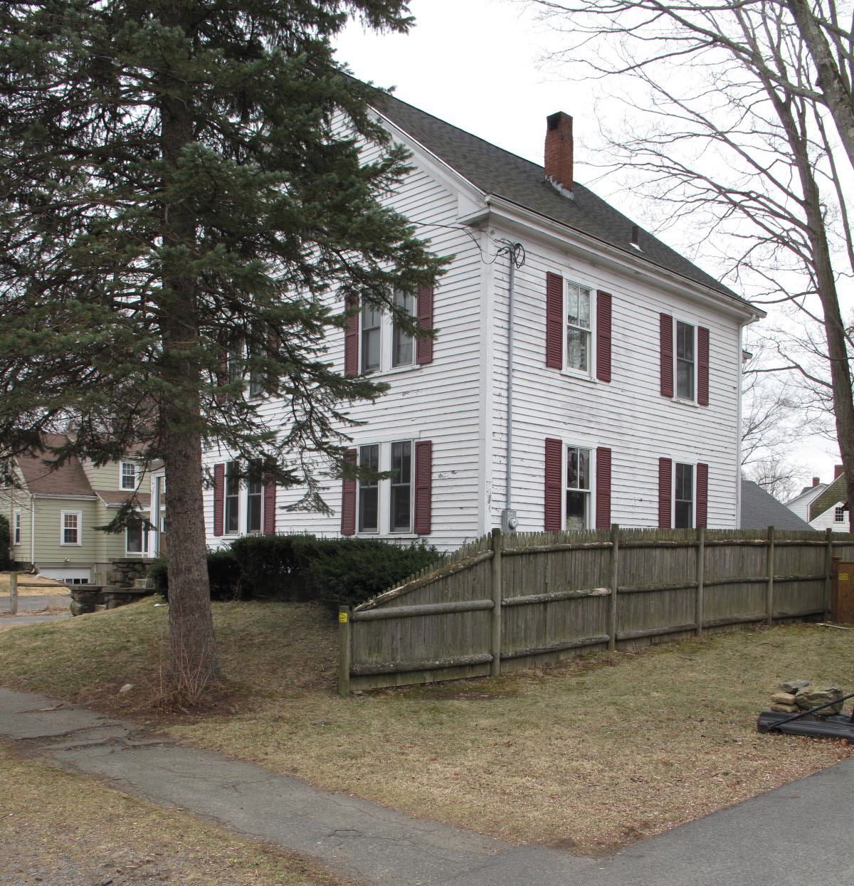
19 Maple Street: view from N (top) and NW (bottom)

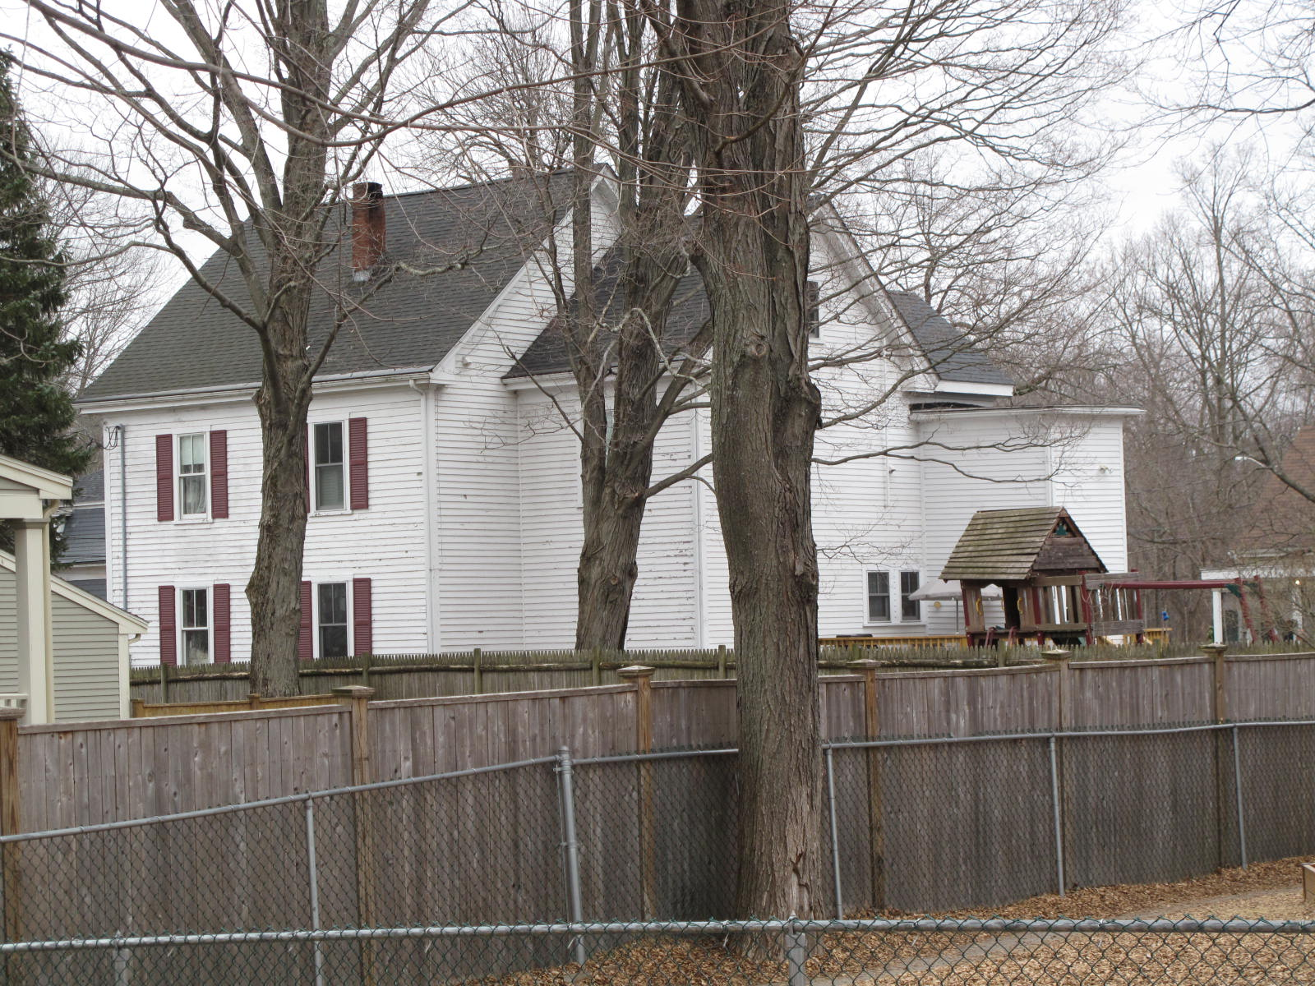

National Register of Historic Places Criteria Statement Form

Check all that apply:

Individually eligible Eligible only in a historic district

Contributing to a potential historic district Potential historic district

Criteria: A B C D

Criteria Considerations: A B C D E F G

Statement of Significance by________Neil Larson_________________________________
The criteria that are checked in the above sections must be justified here.

The Hoyt Brothers’ House is an intact example of late-19th-century domestic architecture in Georgetown’s center. Built ca. 1878 as a two-family dwelling, it is retains its original wood clapboard siding and two-over-one wood sash windows. The building is a contributing component of the village district.

Georgetown Savings Bank to John A. Hoyt, 7 November 1879, SED 1028:181.
The Hoyt brothers all married women whose surname was Johnson, but they were not sisters. Martin’s wife Mary F. was the daughter of Sewell T. and Elizabeth M. Johnson of Newburyport; Charles’s wife Addie F. was the daughter of Benjamin A. and Henrietta Davis Johnson, also of Newburyport; and Forrester’s wife Amanda A. was the daughter of Joseph and Rebecca Kneeland Johnson of Rowley.
Mary F. Hoyt to Newburyport Society for the Relief of Aged Women, 1 November 1929, SED 2830:530. See also Forrester A. Hoyt and Charles N. Hoyt to Martin L. Hoyt, 22 August 1893, SED 1397:61.
Newburyport Society for the Relief of Aged Women to Carrie L. Adams, 8 April 1930, SED 2842:25
Carrie L. Adams to Albert V. and Ruth L. Lindquist, 8 April 1957, SED 4358:521; Albert V. and Ruth L. Lindquist to Henry A. and Mary E. Conti, 14 December 1962, SED 5021:11; Henry A. Conti, 1A Spruce Lane, to Diane E. and Benjamin M. Ryan, 19 Maple Street, 14 December 2004, SED 23784:5.

