FORM B − BUILDING

Massachusetts Historical Commission
Massachusetts Archives Building
220 Morrissey Boulevard
Boston, Massachusetts 02125

Photograph
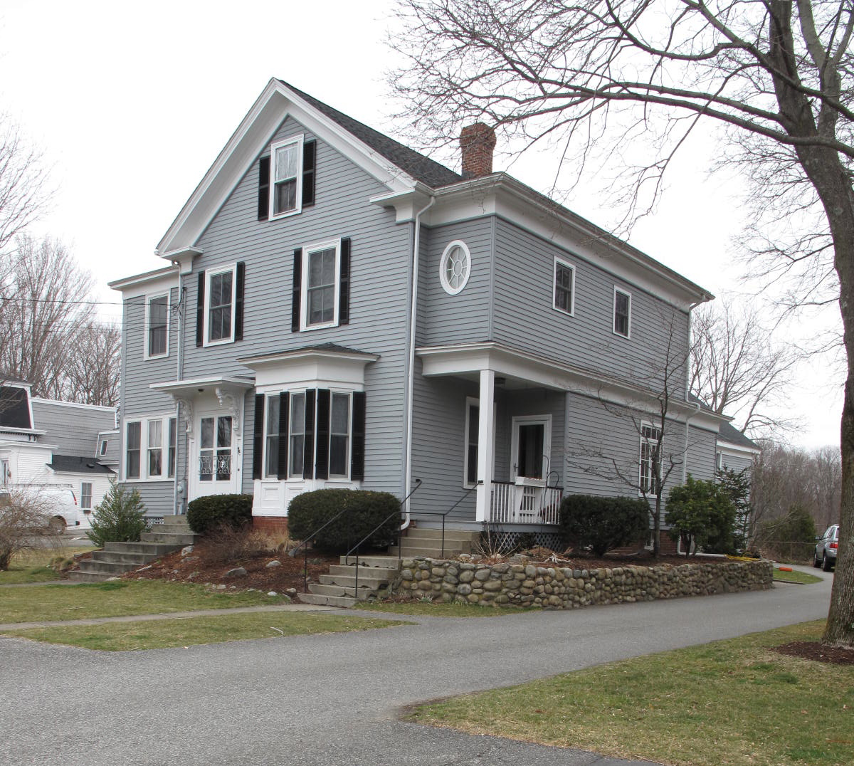
View from southeast

Locus Map (north at top)
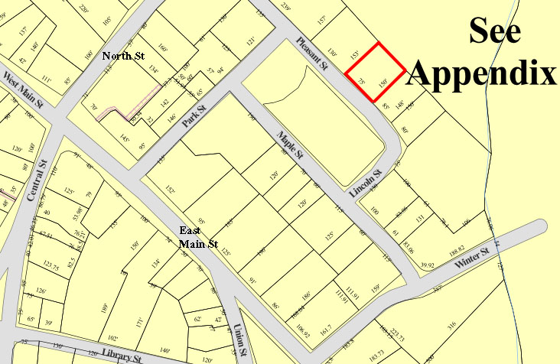

Recorded by: Kathryn Grover & Neil Larson
Organization: Town of Georgetown
Date: October 2012

Assessor’s Number USGS Quad Area(s) Form Number

11A-96 |  | Georgetown |  | C |  | GEO.170

Town/City: Georgetown
Place: (neighborhood or village):
Town Center

Address: 18 Pleasant Street
Historic Name: George A. & Annie F. Kimball House
Uses: Present: single residence
Original: single residence
Date of Construction: ca. 1871
Source: deeds, historic maps
Style/Form: Classical Revival
Architect/Builder: unknown
Exterior Material:
Foundation: brick
Wall/Trim: wood clapboards
Roof: asphalt shingles
Outbuildings/Secondary Structures:
Barn (attached)
Major Alterations (with dates):
Second story added to porch on SE side, ca. 1915
2 story wing added to NW side, ca. 1915
Rear hyphen built, late 20th C

Condition: good
Moved: no yes Date:
Acreage: 0.28 acre
Setting: This house is sited on the north side of Pleasant Street opposite Lincoln Park on a lot with mature trees. The area is a mix of residential and institutional uses.

Recommended for listing in the National Register of Historic Places.
If checked, you must attach a completed National Register Criteria Statement form.

ARCHITECTURAL DESCRIPTION
The George A. & Annie F. Kimball House is a two-story wood frame dwelling located on the northerly side of Pleasant Street northwest of Lincoln Street. Built ca. 1871, the house has interior plan with two principal rooms aligned front-to-back on the southerly side of the house and an entry and secondary room on the northerly side. The front façade contains an entrance with a hood mounted on ornate scrolled brackets offset by a one-story bay window with beveled corners. Two windows are located in the second story and are aligned with the entrance and bay window below them skewing their spacing. A single window is centered in the attic. A Classical entablature distinguishes the raking roof edge and makes short returns at the eaves.

A depiction of the house in an 1887 birdseye view of the village shows a one-story porch on the southerly side open in the front and enclosed in the rear. Around 1915, probably when the house changed hands out of the Kimball family, this porch was renovated and the second story of the house was expanded by an addition on top of it. A two-story addition also was built on the northerly side of the house to add interior space, a first-story sun porch and a second-story bed room, and create balanced wings on the house. These wings have flat roofs with substantial entablatures to match the existing features. The northerly addition terminates at a one-story bay window at the rear of that wall. Original two-over-two wood window sash appear to be intact. Features characteristic of the period of the additions are an oval window on the front wall of the second story addition on the southerly side and the window groups for the sun porch in the northerly addition. A narrow one-story wing also was added to the rear of the house at this time connecting with the wing on the southerly side.

When built, the rear of the house was linked by one or two outbuildings to a domestic barn in the rear; this linkage has been replaced by a one-story, wood frame hyphen with a gable roof built in the late 1900s. The original two-story barn is essentially intact with its gable roof and decorated ventilator, vehicle entry centered in the southerly side wall with mow door above, and original fenestration. The long building occupies most of its small lot, in which it is centered and surrounded by a limited yard. A paved driveway enters the southwest corner of the property from the street and follows the southerly lot line to a parking area in front of the barn.

The George A. & Annie F. Kimball House, built ca. 1871, is a distinctive residence designed in the form of middling village dwellings with connected barns typical in the mid- and late-19th century. The house is essentially intact, and has compatible early-20th-century additions that reflect it’s the history development. The building is a contributing component of the village district.

HISTORICAL NARRATIVE
According to historian Jane Field, the streets around what is now Lincoln Park were “opened to home construction” in 1868. The 1830 and 1856 maps of the village show the area completely undeveloped, but by 1872 the “Park” appears on the town map enclosed by Pleasant, Lincoln, Maple, and Park Streets; only Pleasant among these four streets is shown with its name. At that time no houses had been built on either Maple or Lincoln, and the only dwellings bordering Lincoln Park were those of shoe manufacturer Milton G. Tenney (at Park and Pleasant), shoe industry workers William Augustus Harnden, and George A. Kimball, both on Pleasant Street, and the 10 Pleasant Street home of merchant tailor Stephen Osgood, behind the Baptist Church on North Street. The area around Lincoln Park appears to have developed as a series of individual transactions; though shoe manufacturer George Jewett Tenney owned several parcels later developed as house lots, no single developer platted the area’s residential growth. However, the lots that Tenney controlled, including his own property, were developed with houses designed in the Second Empire style.

In June 1871 Tenney sold the lot on which this house stands to Annie F. Todd Kimball, the wife of George A. Kimball, with the stipulation that whatever house she should build on the lot “be 2 story or one story & French roof & to set on line with Harndens and Osgoods,” the houses by then built at 14 and 10 Pleasant Street, respectively. At least one other deed that Tenney executed in the same month as that for 18 Pleasant Street—to shoe shop cutter Edward A. Chaplin for 11 Maple Street—contained the same stipulation about the size and style of house that 18 Pleasant Street did. Why the Kimballs chose not to build a house in the mandated style is unknown, as is any reaction to their apparent violation.

Born in Rowley in January 1830, George A. Kimball was the son of John and Louisa Adams Kimball, who lived for many years on Library Street in Georgetown. In 1860 he was working as a farmer when he married Anna F. Todd of Rowley in Boston. Their daughter Hattie Palmer Kimball was born in April 1861. Where the family lived in 1870 is not yet known, but the 1872 map of Georgetown documents that they had built this house by that time. In 1880 the family is shown in the census in the house; by then George A. Kimball was a “meat dealer on road,” while Hattie worked as a milliner.

In 1893 Annie Todd Kimball died, and the next year Hattie Palmer Kimball married Georgetown native and shoe cutter John Edward Bickford, son of Isaac T. and Susan S. Bateman Bickford. They were both thirty-three years old, and they had no children. In May 1896 George Kimball deeded 18 Pleasant Street to his daughter, and the 1900 census shows the couple and Kimball in the house together. In 1910 only George A. Kimball, then doing “general work” for a grocery store, and Harriet Kimball Bickford lived in the house.

By 1914 Harriet Bickford had moved to Haverhill, and she sold 18 Pleasant Street to Calvin Noyes Pingree of Georgetown. Born in Georgetown in 1876, Pingree was the son of Asa and Jane Noyes Pingree, and by the time he was twenty he was living in Haverhill and working as a linotype operator for the Sunday Record. In 1910 he married Harriet Olive Harriman, daughter of Georgetown shoe manufacturer Horace E. Harriman and his wife Mary Balcom. By 1917 Pingree was foreman of the Record Publishing Company and by 1920 superintendent, a position he held at least through the late 1940s.

The 1920 census shows Calvin and H. Olive Pingree at 18 Pleasant Street with their children Horace Nelson, born in 1911, Calvin Jr., born in 1912, and Lewis Asa, born in 1914. The Pingree family continues to own the property. The 1940 census shown Calvin Noyes Pingree as a “linertype” operator with $3500 in real property; his wife Olive was then fifty-eight, and her widowed mother Mary C. Harriman lived with them. Calvin N. Pingree died in 1958, and the next year his sons H. Nelson and Lewis deeded their shares in 18 Pleasant Street to their mother. In 1968 Olive Harriman Pingree transferred title to her son, Calvin H. Pingree, and his wife, Patricia L. Pingree, who in 1992 deeded it to current owners Jonathan N. and Daniella M. Pingree.

BIBLIOGRAPHY and/or REFERENCES
Arrington, Benjamin F., ed. Municipal History of Essex County in Massachusetts. NY: Lewis Historical Publishing Co., 1922.
Field, Jane. A Brief History of Georgetown Massachusetts 1838-1963. Rev. ed. 1988. Georgetown: Georgetown Historical Commission, 1988.
Gage, Thomas. The History of Rowley, Anciently Including Bradford, Boxford, and Georgetown, from the Year 1639 to the Present Time. Boston: F. Andrews, 1840.
Georgetown, Boxford, Byfield, Newbury, and West Newbury, Massachusetts, Directory. Boston: W. E. Shaw, 1901-2, 1905, 1909, 1912, 1914, 1916-17, 1918, 1925.
Hill, Edwin P. “History of Georgetown, Massachusetts.” In Standard History of Essex County, Massachusetts. Edited by Cyrus M. Tracey, William E. Graves, and Henry M. Batchelder. Boston: C. F. Jewett, 1878.
Hull, Forrest P. Georgetown: Story of One Hundred Years, 1838-1938. 1938. Reprint. Georgetown, MA: Georgetown Historical Commission, 2006.
Merrill, Samuel. A Merrill Memorial: An Account of the Descendants of Nathaniel Merrill, an Early Settler of Newbury, Massachusetts. Cambridge, MA, 1917-28.
Nelson, Henry M. “Town of Georgetown History.” In Hurd, D. Hamilton. History of Essex County, Massachusetts, with Biographical Sketches of Many of Its Pioneers and Prominent Men. Vol. 1. Philadelphia: J. W. Lewis and Co., 1888.
Sammarco, Anthony Mitchell, for Georgetown Historical Society. Images of America: Georgetown. Portsmouth, NH: Arcadia Publishing, 2002.

MAPS
“Map of the Centre of Georgetown in 1800.” In Perley, Sidney H., “Centre of Georgetown in the Year 1800.” The Essex Antiquarian: A Quarterly Magazine Devoted to the Biography, Genealogy, History, and Antiquities of Essex County, Massachusetts 2, 7 (July 1898): 201.
Map of Georgetown in 1810 and 1840. In Gage, Thomas. The History of Rowley, Anciently Including Bradford, Boxford, and Georgetown, from the Year 1639 to the Present Time. Boston: F. Andrews, 1840. 320.
“Map of New Rowley Surveyed and Drawn by Philander Anderson 1830.” Georgetown Historical Society.
Map of Georgetown. 1856. In Walling. H. F. A Topographical Map Essex County Massachusetts. Boston: Smith and Morley, 1856.
Atlas of Essex County, Massachusetts. Philadelphia: D. G. Beers and Co., 1872). Plates 59 and 61.
“Town of Georgetown Mass.” and “Village of Georgetown Mass.” In Atlas of Essex County, Massachusetts (Boston: George H. Walker, 1884).
“Georgetown, Mass. 1887.” Drawn and Published by George E. Norris, Brockton, Massachusetts. Troy, NY: Burleigh Lithographic Establishment, 1887.”

PHOTOGRAPHS (all photos by Neil Larson, 2012)

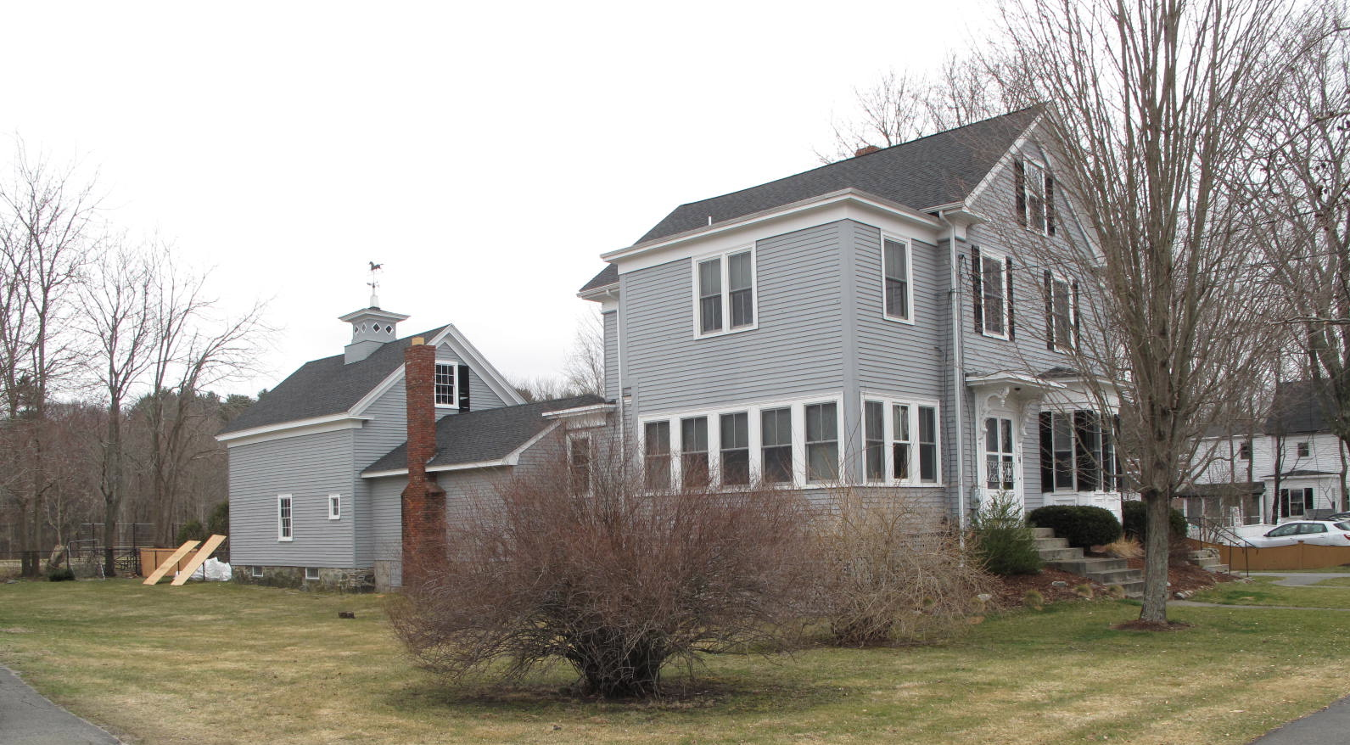
18 Pleasant Street: view from SW

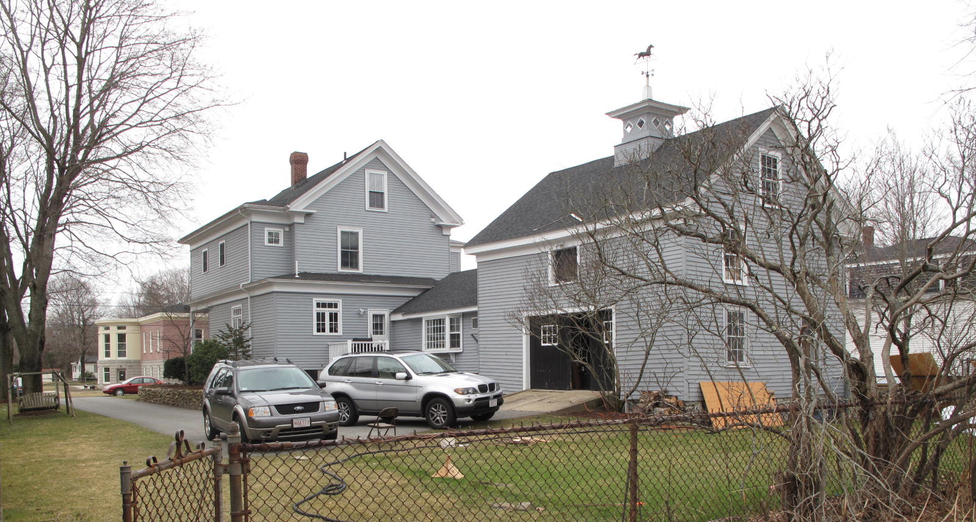
View from E (top) and NW (bottom)

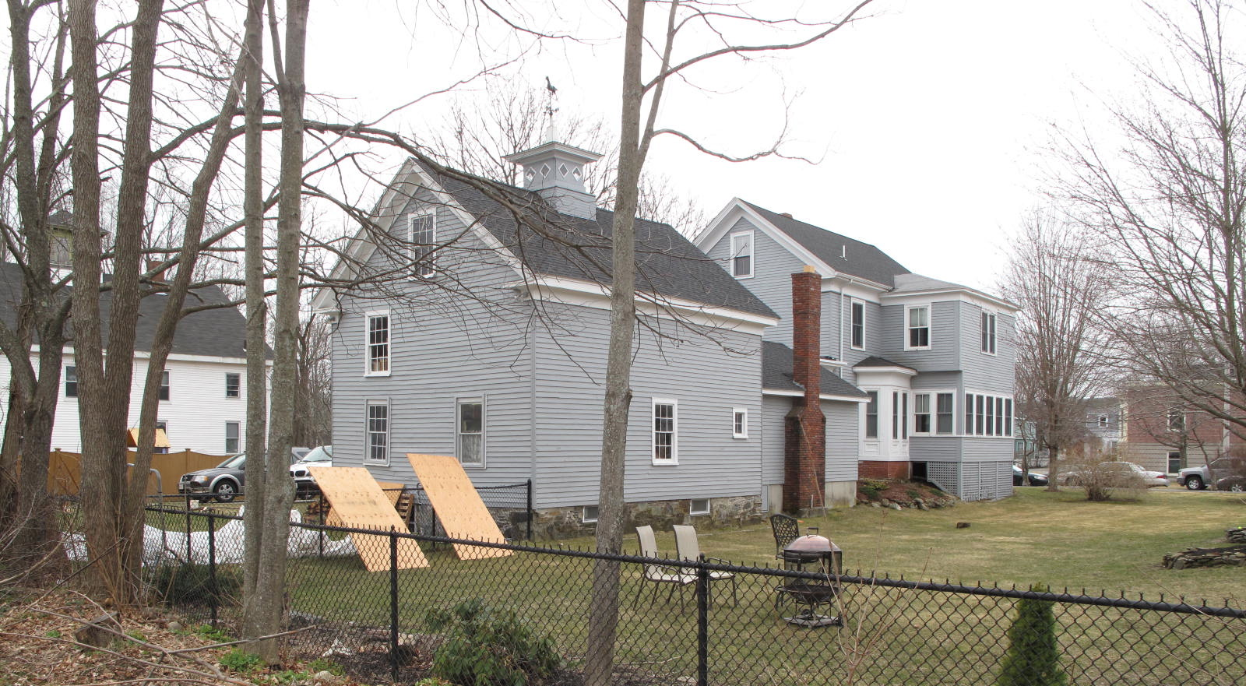

National Register of Historic Places Criteria Statement Form

Check all that apply:

Individually eligible Eligible only in a historic district

Contributing to a potential historic district Potential historic district

Criteria: A B C D

Criteria Considerations: A B C D E F G

Statement of Significance by________Neil Larson_________________________________
The criteria that are checked in the above sections must be justified here.

The George A. & Annie F. Kimball House, built ca. 1871, is a distinctive residence designed in the form of middling village dwellings with connected barns typical in the mid- and late-19th century. The house is essentially intact, and has compatible early-20th-century additions that reflect it’s the history development. The building is a contributing component of the village district.

George J. Tenney to Annie F. Kimball, 2 June 1871, SED 862:36.
See George J. Tenney to Edward A. Chaplin, 2 June 1871, SED 826:165.
George A. Kimball to Harriet P. Bickford, 25 May 1896, SED 1480:90.
Harriet P. Bickford, Haverhill, to Calvin A. Pingree, 6 October 1914, SED 2279:316.
H. Nelson Pingree and Lewis A. Pingree to Olive H. Pingree, 13 February 1959, SED 4537:598; Olive H. Pingree to Calvin H. and Patricia L. Pingree, 13 December 1968, SED 5583:272; Calvin H. and Patricia L. Pingree to Calvin H. Pingree, 31 May 1990, SED 10465:178; Calvin H. Pingree, Groveland, to Jonathan N. and Daniella M. Pingree, 15 February 1992, SED 11139:189.

