FORM B − BUILDING

Massachusetts Historical Commission
Massachusetts Archives Building
220 Morrissey Boulevard
Boston, Massachusetts 02125

Photograph
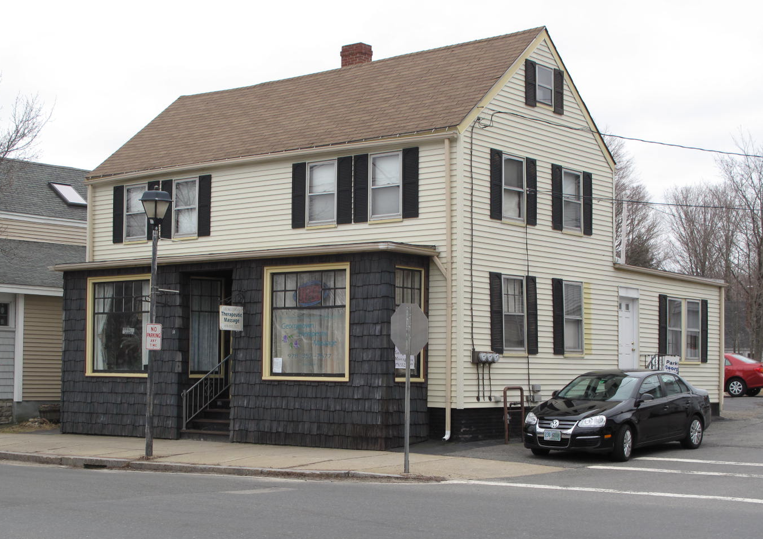
View from north

Locus Map (north at top)
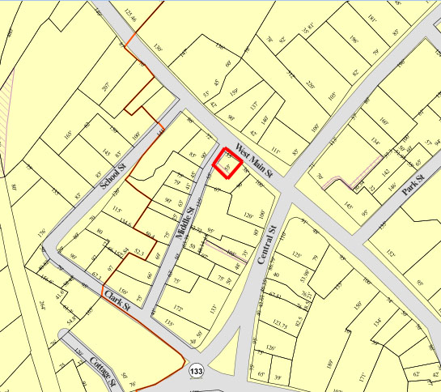

Recorded by: Kathryn Grover & Neil Larson
Organization: Town of Georgetown
Date: October 2012

Assessor’s Number USGS Quad Area(s) Form Number

11A-51 |  | Georgetown |  | C |  | GEO.193

Town/City: Georgetown
Place: (neighborhood or village):
Town Center

Address: 18-20 West Main Street
Historic Name: Chaplin and Carleton Shoe Shop
Uses: Present: commercial
Original: industrial
Date of Construction: ca. 1855
Source: historic maps, local history
Style/Form: indeterminable
Architect/Builder: unknown
Exterior Material:
Foundation: brick
Wall/Trim: vinyl clapboards
Roof: asphalt shingles
Outbuildings/Secondary Structures:
none
Major Alterations (with dates):
Storefront added
Vinyl siding added
Window sash replaced

Condition: good
Moved: no yes Date:
Acreage: 0.07 acre
Setting: This building is at the southeast corner of West Main and Middle Streets in a primarily commercial area.

Recommended for listing in the National Register of Historic Places.
If checked, you must attach a completed National Register Criteria Statement form.

ARCHITECTURAL DESCRIPTION
The Chaplin and Carleton Shoe Shop is a two-story wood frame factory building with a gable roof located on the southwest side of West Main Street and the northeast side of Middle Street. The building appears to have had a shared residential and commercial use, first as a shoe factory and later as a harness shop. The front façade contains a projecting storefront on the first floor, perhaps an alteration to a pre-existing porch, that appears to have been added around 1950. The upper story contains two groups of two windows each, which reflect the early interior division of the building into two separate parts. A two-story cross-gable ell is appended to the easterly side of the rear of the house offset by a one-story shed-roof ell on the westerly side. Regular fenestration patterns on the side walls would seem to be features original to the building.

The square plan of the building fills its small corner lot. A small unpaved parking area is located immediately behind it.

The Chaplin and Carleton Shoe Shop is a rare surviving example of a small mid-19th-century wood frame factory building reflecting Georgetown’s development as a rural industrial center. Later in the 19th century it was adapted for use as a harness shop, and it has functioned as a commercial property ever since. Built ca. 1855, the building is a contributing component of the village district.

HISTORICAL NARRATIVE
The building at 18-20 West Main Street does not appear on the 1830 map of Georgetown, but it is depicted on the 1856 map and identified as the Chaplin and Carleton Shoe Shop. No Georgetown history mentions the existence of this partnership, which was probably, like many others in the shoe industry here and elsewhere in New England, short-lived. It was probably composed of Henry Prescott Chaplin and George H. Carleton, related by marriage; Carleton’s sister Martha was Chaplin’s wife. By 1860 Chaplin was in business on his own in a larger shop at 154-56 Central Street, but the 1860 industrial schedules of the census indicate he was still partners with Carleton. Chaplin and Carleton had $5000 invested capital in the business, used $7400 of leather and other materials, employed ten men and fourteen women, and produced 2000 pair of shoes and 7200 pair of boots together valued at $13,300. Chaplin’s own firm was larger except in invested capital and the cost of materials: he employed fifteen men and ten women and produced boots and shoes worth $15,500. By 1870 the firm had been dissolved: Carleton was then in business as Noyes Carleton and Company and Chaplin as Chaplin and Brewster.

The 1872 map of Georgetown seems to show this corner lot as part of the Little and Moulton shoe shop complex, with Noyes Carleton & Co. operating a factory on the opposite (northwest) side of Middle Street. The entire West Main Street block between Central and Middle was indicated as owned by Daniel E. Moulton of that firm, by then retired, in 1884 (the village map mistakenly show all the buildings as constructed of brick). The 1893 Sanborn fire insurance map shows the building at 18-20 West Main Street as two connected two-story units with a harness shop on the south side and an unidentified store on the corner of Middle Street; the map shows it then as it is now, with a one-story ell on the north side and a two-story ell on the south. The 1885-86 directory shows only two harness makers in Georgetown—Isaac McLean on Mechanic’s Court and Thomas Falconer Hill on Main Street, almost certainly in this building.

Born in Great Village, Nova Scotia, in 1847, Thomas Falconer Hill came to the United States in 1872, when he was about twenty-five years old. He was married and living in Georgetown by 1875, when his oldest son, Charles Francis, was born. The family’s longtime residence was at 21 Prospect Street. In 1880 the Hill household included two boarding harness makers, probably working with Hill, and a nineteen-year-old apprentice harnessmaker. In that year the census’s industrial schedules report that Hill made saddlery and harness, had $600 in capital invested in the business, employed three males who worked ten-hour days throughout the year, paid out $1200 in wages, used $1880 worth of materials and produced $4000 worth of goods. By 1900 Thomas Allen Hill (often shown as T. Allen) was working with his father. Thomas F. Hill was the postmaster of Georgetown as well as a harnessmaker when he died in September 1907.

The 1906 Sanborn map shows the entire south part of the building as a harness shop and a store on the north side. By 1919 both 18 and 20 West Main were the property of Elizabeth A. Bailey of Beverly, who sold both to the barber Arthur J. Hughes in that year. Born in Georgetown in 1872, Hughes was the son of shoeworker Arthur Hughes, and by 1900 he was working as a hairdresser in Georgetown. By 1914 his barber shop, where he worked with his younger brother John, was in this building, where it remained for decades. The 1932 directory shows the hairdressing firm of Hughes Brothers at 18 West Main along with the Railway Express Agency and a shoe repair shop run by James McGauley. Born in Georgetown in 1858, McGauley was the son of Owen and Bridget McGauley and had known the Hughes family for decades; they grew up together on or near Cottage Street. By 1930 he lived with the family of his daughter Katherine, who had married gas station manager Frank J. Donovan in 1911, at 77 West Main Street.

Arthur J. Hughes died in 1944, and two years later his sister Katherine sold 18 West Main Street to Henry Dea, who ran the Henry Dea Insurance Company in this building by 1957. Dea, born in Boston about 1896, came to Georgetown from Andover in 1926 and by 1930 was living on Mill Street, where he had a poultry farm. By 1932 he was the town tax collector and a poultry dealer, and by 1940 he was the town treasurer. He died in 1961 in Georgetown.

In 1957 Dea sold 18 Main Street to Donald F. and Mary R. Greene of Ipswich. Donald Greene died in June 2000, and Mary R. Greene is the current owner.

BIBLIOGRAPHY and/or REFERENCES
Arrington, Benjamin F., ed. Municipal History of Essex County in Massachusetts. NY: Lewis Historical Publishing Co., 1922.
Field, Jane. A Brief History of Georgetown Massachusetts 1838-1963. Rev. ed. 1988. Georgetown: Georgetown Historical Commission, 1988.
Gage, Thomas. The History of Rowley, Anciently Including Bradford, Boxford, and Georgetown, from the Year 1639 to the Present Time. Boston: F. Andrews, 1840.
Georgetown, Boxford, Byfield, Newbury, and West Newbury, Massachusetts, Directory. Boston: W. E. Shaw, 1901-2, 1905, 1909, 1912, 1914, 1916-17, 1918, 1925.
Hill, Edwin P. “History of Georgetown, Massachusetts.” In Standard History of Essex County, Massachusetts. Edited by Cyrus M. Tracey, William E. Graves, and Henry M. Batchelder. Boston: C. F. Jewett, 1878.
Hull, Forrest P. Georgetown: Story of One Hundred Years, 1838-1938. 1938. Reprint. Georgetown, MA: Georgetown Historical Commission, 2006.
Merrill, Samuel. A Merrill Memorial: An Account of the Descendants of Nathaniel Merrill, an Early Settler of Newbury, Massachusetts. Cambridge, MA, 1917-28.
Nelson, Henry M. “Town of Georgetown History.” In Hurd, D. Hamilton. History of Essex County, Massachusetts, with Biographical Sketches of Many of Its Pioneers and Prominent Men. Vol. 1. Philadelphia: J. W. Lewis and Co., 1888.
Sammarco, Anthony Mitchell, for Georgetown Historical Society. Images of America: Georgetown. Portsmouth, NH: Arcadia Publishing, 2002.

MAPS
“Map of the Centre of Georgetown in 1800.” In Perley, Sidney H., “Centre of Georgetown in the Year 1800.” The Essex Antiquarian: A Quarterly Magazine Devoted to the Biography, Genealogy, History, and Antiquities of Essex County, Massachusetts 2, 7 (July 1898): 201.
Map of Georgetown in 1810 and 1840. In Gage, Thomas. The History of Rowley, Anciently Including Bradford, Boxford, and Georgetown, from the Year 1639 to the Present Time. Boston: F. Andrews, 1840. 320.
“Map of New Rowley Surveyed and Drawn by Philander Anderson 1830.” Georgetown Historical Society.
Map of Georgetown. 1856. In Walling. H. F. A Topographical Map Essex County Massachusetts. Boston: Smith and Morley, 1856.
Atlas of Essex County, Massachusetts. Philadelphia: D. G. Beers and Co., 1872). Plates 59 and 61.
“Town of Georgetown Mass.” and “Village of Georgetown Mass.” In Atlas of Essex County, Massachusetts (Boston: George H. Walker, 1884).
“Georgetown, Mass. 1887.” Drawn and Published by George E. Norris, Brockton, Massachusetts. Troy, NY: Burleigh Lithographic Establishment, 1887.”

PHOTOGRAPHS (all photos by Neil Larson, 2012)

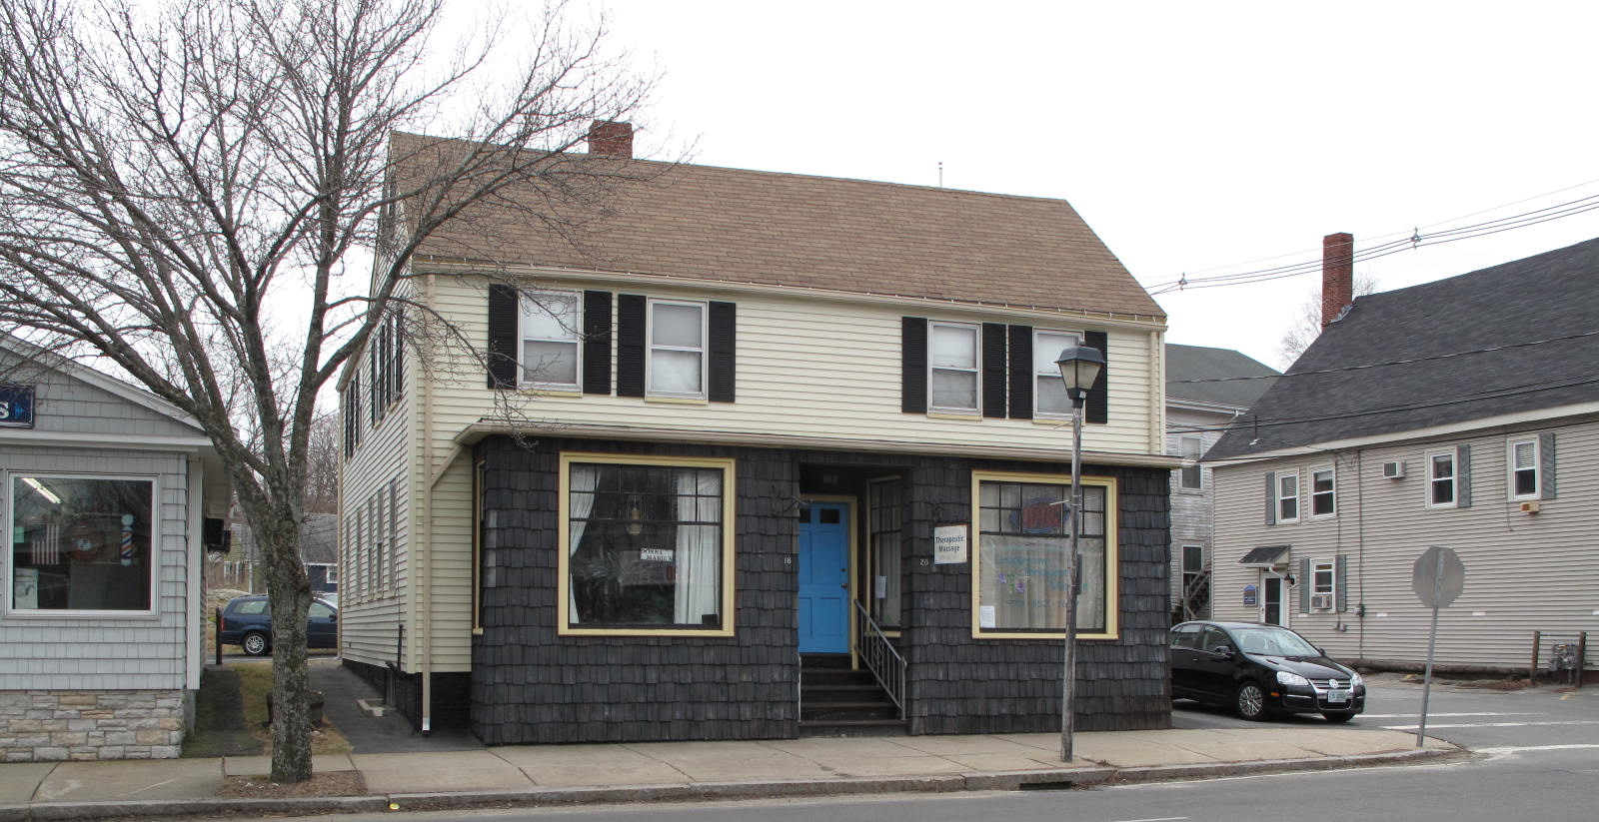
18-20 West Main Street: views from NE (top) and SW (bottom)

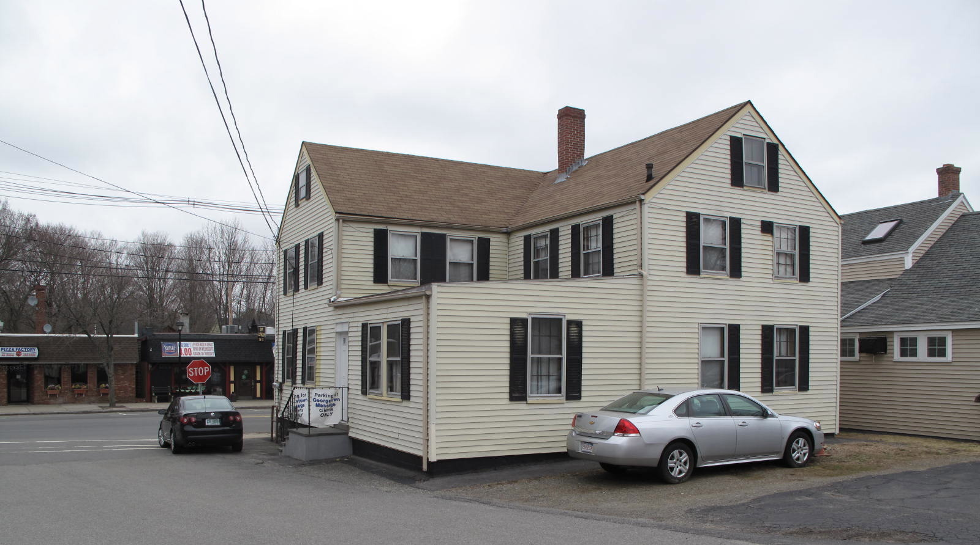

National Register of Historic Places Criteria Statement Form

Check all that apply:

Individually eligible Eligible only in a historic district

Contributing to a potential historic district Potential historic district

Criteria: A B C D

Criteria Considerations: A B C D E F G

Statement of Significance by________Neil Larson_________________________________
The criteria that are checked in the above sections must be justified here.

The Chaplin and Carleton Shoe Shop is a rare surviving example of a small mid-19th-century wood frame factory building reflecting Georgetown’s development as a rural industrial center. Later in the 19th century it was adapted for use as a harness shop, and it has functioned as a commercial property ever since. Built ca. 1855, the building is a contributing component of the village district.

Elizabeth A. Bailey, Beverly, to Arthur J. Hughes, 7 November 1919, SED 2431:190.
Katherine E. Hughes to Henry Dea, 2 October 1946, SED 3485:476.
Henry Dea to Donald F. and Mary R. Greene, Ipswich, 13 November 1957, SED 4421:338; see also Affidavit, Mary R. Greene, 7 June 2002, SED 18839:468.

