FORM B − BUILDING

Massachusetts Historical Commission
Massachusetts Archives Building
220 Morrissey Boulevard
Boston, Massachusetts 02125

Photograph
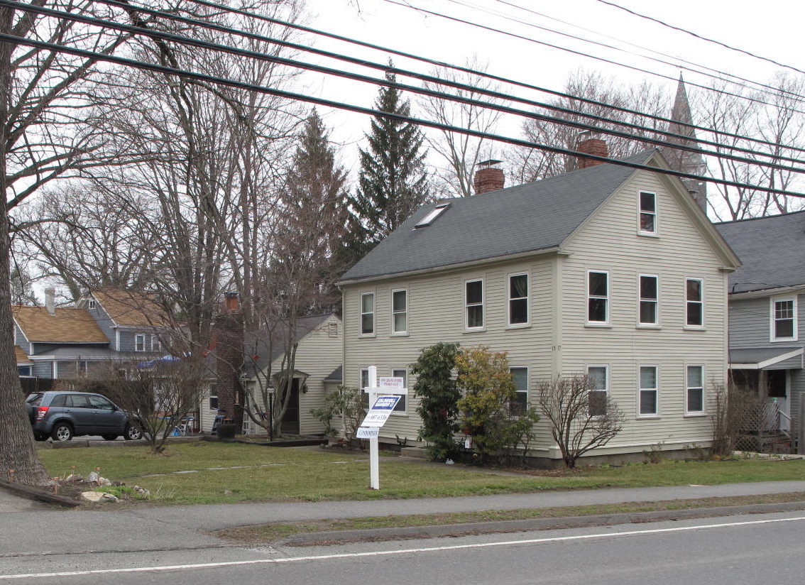
View from SW

Locus Map (north at top)
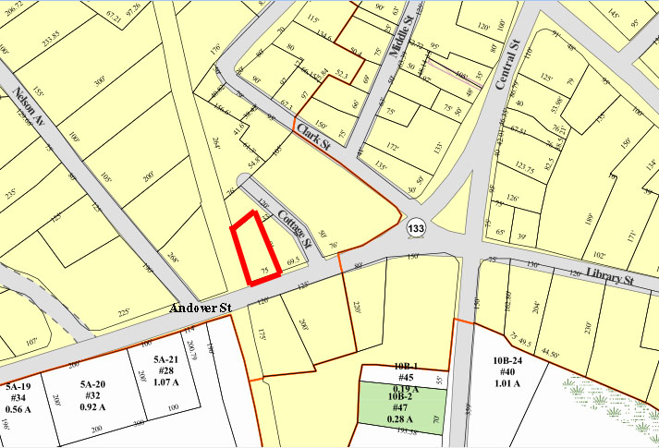

Recorded by: Kathryn Grover & Neil Larson
Organization: Town of Georgetown
Date: October 2012

Assessor’s Number USGS Quad Area(s) Form Number

6C-139 |  | Georgetown |  | C |  | GEO.123

Town/City: Georgetown
Place: (neighborhood or village):
Town Center

Address: 17 Andover Street
Historic Name: Martha Friend House
John & Ann Doonan House
Uses: Present: multiple residence
Original: single residence
Date of Construction: ca. 1845
Source: deeds, historic maps
Style/Form: Greek Revival
Architect/Builder: unknown
Exterior Material:
Foundation: stone
Wall/Trim: vinyl clapboards
Roof: asphalt shingles
Outbuildings/Secondary Structures:

Major Alterations (with dates):

Condition: good
Moved: no yes Date:
Acreage: 0.21 acres
Setting: This house is sited on the north side of Andover Street west of its intersection with Clark Street on a lot with mature trees. It is in the municipal center of town, an area of mixed residential, institutional, and commercial uses.

Recommended for listing in the National Register of Historic Places.
If checked, you must attach a completed National Register Criteria Statement form.

ARCHITECTURAL DESCRIPTION:
The Martha Friend House/John & Ann Doonan House is a two-story wood frame dwelling located on the north side of Andover Street west of Cottage Street; the property adjoins the railroad right-of-way on its west side. With its gable end oriented to the street and principal façade facing west, its plan conforms to middling urban housing of the period, much of it multiple-family in use. The house backs up to the eastern lot line, to which the rear wall of a similar house on the adjoining property (15 Andover St.) also is oriented. Both were owned by the same individual as tenant dwellings. The houses are not identical, and the subject building is wider in proportions. The five-bay front (west) façade has a central entrance with a stone stoop; any evidence of a porch is not visible. The roof has a shallow eave on the front and a thin frieze that the tops of the second-story window trim abut.

The south end of the house facing Andover Street contains three windows evenly spaced in each story and a single window in the gable, which is decorated with a cornice along the raking edge with short returns at the base. The northern and eastern walls have limited fenestration. A one-story ell extends from the north end of the house, to which is attached a one-story dwelling, perhaps in place of what once was a garage and/or barn.

The house is sited in the southeast corner of the lot and is surrounded by lawn. A paved driveway enters the property in the southwest corner and follows the west property line, turning to terminate at a parking area in front of the rear dwelling.

The Martha Friend House/John & Ann Doonan House is an intact example of a tenant dwelling associated with Georgetown’s early development. Built ca. 1845, with its gable end oriented to the street, the house was sited in the mode of urban examples of this type. The building is a contributing component of the village district.

HISTORICAL NARRATIVE
The house at 17 Andover Street is said by the town to have been built in 1810, but no house is shown on this site on the 1830 map of the town, nor does it appear to be described in Orlando B. Tenney’s description of houses standing in Georgetown in 1826. By 1850 it was part of the estate of the late Nathaniel Nelson (1767-1853), a banker who made his fortune in nearby Newburyport and had extensive real property holdings; he lived at 8 Elm Street but owned (and may earlier have lived in) a house further west on Andover Street where his son-in-law, the attorney Jeremiah P. Jones, lived since the 1840s. When Jones and Joseph Kimball, administrators of Nelson’s estate, sold the 17 Andover Street property, they referred to the house as the “Friend House so-called”; an early deed for the adjacent property at 15 Andover Street noted that 17 Andover Street was “recently occupied by Mrs. Friend.” This was probably Martha Friend, a forty-nine-year-old widow who lived with her children Mary A., then twenty-two, and Isaac B., a twenty-year-old shoemaker. She was probably a Georgetown native, Martha Dwinils, who had married the transient John Friend in Dracut in 1826; what became of her and her family is not yet known. Nor can it be established from deeds who might have built 17 Andover Street and when. According to Georgetown’s Orlando B. Tenney, Nathaniel Nelson was “a large landholder . . . ever ready to give encouragement or render financial assistance to promote the growth and prosperity of the town” and was “mainly instrumental in the erection of more than twenty five dwelling houses now standing in town.” Nelson’s own house on Elm Street was built in 1797, and he might have built this house, 15 Andover Street, and others in this area about the same time. However,

In early March 1856 Jones and Joseph Kimball, the executors of Nelson’s estate, sold 17 Andover and its half-acre lot to the Irish immigrant shoemaker John Doonan, Born in Ireland about 1832, Doonan is shown in the house in the 1860 census with his wife Ann and nine boarders or renters, one of them a family of six; all four of the adult boarders had been born in Ireland. By 1870, this small section of Andover Street and the area north of it along Cottage Street was called the Acre in the Essex County directory, no doubt for the well-known section of Lowell that had emerged as an Irish immigrant neighborhood in the 1820s. The 1870 county directory lists fourteen householders, all Irish immigrants, as residents of Georgetown’s Acre—Doonan; Patrick Hughes; his son Patrick and brother Arthur (1838-96); James Carroll, William Cronin, Henry Early, Owen McGinley, and James, James P., James T, Thomas, and Patrick Molloy 2d. Of these fourteen men, ten are listed as shoemakers, one as a shoe manufacturer, one as a farmer, and two as laborers. The 1872 map of Georgetown center depicts this concentration of Irish American settlement between the Boston and Maine rail corridor to west and Clark Street on the east: the homes of Doonan (“Donan” on the map), Patrick Hughes (“Huse”), Patrick Foley, Patrick Molloy (Maloy), N. (though probably Henry) Early, Owen McGauley (McGoley), three buildings marked “shoe shop,” and two houses belonging to Patrick Moan or Moen, also from Ireland but not listed in the 1870 county directory, are shown in the area alongside that of the Daniel Clark family for whom Clark Street was named. The first Roman Catholic service in Georgetown took place in 1849 just west in Nathaniel Nelson’s house on Andover Street, later occupied by Jones.

John and Ann Doonan occupied this house through at least 1885, by which time John Doonan was working as a laborer and was about fifty-five years old. In 1887 his wife Ann died, and in February 1896 he deeded the property to Charles A. Doonan of Merrimac, the son of Francis and Mary Hill Doonan and possibly a nephew. Charles Doonan owned the house until 1955 and rented it to a succession of tenants. By 1932 shoeworker and, later, landscape gardener Boyd Leslie Bateman lived at 17 Andover with his wife Alice and their three children. In 1935 and 1940 the widow H. Esta Haskell lived there with her sons Berman and Roger.

In February 1955 Charles A. Doonan, then living in Haverhill, sold 17 Andover Street to Rose A. Rogers. the wife of Haverhill shoe worker Adelbert James Rogers, and she sold it slightly more than a year later to Gertrude M. Ackerman of Newbury, who occupied the house in 1957. Ackerman was the widow of Alfred R. Ackerman, an automobile inspector and native of Michigan who died between 1928 and 1930. By 1934 she was living in Boston with her son Alfred R. Ackerman Jr., a life insurance agent another son, Philip, a married janitor, was also living in Boston at the time. In 1962 Gertrude Ackerman deeded 17 Andover Street to Philip, who owned and occupied it until 1972. Four years later William C. Scheik Jr. and his wife Frances of Rowley acquired the property, which they owned until 2008. It was they who converted the property to three condominium units. Current owners Paul J. Landry and Coleen Curtin acquired it in 2008 and 2009.

BIBLIOGRAPHY and/or REFERENCES
Arrington, Benjamin F., ed. Municipal History of Essex County in Massachusetts. NY: Lewis Historical Publishing Co., 1922.
Field, Jane. A Brief History of Georgetown Massachusetts 1838-1963. Rev. ed. 1988. Georgetown: Georgetown Historical Commission, 1988.
Gage, Thomas. The History of Rowley, Anciently Including Bradford, Boxford, and Georgetown, from the Year 1639 to the Present Time. Boston: F. Andrews, 1840.
Georgetown, Boxford, Byfield, Newbury, and West Newbury, Massachusetts, Directory. Boston: W. E. Shaw, 1901-2, 1905, 1909, 1912, 1914, 1916-17, 1918, 1925.
Hill, Edwin P. “History of Georgetown, Massachusetts.” In Standard History of Essex County, Massachusetts. Edited by Cyrus M. Tracey, William E. Graves, and Henry M. Batchelder. Boston: C. F. Jewett, 1878.
Hull, Forrest P. Georgetown: Story of One Hundred Years, 1838-1938. 1938. Reprint. Georgetown, MA: Georgetown Historical Commission, 2006.
Merrill, Samuel. A Merrill Memorial: An Account of the Descendants of Nathaniel Merrill, an Early Settler of Newbury, Massachusetts. Cambridge, MA, 1917-28.
Nelson, Henry M. “Town of Georgetown History.” In Hurd, D. Hamilton. History of Essex County, Massachusetts, with Biographical Sketches of Many of Its Pioneers and Prominent Men. Vol. 1. Philadelphia: J. W. Lewis and Co., 1888.

MAPS
“Map of the Centre of Georgetown in 1800.” In Perley, Sidney H., “Centre of Georgetown in the Year 1800.” The Essex Antiquarian: A Quarterly Magazine Devoted to the Biography, Genealogy, History, and Antiquities of Essex County, Massachusetts 2, 7 (July 1898): 201.
Map of Georgetown in 1810 and 1840. In Gage, Thomas. The History of Rowley, Anciently Including Bradford, Boxford, and Georgetown, from the Year 1639 to the Present Time. Boston: F. Andrews, 1840. 320.
“Map of New Rowley Surveyed and Drawn by Philander Anderson 1830.” Georgetown Historical Society.
Map of Georgetown. 1856. In Walling. H. F. A Topographical Map Essex County Massachusetts. Boston: Smith and Morley, 1856.
Atlas of Essex County, Massachusetts. Philadelphia: D. G. Beers and Co., 1872). Plates 59 and 61.
“Town of Georgetown Mass.” and “Village of Georgetown Mass.” In Atlas of Essex County, Massachusetts (Boston: George H. Walker, 1884).
“Georgetown, Mass. 1887.” Drawn and Published by George E. Norris, Brockton, Massachusetts. Troy, NY: Burleigh Lithographic Establishment, 1887.”

PHOTOGRAPHS (all photos by Neil Larson, 2012)

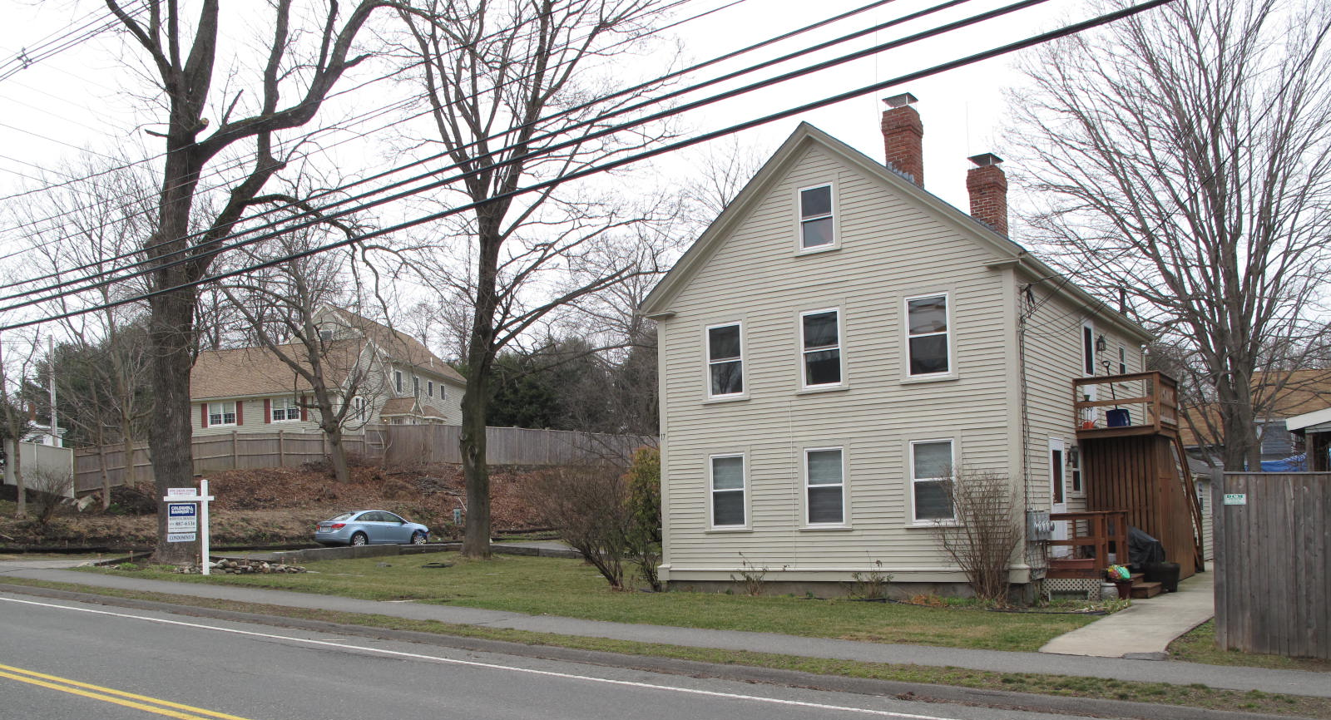

View from southwest (top); view from northeast (bottom)

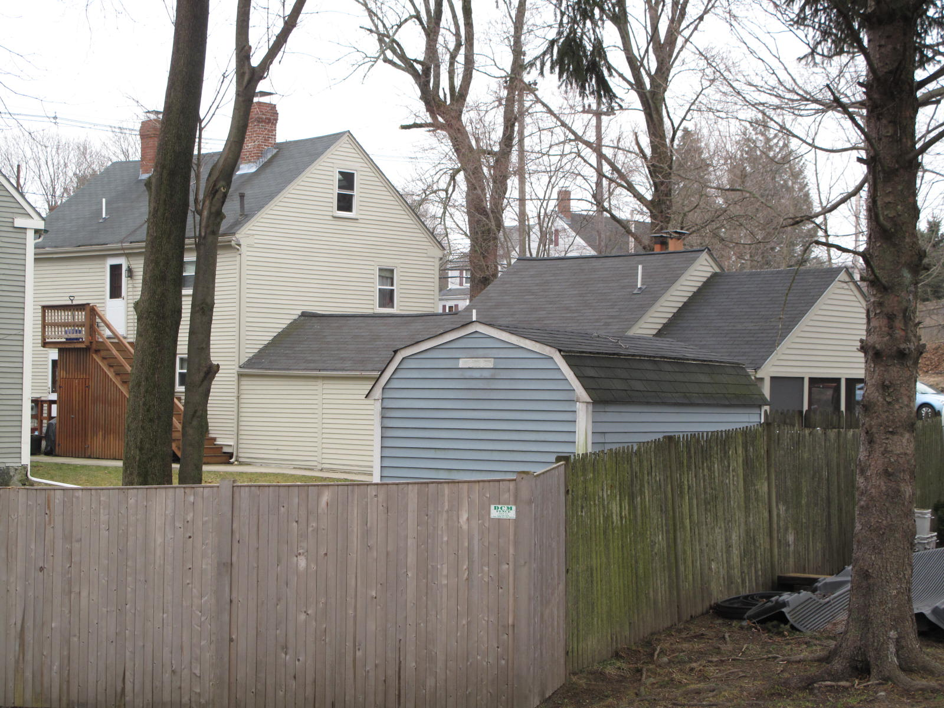

National Register of Historic Places Criteria Statement Form

Check all that apply:

Individually eligible Eligible only in a historic district

Contributing to a potential historic district Potential historic district

Criteria: A B C D

Criteria Considerations: A B C D E F G

Statement of Significance by________Neil Larson__________________
The criteria that are checked in the above sections must be justified here.

The Martha Friend House/John & Ann Doonan House is an intact example of a tenant dwelling associated with Georgetown’s early development. Built ca. 1845, with its gable end oriented to the street, the house is was sited in the mode of urban examples of this type. The building is a contributing component of the village district.

“Hon. O. B. Tenney.” The article states that Tenney’s description is “thought to include every dwelling house then standing within the radius named,” which included Andover Street.
“Hon. O. B. Tenney. A Sketch of One of Georgetown’s Oldest and Most Respected Citizens. Together with Other Interesting Historical Matter,” clipping from unidentified newspaper courtesy Joseph Knapp.
Joseph Kimball and Jeremiah P. Jones, administrators estate Nathaniel Nelson, to John Doonan, 4 March 1856: SED 527:252.
See Henry M. Nelson, “Town of Georgetown History.” In History of Essex County, Massachusetts, with Biographical Sketches of Many of Its Pioneers and Prominent Men, ed. D. Hamilton Hurd (Philadelphia: J. W. Lewis and Co., 1888) 1:834, 837.
Her death record states she died of “cardiac asthma from lack of food and dipsomania.” No definitive death record for John Doonan has been found in Massachusetts.
John Doonan to Charles A. Doonan, Merrimac MA, 24 February 1896, SED 1471:437; Charles A. Doonan, Haverhill, to Rose A. Rogers, 2 February 1955, SED 4187:373.
Rose A. Rogers, wife of Adelbert J., to Gertrude M. Ackerman, Newbury, 17 July 1956, SED 4288:381.
Gertrude M. Ackerman, widow, to Philip Ackerman, 2 April 1962, SED 4901:390; Philip and Anne Ackerman to Michael R. Carratu and George S. Thayer, Beverly, 30 June 1972, SED 5885:562; William C. Schiek Jr.. trustee 17 Andover Street Real Estate Trust, to Paul J. Landry, Amesbury, 27 August 2008, SED 28012:254; William C. Schiek Jr.. trustee 17 Andover Street Real Estate Trust, to Coleen Curtin, Somersworth NH, 16 June 2009, SED 28702:237

