FORM B − BUILDING

Massachusetts Historical Commission
Massachusetts Archives Building
220 Morrissey Boulevard
Boston, Massachusetts 02125

Photograph
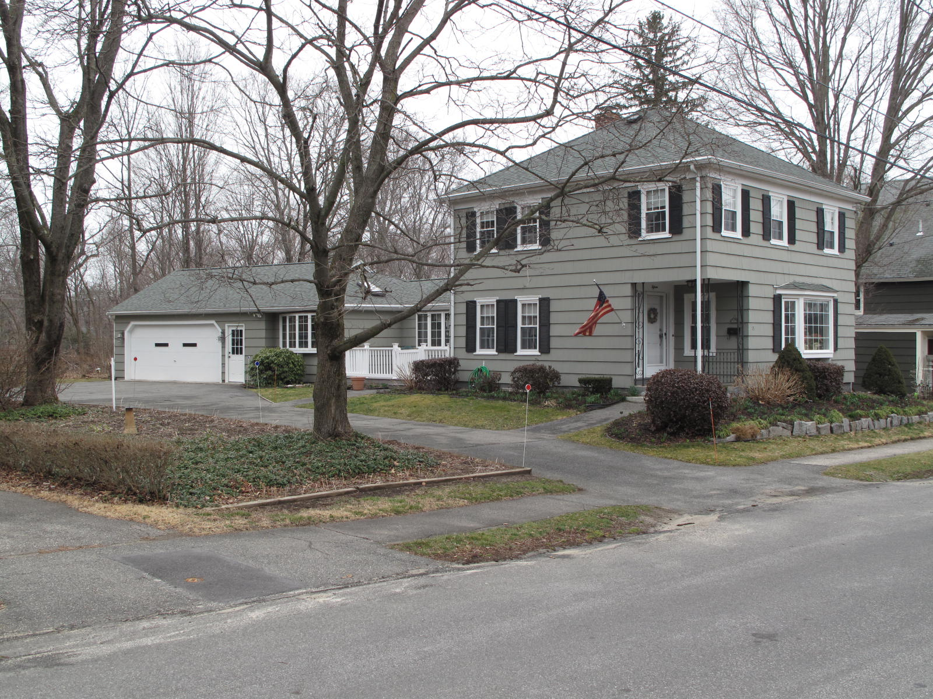
View from south

Locus Map (north at top)
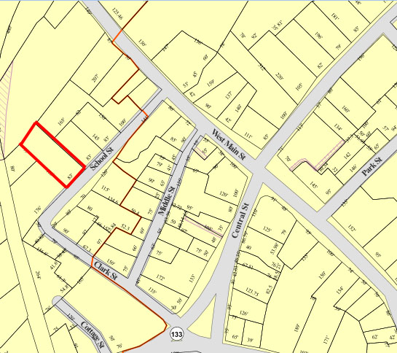

Recorded by: Kathryn Grover & Neil Larson
Organization: Town of Georgetown
Date: October 2012

Assessor’s Number USGS Quad Area(s) Form Number

6C-126 |  | Georgetown |  | C |  | GEO.186

Town/City: Georgetown
Place: (neighborhood or village):
Town Center

Address: 15 School Street
Historic Name: Herbert A. & Sarah M. Dale House
Uses: Present: single residence
Original: single residence
Date of Construction: ca. 1858
Source: deeds
Style/Form: Colonial Revival
Architect/Builder: unknown
Exterior Material:
Foundation: brick
Wall/Trim: wood shingles
Roof: asphalt shingles
Outbuildings/Secondary Structures:
none
Major Alterations (with dates):
house enlarged & hilled roof added, ca. 1955
additions on rear, ca. 1955
window sash replaced

Condition: good
Moved: no yes Date:
Acreage: 0.39 acre
Setting: This house is sited on the northwest side of School Street on a lot with mature trees. The area is a mix of residential, institutional, and commercial uses.

Recommended for listing in the National Register of Historic Places.
If checked, you must attach a completed National Register Criteria Statement form.

ARCHITECTURAL DESCRIPTION
The Herbert A. & Sarah M. Dale House is a two-story wood frame dwelling with a hipped roof located on the northwest side of School Street northeast of Clark Street. Built ca. 1858, the house originated with a two-bay front-gable façade with an entrance and porch on the southerly side and a one-story rear kitchen, as depicted on the 1887 birdseye map of the village. In the 1950s the house was altered by expanding the side porch into a two-story enclosure and replacing the gable roof with a hipped one. A new entrance was tucked under a porch hollowed out in the southeast corner of the front facade. The original one-story rear ell appears to remain with a one-story hipped roof wing added at an angle to the rear. The wing contains domestic space as well as a two-car garage with a single overhead door.

The house is centered in the front of the lot with a very small front yard. The area southwest of the house contains a wide driveway leading from the street to the garage in the rear. A small yard occupies the rear of the parcel.

The Herbert A. & Sarah M. Dale House, built ca. 1858 and renovated ca. 1955, is an altered example of mid-19th-century domestic architecture in Georgetown. Originating as a small front-gable house with an entrance on the side, typical of a factory worker’s dwelling of the period, it was given a more contemporary mid-20th-century appearance by squaring off the plan and covering the enlarged house with a hipped roof. In spite of these changes, the property is a contributing component of the village district.

HISTORICAL NARRATIVE
The house at 15 School Street was built between May 1858 and July 1860 for shoemaker Herbert Augustine Dale and his family. In May 1858 Dale deeded to his mother Betsey Wood Dale the quarter-acre lot on which 15 School Street now stands as well as fourteen acres of woodland in Boxford, where he had been born in 1831; it was also his mother’s native place. The 1860 census shows Dale on School Street with $1200 in real property. He was then working as a bootmaker, and his household included his wife Sarah M. Boynton Dale, whom he married in Bradford in 1853, and their children Lizzie Huestes, born in 1853; Alvin, born about 1855; Georgianna, born about 1857; and Frank Herbert, born in 1859.

In 1836, when Herbert Dale was only five years old, his father Samuel drowned in “Rowley river” at the age of thirty-six. He and his mother lived in Georgetown with the family of shoemaker Jacob Tyler in 1850, but by 1860 his mother was living in Groveland and he and his family were in the School Street house. By 1870 Betsey Dale is shown as the owner of 15 School Street in the census, and by then Herbert and Sarah Dale had another child, Oliver, born about 1864. The 1870 census and 1872 map both show Dale on School Street.

In 1873 the Dales’ eldest child Lizzie, then nineteen, married John S. Wells of Topsfield. In 1877 Betsey Wood Dale died, and by 1880 Lizzie Dale Wells was living with her husband in the 15 School Street house with their two children Francis C. and Grace A. Wells. Herbert Dale was then a shoe factory trimmer, son Alvin carried mail for the town, Frank H. ran a buttonhole machine in a shoe factory, and Oliver, then sixteen, was learning the “painter’s trade.” John Wells was a shoemaker, and his wife Lizzie is shown in the census as epileptic. John Wells died of consumption in 1881 at the age of forty-four, and Lizzie Wells continued to live at 15 School Street with her children and parents.

By 1885 Herbert Dale was working as a fish dealer in Georgetown. He died in 1908, and his widow and children Frank H. and Lizzie Dale Wells remained in the house. After the death of Frank H. Dale in January 1928, the Essex County probate court commissioner Henry K. Palmer sold the 15 School Street property to Georgia Nichols, probably his sister (though no birth or marriage record has been found for her), and in 1929 the property was acquired by Frances C. and Abigail F. Banks Wells. Francis, or Frank, Wells was Lizzie Dale Wells’s son, born in Georgetown in 1873. Earlier a resident of Haverhill, Wells was a motorman for the Eastern Massachusetts Street Railway Company. In July 1958, scarcely a month after the death of his wife Abbie, Frank Wells sold 15 School Street to Clifford D. and Agnes P. Emerson, who lived at 16 School Street and owned this property until 1984; in that year the widower Clifford Emerson sold 15 School Street to current owners Steven A. DeSisto and Donna L. Gordon.

BIBLIOGRAPHY and/or REFERENCES
Arrington, Benjamin F., ed. Municipal History of Essex County in Massachusetts. NY: Lewis Historical Publishing Co., 1922.
Field, Jane. A Brief History of Georgetown Massachusetts 1838-1963. Rev. ed. 1988. Georgetown: Georgetown Historical Commission, 1988.
Gage, Thomas. The History of Rowley, Anciently Including Bradford, Boxford, and Georgetown, from the Year 1639 to the Present Time. Boston: F. Andrews, 1840.
Georgetown, Boxford, Byfield, Newbury, and West Newbury, Massachusetts, Directory. Boston: W. E. Shaw, 1901-2, 1905, 1909, 1912, 1914, 1916-17, 1918, 1925.
Hill, Edwin P. “History of Georgetown, Massachusetts.” In Standard History of Essex County, Massachusetts. Edited by Cyrus M. Tracey, William E. Graves, and Henry M. Batchelder. Boston: C. F. Jewett, 1878.
Hull, Forrest P. Georgetown: Story of One Hundred Years, 1838-1938. 1938. Reprint. Georgetown, MA: Georgetown Historical Commission, 2006.
Merrill, Samuel. A Merrill Memorial: An Account of the Descendants of Nathaniel Merrill, an Early Settler of Newbury, Massachusetts. Cambridge, MA, 1917-28.
Nelson, Henry M. “Town of Georgetown History.” In Hurd, D. Hamilton. History of Essex County, Massachusetts, with Biographical Sketches of Many of Its Pioneers and Prominent Men. Vol. 1. Philadelphia: J. W. Lewis and Co., 1888.
Sammarco, Anthony Mitchell, for Georgetown Historical Society. Images of America: Georgetown. Portsmouth, NH: Arcadia Publishing, 2002.

MAPS
“Map of the Centre of Georgetown in 1800.” In Perley, Sidney H., “Centre of Georgetown in the Year 1800.” The Essex Antiquarian: A Quarterly Magazine Devoted to the Biography, Genealogy, History, and Antiquities of Essex County, Massachusetts 2, 7 (July 1898): 201.
Map of Georgetown in 1810 and 1840. In Gage, Thomas. The History of Rowley, Anciently Including Bradford, Boxford, and Georgetown, from the Year 1639 to the Present Time. Boston: F. Andrews, 1840. 320.
“Map of New Rowley Surveyed and Drawn by Philander Anderson 1830.” Georgetown Historical Society.
Map of Georgetown. 1856. In Walling. H. F. A Topographical Map Essex County Massachusetts. Boston: Smith and Morley, 1856.
Atlas of Essex County, Massachusetts. Philadelphia: D. G. Beers and Co., 1872). Plates 59 and 61.
“Town of Georgetown Mass.” and “Village of Georgetown Mass.” In Atlas of Essex County, Massachusetts (Boston: George H. Walker, 1884).
“Georgetown, Mass. 1887.” Drawn and Published by George E. Norris, Brockton, Massachusetts. Troy, NY: Burleigh Lithographic Establishment, 1887.”

PHOTOGRAPHS (all photos by Neil Larson, 2012)

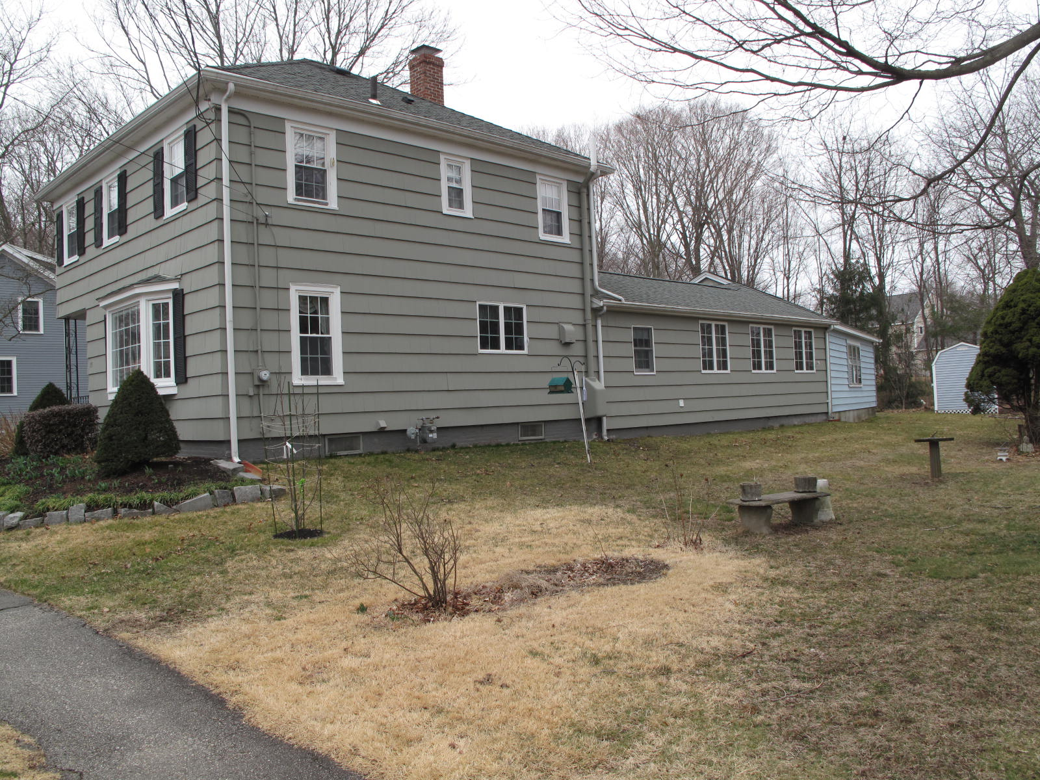
15 School Street: view from north

National Register of Historic Places Criteria Statement Form

Check all that apply:

Individually eligible Eligible only in a historic district

Contributing to a potential historic district Potential historic district

Criteria: A B C D

Criteria Considerations: A B C D E F G

Statement of Significance by________Neil Larson_________________________________
The criteria that are checked in the above sections must be justified here.

The Herbert A. & Sarah M. Dale House, built ca. 1858 and renovated ca. 1955, is an altered example of mid-19th-century domestic architecture in Georgetown. Originating as a small front-gable house with an entrance on the side, typical of a factory worker’s dwelling of the period, it was given a more contemporary mid-20th-century appearance by squaring off the plan and covering the enlarged house with a hipped roof. In spite of these changes, the property is a contributing component of the village district.

Herbert A. Dale to Betsey P. Dale, Groveland, 14 May 1858, SED 571:72.
Henry K. Palmer, Commissioner probate court, to Georgia Nichols, 2 June 1928, SED 2825:516 ; Warren H. Morse to Francies C. and Abbie F. Wells, 17 October 1929, SED 2825:517.
Francis C. Wells to Clifford D. and Agnes P. Emerson, 28 July 1958, SED 4486:457; Clifford D. Emerson to Steven A. DeSisto and Donna L. Gordon, 4 May 1984, SED 7414:10.

