FORM B − BUILDING

Massachusetts Historical Commission
Massachusetts Archives Building
220 Morrissey Boulevard
Boston, Massachusetts 02125

Photograph
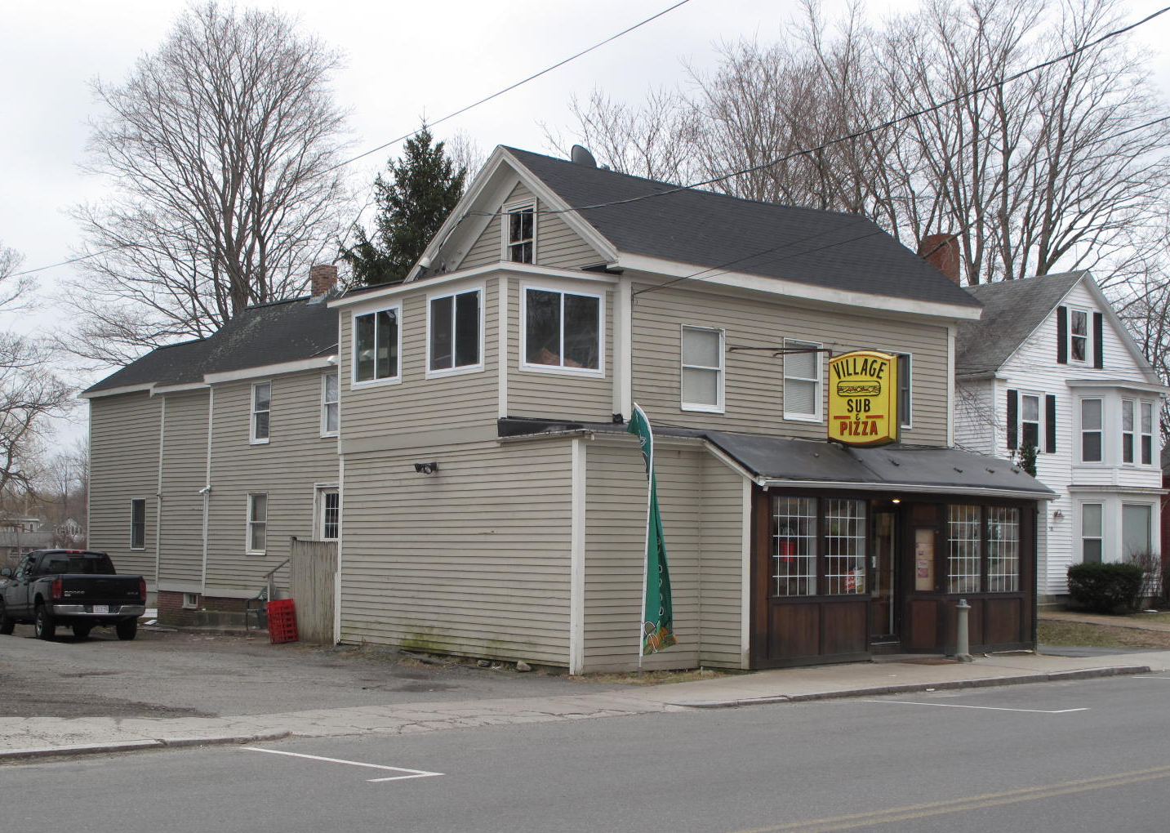
View from NW

Locus Map (north at top)
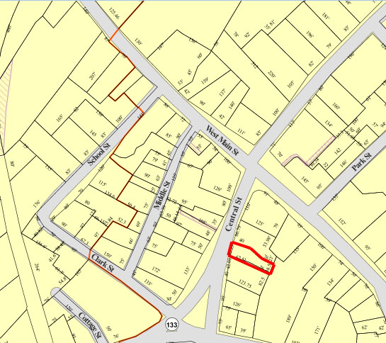

Recorded by: Kathryn Grover & Neil Larson
Organization: Town of Georgetown
Date: October 2012

Assessor’s Number USGS Quad Area(s) Form Number

11A-63 |  | Georgetown |  | C |  | GEO.128

Town/City: Georgetown
Place: (neighborhood or village):
Town Center

Address: 14 Central Street
Historic Name: William H. & Olive P. Harriman House
Uses: Present: store and residence
Original: single residence
Date of Construction: ca. 1845
Source: deeds
Style/Form: Greek Revival
Architect/Builder: unknown
Exterior Material:
Foundation: brick
Wall/Trim: vinyl clapboards
Roof: asphalt shingles
Outbuildings/Secondary Structures:

Major Alterations (with dates):
Two-story addition to front, ca. 1870
Storefront altered
Vinyl siding added
Windows replaced
Two-story addition on rear

Condition: good
Moved: no yes Date:
Acreage: 0.15 acre
Setting: This house is on the east side of Central Street between the village’s commercial district and its municipal center. The area is a mix of residential, commercial, and institutional uses.

Recommended for listing in the National Register of Historic Places.
If checked, you must attach a completed National Register Criteria Statement form.

ARCHITECTURAL DESCRIPTION
The William H. & Olive P. Harriman House, built ca. 1845, is a two-story wood frame dwelling located on the east side of Central Street south of Main Street. As built, it was a presented a gable end to the street and principal façade facing south, similar to its neighbor at 12 Central Street; its plan conforms to middling urban housing of the period, much of it multiple-family in use. At some later time, ca. 1870, a two-story, cross-gable addition was built on the street end for commercial use. (The addition is not pictured in a photograph taken in 1870. The street façade contains a storefront on the first story, now substantially altered, and three windows across the second story. A Classical entablature distinguishes the roof edge. More recently, a two-story addition has been made to the north end of this section.

The house behind this addition appears to have had a plan comprised of three rooms aligned front-to-back with the front two divided by a center passage with stairs. The placement of chimneys on the ridge of the roof respond to stove locations on the east sides of the two front rooms and the west side of the third or rear room The principal south façade is divided into seven bays, with two windows for each room and what now is a blank space above the main entrance. One of the two bays in the rear room also may contain a doorway. The first story of the façade is concealed by a one-story shed that probably originated as a porch. The building has been further extended by a two-story addition on the east end.

The house is situated on a narrow lot with driveways on both sides and a small yard in the rear. The store addition was erected on what had been a small front yard bringing the west end of the building to the edge of the sidewalk.

The William H. & Olive P. Harriman House is an altered example of a dwelling associated with Georgetown’s early commercial development in the early 19th century. Built ca.1845 with its narrow gable end oriented to the street, the house was sited in the mode of urban examples of this type. A store annex was added to the street end of the house in ca. 1870. The building is a contributing component of the village district.

HISTORICAL NARRATIVE
Deeds suggest that a building was constructed on the site of 14 Central Street between August 1841 and April 1847. In 1841 the physician Robert Herbert sold Newburyport mariner John C. Ramsdell a house lot “on the road from Little’s Corner” in Georgetown, and in 1847 Ramdell sold the lot with buildings on it to Newburyport merchant William Stone. Stone may never have lived in Georgetown; directories and censuses consistently show him as a resident of Newburyport. In July 1857 Stone sold the property to William Henry Harrison Harriman, a druggist and ambrotypist born in Bradford. This William Harriman is not to be confused with William Brown Harriman, though it is easy to conflate them: both married women whose first names were Olive, both had children named Caroline in their household, and both died in the same year, some two months apart. William Brown Harriman, born in Rowley in 1810, was the son of Moses Harriman and Olive Brown; he married Olive Nelson and became a well-known Georgetown boot and shoe manufacturer with a factory and home on Elm Street. William H. H. Harriman was born in 1814, the son of Enoch and Sarah Brocklebank Harriman, and he married Norway, Maine, native Olive Peabody in Boxford in 1837.

The 1860 census shows William H. Harriman residing at 14 Central Street with $1800 in real property and working as an ambrotypist. His household included his wife Olive and Caroline F. Harriman, then seventeen years old and a retail clerk. Caroline may have been the couple’s niece: a Caroline Foster Harriman was born in 1843 to George Harriman, William H.’s older brother, and George’s wife Eliza Peabody, Olive’s oldest sister.

The 1870 census shows William H. Harriman as a fancy goods dealer and Caroline as a clerk in his store, while the Essex County directory of that year shows him as a photographer. In 1883 OIive Peabody Harriman died, and five months later, in February 1884, William H. Harriman died; his death record shows him as a druggist. What became of Caroline F. Harriman is not known, but William Harriman’s will transferred title to 14 Central Street, directly or indirectly, to George Lyman Metcalf, whose New Hampshire-born father Fisher Metcalf had married Eunice Peabody, the sister of Olive and Eliza. A shoemaker, Fisher Metcalf died in Georgetown in 1856, and by 1860 Eunice Peabody Metcalf was running a small boardinghouse in Georgetown where several Peabody relatives were then living.

In 1872 George Metcalf married Olive V. Andrews of Boxford, and he was working as a pressman in a “tailoring house,” perhaps Stephen Osgood’s, in 1880. He may have moved to this house after William Harriman’s death, and he was certainly living there by 1900. At that time he worked as a shoe stitcher for G. W. Chaplin Company in Georgetown. By 1907 he was sharing the house with his son Robert F. Metcalf, born in 1880 and by then an attorney in Haverhill. By 1914 Robert Metcalf had opened an additional law practice at 14 Central, and his parents and he occupied part of the property. By 1920 George Metcalf had retired, and the census shows him and his wife at 16 Central; by then the house may have been divided into two units, 14 and 16, as shown on later registered plans which also identify it as a 2.5-story frame “office and dwelling.”

In June 1920, George Metcalf sold 14-16 Central Street to Thomas Barney of Boxford and moved across the street to 19-21 Central Street, where his son and his son’s family also lived; George Metcalf died there in 1927. Barney sold the house in 1924 to Ralph A. Bishop of Salem, who was born Raoul Levesque about 1895. Bishop was the son of Salem grocer Adelard Levesque. He was working as a clerk in Salem when he married, between 1915 and 1917, and by 1920 he was a leather worker. By 1930 Bishop had opened a meat market in Georgetown at 14 Central Street, where he also lived with his wife Jane and children Gerard and Florence, and by then he had changed his name to Ralph Bishop. He owned and apparently rented 12 Central Street as well.

Ralph Bishop owned 14 Central Street until 1945 (he was living in Topsfield by 1957), and the property changed hands three times before Doris A. Marston acquired it, 12 Central Street, and a third lot bordering the Protection Lodge of the International Order of Odd Fellows on the southwest. Marston subdivided the property and sold it in three parcels to John J. and Eleanor F. Salah, who were then living at 14-16 Central Street, in 1972. Born in 1929 in Gloucester, John Salah was the son of Syrian immigrant grocer Kalal Salah and grew up in Gloucester; he worked as a clerk for his father’s grocery until about 1955, and he was later an automobile dealer and a bartender at Gloucester’s Lebanon Club. By 1963 he had become a realtor. In 1986 the Salahs sold 14-16 Central Street to their son Craig, who now operates the Village Sub Shop from the building and remains its owner.

BIBLIOGRAPHY and/or REFERENCES
Arrington, Benjamin F., ed. Municipal History of Essex County in Massachusetts. NY: Lewis Historical Publishing Co., 1922.
Field, Jane. A Brief History of Georgetown Massachusetts 1838-1963. Rev. ed. 1988. Georgetown: Georgetown Historical Commission, 1988.
Gage, Thomas. The History of Rowley, Anciently Including Bradford, Boxford, and Georgetown, from the Year 1639 to the Present Time. Boston: F. Andrews, 1840.
Georgetown, Boxford, Byfield, Newbury, and West Newbury, Massachusetts, Directory. Boston: W. E. Shaw, 1901-2, 1905, 1909, 1912, 1914, 1916-17, 1918, 1925.
Hill, Edwin P. “History of Georgetown, Massachusetts.” In Standard History of Essex County, Massachusetts. Edited by Cyrus M. Tracey, William E. Graves, and Henry M. Batchelder. Boston: C. F. Jewett, 1878.
Hull, Forrest P. Georgetown: Story of One Hundred Years, 1838-1938. 1938. Reprint. Georgetown, MA: Georgetown Historical Commission, 2006.
Merrill, Samuel. A Merrill Memorial: An Account of the Descendants of Nathaniel Merrill, an Early Settler of Newbury, Massachusetts. Cambridge, MA, 1917-28.
Nelson, Henry M. “Town of Georgetown History.” In Hurd, D. Hamilton. History of Essex County, Massachusetts, with Biographical Sketches of Many of Its Pioneers and Prominent Men. Vol. 1. Philadelphia: J. W. Lewis and Co., 1888.

MAPS
“Map of the Centre of Georgetown in 1800.” In Perley, Sidney H., “Centre of Georgetown in the Year 1800.” The Essex Antiquarian: A Quarterly Magazine Devoted to the Biography, Genealogy, History, and Antiquities of Essex County, Massachusetts 2, 7 (July 1898): 201.
Map of Georgetown in 1810 and 1840. In Gage, Thomas. The History of Rowley, Anciently Including Bradford, Boxford, and Georgetown, from the Year 1639 to the Present Time. Boston: F. Andrews, 1840. 320.
“Map of New Rowley Surveyed and Drawn by Philander Anderson 1830.” Georgetown Historical Society.
Map of Georgetown. 1856. In Walling. H. F. A Topographical Map Essex County Massachusetts. Boston: Smith and Morley, 1856.
Atlas of Essex County, Massachusetts. Philadelphia: D. G. Beers and Co., 1872). Plates 59 and 61.
“Town of Georgetown Mass.” and “Village of Georgetown Mass.” In Atlas of Essex County, Massachusetts (Boston: George H. Walker, 1884).
“Georgetown, Mass. 1887.” Drawn and Published by George E. Norris, Brockton, Massachusetts. Troy, NY: Burleigh Lithographic Establishment, 1887.”

PHOTOGRAPHS (all photos by Neil Larson, 2012)

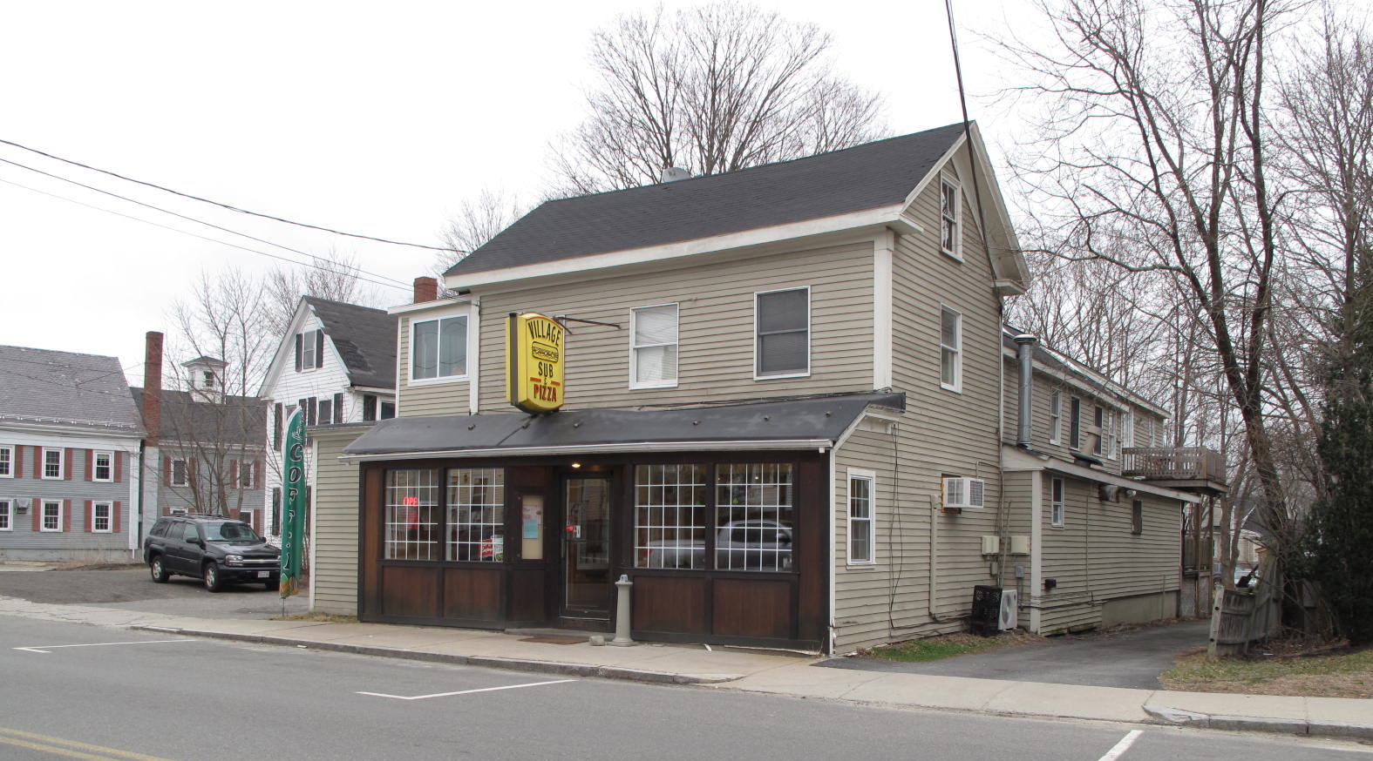
View from SW (top) and east (bottom)

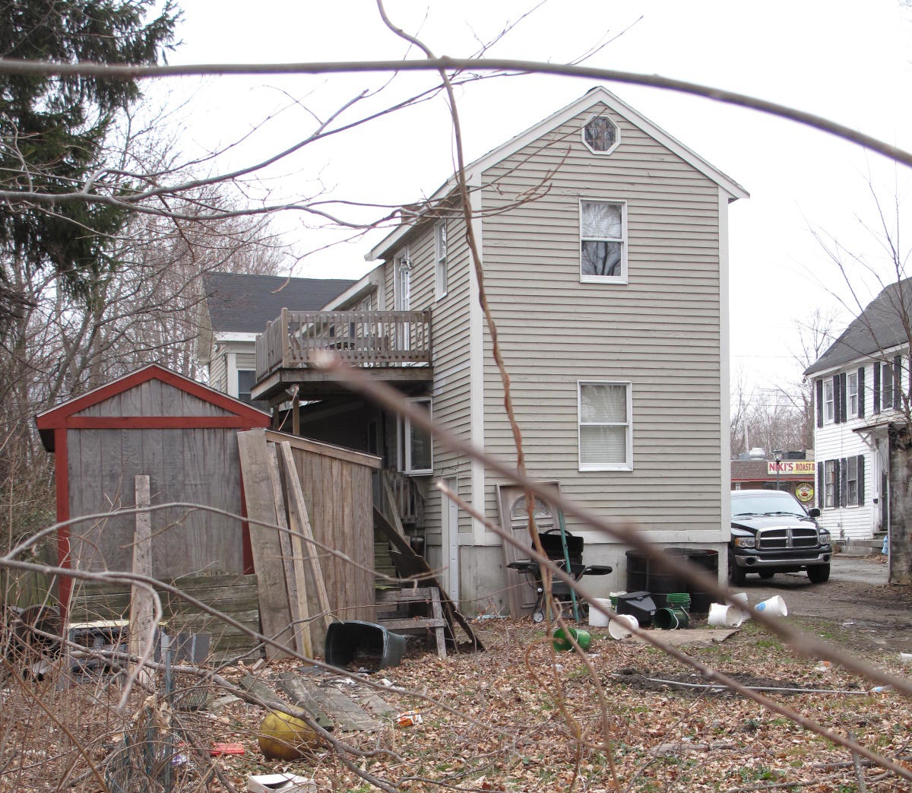

National Register of Historic Places Criteria Statement Form

Check all that apply:

Individually eligible Eligible only in a historic district

Contributing to a potential historic district Potential historic district

Criteria: A B C D

Criteria Considerations: A B C D E F G

Statement of Significance by________Neil Larson_________________________________
The criteria that are checked in the above sections must be justified here.

The William H. & Olive P. Harriman House is an altered example of a dwelling associated with Georgetown’s early commercial development in the early 19th century. Built ca.1845 with its narrow gable end oriented to the street, the house was sited in the mode of urban examples of this type. A store annex was added to the street end of the house in ca. 1870. The building is a contributing component of the village district.

Anthony Mitchell Sammarco, for the Georgetown Historical Society, Images of America: Georgetown (Charleston SC: Arcadia Publishing, 2002), 10.
Richard Herbert, physician, to John C. Ramsdell, Newburyport, mariner, 23 August 1841, SED 326:210; John C. Ramsdell, Newburyport, to William Stone, Newburyport, 20 April 1847, SED 382:3; William Stone, Newburyport, to William H. Harriman, 22 July 1857, SED 1154:188.
Metcalf’s ownership and title from Harriman’s will is established in George L. Metcalf to Thomas Barney, Boxford, 28 June 1920, SED 2454:115.
Thomas Barney to Ralph A. Bishop, Salem, 10 November 1924, SED 2623:354; Ralph Bishop to Joseph J. Mirabito and Joseph Laurino, 13 November 1945, SED 3437:154; Joseph J. Mirabito and Joseph Laurino, Wakefield, to William S. Phillips, Frank B. Hedges, and William E. Hedges, all Marblehead, 24 May 1950, SED 3742:275; William S. Margaret S. Phillips to Doris A Marston, 21 May 1956, SED 4270:565; Doris A. Marston, individually and as sole remaining trustee of Countryside Realty Trust, to John J. and Eleanor F. Salah, 14-16 Central Street, 17 July 1972, SED 5886:351; John J. and Eleanor F. Salah, Gloucester, to Craig S. Salah, 14-16 Central Street, 8 July 1986, SED 8461:524. See also “Plan of Property in Georgetown, Mass., as Surveyed for Doris A. Marston,” April 1961, SEP 4765:1, where 14-16 Central is the southernmost parcel with detached garage, and “Subdivision Plan of Land at 12, 14 & 16 Central Street, Georgetown, MA, Owner: John J. and Eleanor Salah, 14-16 Central Street,” 7 May 1986, SEP 214:13, where 14-16 Central is Lot 2.

