FORM B − BUILDING

Massachusetts Historical Commission
Massachusetts Archives Building
220 Morrissey Boulevard
Boston, Massachusetts 02125

Photograph
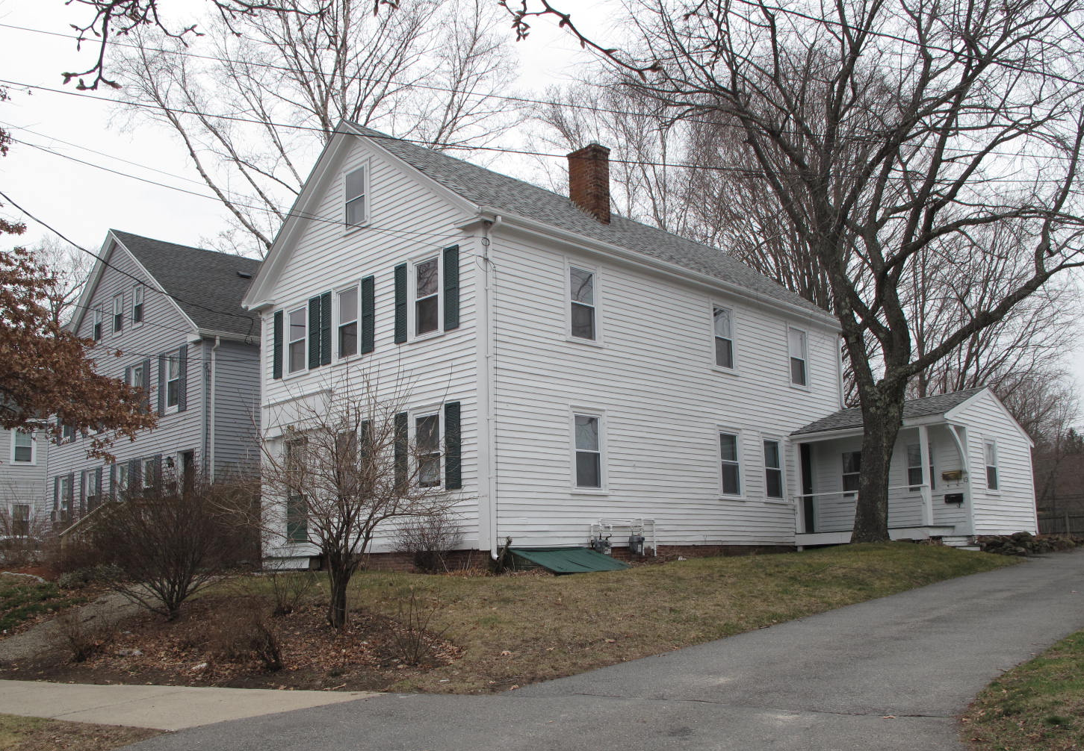
View from SE

Locus Map (north at top)
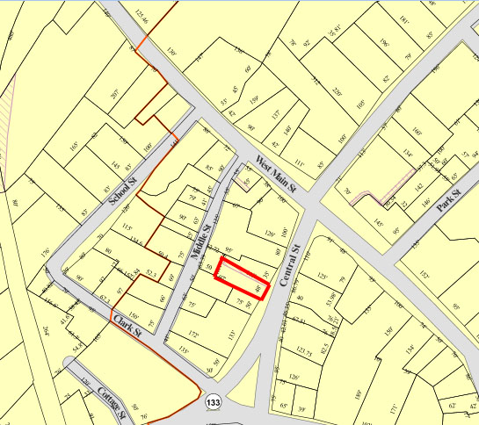

Recorded by: Kathryn Grover & Neil Larson
Organization: Town of Georgetown
Date: October 2012

Assessor’s Number USGS Quad Area(s) Form Number

11A-56 |  | Georgetown |  | C |  | GEO.127

Town/City: Georgetown
Place: (neighborhood or village):
Town Center

Address: 13 Central Street
Historic Name: John & Lydia Bagley House
Uses: Present: single residence
Original: single residence
Date of Construction: ca. 1840
Source: historic maps, deeds
Style/Form: Greek Revival
Architect/Builder: unknown
Exterior Material:
Foundation: brick
Wall/Trim: vinyl clapboards
Roof: asphalt shingles
Outbuildings/Secondary Structures:
none
Major Alterations (with dates):
Entrance altered, porch removed
Rear additions
Vinyl siding added
Window sash replaced

Condition: good
Moved: no yes Date:
Acreage: 0.14 acre
Setting: This building is sited on the west side of Central Street near the south edge of the Georgetown commercial district. The area is a mix of residential, institutional, and commercial uses.

Recommended for listing in the National Register of Historic Places.
If checked, you must attach a completed National Register Criteria Statement form.

ARCHITECTURAL DESCRIPTION
The John & Lydia Bagley House, built around 1840, is a two-story wood frame dwelling located on the west side of Central Street south of Main Street. With its gable end fronting on the street, the house has a side-entry plan three rooms deep with a chimney between the front two rooms. The entrance is offset on the south side of the three-bay front façade; while the original doorway with sidelights has been replaced with a modern unit, the trabeated architrave with tall frieze is intact. Three windows are spaced across the second story and a single window is centered in the gable. The raking edges of the roof edge have simple entablatures that return a short distance at the eaves. A one-story wing has been added across the rear and extends out past the east side of the building.

The house is centered in the front of the lot with a small yard in front. The property shares a driveway with its neighbor at 11 Central Street, which runs alongthe east lot line and terminates at a parking area behind the house where a small yard occupies the rear of the lot.

The John & Lydia Bagley House is an example of Greek Revival-style domestic architecture in Georgetown. Built ca. 1840, it retains the distinctive form and proportions of front-gable townhouses of the era. Although the front entrance has been altered, it retains a distinctive trabeated architrave characteristic of the Greek Revival taste. The building is a contributing component of the village district.

HISTORICAL NARRATIVE
Early maps do not show a building on this site before 1856. The house’s first occupants were the painter John Bagley and his family, who also owned the paint shop next door at 11 Central Street. In the 1840 census, John Bagley is enumerated as a head of household after William Boyton, whom maps place at 15 Central Street at this time. The house was built not long after 1838 when Bagley and his business partner, Alfred B. Clough, acquired the Central Street parcel now comprised of 11 and 13 Central Street from Georgetown shoe manufacturer Joseph Little. Bagley and Clough built a shop at 11 Central Street, above which Clough apparently lived, while Bagley and his family resided in the house built next door at 13 Central Street by 1840. In 1838 Clough sold his interest to the lower story of the shop building to Bagley, which, according to the deed, functioned “as a dwelling house and paint shop.” In February 1842 Clough deeded “the shop, house and land where Bagley now lives” to Bagley and left Georgetown.

Born in Salisbury in 1804, John Bagley was married to Eliza Bickford of Salisbury and living in his native town by 1833 when his daughter Harriet was born; another daughter, Anne E., was born there two years later. The family was living in Georgetown when the 1840 census was taken, but having taken up residence at 13 Central Street. Eliza Bickford Bagley died at the age of thirty-nine in 1849. The 1850 census shows Bagley sharing his household with his teenage daughters Harriet and Anne Elizabeth and with a boarder, William Augustus Harnden; a painter like Bagley, he was probably apprenticed to or working with him at the time. In 1852 Bagley remarried Lydia Adams Oliver, a native of Malden; their daughter Isabelle Oliver Bagley was born in 1853 and son John Adams Bagley in 1855. In 1853 Harriet Bagley married Harnden, and in 1855 Anne E. Bagley married Chaplin G. Tyler and was living with him at his mother’s household on Elm Street in Georgetown.

In 1865 John Bagley died at the age of sixty-one, and his widow Lydia remained in the house with her two children and boarding physician Richard B. Root in 1870. The 1872 map shows 13 Central occupied by “Mrs. Bagley”; so, too, does the 1884 map (mislabeled “Mrs. Bayley”), though it seems to show the property further west than it is. By 1880 Lydia Bagley shared the house with her daughter Isabelle, and by 1900 the two were at that address although Isabelle, who worked part of the year as a milliner, had lived in Haverhill in the late 1880s and early 1890s,

In 1904 Lydia Bagley died, and the 1905 directory shows Isabelle alone in the household. In June 1905 she, her brother John, her half-sisters Harriet Harnden and Annie Tyler, and other Bagley heirs sold 11 and 13 Central Street to Forrester A. Hoyt, who in 1921 sold 13 Central, which included a house and barn, to Elizabeth J. McLean. Born in Pennsylvania about 1882, McLean may have bought the property for her parents. Harnessmaker Issac McLean emigrated from Nova Scotia to Georgetown with his wife Mary J. McIntosh McLean in 1883; their daughter Ida May was born that year. His harness factory was in Bailey’s Block on Main Street; where his wife also carried on a dressmaking business. In 1905 Isaac, his wife, and their daughter Ida lived on Main Street, but they were renting on Central Street (perhaps this house) in 1910, by which time Isaac worked as a farm laborer; his wife married died that year. Elizabeth McLean lived at 11 Middle Street with her sister Ida and brother John before she acquired 13 Central Street. Ida worked as a shoe shop stitcher, while John was also in the shoe industry.

The 1925 directory shows Elizabeth and Ida McLean at 13 Central Street with Mary McKenney, a fancy shoe stitcher who rented from them. Elizabeth McLean was then working as a waitress, though most censuses and directories show her without occupation outside the home. In 1930 McKenney still boarded with the “Misses McLean,” as the directory terms them in 1932, and the sisters also boarded Grace Vickering and an eighteen-year-old ward of the state, Elsie D. Berhardt.

By 1940 Elizabeth McLean was working as a dressmaker, while Ida remained a shoe stitcher. In 1957 the directory shows only Ida in the house, and by the time of their deaths both sisters were living in Haverhill. Ida McLean died in 1868; her sister died four years later.

Elizabeth McLean had put the 13 Central Street property in trust in 1970, two years before she died, and in January 1973 her trustee sold the property to Rutherford Associates, who by then owned 11 Central Street as well. In 1994 Russell C. Rutherford sold 13 Central Street to current owner Bruce E. Prescott.

BIBLIOGRAPHY and/or REFERENCES
Arrington, Benjamin F., ed. Municipal History of Essex County in Massachusetts. NY: Lewis Historical Publishing Co., 1922.
Field, Jane. A Brief History of Georgetown Massachusetts 1838-1963. Rev. ed. 1988. Georgetown: Georgetown Historical Commission, 1988.
Gage, Thomas. The History of Rowley, Anciently Including Bradford, Boxford, and Georgetown, from the Year 1639 to the Present Time. Boston: F. Andrews, 1840.
Georgetown, Boxford, Byfield, Newbury, and West Newbury, Massachusetts, Directory. Boston: W. E. Shaw, 1901-2, 1905, 1909, 1912, 1914, 1916-17, 1918, 1925.
Hill, Edwin P. “History of Georgetown, Massachusetts.” In Standard History of Essex County, Massachusetts. Edited by Cyrus M. Tracey, William E. Graves, and Henry M. Batchelder. Boston: C. F. Jewett, 1878.
Hull, Forrest P. Georgetown: Story of One Hundred Years, 1838-1938. 1938. Reprint. Georgetown, MA: Georgetown Historical Commission, 2006.
Merrill, Samuel. A Merrill Memorial: An Account of the Descendants of Nathaniel Merrill, an Early Settler of Newbury, Massachusetts. Cambridge, MA, 1917-28.
Nelson, Henry M. “Town of Georgetown History.” In Hurd, D. Hamilton. History of Essex County, Massachusetts, with Biographical Sketches of Many of Its Pioneers and Prominent Men. Vol. 1. Philadelphia: J. W. Lewis and Co., 1888.

MAPS
“Map of the Centre of Georgetown in 1800.” In Perley, Sidney H., “Centre of Georgetown in the Year 1800.” The Essex Antiquarian: A Quarterly Magazine Devoted to the Biography, Genealogy, History, and Antiquities of Essex County, Massachusetts 2, 7 (July 1898): 201.
Map of Georgetown in 1810 and 1840. In Gage, Thomas. The History of Rowley, Anciently Including Bradford, Boxford, and Georgetown, from the Year 1639 to the Present Time. Boston: F. Andrews, 1840. 320.
“Map of New Rowley Surveyed and Drawn by Philander Anderson 1830.” Georgetown Historical Society.
Map of Georgetown. 1856. In Walling. H. F. A Topographical Map Essex County Massachusetts. Boston: Smith and Morley, 1856.
Atlas of Essex County, Massachusetts. Philadelphia: D. G. Beers and Co., 1872). Plates 59 and 61.
“Town of Georgetown Mass.” and “Village of Georgetown Mass.” In Atlas of Essex County, Massachusetts (Boston: George H. Walker, 1884).
“Georgetown, Mass. 1887.” Drawn and Published by George E. Norris, Brockton, Massachusetts. Troy, NY: Burleigh Lithographic Establishment, 1887.”

PHOTOGRAPHS (all photos by Neil Larson, 2012)

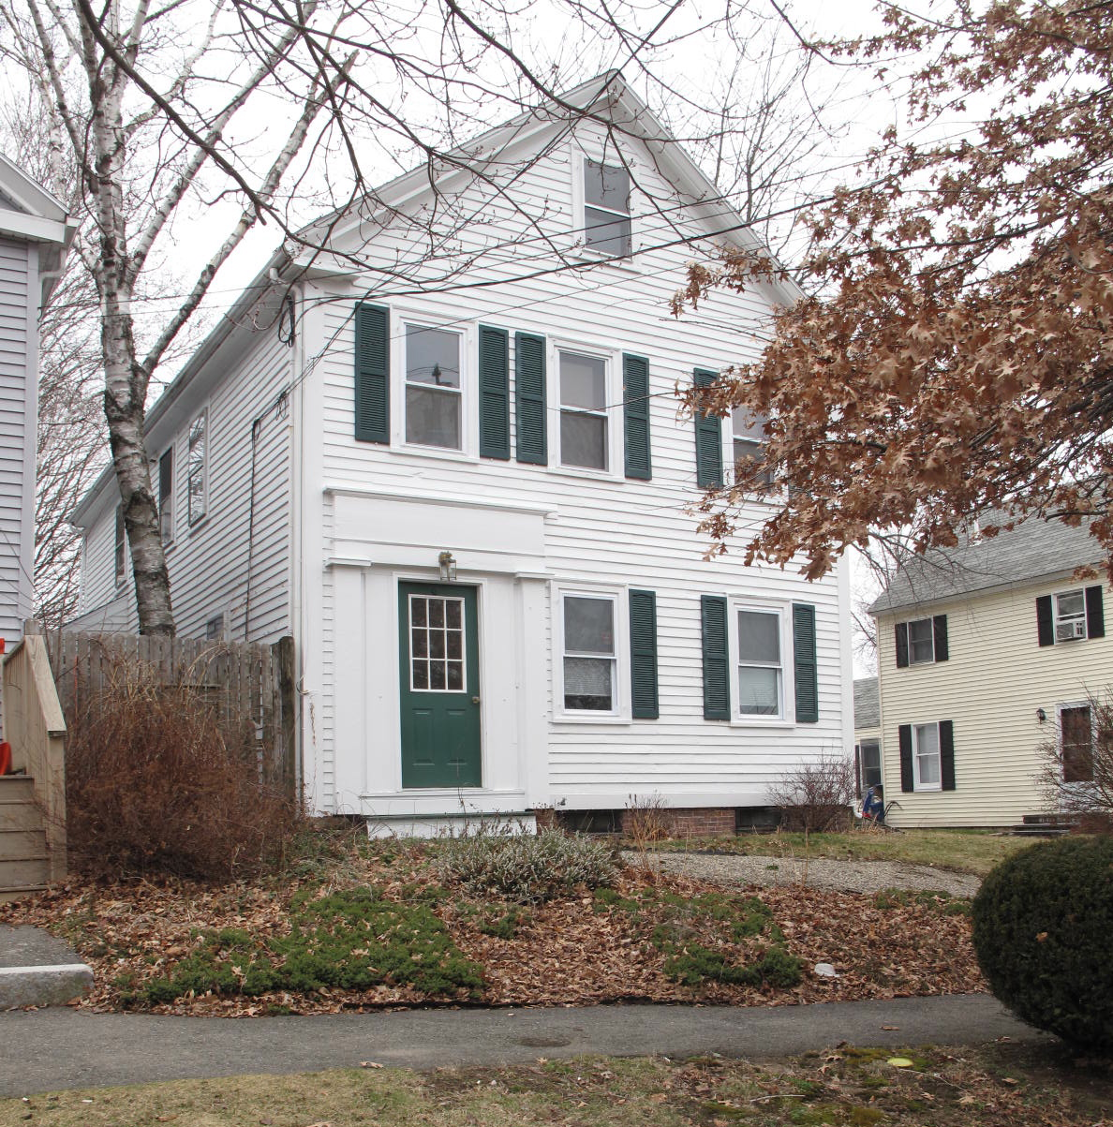
13 Central Street: view from SW (top) and NE (bottom)

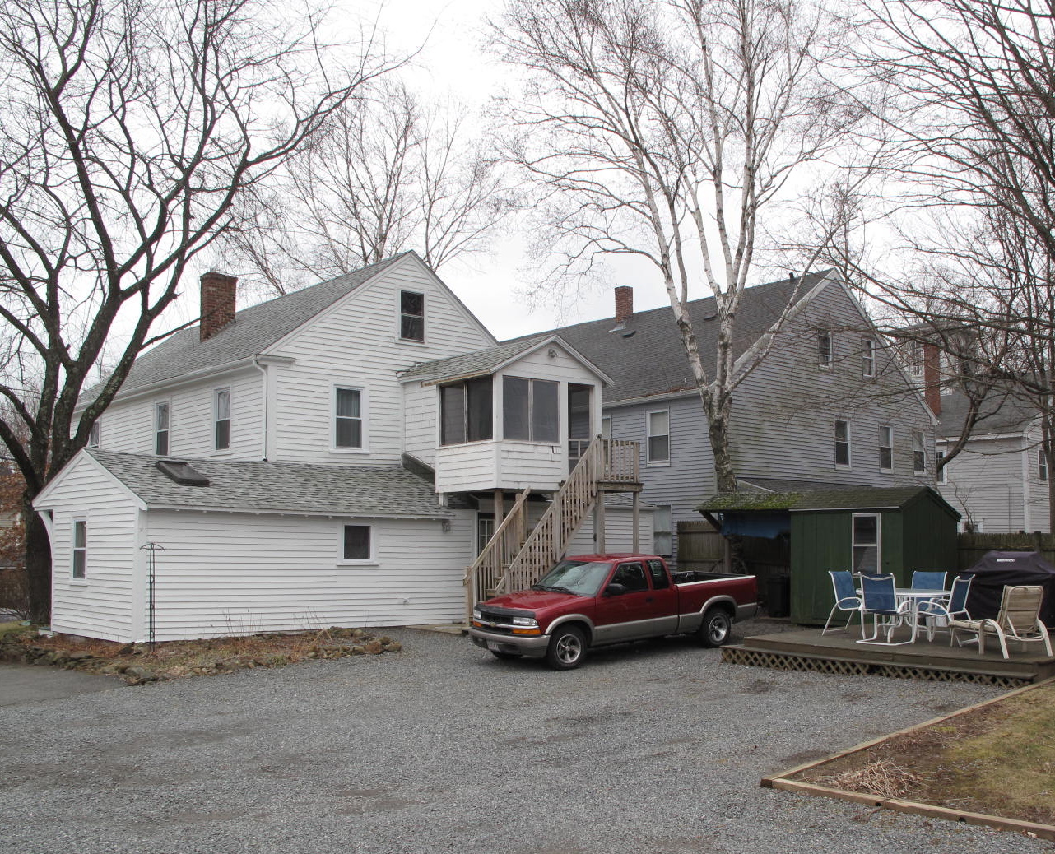

National Register of Historic Places Criteria Statement Form

Check all that apply:

Individually eligible Eligible only in a historic district

Contributing to a potential historic district Potential historic district

Criteria: A B C D

Criteria Considerations: A B C D E F G

Statement of Significance by________Neil Larson_________________________________
The criteria that are checked in the above sections must be justified here.

The John & Lydia Bagley House is an example of Greek Revival-style domestic architecture in Georgetown. Built ca. 1840, it retains the distinctive form and proportions of front-gable townhouses of the era. Although the front entrance has been altered, it retains a distinctive trabeated architrave characteristic of the Greek Revival taste. The building is a contributing component of the village district.

Joseph Little to John Bagley and Alfred B. Clough, 2 November 1838, SED 178:220
Joseph Little to John Bagley and Alfred B. Clough, 2 November 1838, SED 178:220; Alfred B. Clough, Georgetown, to John Bagley, 10 March 1840, SED 338:178; Alfred B. Clough to John Bagley, 1 February 1842, SED 178:221.
John A. Bagley, Laporte IN; Isabella O. Bagley, Georgetown; Annie B. Jones, Cambridge; Harriet E. Harnden, Boston; Mattie E. Bassett, Lynn; George J. Buttrick, Salem; Annie C. Tyler, Salem; Hattie Allen, Lynn; Chaplain G. Tyler, New Bedford; to Forrester A. Hoyt, 19 June 1905, SED 1790:298; Forrester A. Hoyt to Elizabeth J. McLean, 26 May 1921, SED 2488:101.
Elizabeth J. McLean to Elizabeth J. McLean Trust, 15 October 1970, SED 5720:439; Maud P. Thompson, trustee Elizabeth J. McLean Trust, to Rutherford Associates, 11 Central Street, 25 January 1973, SED 5944:739; Rutherford Associates to Russell C. Rutherford Sr., 2 December 1980, SED 6769:336; Russell C. Rutherford Sr. to Bruce E. Prescott Jr., 13 Central Street, 1 December 1994, SED 12843:585.

