FORM B − BUILDING

Massachusetts Historical Commission
Massachusetts Archives Building
220 Morrissey Boulevard
Boston, Massachusetts 02125

Photograph
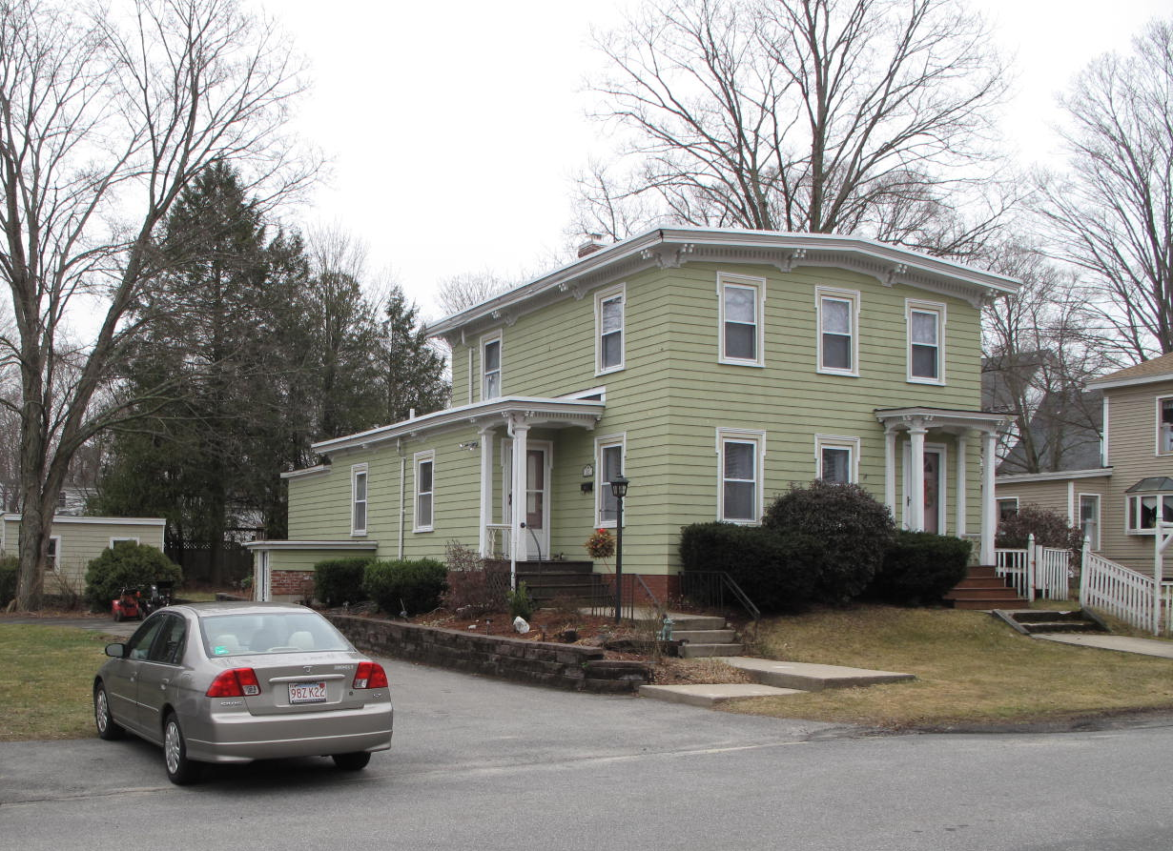
View from northwest

Locus Map (north at top)
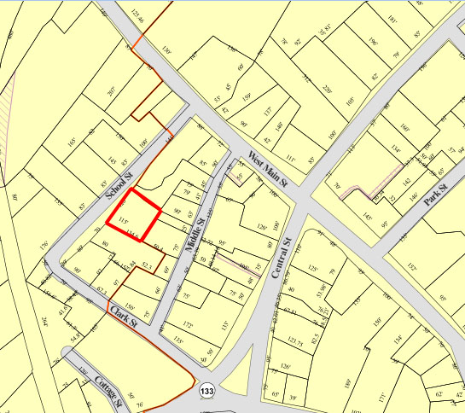

Recorded by: Kathryn Grover & Neil Larson
Organization: Town of Georgetown
Date: October 2012

Assessor’s Number USGS Quad Area(s) Form Number

6C-167 |  | Georgetown |  | C |  | GEO.185

Town/City: Georgetown
Place: (neighborhood or village):
Town Center

Address: 12 School Street
Historic Name: Samuel E. & Hannah M. Clark House
Uses: Present: single residence
Original: single residence
Date of Construction: ca. 1870
Source: deeds, historic maps
Style/Form: Italianate
Architect/Builder: Samuel E. Clark, probable builder
Exterior Material:
Foundation: brick
Wall/Trim: wood clapboards
Roof: asphalt shingles
Outbuildings/Secondary Structures:
none
Major Alterations (with dates):
window sash replaced

Condition: good
Moved: no yes Date:
Acreage: 0.34 acre
Setting: This house is sited on the east side of School Street on a lot with mature trees. The area is a mix of residential and institutional uses.

Recommended for listing in the National Register of Historic Places.
If checked, you must attach a completed National Register Criteria Statement form.

ARCHITECTURAL DESCRIPTION
The Samuel E. & Hannah M. Clark House is a two-story wood frame dwelling located on the southeast side of School Street southwest of West Main Street. The front-gable facade contains an entrance with a porch having chamfered pillars and a bracketed cornice offset by two windows. Three windows are evenly spaced across the upper story. The low-pitched roof has deep eaves with a bracketed cornice and dentil band that wraps around and carries across the side walls. A one-story rear ell extends past the northerly wall of the house and wraps around that side presenting a second entrance and porch on the front. The side wing and porch are decorated in the same manner as main section of the house. It appears that later additions have been made to the rear and southerly sides of the ell.

The house is centered on the frontage of the square lot, set back behind a small front yard. There also are side and rear yards with mature trees. A paved parking area is located on the northerly side of the house.

The Samuel E. & Hannah M. Clark House is an unusual example of mid-19th-century middle-class domestic architecture in the village. Apparently built by its owner, a house carpenter, ca. 1870, it reflects the idiosyncrasy of a self-designed house with its low-pitched gable roof and distinctive Italianate decoration. The house is a contributing component of the village district.

HISTORICAL NARRATIVE
In June 1866, for the Georgetown School District No. 4, Orlando B. Tenney of Georgetown deeded a lot bordering the School Street schoolhouse lot on the south to carpenter Samuel Eustis Clark for $163.17. By 1870 Clark had built the house at 12 School Street on the lot, and he had probably built the house then numbered 9 School Street (now #19), identified in directories as being at the corner of Clark Street, for his brother, the shoecutter Joseph Morton Clark. The brothers are both shown with real property in the 1870 census, Samuel with $2000 and Joseph with $1500, and are enumerated next to each other.

Born in Bradford in 1823, Samuel Adams Eustis Clark was the son of Aaron L. Clark of Hamilton and Mary Adams Clark of Groveland. His brother Joseph M. was born in 1824. By 1850 the brothers were boarding together in the home of tanner and currier John B. Bateman. In 1864 Samuel E. Clark married Hannah M. Cressey of Newburyport; both were in their forties, and they had no children. The 1880 census shows them alone in the household.

In February 1883 Samuel E. Clark died, and his widow appears to have returned to her native Newburyport, where the 1900 census shows her living with her married sister Catharine Goddard Cressey Burrill. Hannah Clark continued to own 12 School Street until December 1908, when she sold the property to Augusta N. Urquhart, to whom she may have been renting the house from a point soon after her husband’s death. Urquhart, born in Deer Isle, Maine, was the daughter of Hezekiah and Lucy Noyes Haskell and in 1881 in Georgetown married William N. Urquhart, a native of Halifax, Nova Scotia, who had immigrated to this country about 1875. At the time of his marriage he was working as a carriage painter, and the 1885 directory shows him living on School Street.

The Urquharts had three children—Herbert William, born in 1883; Roy Haskell, born in 1888; and Ruth Stuart, born in 1893. By 1900 the Urquharts are shown as renting a house on School Street, and by 1901 Urquhart had added blacksmithing to his carriage painting business. By 1910 son Roy had moved away, and the household included William and Augusta Urquhart and their children Herbert, then a bicycle salesman, and Ruth, who was sixteen and already working as a piano teacher; she gave private music lessons from 12 School Street through at least 1920. The 1918 directory shows Urquhart’s blacksmith shop at 20 Middle Street; by then Hebert had married Louise Robinson of Georgetown and was living at 50 West Main Street.

By 1925 Herbert Urquhart had opened an automobile supply store in Haverhill, and his father, having made the transition from horses to cars, was working as a vulcanizer in the same city, probably for his son. He died in February 1926. His widow Augusta remained at 12 School Street until her own death, before 20 May 1937 when her children sold the property to Louise P. Merrill. Merrill, born Louise D. Pingree in Lawrence in 1902, was the wife of shoe factory operative Coleman P. Merrill, a Georgetown native and the son of H. Eugene and Rosanna Ricker Merrill. H. Eugene Merrill was also a shoe shop operative, and in 1910 the family lived on East Main Street in Georgetown. Born in 1901, Coleman P. Merrill married Louise D. Pingree by 1924, the year their son Richard was born; their daughter Jane Louise was born in 1928 in Lawrence. The family was still living on East Main Street in 1932, when Coleman Merrill was working as a truck driver for Haverhill’s Riverside Dairy.

The 1940 directory shows Coleman Merrill as a milkman and deputy sheriff for Essex County living at 12 School Street; by 1957 his wife Louise had opened a dress store called the Cotton Shoppe at 12 School as well. At that time truck driver Frank C. Morse and his wife Elaine also lived at this address. Coleman P. Merrill died in 1964, and in 1977 his widow Louise deeded 12 School Street to Daniel M. Merrill and Elsie M. Merrill, whose relation if any to her is not yet known. In 1986 they sold the property, and in the same year it was acquired by James R. DiMento Sr., James R. DiMento Jr., and Douglas J. DiMento. In December 1992 James DiMento Sr. transferred his interest in the property to current owners James R. DiMento Jr. and his wife Mary Anne.

BIBLIOGRAPHY and/or REFERENCES
Arrington, Benjamin F., ed. Municipal History of Essex County in Massachusetts. NY: Lewis Historical Publishing Co., 1922.
Field, Jane. A Brief History of Georgetown Massachusetts 1838-1963. Rev. ed. 1988. Georgetown: Georgetown Historical Commission, 1988.
Gage, Thomas. The History of Rowley, Anciently Including Bradford, Boxford, and Georgetown, from the Year 1639 to the Present Time. Boston: F. Andrews, 1840.
Georgetown, Boxford, Byfield, Newbury, and West Newbury, Massachusetts, Directory. Boston: W. E. Shaw, 1901-2, 1905, 1909, 1912, 1914, 1916-17, 1918, 1925.
Hill, Edwin P. “History of Georgetown, Massachusetts.” In Standard History of Essex County, Massachusetts. Edited by Cyrus M. Tracey, William E. Graves, and Henry M. Batchelder. Boston: C. F. Jewett, 1878.
Hull, Forrest P. Georgetown: Story of One Hundred Years, 1838-1938. 1938. Reprint. Georgetown, MA: Georgetown Historical Commission, 2006.
Merrill, Samuel. A Merrill Memorial: An Account of the Descendants of Nathaniel Merrill, an Early Settler of Newbury, Massachusetts. Cambridge, MA, 1917-28.
Nelson, Henry M. “Town of Georgetown History.” In Hurd, D. Hamilton. History of Essex County, Massachusetts, with Biographical Sketches of Many of Its Pioneers and Prominent Men. Vol. 1. Philadelphia: J. W. Lewis and Co., 1888.
Sammarco, Anthony Mitchell, for Georgetown Historical Society. Images of America: Georgetown. Portsmouth, NH: Arcadia Publishing, 2002.

MAPS
“Map of the Centre of Georgetown in 1800.” In Perley, Sidney H., “Centre of Georgetown in the Year 1800.” The Essex Antiquarian: A Quarterly Magazine Devoted to the Biography, Genealogy, History, and Antiquities of Essex County, Massachusetts 2, 7 (July 1898): 201.
Map of Georgetown in 1810 and 1840. In Gage, Thomas. The History of Rowley, Anciently Including Bradford, Boxford, and Georgetown, from the Year 1639 to the Present Time. Boston: F. Andrews, 1840. 320.
“Map of New Rowley Surveyed and Drawn by Philander Anderson 1830.” Georgetown Historical Society.
Map of Georgetown. 1856. In Walling. H. F. A Topographical Map Essex County Massachusetts. Boston: Smith and Morley, 1856.
Atlas of Essex County, Massachusetts. Philadelphia: D. G. Beers and Co., 1872). Plates 59 and 61.
“Town of Georgetown Mass.” and “Village of Georgetown Mass.” In Atlas of Essex County, Massachusetts (Boston: George H. Walker, 1884).
“Georgetown, Mass. 1887.” Drawn and Published by George E. Norris, Brockton, Massachusetts. Troy, NY: Burleigh Lithographic Establishment, 1887.”

PHOTOGRAPHS (all photos by Neil Larson, 2012)

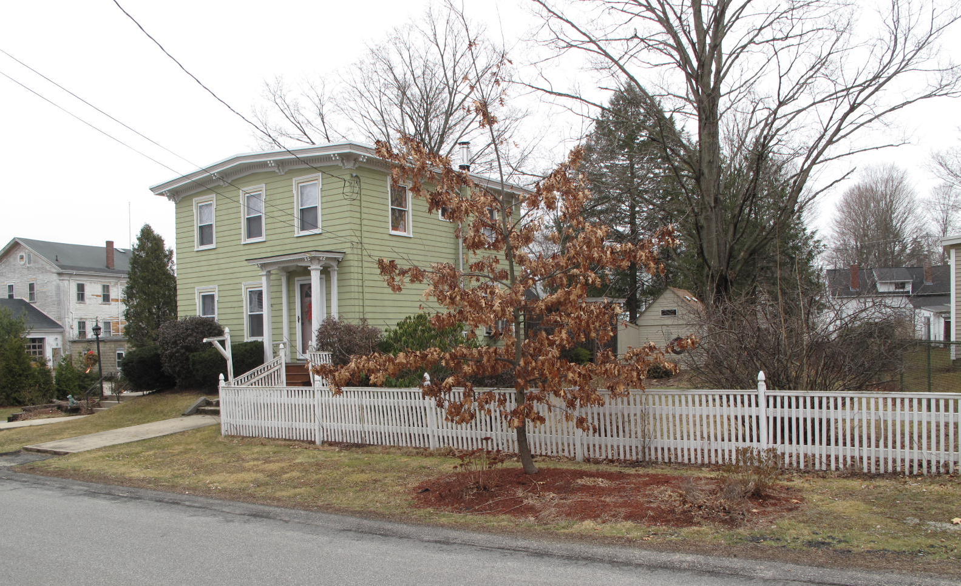
12 School Street: view from SW

National Register of Historic Places Criteria Statement Form

Check all that apply:

Individually eligible Eligible only in a historic district

Contributing to a potential historic district Potential historic district

Criteria: A B C D

Criteria Considerations: A B C D E F G

Statement of Significance by________Neil Larson_________________________________
The criteria that are checked in the above sections must be justified here.

The Samuel E. & Hannah M. Clark House is an unusual example of mid-19th-century middle-class domestic architecture in the village. Apparently built by its owner, a house carpenter, ca. 1870, it reflects the idiosyncrasy of a self-designed house with its low-pitched gable roof and distinctive Italianate decoration. The house is a contributing component of the village district.

Orlando B. Tenney, in behalf of School District No. 4, to Samuel E. Clark, 22 June 1866, SED 706:191.
Hannah M. Clark, Newburyport, to Augusta N. Urquhart, 1 December 1908, SED 1946:352.
Herbert W. Urquhart, Ruth S. Brown, and Roy H. Urquhart to Louise P. Merrill, 29 May 1937, SED 3110:576.
Louise P. Merrill to Daniel M. and Elsie M. Merrill, 9 December 1977, SED 6425:239; Daniel M. and Elsie M. Merrill to James N. Tolman, 2 May 1986, SED 8393:581; James N. Tolman to James R. DiMento Jr., Douglas S. DiMento, and James R. DiMento Sr., 12 School Street, 26 September 1986, SED 8537:231; James R. DiMento Jr. to James R. DiMento Jr. and Mary Anne K. DiMento, 2 December 1992, SED 11631:431. See also “Plan of Land in Georgetown Surveyed for Coleman P. Merrill,” 16 July 1954, SEP 4086:1.

