FORM B − BUILDING

Massachusetts Historical Commission
Massachusetts Archives Building
220 Morrissey Boulevard
Boston, Massachusetts 02125

Photograph
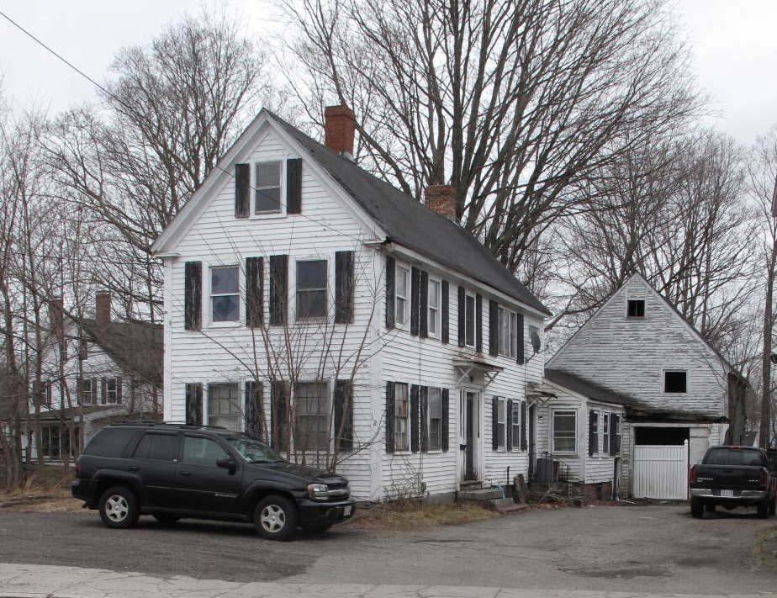
View from SW

Locus Map (north at top)
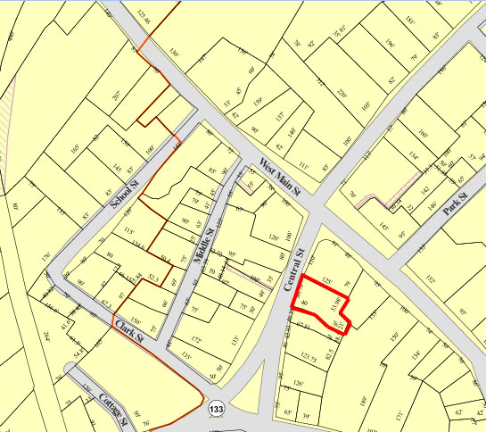

Recorded by: Kathryn Grover & Neil Larson
Organization: Town of Georgetown
Date: October 2012

Assessor’s Number USGS Quad Area(s) Form Number

11A-66 |  | Georgetown |  | C |  | GEO.126

Town/City: Georgetown
Place: (neighborhood or village):
Town Center

Address: 12 Central Street
Historic Name: Joseph P. & Mary A. Stickney House
Uses: Present: single residence
Original: single residence
Date of Construction: ca. 1855
Source: historic maps
Style/Form: Greek Revival
Architect/Builder: unknown
Exterior Material:
Foundation: brick (parged)
Wall/Trim: wood clapboards
Roof: asphalt shingles
Outbuildings/Secondary Structures:
Barn (attached)
Major Alterations (with dates):
Addition on north side
Window sash replaced

Condition: good
Moved: no yes Date:
Acreage: 0.26 acre
Setting: This house is sited on the southeast side of Central Street between the south end of the town’s commercial center and Georgetown Town hall. The area is a mix of commercial, residential, and insititutional uses.

Recommended for listing in the National Register of Historic Places.
If checked, you must attach a completed National Register Criteria Statement form.

ARCHITECTURAL DESCRIPTION
The Joseph P. & Mary A. Stickney House, built ca. 1855, is a two-story wood frame dwelling located on the east side of Central Street south of Main Street. With its gable end oriented to the street and principal façade facing south, its plan conforms to middling urban housing of the period, much of it multiple-family in use. The street façade with its two window bays indicates that the house plan comprises only two rooms divided by a center passage with stairs. The placement of chimneys on the ridge of the roof respond to stove locations on the east sides of the rooms. The principal south façade is five bays wide with a center entrance with sidelights set within a trabeated architrave. A shed-roof hood was added over the door later, and the two second-story windows on the east side have been combined into one with the removal of the wall area between them. Also later, the east end was extended for a second doorway and stairs, probably built to convert the house to a two-family dwelling.

A one-story addition was made to the north side of the house, probably for a bathroom. A one-story rear ell connects the house to a story-and-a-half domestic barn with a vehicle entrance on the first floor and a mow door above. The wood frame outbuilding has a front gable roof and wood clapboard siding.

The house is sited in the south side of its current lot leaving a large side yard, the front section of which is used for parking. A driveway on the south side of the house leads from the street to the barn following the southern lot line. A rear yard is now overgrown with trees.

The Joseph P. & Mary A. Stickney House is an intact example of a dwelling associated with Georgetown’s early commercial development in the early 19th century. Built ca.1855 with its narrow gable end oriented to the street, the house was sited in the mode of urban examples of this type. The building is a contributing component of the village district.

HISTORICAL NARRATIVE
The house at 12 Central Street was probably built between 1850 and 1856 for the merchant Joseph Pike Stickney and his family. Stickney was born in 1809 in Rowley, the son of Moses and Sarah Pike Stickney; his father was an early shoe manufacturer and grocer in Georgetown; Joseph Stickney had a store in the Phoenix Block in Georgetown and was a clerk in Haverhill from the late 1860s through 1880. He was a town clerk in Georgetown from 1841 to 1845 and a postmaster for an unclear term beginning in 1851.

The 1850 census shows Stickney elsewhere in Georgetown with no real property in a household with his wife Sophia Young, a native of Dover, New Hampshire, whom he married in 1833, and their daughters Sarah Maria (born 1835) and Martha Pike (born 1842). The 1856 map of Georgetown attaches his name to the house on this site, and the 1860 census shows him as a merchant with $1400 in real property. By then the Stickney’s daughter Anna Josephine had been born, and the family shared the house with Lucy and Augusta Noyes. Lucy Noyes was a milliner and probably worked with the Stickney’s oldest daughter Sarah, also in that trade at the time.

In 1862 Sophia Young Stickney died of consumption, and four years later Stickney married Sarah M. Spofford, the daughter of Parker and Hannah Spofford of Georgetown. The 1870 census shows Stickney as a shoe store clerk with $2000 in real property; at that time his daughter Sarah (shown as Maria) no longer worked, while Anna, the youngest daughter, worked in one of the area’s many shoe factories. In 1880 she was shown as operating a “ladies shoe-stitching machine” in the census, while her father was a clerk in a “shoe-finding” store.

In 1895 Joseph P. Stickney died at the age of eighty-five, and his widow Sarah died in June 1906. By 1916 the Stickney heirs had sold 12 Central Street to Colby Manson Leavitt, a foreman for the Haverhill shoe factory of F. E. Leavitt and Company and later George B. Leavitt and Company. Leavitt, his wife, and his three children occupied the property until about 1924, when they sold 12 Central to George Robert and Lottie W. Lovelace. Born in Wisconsin about 1876, Lovelace ran a gas station in Georgetown; in 1910 he had worked as a telephone system electrician in Sturgeon Bay, Wisconsin, and by 1920 he and his wife and sister-in-law Louise Vance had moved to Chatham on Cape Cod, where he worked as a telephone supervisor for the U.S. Coast Guard. In 1939 George Lovelace died of lung cancer, and his wife and her sister were shown still living at 12 Central Street in 1940.

After Lottie Lovelace’s death in 1941, an heir, Christopher N. Cutter of Baltimore, sold 12 Central Street to Ralph A. and Jeanne C. Bishop in 1943. Ralph A. Bishop was born Raoul Levesque about 1895, probably in Salem, and was the son of Salem grocer Adelard Levesque. He was working as a clerk in Salem when he married, between 1915 and 1917, and by 1920 he was a leather worker. By 1930 he had opened a meat market in Georgetown next door at 14 Central Street, where he also lived with his wife Jane and children Gerard and Florence. By then he had changed his name to Ralph Bishop. He owned and apparently rented 12 Central Street until 1955, when he sold it to Thomas B. Fordham Jr. and his wife Francine, who in 1960 sold it and several adjoining parcels to King’s Surf, a Florida corporation. Six months later Doris A. Marston acquired three of the parcels, and she sold 12 and 14 Central and another parcel to John J. and Eleanor F. Salah in 1962. Born in 1929 in Gloucester, John Salah was the son of Syrian immigrant grocer Kalal Salah and grew up in Gloucester; he worked as a clerk for his father’s grocery until about 1955, and he was later an automobile dealer and a bartender at Gloucester’s Lebanon Club. By 1963 he had become a realtor. The Salahs are the current owners of 12 Central Street.

BIBLIOGRAPHY and/or REFERENCES
Arrington, Benjamin F., ed. Municipal History of Essex County in Massachusetts. NY: Lewis Historical Publishing Co., 1922.
Field, Jane. A Brief History of Georgetown Massachusetts 1838-1963. Rev. ed. 1988. Georgetown: Georgetown Historical Commission, 1988.
Gage, Thomas. The History of Rowley, Anciently Including Bradford, Boxford, and Georgetown, from the Year 1639 to the Present Time. Boston: F. Andrews, 1840.
Georgetown, Boxford, Byfield, Newbury, and West Newbury, Massachusetts, Directory. Boston: W. E. Shaw, 1901-2, 1905, 1909, 1912, 1914, 1916-17, 1918, 1925.
Hill, Edwin P. “History of Georgetown, Massachusetts.” In Standard History of Essex County, Massachusetts. Edited by Cyrus M. Tracey, William E. Graves, and Henry M. Batchelder. Boston: C. F. Jewett, 1878.
Hull, Forrest P. Georgetown: Story of One Hundred Years, 1838-1938. 1938. Reprint. Georgetown, MA: Georgetown Historical Commission, 2006.
Merrill, Samuel. A Merrill Memorial: An Account of the Descendants of Nathaniel Merrill, an Early Settler of Newbury, Massachusetts. Cambridge, MA, 1917-28.
Nelson, Henry M. “Town of Georgetown History.” In Hurd, D. Hamilton. History of Essex County, Massachusetts, with Biographical Sketches of Many of Its Pioneers and Prominent Men. Vol. 1. Philadelphia: J. W. Lewis and Co., 1888.

MAPS
“Map of the Centre of Georgetown in 1800.” In Perley, Sidney H., “Centre of Georgetown in the Year 1800.” The Essex Antiquarian: A Quarterly Magazine Devoted to the Biography, Genealogy, History, and Antiquities of Essex County, Massachusetts 2, 7 (July 1898): 201.
Map of Georgetown in 1810 and 1840. In Gage, Thomas. The History of Rowley, Anciently Including Bradford, Boxford, and Georgetown, from the Year 1639 to the Present Time. Boston: F. Andrews, 1840. 320.
“Map of New Rowley Surveyed and Drawn by Philander Anderson 1830.” Georgetown Historical Society.
Map of Georgetown. 1856. In Walling. H. F. A Topographical Map Essex County Massachusetts. Boston: Smith and Morley, 1856.
Atlas of Essex County, Massachusetts. Philadelphia: D. G. Beers and Co., 1872). Plates 59 and 61.
“Town of Georgetown Mass.” and “Village of Georgetown Mass.” In Atlas of Essex County, Massachusetts (Boston: George H. Walker, 1884).
“Georgetown, Mass. 1887.” Drawn and Published by George E. Norris, Brockton, Massachusetts. Troy, NY: Burleigh Lithographic Establishment, 1887.”

PHOTOGRAPHS (all photos by Neil Larson, 2012)

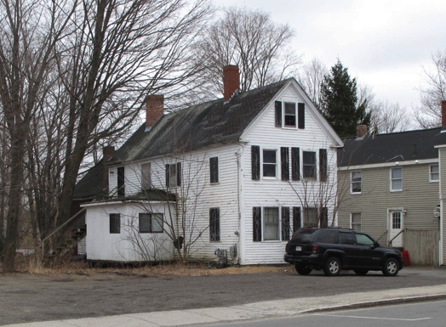
View from NW

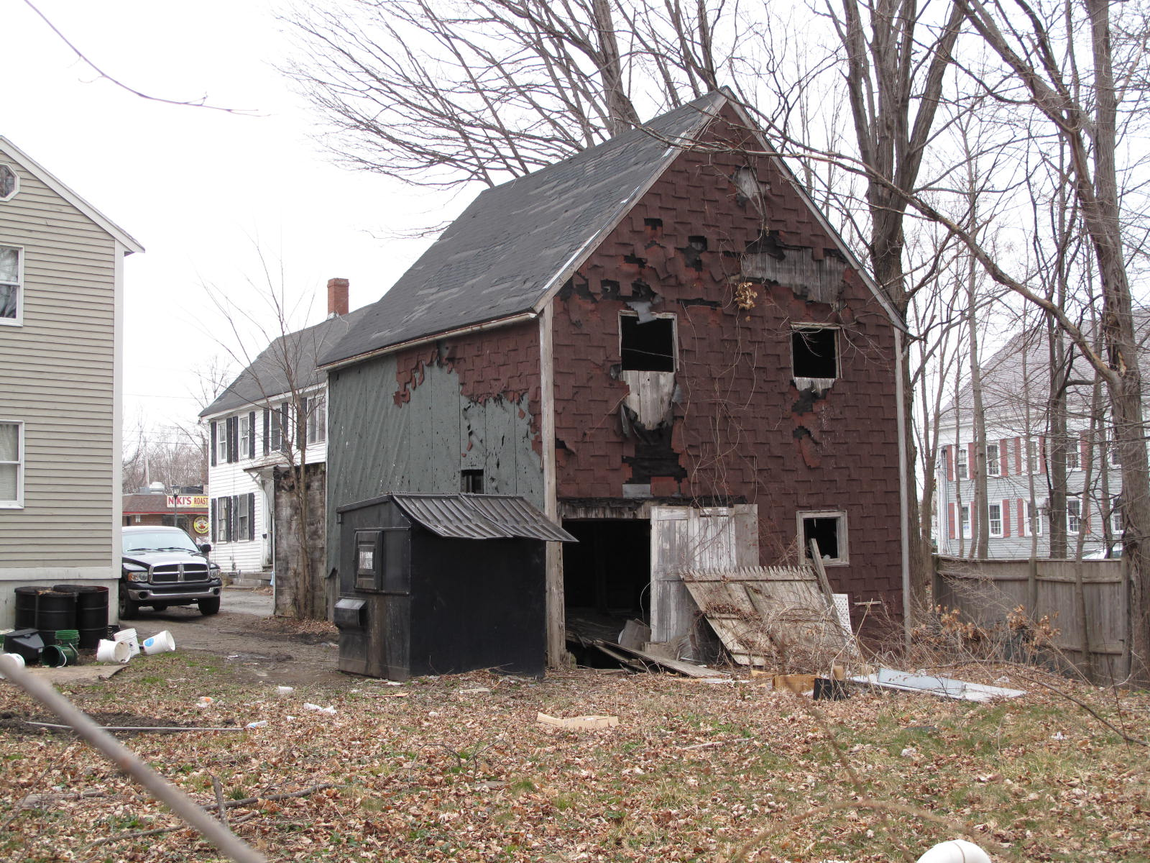
View from SE

National Register of Historic Places Criteria Statement Form

Check all that apply:

Individually eligible Eligible only in a historic district

Contributing to a potential historic district Potential historic district

Criteria: A B C D

Criteria Considerations: A B C D E F G

Statement of Significance by________Neil Larson_________________________________
The criteria that are checked in the above sections must be justified here.

The Joseph P. & Mary A. Stickney House is an intact example of a dwelling associated with Georgetown’s early commercial development in the early 19th century. Built ca.1855 with its narrow gable end oriented to the street, the house is was sited in the mode of urban examples of this type. The building is a contributing component of the village district.

Henry M. Nelson, “Town of Georgetown History,” in History of Essex County, Massachusetts, with Biographical Sketches of Many of Its Pioneers and Prominent Men, ed. D. Hamilton Hurd (Philadelphia: J. W. Lewis and Co., 1888), 1: 851, 852, 857.
Christopher N. Cutter, Baltimore, to Ralph A. and Jeanne C. Bishop, 9 November 1943, SED 3386:392.
Ralph A. and Jeanne C. Bishop, “sometimes called Raoul A. and Jane C. Levesque,” to Thomas B. Fordham Jr. and Francine T. Fordham, 22 March 1955, SED 4149:323; Thomas B. Fordham Jr. and Francine T. Fordham to King’s Surf, 22 July 1960, SED 4686:550; King’s Surf, LTd., to Doris A. Marston, 21 December 1960, SED 4731:374; Doris A. Marston, individually and as sole remaining trustee of Countryside Realty Trust, to John J. and Eleanor F. Salah, 14-16 Central Street, 17 July 1972, SED 5886:351.

