FORM B − BUILDING

Massachusetts Historical Commission
Massachusetts Archives Building
220 Morrissey Boulevard
Boston, Massachusetts 02125

Photograph
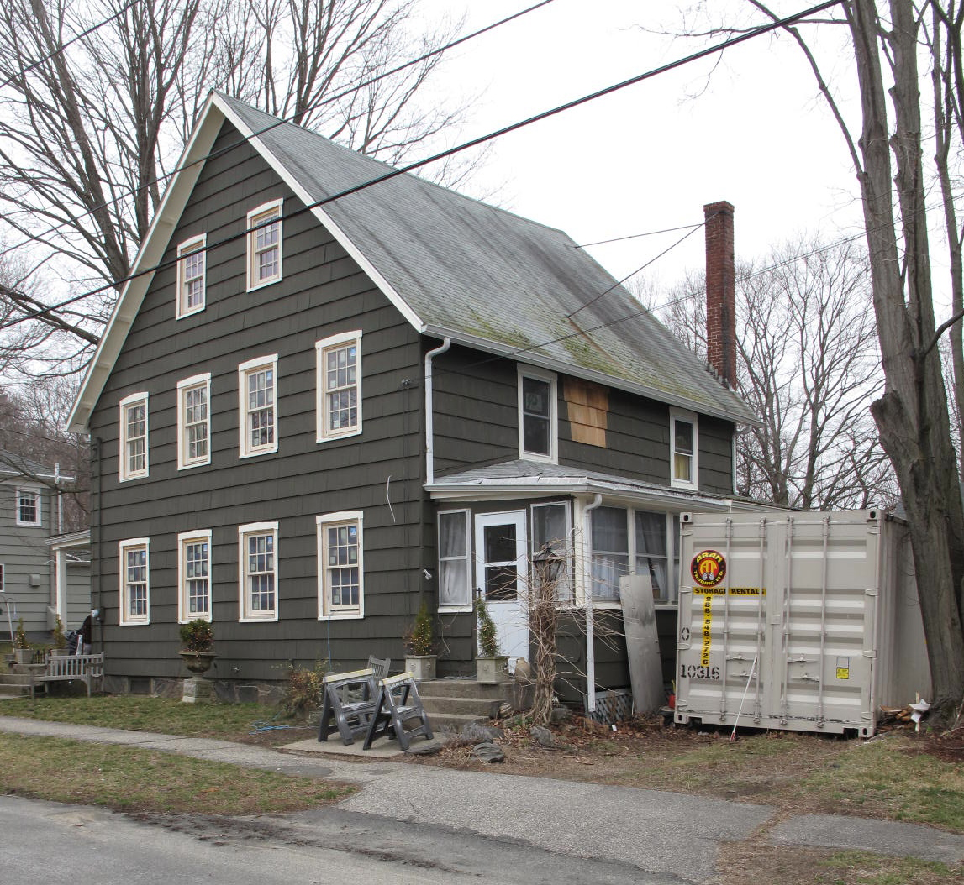
View from northeast

Locus Map (north at top)
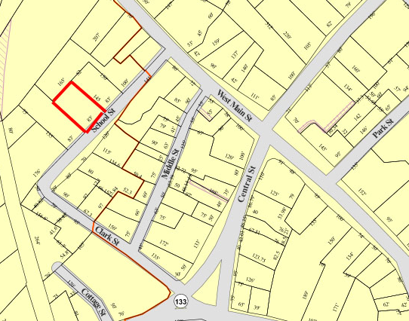

Recorded by: Kathryn Grover & Neil Larson
Organization: Town of Georgetown
Date: October 2012

Assessor’s Number USGS Quad Area(s) Form Number

6C-125 |  | Georgetown |  | C |  | GEO.184

Town/City: Georgetown
Place: (neighborhood or village):
Town Center

Address: 11 School Street
Historic Name: Dorman Double House
Uses: Present: single residence
Original: two-family residence
Date of Construction: ca. 1860
Source: deeds, historic maps, censuses
Style/Form: Gothic Revival
Architect/Builder: unknown
Exterior Material:
Foundation: stone
Wall/Trim: wood shingles
Roof: asphalt shingles
Outbuildings/Secondary Structures:
shop
Major Alterations (with dates):
Wood shingle siding added
Window sash replaced

Condition: good
Moved: no yes Date:
Acreage: 0.27 acre
Setting: This house is sited on the northwest side of School Street on a lot with mature trees. The area is a mix of residential, institutional, and commercial uses.

Recommended for listing in the National Register of Historic Places.
If checked, you must attach a completed National Register Criteria Statement form.

ARCHITECTURAL DESCRIPTION
The Dorman Double House is a two-story wood double frame dwelling located on the northwest side of School Street southwest of West Main Street. The dwelling units are divided vertically along the ridgeline of the front gable roof; a one-story kitchen ell is attached to the rear of the westerly half. The front-gable facade contains four windows evenly-spaced across the first and second stories and two windows in the attic. The windows retain their original surrounds with pointed headers. The roof edge overhangs the walls but is unembellished. Entrances are located at the front of the side walls and are contained in one-story wings, the front halves of which are porches opening on the front facade. The second stories contain two windows. The existing wood shingle siding is an addition, and the window sash are recent replacements.

The house is centered on its street frontage with small front and side yards. The larger rear yard contains what appears to be a small wood frame, gable roof shop building. A shed roof addition on one side contains a single car bay with hinged doors. An unpaved driveway enters the property on the easterly side of the house.

The Dorman Double House is distinctive example of double house built in the mid-19th-century. Built ca. 1860, the house retains its distinguishing features and, with its small shop building, is a contributing component of the village district.

HISTORICAL NARRATIVE
Charles E. and George H. Dorman had acquired this School Street lot in 1857 for $130, and in 1860 the brothers were enumerated in a household with their parents, Cyrus and Sarah Dorman, among other residents on School Street. The double house at 11 School Street was built between 1857 and 1860. Cyrus Dorman, born in Rowley in 1799, married Sarah Harriman, the daughter of Jonathan and Sarah Moulton Harriman of Rowley, in 1828, and the couple’s children Charles Edward, Martha Josephine, and George Hastings were born in Rowley between 1830 and 1834. By 1840 the family was living in Georgetown. The 1850 and 1860 censuses enumerate Dorman in each instance before Samuel Coffin, who then owned 17 Middle Street, and it seems likely that in 1850 Dorman was renting a house on that street from trader William Boynton, who owned considerable property in the neighborhood. Cyrus Dorman’s shoe last manufacturing business was documented in the industrial schedules of the federal census in 1850 and 1860. In 1850 he used six thousand wood blocks to make six thousand lasts worth $1020 and employed three people, two of them his sons; by 1860, when he was sixty, he employed only himself and made four thousand lasts worth only $600. Cyrus Dorman himself owned no personal property; he evidently was intent in having the School Street property in his son’s names rather than his own.

The 1870 census lists Cyrus Dorman on School Street with his wife and son, Charles. Listed next is the household of his daughter, Martha, her husband, Edward P. Wildes, and their son Charles E., age 12 years. The enumeration indicates that they were separate households in the double house on School Street. Cyrus Dorman died the following year at the age of seventy-one. In May of the same year his sons deeded the property to Edward P. Wildes, who had married their sister Martha Josephine Dorman in 1857, but it is not clear from the 1880 census whether Sarah Harriman Dorman lived in the house afterward. The 1872 map attaches the name “C. Dorman” to the house. By 1880 Edward P. and Martha Dorman Wildes had built their house at 24 Pleasant Street, but Sarah Dorman and her son Charles, then a traveling stationery salesman, still may have been living in the School Street house. In 1889 Sarah Harriman Dorman died, and four years later Charles E. Dorman died in South Hampton, New Hampshire.

In December 1874 the Wildeses sold 11 School Street to Ann S. Jewett, who with her husband Charles E. Jewett owned and occupied 7 School Street by about 1875. The 1884 map attaches the name “E. C. Jewett” to the 11 School Street house (probably meaning “C. E. Jewett), but the couple appears to have rented the property. In 1912 Ann S. Jewett defaulted on the 1874 mortgage on the property, and it was sold at auction for $1100 to John LaBord. Born in Quebec in 1861, La Bord immigrated to the United States as a child and was living in Georgetown in 1900, though directories and censuses show him in Groveland in 1908 and 1910. In 1908 he had acquired 9 and 11 Middle Street, and the 1914 Georgetown directory shows La Bord with his painting business at 11 Middle Street and his house on East Main Street, where he still lived in 1920. Like earlier owners of 11 School Street, he would have rented the house, though he sold it soon afterward, in April 1913, to Amy M. Poor. Poor was the wife of Lester Dean Poor, a native of West Newbury and the son of farmer Abel M. Poor and his wife Serena Phinney, who emigrated from Nova Scotia.

Lester and Amy M. (sometimes shown as Mamie) Butler Poor had a daughter, Natalie, in 1917 in Swampscott, and the family seems to have moved around frequently between North Shore towns. The 1916 directory shows them at 11 School Street, but the 1912 and 1918 directories note that he had “removed to Lawrence.” In 1920 the family was in Methuen, where Poor worked as a truckman. By 1925 the Poors had moved back to 11 School Street, and Lester then commuted to Manchester, New Hampshire, where he worked as a salesman.

The 1940 census shows only Amy Poor and her daughter Natalie, a shoe stitcher, owning and occupying 11 School Street; according to his World War II draft registration, Lester Poor was then working at Brown and Sharp in Providence, Rhode Island, and may have been there when the 1940 census was taken. In 1943 Natalie Poor married Albert Lawrence Tidd, a Georgetown native and the son of George C. and Jennie Hoyt Tidd. After the death of her mother the 11 School Street property passed to Natalie Poor Tidd. She owned the property until 1992, when she sold it to Karen A. Freeman of Amesbury and Dawn K. Freeman of Roanoke, Virginia, reserving for herself a life estate.

BIBLIOGRAPHY and/or REFERENCES
Arrington, Benjamin F., ed. Municipal History of Essex County in Massachusetts. NY: Lewis Historical Publishing Co., 1922.
Field, Jane. A Brief History of Georgetown Massachusetts 1838-1963. Rev. ed. 1988. Georgetown: Georgetown Historical Commission, 1988.
Gage, Thomas. The History of Rowley, Anciently Including Bradford, Boxford, and Georgetown, from the Year 1639 to the Present Time. Boston: F. Andrews, 1840.
Georgetown, Boxford, Byfield, Newbury, and West Newbury, Massachusetts, Directory. Boston: W. E. Shaw, 1901-2, 1905, 1909, 1912, 1914, 1916-17, 1918, 1925.
Hill, Edwin P. “History of Georgetown, Massachusetts.” In Standard History of Essex County, Massachusetts. Edited by Cyrus M. Tracey, William E. Graves, and Henry M. Batchelder. Boston: C. F. Jewett, 1878.
Hull, Forrest P. Georgetown: Story of One Hundred Years, 1838-1938. 1938. Reprint. Georgetown, MA: Georgetown Historical Commission, 2006.
Merrill, Samuel. A Merrill Memorial: An Account of the Descendants of Nathaniel Merrill, an Early Settler of Newbury, Massachusetts. Cambridge, MA, 1917-28.
Nelson, Henry M. “Town of Georgetown History.” In Hurd, D. Hamilton. History of Essex County, Massachusetts, with Biographical Sketches of Many of Its Pioneers and Prominent Men. Vol. 1. Philadelphia: J. W. Lewis and Co., 1888.
Sammarco, Anthony Mitchell, for Georgetown Historical Society. Images of America: Georgetown. Portsmouth, NH: Arcadia Publishing, 2002.

MAPS
“Map of the Centre of Georgetown in 1800.” In Perley, Sidney H., “Centre of Georgetown in the Year 1800.” The Essex Antiquarian: A Quarterly Magazine Devoted to the Biography, Genealogy, History, and Antiquities of Essex County, Massachusetts 2, 7 (July 1898): 201.
Map of Georgetown in 1810 and 1840. In Gage, Thomas. The History of Rowley, Anciently Including Bradford, Boxford, and Georgetown, from the Year 1639 to the Present Time. Boston: F. Andrews, 1840. 320.
“Map of New Rowley Surveyed and Drawn by Philander Anderson 1830.” Georgetown Historical Society.
Map of Georgetown. 1856. In Walling. H. F. A Topographical Map Essex County Massachusetts. Boston: Smith and Morley, 1856.
Atlas of Essex County, Massachusetts. Philadelphia: D. G. Beers and Co., 1872). Plates 59 and 61.
“Town of Georgetown Mass.” and “Village of Georgetown Mass.” In Atlas of Essex County, Massachusetts (Boston: George H. Walker, 1884).
“Georgetown, Mass. 1887.” Drawn and Published by George E. Norris, Brockton, Massachusetts. Troy, NY: Burleigh Lithographic Establishment, 1887.”

PHOTOGRAPHS (all photos by Neil Larson, 2012)

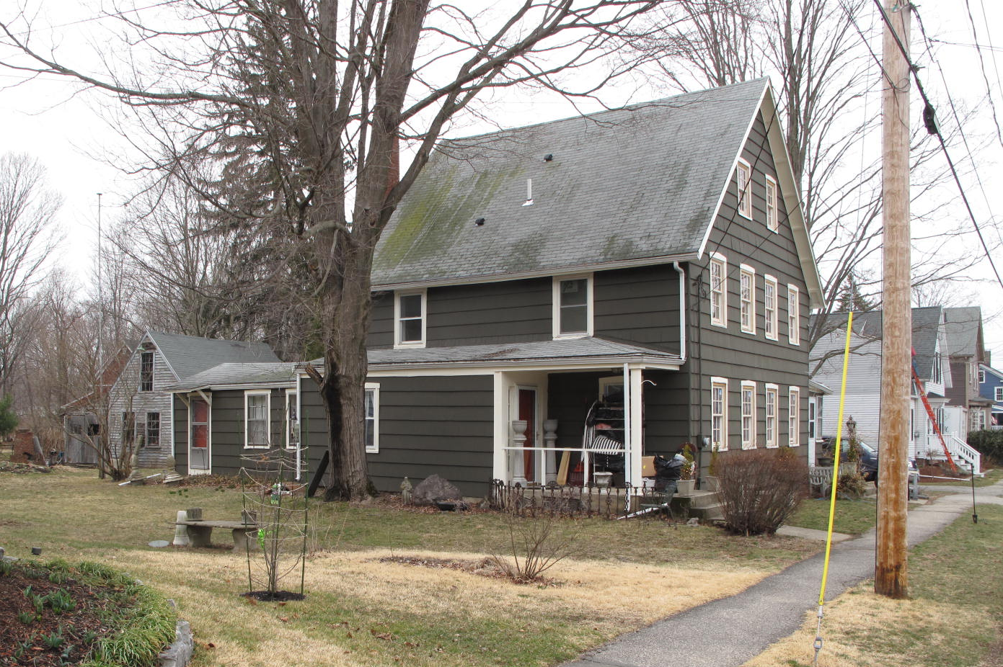
11 School Street: view from SW

National Register of Historic Places Criteria Statement Form

Check all that apply:

Individually eligible Eligible only in a historic district

Contributing to a potential historic district Potential historic district

Criteria: A B C D

Criteria Considerations: A B C D E F G

Statement of Significance by________Neil Larson_________________________________
The criteria that are checked in the above sections must be justified here.

The Dorman Double House is distinctive example of double house built in the mid-19th-century. Built ca. 1860, the house retains its distinguishing features and, with its small shop building, is a contributing component of the village district.

Jeremiah P. Jones to Charles E. and George H. Dorman, 23 October 1857, SED 561:47.
John LaBord to Amy M. Poor, 15 April 1913, SED 2212:460.
Natalie S. Tidd to Karen A. Freeman, Amesbury, and Dawn K. Freeman, Roanoke VA, 10 April 1992, SED 11238:457.

