FORM B − BUILDING

Massachusetts Historical Commission
Massachusetts Archives Building
220 Morrissey Boulevard
Boston, Massachusetts 02125

Photograph
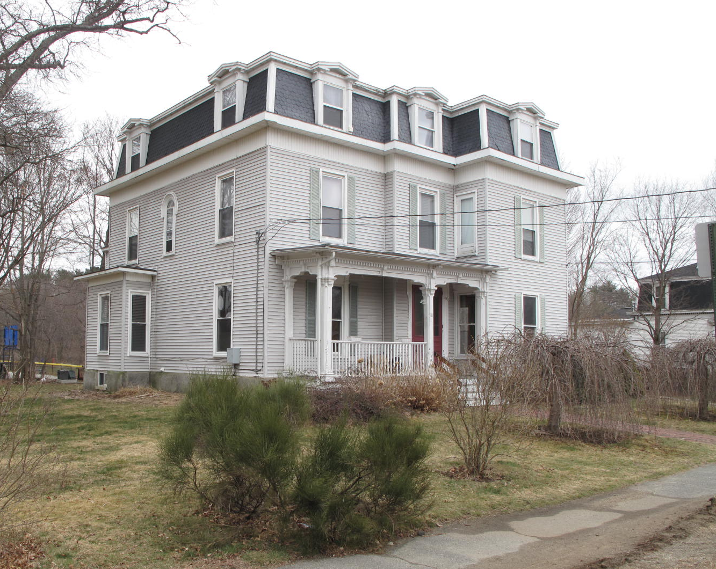
View from southwest

Locus Map (north at top)
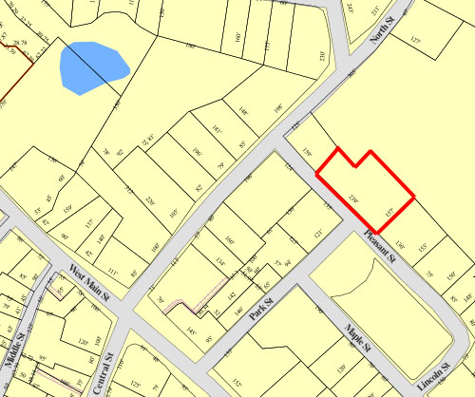

Recorded by: Kathryn Grover & Neil Larson
Organization: Town of Georgetown
Date: October 2012

Assessor’s Number USGS Quad Area(s) Form Number

11A-98 |  | Georgetown |  | C |  | GEO.169

Town/City: Georgetown
Place: (neighborhood or village):
Town Center

Address: 10 Pleasant Street
Historic Name: Stephen & Sarah Osgood House
Uses: Present: multiple residence
Original: single residence
Date of Construction: ca. 1870
Source: deeds, historic maps
Style/Form: Second empire
Architect/Builder: unknown
Exterior Material:
Foundation: brick
Wall/Trim: vinyl clapboards
Roof: slate shingles
Outbuildings/Secondary Structures:
None
Major Alterations (with dates):
Rear ell raised to two stories, late 20th C
Vinyl siding added
Window sash replaced

Condition: good
Moved: no yes Date:
Acreage: 0.80 acre
Setting: This house is sited on the north side of Pleasant Street on a lot with mature trees. It is bordered on the northeast by the grounds of the Perley School and on the southeast by Lincoln Park. The area is a mix of residential and institutional uses.

Recommended for listing in the National Register of Historic Places.
If checked, you must attach a completed National Register Criteria Statement form.

ARCHITECTURAL DESCRIPTION
The Stephen & Sarah Osgood House is a two-story wood frame dwelling located on the northerly side of Pleasant Street east of North Street. Built ca. 1870, the house has interior plan with two rooms divided by a center passage; chimneys, now removed, were located in the interior of the house. The design of the house is distinguished by a tall, slate-covered mansard roof that steps its way around the irregular facades seated on a stolid cornice (now obscured by vinyl siding) and punctuated with characteristic dormers having pediments engaged into another cornice encircling the mansard’s top. The front façade is broken into three stages with a central one-bay entrance pavilion flanked by a recessed bay on the left side and a projecting bay on the right side. A porch ornamented with chamfered pillars and a hefty entablature with a pronounced dentil band abuts the side of the projecting bay and spans the entrance and the rest of the façade to the outside corner. Corner quoins are concealed under the added vinyl siding.

The westerly side of the house contains three window bays with a one-story box bay in the rear and an arched window in the second story of the center bay indicating the location of the staircase within. The easterly side contains four bays with another one-story box bay; the rear bay is stepped back and contains a secondary service entrance providing access to a one-story rear ell with a mansard roof, now covered with vinyl clapboards. What appears to have been a one-story annex on the rear of the ell was later raised to two stories and capped by a low-pitch gable roof.

Historic maps show a domestic barn with a mansard roof located northwest of the house. This building has been removed and its site incorporated in the large lawn on that side of the lot. A number of mature trees have been preserved and a wooded area has been allowed to develop along the northerly bounds of the property to screen the house from the neighboring public school. The yard on the easterly side of the house has been paved for parking .

The Stephen & Sarah Osgood House built ca. 1870, is a distinctive residence designed in the Second Empire style. In spite of added vinyl siding and window replacement, the house retains the form, mansard roof and dormers, front porch characteristic of the period and style. Its association with some of the town’s noteworthy residents is historically significant. The building is a contributing component of the village district.

HISTORICAL NARRATIVE
According to historian Jane Field, the streets around what is now Lincoln Park were “opened to home construction” in 1868. The 1830 and 1856 maps of the village show the area completely undeveloped, but by 1872 the “Park” appears on the town map enclosed by Pleasant, Lincoln, Maple, and Park Streets; only Pleasant among these four streets is shown with its name. At that time no houses had been built on either Maple or Lincoln, and the only dwellings bordering Lincoln Park were those of shoe manufacturer Milton G. Tenney (at Park and Pleasant), shoe industry workers William Augustus Harnden, and George A. Kimball, both on Pleasant Street, and the 10 Pleasant Street home of merchant tailor Stephen Osgood, behind the Baptist Church on North Street. The area around Lincoln Park appears to have developed as a series of individual transactions; though shoe manufacturer George Jewett Tenney owned several parcels later developed as house lots, no single developer platted the area’s residential growth. However, the lots that Tenney controlled, including his own property, were developed with houses designed in the Second Empire style.

In May 1869 George J. Tenney sold the lot at 10 Pleasant street to Osgood for 700 dollars. No buildings or design requirements were stated mentioned in the deed, but Osgood went on to build the existing Second Empire residence. Yet, at least one deed that Tenney executed, that conveying the lot at 11 Maple Street to shoe shop cutter Edward A. Chaplin in June 1871, stipulated that the parcel in question “be used as a house lot and . . . have a two story or one story & French roof on it.” The house at 10 Pleasant Street had certainly been built by June 1871, for Tenney’s deed to Annie F. Kimball for 18 Pleasant street stipulated that the house be “2 story or one story & French roof & to set on line with Harndens and Osgoods,” the houses by then built at 14 and 10 Pleasant Street, respectively.

Born in Salisbury in 1827, Stephen Osgood built a career in Georgetown as a merchant tailor of commercial significance. The son of ship caulker Stephen Osgood Sr. and his wife Charlotte Morrill, Osgood had shipped in the merchant marine as a young man and in 1849 joined the hordes who traveled to California during the gold rush. By early 1850, however, he had returned to his native state and on 9 April that year in Georgetown he married Sarah P. Carter, the daughter of Georgetown merchant and patent medicine manufacturer Moses Carter and his wife Almira Platts. According to one biographical account Osgood first apprenticed to Georgetown tailor Samuel Plumer, but he soon established his own business. By 1860, the industrial schedules of the federal census indicate, he was employing three men and nine women in the manufacture of men’s broadcloth and cassimere coats, pants, and vests. By 1880 he employed five men and eighteen women, was running his shop ten hours a day throughout the year, and produced clothing valued at seventeen thousand dollars. By then his sons Louis K. and Charles C. were both working as cutters of “gentlemen’s clothing” in his shop. Local histories state that his business was in the Masonic Block, which burned in 1885 and was replaced by the Union Block in 1886. Osgood was a Georgetown selectman, assessor, and overseer of the poor, a state representative (1871) and senator (1879-80), and the town’s postmaster from 1901 through 1904.

The 1860 census shows Carter living near his father-in-law Moses Carter on North Street wit his wife, his sons Louis Kossuth (born 1852), Stephen Carter (born 1854), and Charles Carter (born 1857), an Irish immigrant tailor and a tailor’s apprentice who no doubt worked for him, and a domestic servant. The 1870 directory shows him as living on “Washington sq[uare],” which seems to have been the first name for Lincoln Park, and by then the couple’s daughter Charlotte Alice had been born. The census shows him with $15,000 in real property and an equal amount of personal property. By 1880 the household included Osgood and his wife, sons Louis and Charles, daughter Charlotte, and a domestic servant, and the 1885 directory identifies him as a “merchant tailor” living on Pleasant Street at the head of Park Street.

In 1892 the Osgoods’ daughter Charlotte married Clement C. Haskell, a merchant from East Livermore, Maine, who had acquired substantial acreage in Orange County, Florida in the mid-1870s and was among the developers and capitalists in the area who founded the South Florida Railroad in 1879 as a way to improve the shipment of citrus fruits to markets. He was living at “Lake Maitland” at the time of his marriage (his second) to Charlotte Osgood, but he died only eight years later, in 1900. The 1900 census shows Stephen Osgood as the postmaster in the 10 Pleasant Street house with his wife, son Louis K.,, his newly widowed daughter Charlotte Haskell, and her two children—Osgood Fitz-Osborne Haskell, born in Florida in 1895, and Charlotte P. Haskell, born in 1896. By then Charles C. Osgood had established himself in his own merchant tailoring business in Haverhill as C. C. Osgood and Company, and Louis worked for him there.

In 1902 Sarah Carter Osgood died, and by 1910 Osgood and his son Louis lived at 10 Pleasant Street with Charlotte Osgood Haskell, shown in the census as a professional musician. Her son Osgood was fifteen and Charlotte thirteen. In 1911 Stephen Osgood died at the age of eighty-four, and in 1918 Charlotte Osgood Haskell died at the age of fifty-five. In 1920 10 Pleasant Street was occupied by Louis K. Osgood and his niece Charlotte, then twenty-three; Osgood Haskell was boarding on Prospect Street and in 1920s and 1930s he was working for Smith Motor Company in Haverhill as a salesman and living in Haverhill and Groveland.

Louis K. Osgood became the owner of C. C. Osgood and Company after the death of his older brother, sometime between 1920 and 1924, and he died between 1932 and 1940. The 1940 census shows Osgood Haskell as owner and occupant of 10 Pleasant Street. He shared the house with his wife Edith, children Peter and Mary Jo, and a maid named Anna Blaisdell. By 1945 Haskell was working for General Electric in Lynn.

Haskell left 10 Pleasant Street soon afterward because he had defaulted upon a mortgage that had been in place for more than sixty years. In May 1878 Stephen Osgood had taken it out, and censuses show him owning the house with an outstanding mortgage until the time of his death. The loan was in default in August 1941 when Georgetown Savings Bank foreclosed on the property. In February 1946 the bank sold 10 Pleasant Street to Irving F. and Kenneth A. Anderson of Gloucester; the 1957 directory shows Kenneth Anderson, an auditor in Boston, in the house with the family of Elsworth H. Welch, then principal of the Perley Elementary School.

In 1960 Kenneth Anderson sold 10 Pleasant Street to the First Baptist Church, which then transferred its 40 North Street rectory to this Pleasant Street house. The church in turn sold it in 1968, and the house changed handed often over the next decades until current owner Paul J. Pagliarulo acquired it in 1999.

BIBLIOGRAPHY and/or REFERENCES
Arrington, Benjamin F., ed. Municipal History of Essex County in Massachusetts. NY: Lewis Historical Publishing Co., 1922.
Field, Jane. A Brief History of Georgetown Massachusetts 1838-1963. Rev. ed. 1988. Georgetown: Georgetown Historical Commission, 1988.
Gage, Thomas. The History of Rowley, Anciently Including Bradford, Boxford, and Georgetown, from the Year 1639 to the Present Time. Boston: F. Andrews, 1840.
Georgetown, Boxford, Byfield, Newbury, and West Newbury, Massachusetts, Directory. Boston: W. E. Shaw, 1901-2, 1905, 1909, 1912, 1914, 1916-17, 1918, 1925.
Hill, Edwin P. “History of Georgetown, Massachusetts.” In Standard History of Essex County, Massachusetts. Edited by Cyrus M. Tracey, William E. Graves, and Henry M. Batchelder. Boston: C. F. Jewett, 1878.
Hull, Forrest P. Georgetown: Story of One Hundred Years, 1838-1938. 1938. Reprint. Georgetown, MA: Georgetown Historical Commission, 2006.
Merrill, Samuel. A Merrill Memorial: An Account of the Descendants of Nathaniel Merrill, an Early Settler of Newbury, Massachusetts. Cambridge, MA, 1917-28.
Nelson, Henry M. “Town of Georgetown History.” In Hurd, D. Hamilton. History of Essex County, Massachusetts, with Biographical Sketches of Many of Its Pioneers and Prominent Men. Vol. 1. Philadelphia: J. W. Lewis and Co., 1888.
Sammarco, Anthony Mitchell, for Georgetown Historical Society. Images of America: Georgetown. Portsmouth, NH: Arcadia Publishing, 2002.

MAPS
“Map of the Centre of Georgetown in 1800.” In Perley, Sidney H., “Centre of Georgetown in the Year 1800.” The Essex Antiquarian: A Quarterly Magazine Devoted to the Biography, Genealogy, History, and Antiquities of Essex County, Massachusetts 2, 7 (July 1898): 201.
Map of Georgetown in 1810 and 1840. In Gage, Thomas. The History of Rowley, Anciently Including Bradford, Boxford, and Georgetown, from the Year 1639 to the Present Time. Boston: F. Andrews, 1840. 320.
“Map of New Rowley Surveyed and Drawn by Philander Anderson 1830.” Georgetown Historical Society.
Map of Georgetown. 1856. In Walling. H. F. A Topographical Map Essex County Massachusetts. Boston: Smith and Morley, 1856.
Atlas of Essex County, Massachusetts. Philadelphia: D. G. Beers and Co., 1872). Plates 59 and 61.
“Town of Georgetown Mass.” and “Village of Georgetown Mass.” In Atlas of Essex County, Massachusetts (Boston: George H. Walker, 1884).
“Georgetown, Mass. 1887.” Drawn and Published by George E. Norris, Brockton, Massachusetts. Troy, NY: Burleigh Lithographic Establishment, 1887.”

PHOTOGRAPHS (all photos by Neil Larson, 2012)
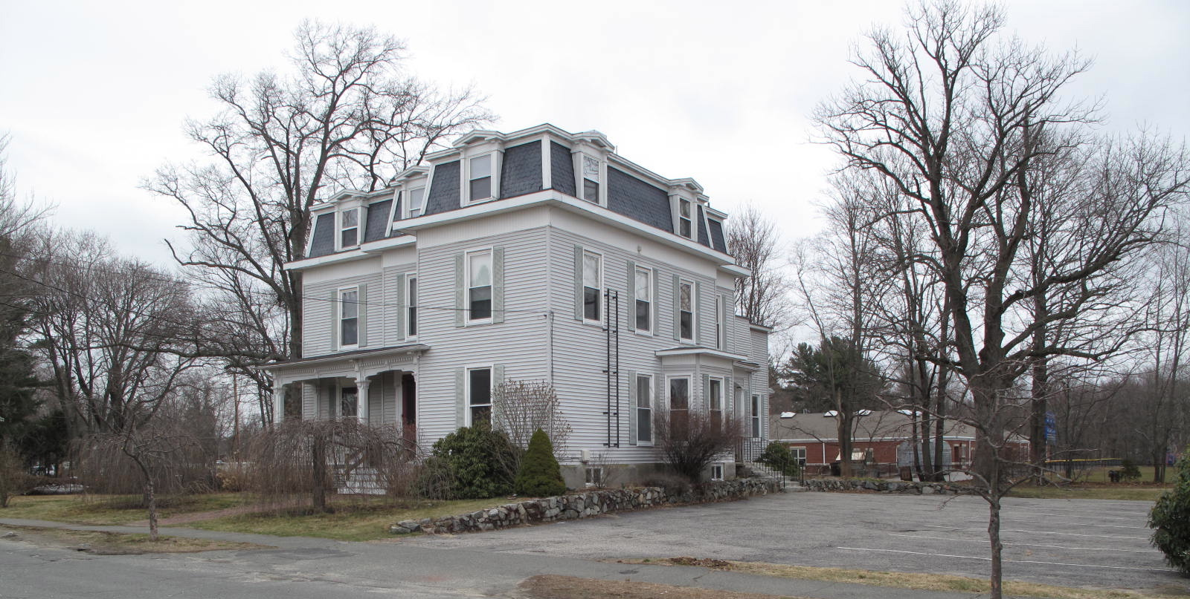
10 Pleasant Street: view from SE (top) and NW (bottom)

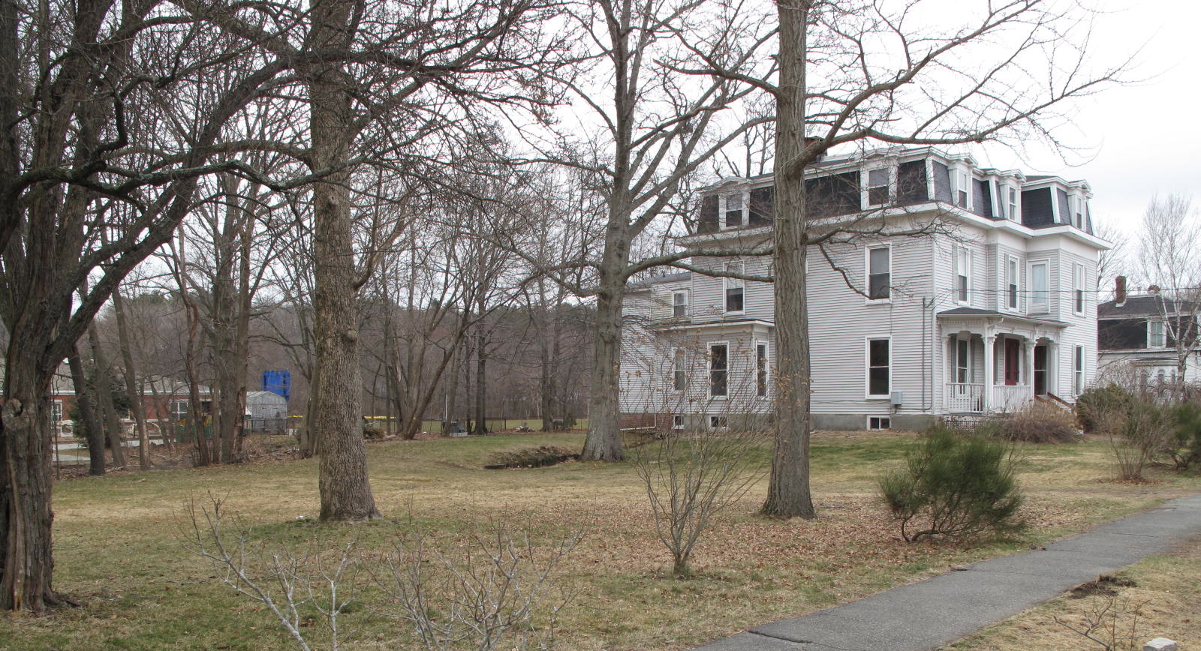

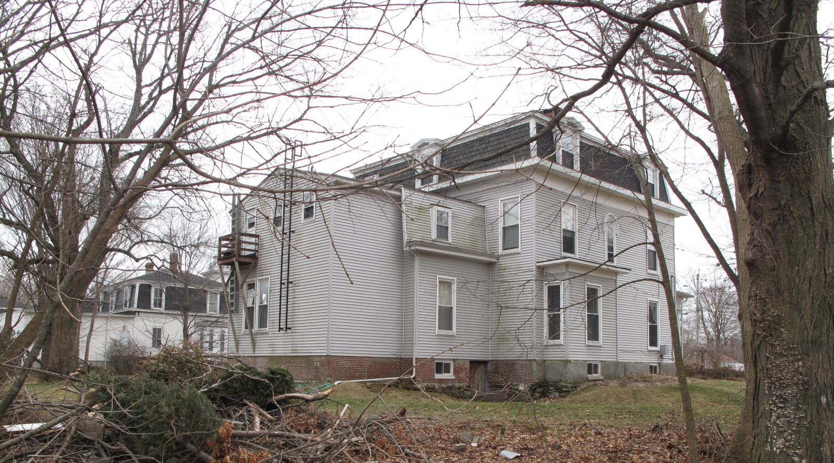
View from N (top) and NE (bottom)

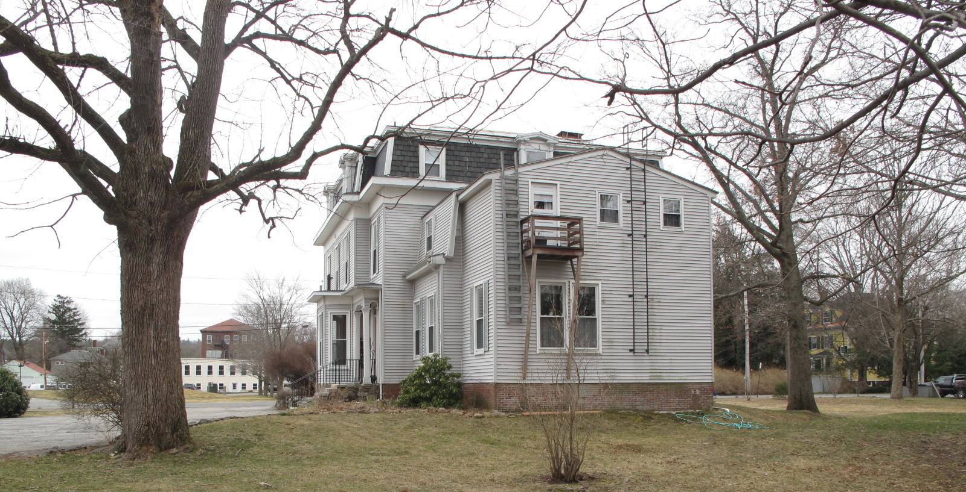

National Register of Historic Places Criteria Statement Form

Check all that apply:

Individually eligible Eligible only in a historic district

Contributing to a potential historic district Potential historic district

Criteria: A B C D

Criteria Considerations: A B C D E F G

Statement of Significance by________Neil Larson_________________________________
The criteria that are checked in the above sections must be justified here.

The Stephen & Sarah Osgood House built ca. 1870, is a distinctive residence designed in the Second Empire style. In spite of added vinyl siding and window replacement, the house retains the form, mansard roof and dormers, front porch characteristic of the period and style. Its association with some of the town’s noteworthy residents is historically significant. The building is a contributing component of the village district.

George J. Tenney to Stephen Osgood, 20 May 1869, SED 776:242.
See George J. Tenney to Edward A. Chaplin, 2 June 1871, SED 826:165.
George J. Tenney to Annie F. Kimball, 2 June 1871, SED 862:36.
Proceedings of the Most Worshipful Grand Lodge of Ancient Free and Accepted Masons of the Commonwelath of Massachusetts, for the Year 1911 (Boston: Rockwell and Churchill Press, 1912), 115-17.
Gayle and Steve Rajtar, “Making Tracks to Winter Park,” Winter Park Magazine, January 2011, http://winterparkmag.com/winterparkmag/index.php?option=com_content&task=view&id=886&Itemid=78
Georgetown Savings Bank, holder of mortgage given by Stephen Osgood 1 May 1878 (SED 996:268), foreclosure, 8 August 1941, SED 3267:331; Georgetown Savings Bank to Charles H. Coull, Gloucester, 5 February 1946, SED 3440:315; Charles H. Coull, Gloucester, to Irving F. Anderson and Kenneth A. Anderson, both Gloucester, 2 July 1946, SED 3468:360.
Kenneth A. Anderson to First Baptist Church of Georgetown Inc., 30 November 1969, SED 4624:168; First Baptist Church Inc. of Georgetown to Richard H. Ford Inc., West Newbury, 10 February 1968, SED 5510:232; Edward F. Oakes, Troy NH, to Paul J. Pagliarulo, 10 Pleasant Street Realty Trust, 31 March 1999, SED 15572:302.

