FORM B − BUILDING

Massachusetts Historical Commission
Massachusetts Archives Building
220 Morrissey Boulevard
Boston, Massachusetts 02125

Photograph
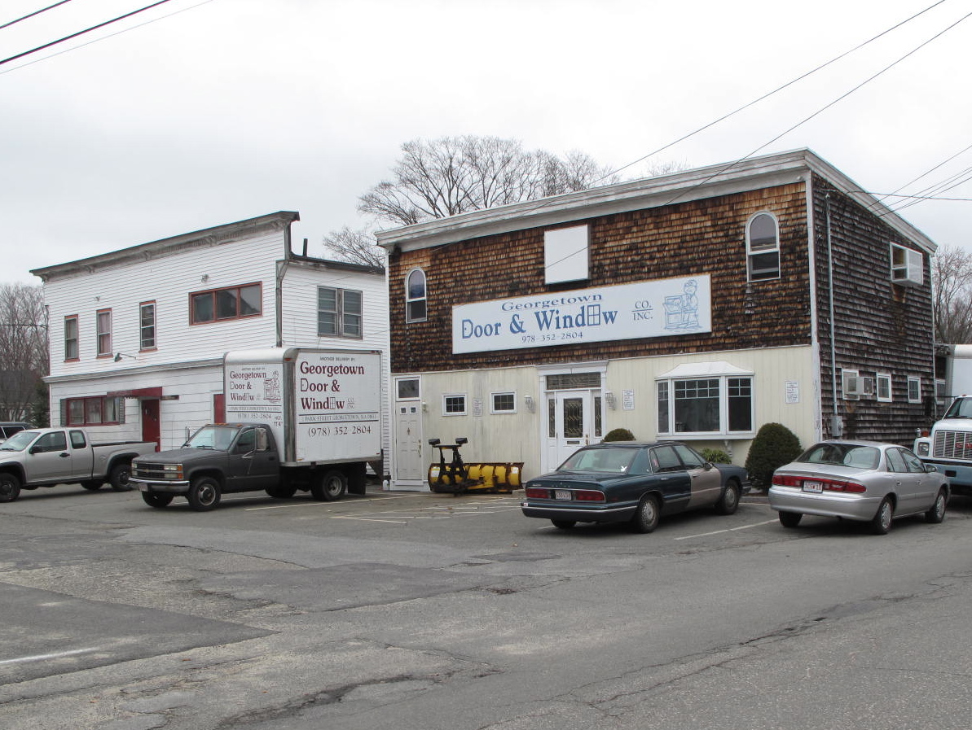
View of 1 Park St. (right) & 5 Park St. (left) from SE

Locus Map (north at top)
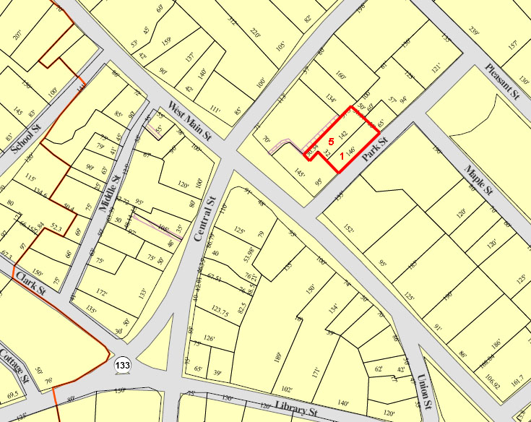

Recorded by: Kathryn Grover and Neil Larson
Organization: Town of Georgetown
Date (month / year): June 2012

Assessor’s Number USGS Quad Area(s) Form Number

11A / 105 & 106 |  | Georgetown |  | C |  | GEO.167  GEO.168

Town/City: Georgetown
Place: (neighborhood or village):
Town Center

Address: 1 & 5 Park Street
Historic Name: John J. Molloy Shoe Shop (#1)
George S. Rollins Company, Inc. (#1 & #5)
Georgetown Bowling Alley (#5)

Uses: Present: commercial
Original: industrial
Date of Construction: ca. 1915 (#1 & #5)
Source: deeds, historic maps, directories
Style/Form: undetermined
Architect/Builder: unknown
Exterior Material:
Foundation: brick
Wall/Trim: wood shingle siding (#1)
vinyl clapboards (#5)
Roof: asphalt
Outbuildings/Secondary Structures:
None
Major Alterations (with dates):
Façade alterations to #1, ca. 1920 & ca. 1975
Façade alterations to #5, ca. 1936
Rear section of #5 rebuilt
Vinyl siding added to #5

Condition: good
Moved: no yes Date:
Acreage: 0.14 (#1) + 0.18 (#5) = 0.32 acre
Setting: These buildings stand behind main blocks in the town center in an area of mixed residential, commercial, and institutional uses.

Recommended for listing in the National Register of Historic Places.
If checked, you must attach a completed National Register Criteria Statement form.

ARCHITECTURAL DESCRIPTION:
The two associated wood frame industrial buildings are located on the west side of Park Street north of East Main Street. They occupy the bulk of their respective lots (subdivided about 1936) with small paved parking areas in front (south) and an equal amount of storage areas in the rear. Both were built ca. 1915 replacing and, perhaps, incorporating parts of earlier, larger 19th-century shoe factories. Since their construction they have been altered in their appearance and use. Both have two-story front sections, presumably where manufacturing work took place and one-story rear sections that functioned as warehousing. The building at #1 Park The wood shingle exterior of the building at #1 Park remain from substantial renovations made to the building ca. 1920. Ground level alterations were made to the façade in 1975 for its current use as a door and sash store. The parapet front with cornice on the building at #5 Park appear to survive from its ca. 1915 construction, although it also reflects alterations made when the building became a bowling alley in 1936. The one-story rear section, where the bowling alleys are located looks like it has been rebuilt more recently.

HISTORICAL NARRATIVE
The commercial buildings at 1 and 5 Park Street were built about 1915 and 1940, respectively, on land occupied by a variety of businesses in the nineteenth century but vacant by 1906. Park Street itself appears to have been platted between 1856 and 1872, and in the latter year the site was occupied by a building perpendicular to the course of Park Street that housed a shoe shop, a carriage shop, and a livery stable. The livery may have been connected with the Pentucket House, though the 1893 Sanborn map shows that hotel to have had a livery attached to the rear, just north of the livery shown on the site of 5 Park Street. The 1874 Essex County directory shows only two liveries in town, one run by S. and S. Nelson at an unstated location and the other by Josephus Adams, the latter near his home at the head of Elm Street. Who operated the shoe shop has not been determined: in 1871 fourteen boot and shoe manufacturers were listed in Georgetown in the county directory, thirteen of them without addresses. The only carriage shop listed in Georgetown in early 1870s directory was Osgood Brothers, whose advertisement in the 1871 county directory notes that the firm made eight brands of buggies but did not indicate who or where they were. The 1872 map of town shows a carriage shop marked “S. Osgood” at the west end of School Street, no doubt indicating that the merchant tailor Stephen Osgood, a brother of whom is known to have operated a carriage factory “for a time” in Georgetown, owned the building. By 1884, however, the Park Street building housing these three businesses had been razed, and two long, narrow, unlabeled outbuildings stood parallel to Park Street on the site. The 1887 bird’s-eye view of the town shows the building on the site of 1 Park Street as owned and occupied by Stephen Osgood, while the building on the site of 5 Park Street was the Pentucket House boarding and livery stable, operated by Edward A. Hood. Deeds indicate that Osgood (and, after his death, his estate) owned the lot and these two buildings probably from 1882 until 1913.

Born in Salisbury, Massachusetts, Stephen Osgood (1827-1911) was the son of ship caulker Stephen Osgood and his wife Charlotte Morrill; the Osgood family had been residents of Salisbury for decades. Stephen Osgood of Georgetown was one of at least eight children; his younger brother Charles Emmons Osgood was a carriage maker, while brother Warren F. was a carriage trimmer by trade. Both served in the Civil War, and Charles E. Osgood left the service a second lieutenant. It was probably he who ran the Georgetown carriage shop, though he does not appear to have lived in Georgetown, and by 1800 he had taken a job as a custom house clerk and was living in Amesbury. Warren had by then moved to Minneapolis.

Stephen Osgood began his career making men’s clothing in 1848 and was living and working in Georgetown by 1850, when he married Sarah P. Carter, daughter of trader Moses Carter and his wife Almira. By 1860, the industrial schedules of the federal census indicate, he was employing three men and nine women in the manufacture of men’s broadcloth and cassimere coats, pants, and vests. By 1880 he employed five men and eighteen women, was running his shop ten hours a day throughout the year, and produced clothing valued at seventeen thousand dollars. By then his sons Louis K. and Charles C. were both working as cutters in his shop. Local histories state that his business was in the Masonic Block, which burned in 1885 and was replaced by the Union Block in 1886. Osgood might have moved his business to the Park Street building after the 1885 fire, as the 1887 bird’s-eye view indicates. He was the town’s postmaster from 1901 and 1905, and he remained in the clothing manufacturing business until he died in 1911.

Though the deeds documenting it have not yet been located, Osgood appears to have owned the property with shoe manufacturer Milton G. Tenney, who in the early 1880s operated the shoe factory across Park Street from this building. In 1913 his heirs and Osgood’s executor sold their undivided halves to Laurence L. Chaplin, a shoe factory foreman whose family had been in the local shoe business for many years. Chaplin sold it two weeks later to shoe worker John J. Molloy. The deed to Molloy mentions no buildings, and the 1906 Sanborn map shows none on the site.

Born in 1859 in Georgetown, John Joseph Molloy was the son of shoe manufacturer Patrick Molloy and his wife Bridget Convery, both Irish immigrants. Patrick Molloy was identified as a shoe manufacturer in the 1870 and 1874 county directories and was the head of one of at least three Molloy families living in Georgetown at that time; their relation has not been determined. By 1900 John J. Molloy and his brothers Patrick and James were all working as lasters, though John briefly had a career selling barbers’ supplies in the first decade of the 1900s. By 1916 John J. Molloy and his brother Alfred had founded Molloy Shoe Company, whose address is given as 7 Park thought the shop was almost certainly in this building.

In 1920, when Molloy founded Georgetown Standard Shoe Company with Theodore McDonald, and Henry J. Minchin, John J. Molloy, he sold 1 and 5 Park to Haverhill shoe manufacturer George S. Rollins. According to historian Benjamin Arrington, Rollins “in 1920 purchased the Molloy factory and other buildings adjoining, remodeled them into a modern factory and moved his entire business here. While his line of work is entirely foreign to the old-time type of Georgetown footwear, he has, with modern machinery methods, maintained the quality of his former output, and has from the beginning done a capacity business since locating here. Being a large employer of men and women, his business is of great benefit to the town as a whole.”

Born in Deerfield, New Hampshire, George Sylvester Rollins (1874-1943) was living in Haverhill and working as a shoe factory edge setter in1895, when he married Elsie I. Hastings, a shoe stitcher who had come to Haverhill from New Brunswick. By 1909 the Haverhill directory lists him as a shoe contractor, and by 1911 he was a principal in the shoe making firm of Rollins and Colcord in that city. By 1925 his firm, George S. Rollins Company, Inc., was still operating at this Park Street site, but in 1926 a trustee in bankruptcy for Rollins’s estate sold the 1 and 5 Park Street property to shoe manufacturer Charles S. Marston Jr., who had taken over what was then the Georgetown Boot and Shoe Company factory across Park Street. By 1927 directories indicate that the Rollins shop had returned to Haverhill, and the 1932 directory indicates that the 1 Park Street factory was vacant.

Born in Essex, Charles Sumner Marston Jr. (1884-1965) was a manufacturer of ice skates and athletic shoes, and the 1949 Sanborn map suggests that he used the 1 Park Street building for storage. His father worked at Essex Shoe Company in Essex. Charles Marston Jr. lived most of his life in Haverhill. He and his wife Alice Currier, born in Lawrence to French Canadian immigrant parents, had three sons, Charles S. III (1921-2007), Stanley C. (1923-98), and Robert P., born in 1925; all of them worked in the family business.

In 1936 Marston sold 5 Park Street, which at the time had a building on it, to Fred Harold Harriman, who opened the six-lane Georgetown Bowling Alley either in the existing building or a new one; one candlepin bowling website states that the building was constructed in the early 1930s. Born in 1878 in Georgetown, Harriman was the son of boot manufacturer Horace E. Harriman and grew up on Elm Street, first at 59 Elm and later at 94 Elm; by 1942 he lived at 95 Elm, the home of his aunt Caroline Harriman Tyler. By 1899 Fred Harriman was a bank cashier and remained in that occupation, most of the time at First National Bank in Haverhill, for the rest of his life. The bowling alley must have been an avocation and an income property. The 1940 directory shows him as proprietor of Georgetown Bowling Alley, and by 1942 he had retired from banking and listed himself as self-employed on Park Street.

In June 1945 Harriman sold 5 Park Street to John C. and Elizabeth L. Eaton, who four years later acquired 1 Park Street from Charles S. Marston Jr. How the buildings were then used is not yet known; the 1949 Sanborn map shows the two joined by a 1-story addition between the two-story western sections of each structure. In 1958 Elizabeth L. Eaton sold both parcels to Louis J. Giannelli Company of Boston, who sold them several months later to Warren A. Rice of Lincoln; Rice in turn sold 1 Park Street in September 1959 to Chester W. Richardson of Georgetown and 5 Park Street in June 1963 to Roland E. Spofford. Richardson owned 1 Park until 1975, when he sold the property to Paul and Dorothy M. Zocco, whose family now owns it in trust and has operated Georgetown Door and Window Company from the building. Spofford owned 5 Park Street until 1973, when he sold it to John R. Babin of Melrose and George C. H. Perkins Jr. of North Reading. Perkins has been sole owner of 5 Park Street, now Georgetown Candlepin Bowling Lanes, since 1975.

BIBLIOGRAPHY and/or REFERENCES
Arrington, Benjamin F., ed. Municipal History of Essex County in Massachusetts. NY: Lewis Historical Publishing Co., 1922.
Field, Jane. A Brief History of Georgetown Massachusetts 1838-1963. Rev. ed. 1988. Georgetown: Georgetown Historical Commission, 1988.
Gage, Thomas. The History of Rowley, Anciently Including Bradford, Boxford, and Georgetown, from the Year 1639 to the Present Time. Boston: F. Andrews, 1840.
Georgetown, Boxford, Byfield, Newbury, and West Newbury, Massachusetts, Directory. Boston: W. E. Shaw, 1901-2, 1905, 1909, 1912, 1914, 1916-17, 1918, 1925.
Hill, Edwin P. “History of Georgetown, Massachusetts.” In Standard History of Essex County, Massachusetts. Edited by Cyrus M. Tracey, William E. Graves, and Henry M. Batchelder. Boston: C. F. Jewett, 1878.
Hull, Forrest P. Georgetown: Story of One Hundred Years, 1838-1938. 1938. Reprint. Georgetown, MA: Georgetown Historical Commission, 2006.
Nelson, Henry M. “Town of Georgetown History.” In Hurd, D. Hamilton. History of Essex County, Massachusetts, with Biographical Sketches of Many of Its Pioneers and Prominent Men. Vol. 1. Philadelphia: J. W. Lewis and Co., 1888.

MAPS
“Map of the Centre of Georgetown in 1800.” In Perley, Sidney H., “Centre of Georgetown in the Year 1800.” The Essex Antiquarian: A Quarterly Magazine Devoted to the Biography, Genealogy, History, and Antiquities of Essex County, Massachusetts 2, 7 (July 1898): 201.
Map of Georgetown in 1810 and 1840. In Gage, Thomas. The History of Rowley, Anciently Including Bradford, Boxford, and Georgetown, from the Year 1639 to the Present Time. Boston: F. Andrews, 1840. 320.
“Map of New Rowley Surveyed and Drawn by Philander Anderson 1830.” Georgetown Historical Society.
Map of Georgetown. 1856. In Walling. H. F. A Topographical Map Essex County Massachusetts. Boston: Smith and Morley, 1856.
Atlas of Essex County, Massachusetts. Philadelphia: D. G. Beers and Co., 1872). Plates 59 and 61.
“Town of Georgetown Mass.” and “Village of Georgetown Mass.” In Atlas of Essex County, Massachusetts (Boston: George H. Walker, 1884).
“Georgetown, Mass. 1887.” Drawn and Published by George E. Norris, Brockton, Massachusetts. Troy, NY: Burleigh Lithographic Establishment, 1887.”
Sanborn Map Co. Insurance maps for Haverhill, Massachusetts. 1893, 1906, 1949.

PHOTOGRAPHS (all photos by Neil Larson, 2012)

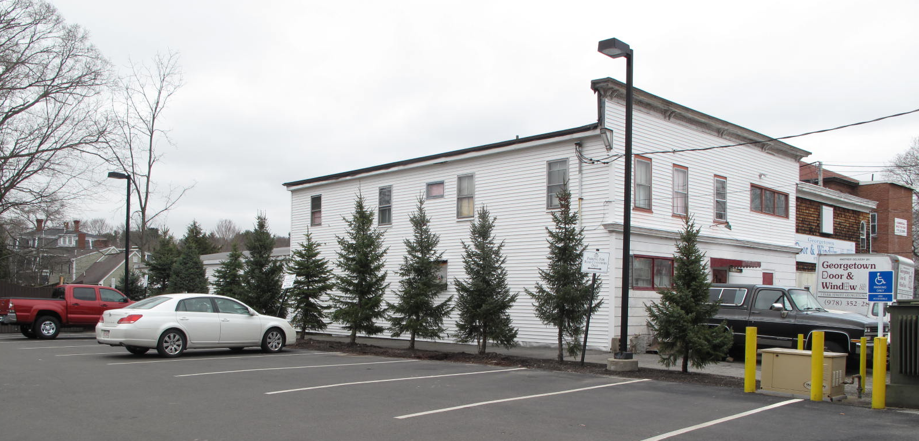
View of 5 Park St. (left) & 1 Park St. (right) from SW

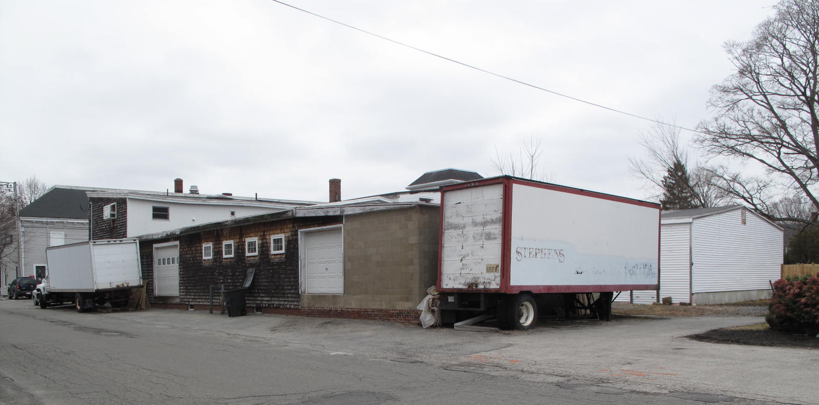
View of 1 Park St. (left) and 5 Park St. (right) from NE

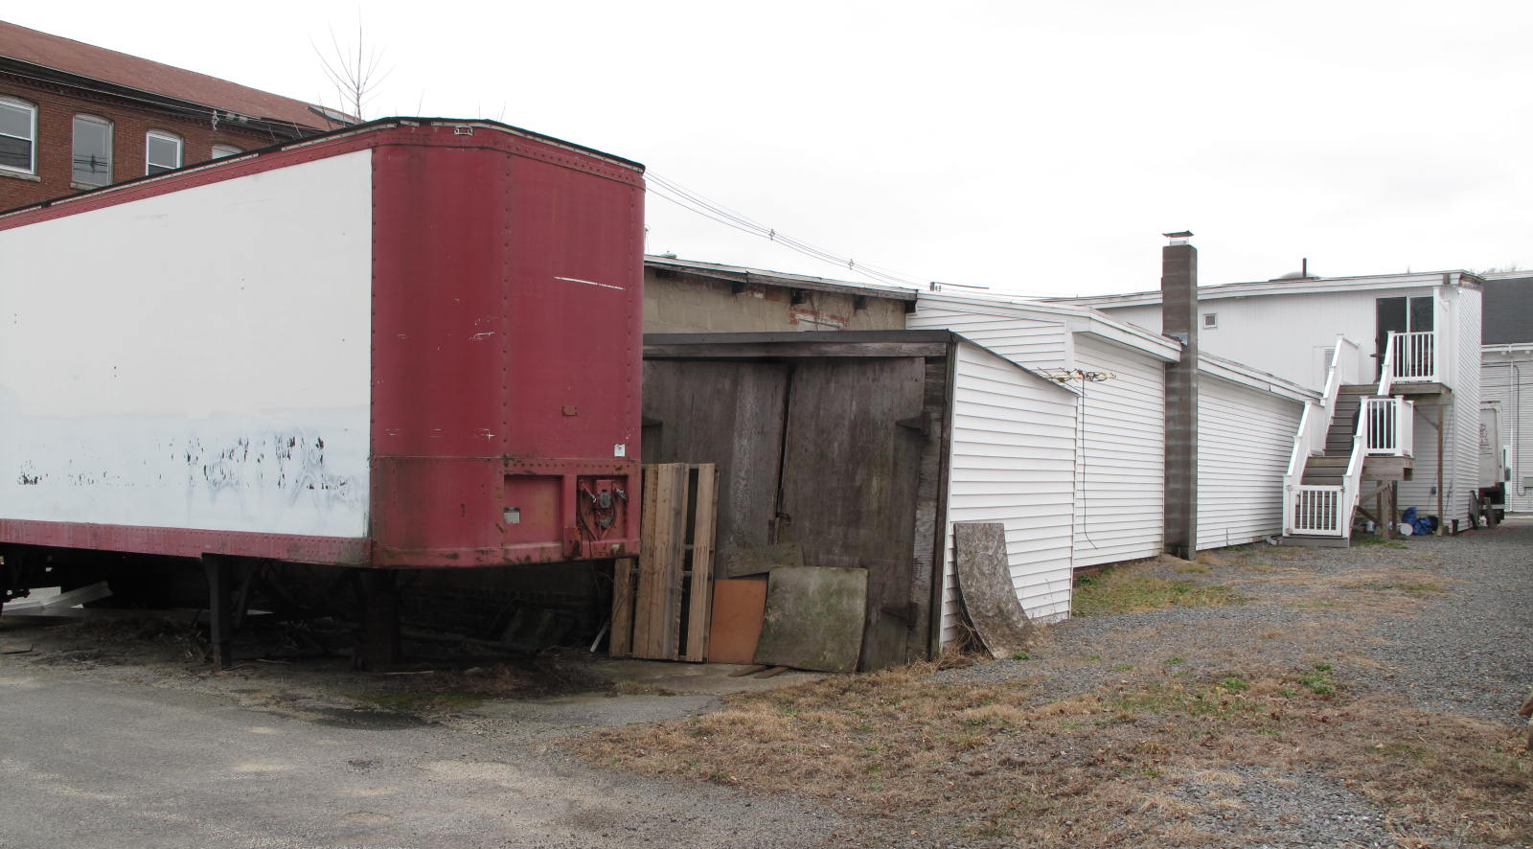
View of 1 Park St. from NW

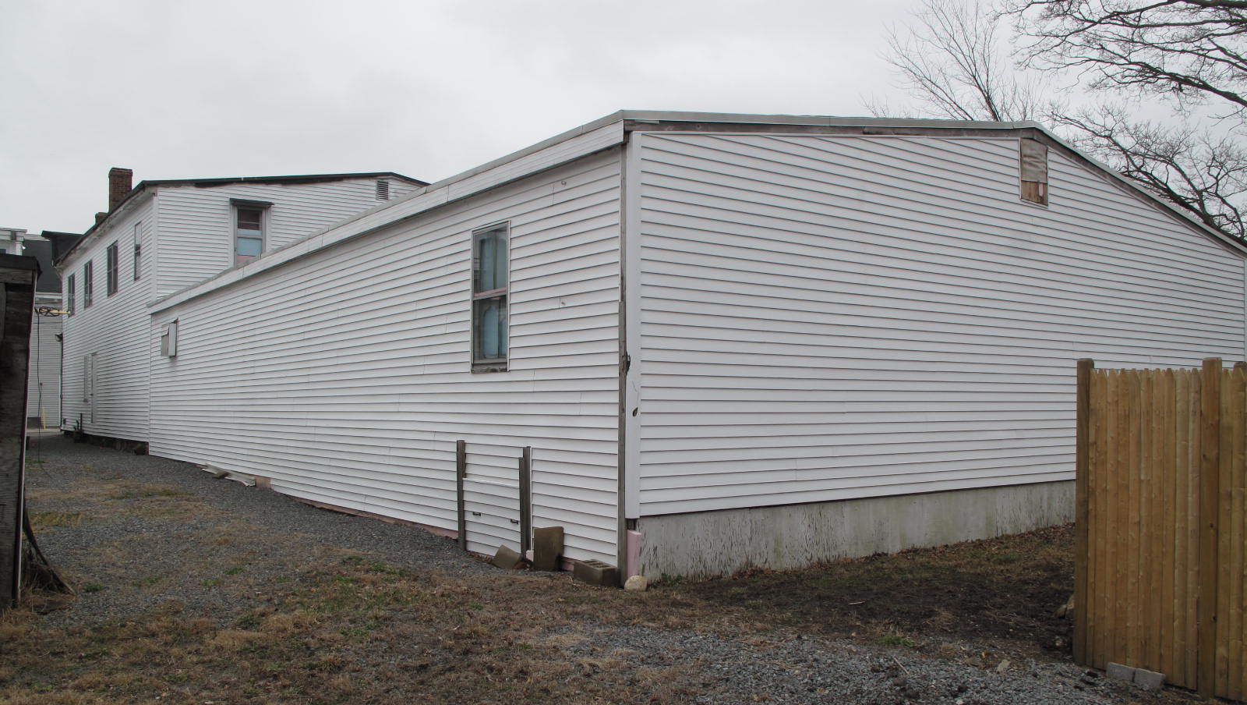
View of 5 Park St. from NE

National Register of Historic Places Criteria Statement Form

Check all that apply:

Individually eligible Eligible only in a historic district

Contributing to a potential historic district Potential historic district

Criteria: A B C D

Criteria Considerations: A B C D E F G

Statement of Significance by________Neil Larson_________________________________
The criteria that are checked in the above sections must be justified here.

The two adjacent and similar industrial buildings are distinctive surviving landmarks of Georgetown’s shoemaking history. Although altered for more recent commercial uses, they retain integrity of location and design to contribute to a historic district in the village center.

Benjamin F. Arrington, ed., Municipal History of Essex County in Massachusetts (New York: Lewis Historical Publishing Co., 1922), 257, states that the factory was “at the head of School Street.”
: Sarah B. Dorman, Georgetown, to Stephen Osgood, Georgetown, 6 October 1882, SED 1122:52.
George B. Tenney, Boston, and Robert M. Tenney, Cambridge, executors under will of Milton G. Tenney, to Laurence L. Chaplin, 14 March 1913, SED 2205:484; Charlotte O. Haskell, Georgetown, administrator of estate of Stephen Osgood, Georgetown, to Laurence L. Chaplin, 28 February 1913, SED 2205:482; Laurence L. Chaplin, Georgetown, to John J. Molloy, Georgetown, 15 March 1913, SED 2204:553.
See Henry M. Nelson, “Town of Georgetown History,” in History of Essex County, Massachusetts, with Biographical Sketches of Many of Its Pioneers and Prominent Men, ed. D. Hamilton Hurd (Philadelphia: J. W. Lewis and Co., 1888), 840, which states that in 1850 a James Malloy lived at the Brocklebank House on Central Street, where the first Catholic mass was held that year. “The opening of the Newburyport Railroad, led to the permanent location of several Catholics in town, who had been employed, among them Michael and Dennis Buckley. Three brothers of the same name of Molloy, cousins of James, one of whom had arrived in 1849, were settled here 1852.”
John J. Molloy, Georgetown, to George S. Rollins, Georgetown, 27 October 1920, SED 2469:235. Arrington, Municipal History, 260, states that Georgetown Standard Shoe Company “makes men's and boys' medium priced standard screw and loose-nailed goods. As a specialty the firm makes wood-soled brogans for use in foundries, woolen and felt mills, hat-shops, tanneries and by the miners.” Where it was located is not clear.
Arrington, Municipal History, 260.
Alfred Eaton, trustee in bankruptcy for estate of George S. Rollins, to Charles S. Marston Jr., 23 June 1926, SED 2694:89.
Charles S. Marston Jr., Haverhill, to Fred H. Harriman, Georgetown, 8 December 1936, SED 3102:570.
Fred H. Harriman to John C. and Elizabeth L. Eaton, 30 June 1945, cited with no deed book and page number in Elizabeth L. Eaton, Georgetown, to Louis J. Giannelli Co., 29 October 1958, SED 4509:114; Charles S. Marston Jr. to John C. Eaton, 4 May 1949, cited with no deed book and page number in Elizabeth L. Eaton, 15 November 1957, Southern Essex Registry Land Court Document 28045. On 1 Park Street see also C. S. Marston Inc. to Elizabeth L. Eaton, 13 May 1958, SED 4462:509.
Elizabeth L. Eaton to Louis J. Gianelli Co., 29 October 1958, SED 4509:114; Louis J. Gianelli Co., Boston, to Warren A. Rice, Lincoln, 20 February 1959, SED 4539:528; Warren A. Rice, Lincoln, to Chester W. Richardson, Georgetown, 18 September 1959, SED 4603:67; Warren A. Rice, Lincoln, to Roland E. Spofford, 4 June 1963, SED 5068:75.
Chester W. and Dorothy M. Richardson to Paul and Dorothy M. Zocco, 11 August 1975, SED 6171:538; Philip Zocco, trustee Zocco Realty Trust, to Philip J. Zocco, trustee Zocco Realty Trust II, 24 February 2009, SED 28349:405; Roland E. Spofford, Georgetown, to John R. Babin, Melrose, and George C. H. Perkins Jr., North Reading, 5 February 1973, SED 5946:605; George C. H. Perkins and George C. H. Perkins Jr., trustees GBA Realty Trust, to George C. H. Perkins Jr., North Reading, 31 December 1975, SED 6209:145.

