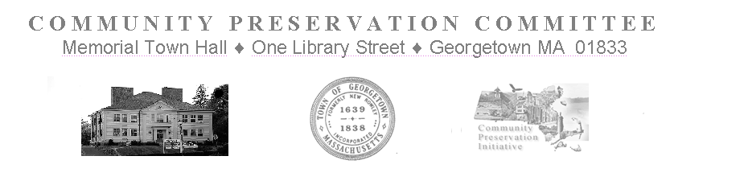

Community Preservation Committee Meeting
Tuesday, February 7, 2023
Held at 7:00 PM
via Zoom Meeting
https://us2wevb.zoom.us/j/82371954884
Meeting ID: 823 7195 4884
This Public Meeting is being conducted in a way that is an attempt to satisfy the Open Meeting Law, and other State Laws pertaining to the Public Hearings of the Town’s Public Bodies. It is a good faith, best effort to comply with the pandemic extensions signed into law on June 16, 2021 in Chapter 20 of the Acts of 2021 and further extended through March 31, 2023 by Chapter 22 of the Acts of 2022. Internet based technologies will be used by the CPC to conduct Public Meetings and Hearings until further legislative changes are enacted, or the extension expires.

Meeting Minutes

In Attendance: H. LaCortiglia, R. Bancroft, G. Fowler, P. Burns, T. Ruh, J. DiMento (arrives at 7:16)
Not in Attendance:, D. Schauer, S. Epstein, J. Davenport,
Meeting is Called to Order at: 7:02pm

- Invoices:
  - None
- Correspondence:
  - None
- New Business:
      - Preliminary Monetary Review
        - Residual Accounts
          - The CPC’s Affordable Housing Trust’s Representative, T. Ruh has been working with the Town Accountant to create a comprehensive spreadsheet listing accounts from previous appropriations with remaining balances. Members will investigate accounts in their areas of interest and report back to the board with information regarding the necessity of maintaining specific accounts vs. returning the accounts’ residual balances to the fund. A possible meeting for this was suggested to be held after the CPC’s Public Informational Hearing in April.
        - Fund Status
          - T. Ruh walks the Committee through the newest version of the calculator spreadsheet which has been updated and reformatted to be more informative and user friendly. Members ask questions and familiarize themselves with the new tool.
        - Project Withdrawal
          - CPC’s Vice Chairman, and Open Space Committee’s representative, P. Burns announces the withdrawal of the Project request for additional funding for the UART Trail. The project bid was altered to allow the existing funding to be sufficient.
- Old Business:
      - Proposed Project List Submission
        - G. Fowler reports that the Town Warrant is currently open. A list of the remaining Proposed Projects that are currently under consideration for Recommendation will be sent to the Board of Selectmen with a request to have them included as placeholders for the May 2023 Annual Town Meeting Warrant.
- Meeting Schedule:
      - Draft Meeting Schedule
        - No changes are suggested
Motion by J. DiMento to adjourn
Second by R. Bancroft
Roll call vote is taken
P. Burns - yes
R. Bancroft -yes
T. Ruh -yes
G. Fowler - yes
J. DiMento - yes
H. LaCortiglia – yes
Motion Carries Unanimously– 6-0
Meeting is adjourned at 7:53 pm

