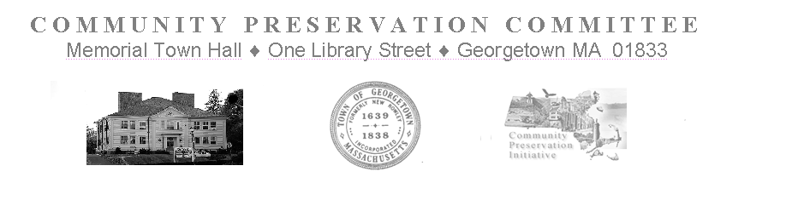

Community Preservation Committee Meeting
Tuesday, January 17, 2023
Held at 7:00 PM
Zoom Meeting was at:
https://us02web.zoom.us/j/84625258028
This Public Meeting is being conducted in a way that is an attempt to satisfy the Open Meeting Law, and other State Laws pertaining to the Public Hearings of the Town’s Public Bodies. It is a good faith, best effort to comply with the pandemic extensions signed into law on June 16, 2021 in Chapter 20 of the Acts of 2021 and further extended through March 31, 2023 by Chapter 22 of the Acts of 2022. Internet based technologies will be used by the CPC to conduct Public Meetings and Hearings until further legislative changes are enacted, or the extension expires.

Meeting Minutes

In Attendance: H. LaCortiglia, P. Burns, S. Epstein (leaves at 7:35), J. Davenport, T. Ruh,
R. Bancroft, J. DiMento (arrives at 7:20)
Not in Attendance:, D. Schauer, G. Fowler
Meeting is Called to Order at: 7:04 pm

- Invoices:
  - Community Preservation Coalition Annual Dues
Motion by T. Ruh to pay the invoice for the Annual Coalition dues
Seconded by R. Bancroft
Roll Call vote is taken
  - S. Epstein, abstains
  - P. Burns, yes
  - R. Bancroft, yes
  - J. Davenport, yes
  - T. Ruh, yes
  - H. LaCortiglia, yes
Motion Carries 5-0 with 1 abstention
- Correspondence:
      - Town Treasurer: Additional Match from State Surplus has been received
        - The Committee discusses the State Match and views an email confirming the match receipt.
- New Business:
      - Second Level Suggestions Received
        - Four Second Level Submissions have been received since the CPC’s last meeting. The Committee proceeds to review them.
- Second Level Reviews
        - American Legion Park ADA
          - Craig Marchionda, as Contact Person is looking to extend and further the ADA improvement project that was previously approved by Town Meeting in the last cycle. Asking for additional funding for surfacing and site preparation.
Requesting 14,946.00
        - Invasive Plant Mapping
          - Amy Smith as Contact Person is proposing a invasives plant assay throughout the town. The project involves purchasing two iPads for data collection and funding to provide for data collectors. The iPads will be town property. The software is free to use. Data collection will be done only on public lands.
Requesting 8500.00
        - Community Gardens
          - Pete Burns, Open Space Committee Chair and Steve Przyjemsky, Conservation Commission Agent for the Town describe the project. Looking to do a design plan for the Community Gardens which will investigate what the Town’s users would like to see there. Orchards, greenhouse, etc.
Requesting 50,000.00

        - Universal Access Trails II
          - Pete Burns, Open Space Committee Chair explains that the original appropriation for this approved in the previous cycle, was no longer adequate due to the wait time that it took to execute the project. Additional funding is needed in order to enter into the contract with the vendor.
Requesting 8,000.00

- Meeting Schedule:
      - Draft Meeting Schedule.
      - It is noted that there are still a number of Projects which were initially proposed in this cycle which have not had Second Level review. Contact Persons were notified twice to submit their Second Level Submissions forms. Forms were to have been received by the 15th of January.
      - Our next meeting will be February 7th. It will be a Preliminary Monetary Review.

Motion by T. Ruh to adjourn
Seconded by J. Dimento
Roll Call Vote is taken
- J. DiMento, yes
- P. Burns, yes,
- R. Bancroft,yes
- J. Davenport,yes
- T. Ruh, yes.
- H. LaCortiglia, yes
Motion carries 6-0 unanimously
Meeting is adjourned at 8:13pm

