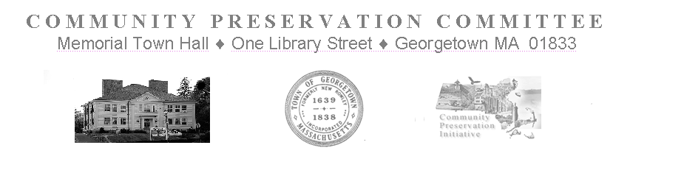

Community Preservation Committee Meeting
Tuesday, April 4, 2023
Held at 7:00 PM
via Zoom Meeting
https://us02web.zoom.us/j/84146181201
This Public Meeting is being conducted in a way that is an attempt to satisfy the Open Meeting Law, and other State Laws pertaining to the Public Meetings and Hearings of the Town’s Public Bodies. It is a good faith, best effort to comply with the pandemic extensions signed into law on June 16, 2021 in Chapter 20 of the Acts of 2021 and further extended through March 31, 2023 by Chapter 22 of the Acts of 2022, and further extended by the Acts of 2023 until March 31, 2025. Internet based remote participation technologies will be used by the CPC to conduct Public Meetings and Hearings until further legislative changes are enacted, or the extensions expire.

Meeting Minutes

(Note that a video of this meeting is available at: http://gctv.georgetownma.gov/show/7553)

Members In Attendance: H. LaCortiglia, P. Burns, R. Bancroft, G. Fowler, T. Ruh, S. Epstein
J. DiMento (arrives at 7:20pm) J. Davenport (arrives at 7:20pm)
Members Not In Attendance: D. Schauer
Meeting is called to Order at: 7: 02pm

    - Invoices
Motion by R. Bancroft to pay the invoice for the Newspaper Publication of the Hearing Notice ($196.00) and a reimbursement for the Zoom subscription ($149.90)
Seconded by P. Burns
  - Discussion follows focused on the Zoom bill addressed to the CPC at 144 Jewett Street paid for by the Chair using his credit card. Chair stated he was planning on not voting on the motion. The Chair explained the rationale for using his card for the transaction.
Vote is taken by Roll Call
  - P. Burns, yes
  - T. Ruh, no
  - J. DiMento,( not present)
  - J. Davenport, (not present)
  - R. Bancroft, yes
  - D. Schauer, (not present)
  - G. Fowler, yes
  - S. Epstein, no
  - H. LaCortiglia, yes
Motion Carries - 4 yes and 2 no

- Annual Public Informational Hearing
  - The Chairman welcomes everyone to the Hearing and explains the process for participation.
  - The Legal Notice for the Hearing is read into the record by Vice Chair P. Burns.
(J. DiMento and J. Davenport arrive at 7:20pm)
The Chair presents a slide presentation giving an overview of the CPA process. S. Epstein claims that the Chair is editorializing and objects to it. S. Epstein also objects to the editorializing of the laws related to the CPC in the slide presentation and would like that objection noted in the record.

The following projects, having received a Recommendation to Town Meeting from the CPC, are presented by their proponents for comments and questions from the Public.

    - Affordable Housing Trust Block Grant --T. Ruh presents the Block Grant of $595,000 details how it is used.
Members of the public are invited to ask questions or make comments.
None are heard

    - Town Records Preservation – Kerri McManus presents the project to scan public documents at cost of $230,000.
Members of the public are invited to ask questions or make comments.
J. Davenport, CPC Representative on the CPC, notes that the Historical Commission is in favor of this project. Members of the public are invited to ask questions or make comments.
None are heard.

    - Equal Access to American Legion Park – Craig Marchionda presents the project at a cost of $14,946.
Members of the public are invited to ask questions or make comments.
Jenelle Walsh and Anne Berardi speak in favor of the project.

    - East Main Street Recreational Facility Electrification -Park and Recreation Commission – Orlando Pacheco, Town Administrator explains the project at a cost of $31,035.
J. DiMento, representative on the CPC from the Park and Recreation Commission notes that this is a more cost effective project than the original projections many years ago. Members of the public are invited to ask questions or make comments.
None are heard.

    - American Legion Park Irrigation -Park and Recreation Commission -
Orlando Pacheco, Town Administrator explains the project at a cost of $10,531.35.
J. DiMento, representative on the CPC from the Park and Recreation Commission notes that this will pay for itself in 2 or so years.
Members of the public are invited to ask questions or make comments.
None are heard.

    - Town Hall Window Restoration and Preservation -Historical Commission -
Orlando Pacheco, Town Administrator shows a slide presentation and explains the project at a cost of $457,000.
Members of the public are invited to ask questions or make comments.
Anne Berardi asks about efficiency of the restored windows and it is explained that new storm windows will be installed as part of the project.
Members of the public are invited to ask questions or make comments.
None are heard.

Motion by J. DiMento to adjourn the Public Hearing and the Meeting.
Seconded by S. Epstein
During discussion of the motion G. Fowler asks about holding a CPC meeting on April 18 to discuss the Board of Selectman’s addition of a warrant article using CPC funding. The Chairman states that he will post a meeting for April 18, 2023.
Vote is taken by Roll Call
P. Burns, yes
T. Ruh, yes
J. DiMento, yes
J. Davenport, yes
R. Bancroft, yes
D. Schauer (not present)
G. Fowler, yes
S. Epstein, yes
H. LaCortiglia, yes
Motion Carries -unanimously
- Adjournment is at 8:31pm

